Lab(1)
Introduction
Parasitology : is the study of relationships between parasites and their host Parasites : are living organisms, which depend on a living host for their nourishment and survival .
all parasitic organisms are eukaryotes . parasites can be classified as: (Ectoparasite : inhabit only the body surface of the host without penetrating the tissue e.g. lice, ticks ,)
or (Endoparasite which lives within the body of the host e.g. malaria, giardia ). parasites may be simple unicellular protozoa or complex multicellular metazoa.
Host : an organism, which harbors the parasite and provides nourishment and is relatively larger than the parasite .
Definitive host: the organism in which the adult or sexually mature stage of the parasite lives.
Intermediate host : the organism in which the parasite lives during a period of its development only.
Vector: a living carrier that transports a pathogenic organism from an infected to non infected host (e.g. the female Anopheles mosquito that transmits malaria)

Host – parasite relationships :
Symbiosis: both host and parasite dependent upon each other, none of them suffers any harm from the association .
Commensalism: only the parasite derives benefit from association without causing any injury to the host .
parasitism: the parasite derives benefites and the host is always harmed due to the association.
Transmission of parasites:
1-Food or water contamination ( Amoeba,Giardia).
2-Vectors (Sand fly Leishmaniasis, Tse tse fly Trypanosomiasis).
3-Sexual contact (Trichomonas).
4-Inhalation of contaminated dust or air (egg of Enterobious vermicularis).
5-Skin penetration (Acanthamoeba ).
Parasitic damage to host:
1-Trauma (damage to tissues , intestine, liver, eye).
2-abortion
2-Diarrhea
3-Tissue reponse (localized inflammation , eosinophilia).
4-Blood loss ( anemia caused by severe infection with plasmodium falciparum).
5- Meningoencephalitis (African trypanosomiasis)
Types of specimens which can be examined for diagnosis of parasites:
1-Natural secretions:
- stool (Entamoeba histolytica )
- urin (Trichomonas vaginalis).
2-Blood: ( Plasmodium spp.).
3-Vaginal secretions: (Trichomonas vaginalis).
4-Biobsy of liver or spleen: ( Leishmania donovani )

Detection of parasites :
1-Clinical diagnosis: depends on symptoms
2-Laboratory diagnosis :
- Microscopic examination
- wet preparation
- perception
- flotation
b. Serological exam
c. Animal inoculation
d. Intra-dermal sensitivity exam
e. Culture method
f. Tap technique
g. X-ray technique

Lab (2)
Kingdom : Protista
Subkingdom : Protozoa
Phylum : Sarcomastigophora
Class: lobosea
Genus : 1-Entamoeba histolytica (pathogenic amoeba)
2-Entamoeba coli (non-pathogenic amoeba)
3-Entamoeba hartmanii ( non-pathogenic protozoa)

1-Entamoeba histolytica
Disease name : Amebic dysentery or Amebiasis
Site of infection : Large intestine
Entamoeba histolytica : pathogenic amoeba have two stages Trophozoite (vegetative and diagnostic stage ) and Cyst ( infective and diagnostic stage ) .
Morphology of trophozoite
Trophozoite of E. histolytica is (15-30) micrometer in diameter, has asingle nucleus with a small centrally placed karyosome . The nuclear chromatin is evenly distributed along the periphery of the nucleus . The fine granular endoplasm may contain ingested RBCs
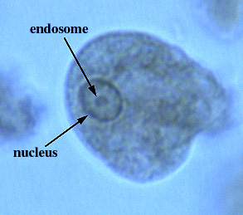
Entamoeba histolytica (trophozoite)
Morphology of cyst
Cyst of E. histolytica is (10-15) micrometer in diameter and contain one to four nuclei . Chromatoid bodies are usually present in young cysts as elongated bars with bluntly rounded ends. Glycogen is usually diffuse, but in young cysts it is often present as a concentrated mass, staining reddish brown with iodine.
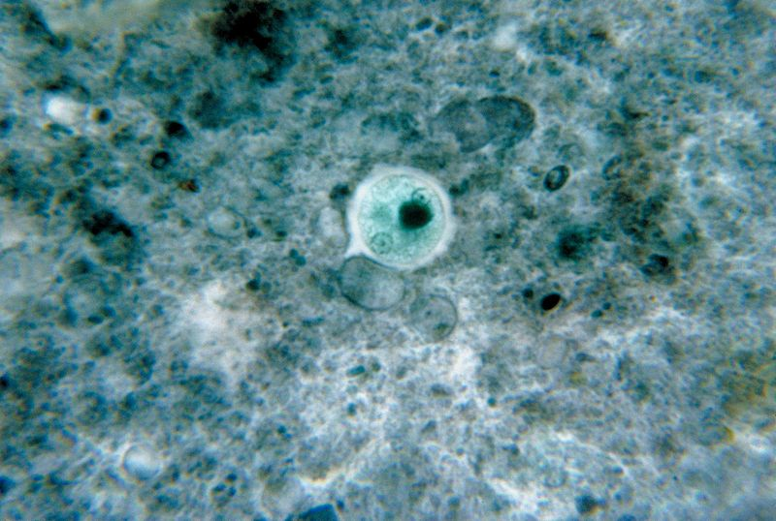
Entamoeba histolytica (cyst)
Life cycle
Infection occurs by ingestion of cysts on focally contaminated food or hands. The cyst is resistant to the gastric environment and passes into small intestine where it decysts. The metacyst divides into four and then eight amoebae which move to the large intestine. The majority of the organisms are passed out of the body with the feces but with chronic infection some amoeba invade the mucosal tissue forming flask-shaped lesions. The organisms encyst for mitosis and are passed through with feces.(there are no intermediate or reservoir host).
Symptoms : including diarrhea with blood and mucus, fever and dehydration.
Laboratory diagnosis:
1-Laboratory diagnosis by finding the characteristic cysts in an iodine stained or formolether concentration method or a permanent stained preparation . Direct microscopy should be done by mixing asmall amount of the specimen in 0.9% sodium chloride solution
2-The tests of indirect fluorescent antibody test (IFAT), or (ELISA) .

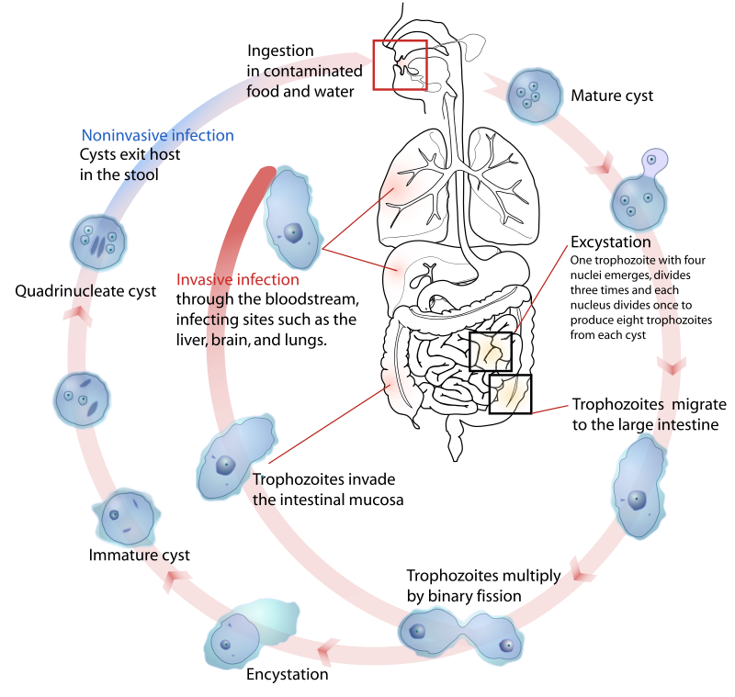
Life cycle of Entamoeba histolytica

2-Entamoeba coli
Entamoeba coli are anon-pathogenic ameba with world wide distribution. Its life cycle is similar to that of E.histolytica but it does not have an invasive stage and does not ingest red blood cells.
Morphology of trophozoite
Trophozoite is larger than of E.histolytica .It exhibits blunt pseudopodia with sluggish movement. A permanently stained preparation shows a nucleus with a moderately large eccentric karyosome with the chromatin clumped on the nuclear membrane. The cytoplasm appears granular containing vacuoles with ingested bacteria and other food particles.
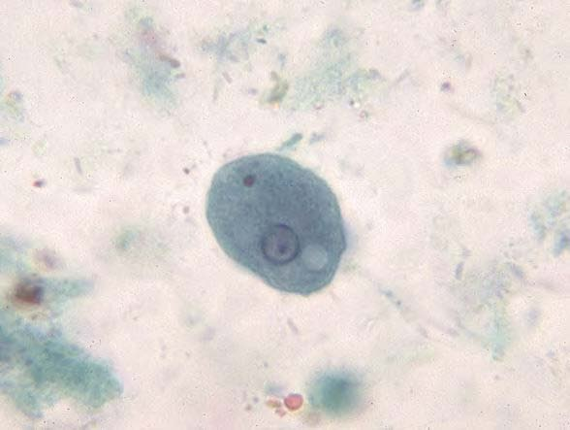
Entamoeba coli (trophozoite)
Morphology of cyst
Cyst of E.coli contain (1-8) nuclei with irregular peripheral chromatin, karyosomes not central. Chromatoid bodies are not frequently seen but when present they are usually splinter-like with pointed ends. Glycogen is usually diffuse but in young cyst is occasionally found as a well-defined mass, which stains reddish brown with iodine.
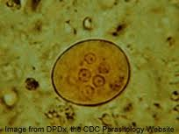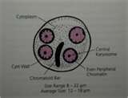
Entamoeba coli (cyst)
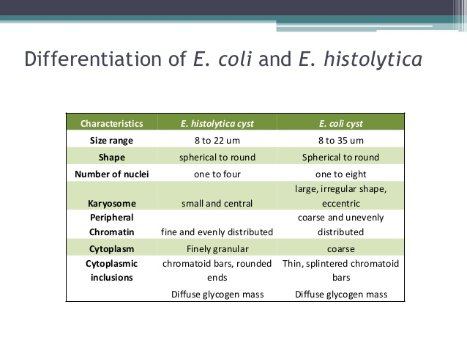
- Entamoeba Hartmanni

• Morphologically similar to E.histolytica but trophozoites &cysts are smaller
•• Trophozoites has one nucleus with peripheral chromatin and small karyosome, never contain ingested red blood cells
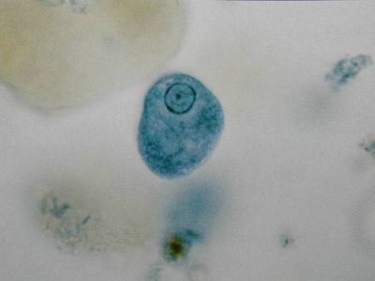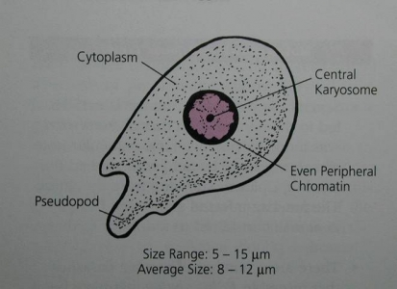
Entamoeba hartmanii troph.
Cyst: contain 4 nuclei(mature) blunt chromatoid bodies in mature cyst
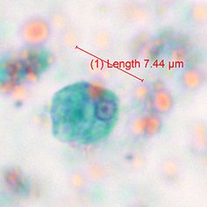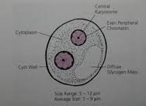
Entamoeba hartmanii cyst
life cycle
similar to that of E. histolytica but it does not have an invasive stage
the cyst can survive outside the body and can be transmitted to humans via ingestion of contaminated food or water.
may also be spread directly by person-to- person contact (fecal-oral route)
whilst the cysts are in the small intestine, the trophozoites emerge, pass down into the colon and then multiply. Cysts and trophozoites are excreted in the feces.
Diagnosis
- finding the characteristic cysts in a wet preparation or an iodine stained, formol-ether concentration method.
- detecting the characteristic trophozoites in a wet preparation or a permanent stained preparation
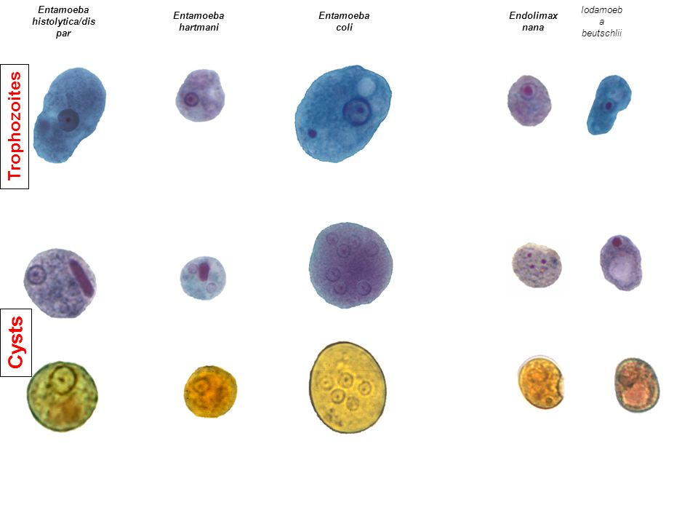

Lab 3
Kingdom : Protista
Subkingdom : Protozoa
Phylum : Sarcomastigophora
Class: Lobosea

1-Endolimax nana (non-pathogenic amoeba)
2-Iodamoeba butschlii (non-pathogenic amoeba)
3-Entamoeba gingivalis (non-pathogenic amoeba)

4- Naegleria fowleri (pathogenic free living amoeba)

5- Acanthamoeba spp. (pathogenic free living amoeba)

1--Endolimax nana
Site of infection: intestine
Transmission via cyst form(infected stage); contaminated food and water
Morphology of trophozoite
Trophozoite Motility is sluggish with blunt hyaline pseudopodia. The nucleus exhibits a large karyosome with no peripheral chromatin on the nuclear membrane.

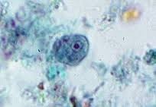
Morphology of cyst
Cyst can be spherical or ovoid in shape and contain (4) pinpoint nuclei, which are highlighted by the addition of iodine. Chromatoid bodies are not found and glycogen is diffuse.
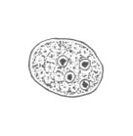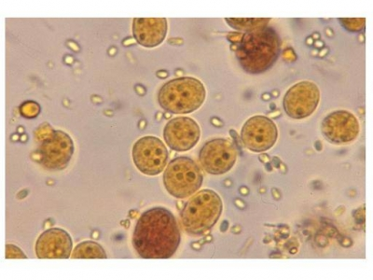
Diagnosis: Microscopic examination of the stool finding trophozoite or cyst(Diagnostic stage)

4-Iodamoeba butschlii
Site of infection: intestine
The transmission of this parasite is by fecal-oral route and infection is asymptomatic.
Morphology of trophozoite
Trophozoite iS actively motile. On a permanently stained fecal smear ,a nucleus with a large karyosome is evident. Chromatoid bodies form striations around the karyosome. The cytoplasm appears granular containing vacuoles with ingested bacteria and debris.
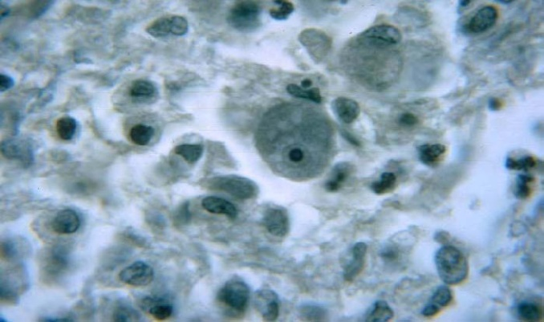
Iodamoeba butschlii (trophozoite)
Morphology of cyst
Cyst have one nucleus in mature cysts usually eccentrically placed. Chromatoid bodies are not present and glycogen is present as acompact well defined mass staining dark brown with iodine.
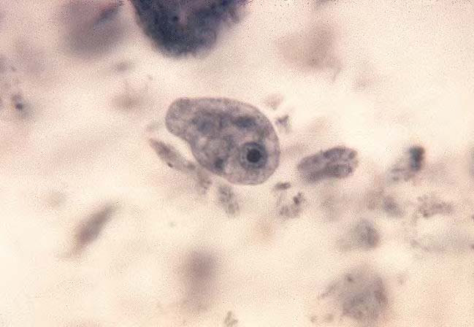
Iodamoeba butschlii (cyst)
Laboratory Diagnosis
Laboratory diagnosis is made by finding the characteristic cysts in an iodine stained, formolether concentration method. Trophozoites are difficult to detect in a wet preparation.
5-Entamoeba gingivalis
Entamoeba gingivalis is found in mouth near the base of the teeth(site of infection). It has only trophozoite(diagnostic and infective stage).
Morphology of trophozoite
Trophozoite contain single small spherical nucleus, contains irregular distributed small masses of chromatin, central or eccentric karyosome. They are several food vacuoles in endoplasm contain largely dark bodies .
4- Naegleria fowleri
Naegleria fowleri is a thermophilic (heat-loving), free-living amoeba. It is found in warm and hot freshwater ponds, lakes and rivers, and in the very warm water of hot springs. As the water temperature rises, its numbers increase.
Disease name: primary amebic meningoencephalitis (PAM)
Definitive host: None, free-living organism
Accidental host: Humans and other mammals
Morphology
In all three stages, there is one nucleus with a large karyosome and no peripheral chromatin
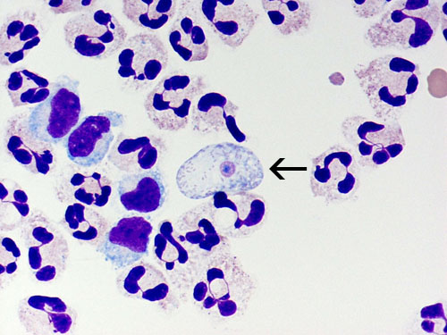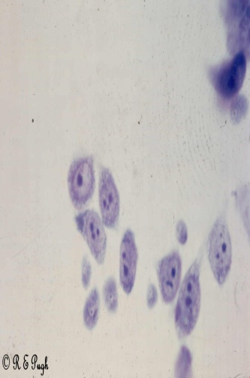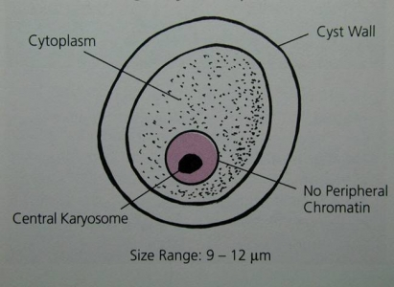
- Trophozite is the feeding, dividing, and infective stage for humans they are motile. Movement occurs by the organism blunt pseudopodia.
- Flagellate:The flagellate is pear-shaped and has two flagellum.
3-Cyst:The spherical cyst is single-walled with a single nucleus.
Life cycle
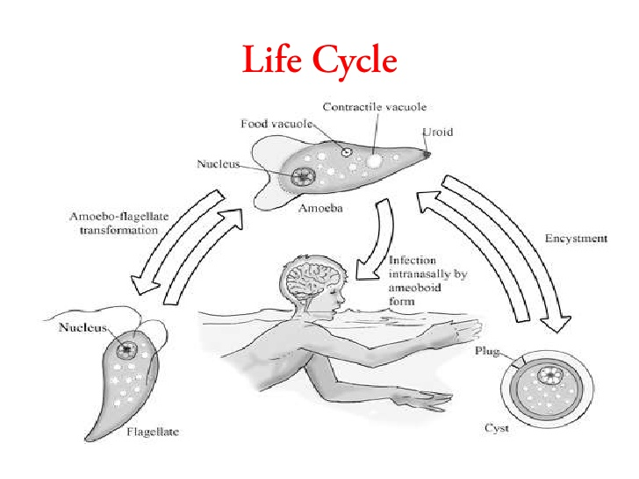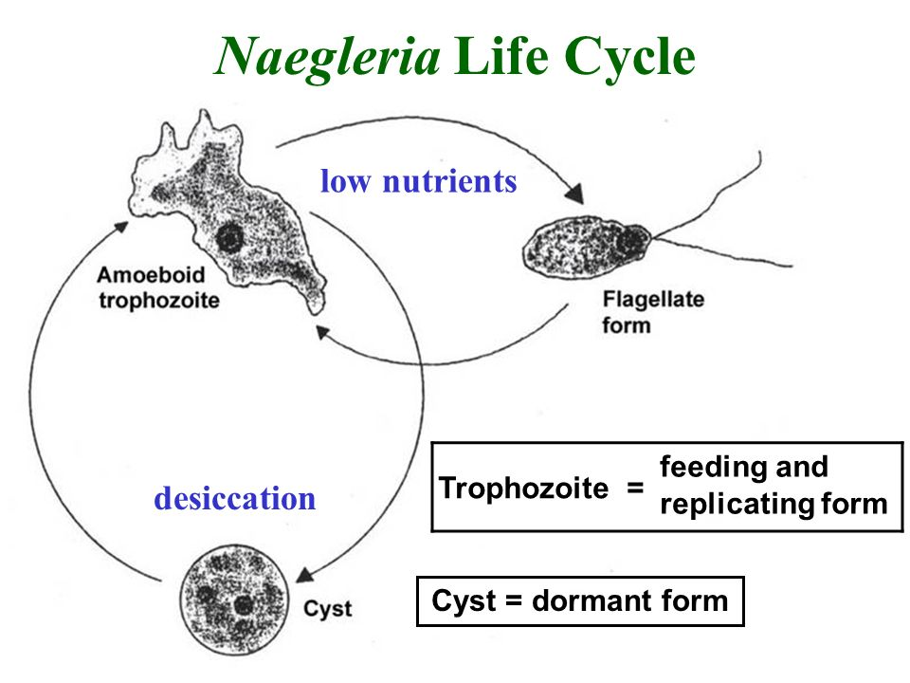
Symptoms -Headaches, nausea, vomiting, fever, seizures, and death
Symptoms - Dramatic and rapidly progressive. Headache, fever, nausea & vomiting occur within 1 to 2 days. Meningoencephalitis, irrational behavior, coma & death usually occur within 9 days of exposure.

Diagnosis - Usually made at autopsy. CSF contain motile amoebae. Early diagnosis is critical. Amoebae in CSF specimens can be cultured on non-nutrient agar containing bacteria.
Acanthamoeba spp.
Disease name: chronic granulomatous amebic encephalitis (GAE)
Morphology:
Acanthamoeba has only two stages, cysts and trophozoites , in its life cycle. No flagellated stage exists as part of the life cycle.

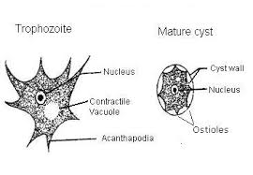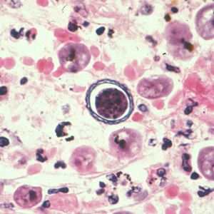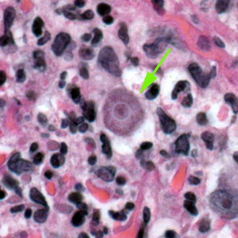
Acathoamoeba cyst Acantho.troph.

Life cycle:
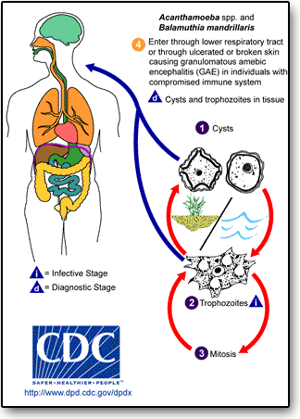

Symptoms
chronic granulomatous amebic encephalitis (GAE)
amebic keratitis
granulomatous skin and lung lesions
Diagnosis:
Tests useful in the diagnosis of GAE include brain scans, biopsies, or spinal taps. In disseminated disease, biopsy of the involved sites (e.g. , skin, sinuses) can be useful in diagnosis,In the case of eye infection diagnosis is based on symptoms, growth of the ameba from a scraping of the eye, and/or seeing the ameba by a process called confocal microscopy.

