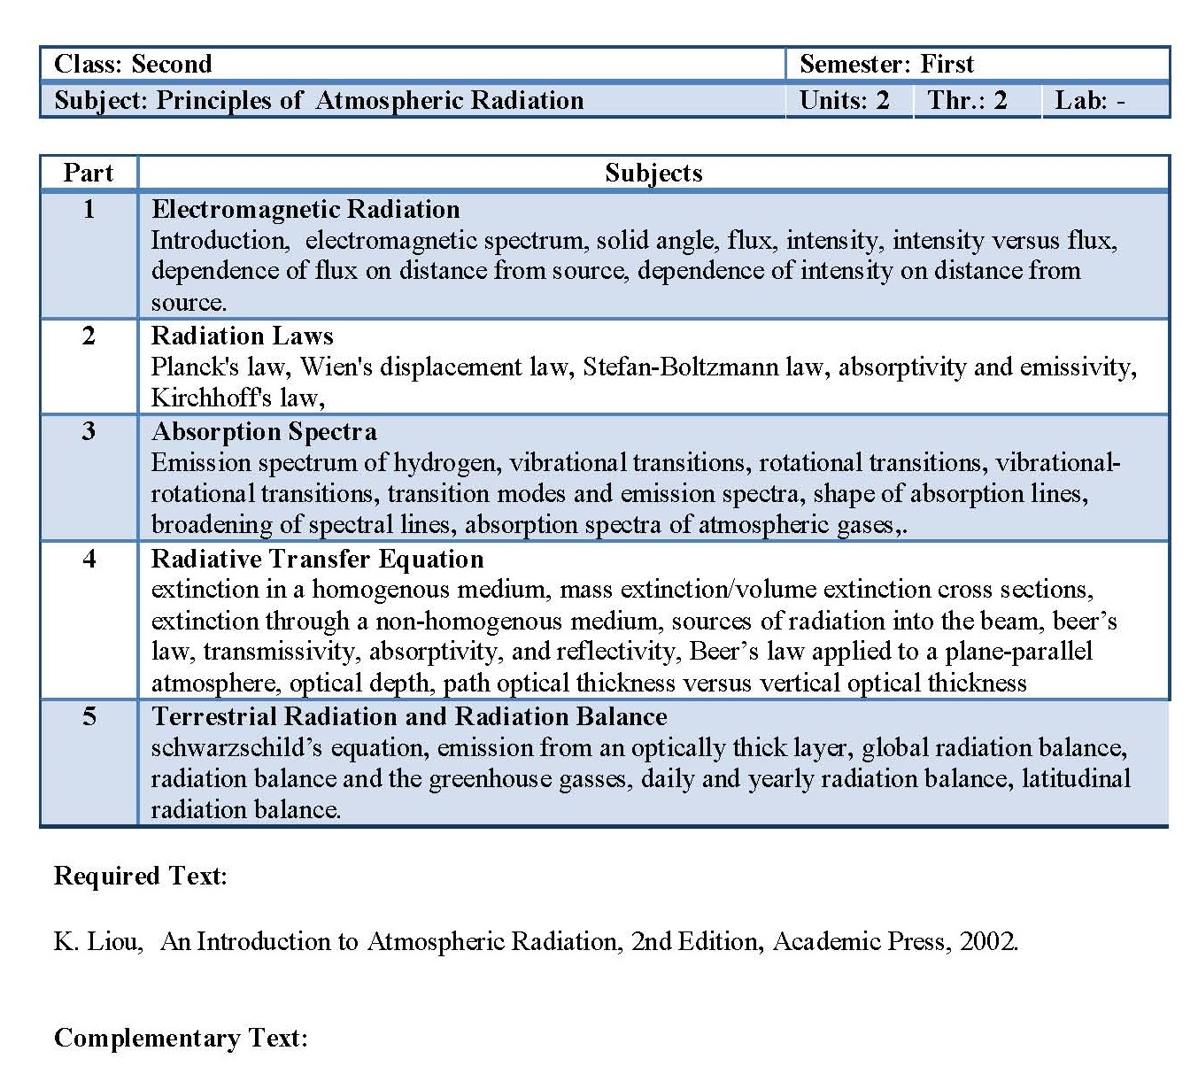

**(First lecture)**

**Electromagnetic radiation**

1. **Introduction :**

Solar energy powers the atmosphere. This energy warms the air and drives the air motion you feel as winds. The seasonal distribution of this energy depends on the orbital characteristics of the Earth around the sun. The Earth’s rotation about its axis causes a *daily cycle* of sunrise, increasing solar radiation until solar noon, then decreasing solar radiation, and finally sunset. Some of this solar radiation is absorbed at the Earth’s surface, and provides the energy for *photosynthesis and life*. Downward infrared (IR) radiation from the atmosphere to the Earth is usually **slightly less** than upward IR radiation from the Earth, causing net cooling at the Earth’s surface both day and night. The combination of daytime solar heating and continuous IR cooling yields a diurnal (daily) cycle of net radiation.

1. **Electromagnetic spectrum**

The electromagnetic (EM) spectrum is the includes full-range of EM radiation, EM spectrum consists of ***gamma rays*** (highest frequency and shortest wavelength) to ***radio waves*** (lowest frequency and longest wavelength) in addition to visible light as in Figure 1.This spectrum can be divided into seven regions vary in wavelength and frequency *(gamma rays, X-rays, ultraviolet, visible light, infrared, microwaves and radio waves)*. The main regions use in satellite sensing are visible light, reflected and emitted infrared, and the microwave regions.

When a radiation enters the atmosphere; and prior to reach the ground surface it collided with gas molecules, suspended dust particles, and aerosols. Three essential interactions in the atmosphere are may occur: **absorption**, **transmission** and **scattering**. The radiation transmitted is then reflected or absorbed by objects in the surface of the Earth.

**Scattering:**

Scattering Occurs when particles or *big gas molecules* sparse in the atmosphere react and the result of this effect on of the EM radiation leads to a deviation from the original path. How much scattering takes place depends on many factors as well as the wavelength of the radiation, the abundance of particles or gases, and therefore the distance the radiation travels through the atmosphere. There are three types of Scattering may take place.



**Figure 1. Shows regions of the electromagnetic spectrum**

***Rayleigh scattering***

Rayleigh scattering referred to a selective scattering or *molecular scattering*. It mostly consists of scattering caused when radiation interacts with molecules and particles in the atmosphere. This appears when the particles lead to the scattering are very smaller in diameter (low than one-tenth) than the wavelengths of radiation interacting with different particles. Micro particles present in the atmosphere scatter the shorter wavelengths additional compared to the longer wavelengths. *The scattering impact or the density of the scattered light is reverse proportional to the* ***fourth energy*** *of wavelength for Rayleigh scattering.*

***Mie Scattering***

The second type of scattering is Mie scattering, which appears when the wavelengths of the energy are equal to the diameter of the atmospheric molecules. In this pattern of scattering, longer wavelengths scattered in addition to Rayleigh scattering as in Figure below. ***In Mie scattering, the intensity of the scattered light varies with the inverse of wavelength***. Mie scattering is sometimes caused by aerosol particles like dust, smoke and pollen. Gas molecules within the atmosphere are too tiny to cause Mie scattering of the radiation.

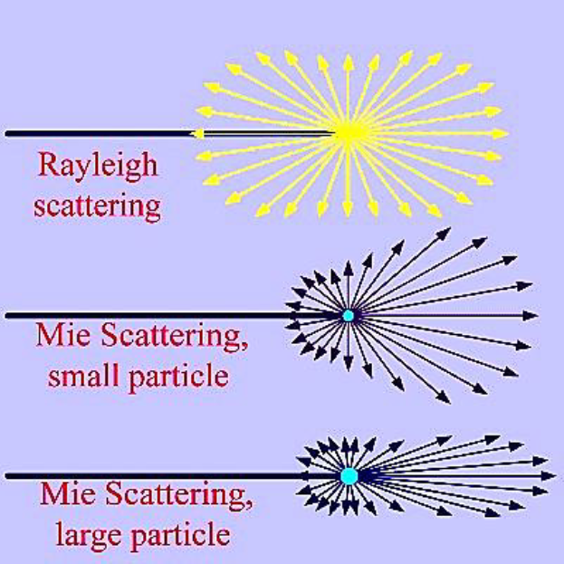

**Figure 2: scattering types**

***Non-Selective Scattering***

The Last type of a scattering is nonselective scatter that happens once the diameters of the atmospheric particles are ***a lot of larger (approximately 10 times)*** than the wavelengths being detected. Particles like pollen, cloud droplets, ice crystals and raindrops cause nonselective scattering of the part of the electromagnetic spectrum (visible light). In respect of visible light (of wavelength 0.4-0.7μm), non-selective scattering is usually caused by water droplets which are having diameter ordinarily in the range of 5 to 100 μm. This scattering is nonselective of wavelength, where all visible and IR wavelengths scattered equally giving white or maybe grey colour to the clouds.

***Absorption***

Absorption is a loss of energy, by gases in the Earth's atmosphere. These gases absorb electromagnetic radiation at specific wavelengths, usually by H2O, O3 and CO2 in a certain part of the electromagnetic spectrum. A Little energy is absorbed (for instance visible light) while in other types like ultraviolet, almost all existing energy is absorbed. The parts of the spectrum that are absorbed by atmospheric gases are called **absorption bands**, this is not very useful for remote sensing.

**3- Solid angle**

The definition of intensity in radiation involves the concept of a solid angle. A solid angle is a 3D angular volume that is defined analogously to the definition of a plane angle in two dimensions. A plane angle, θ, made up of the lines from two points meeting at a vertex, is defined by the arc length of a circle subtended by the lines and by the radius of that circle, as shown below. The dimensionless unit of plane angle is the radian, with 2π radians in a full circle.

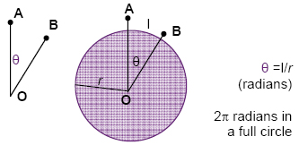

**Figure 3: radians definition**

A solid angle, ω, made up of all the lines from a closed curve meeting at a vertex, is defined by the surface area of a sphere subtended by the lines and by the radius of that sphere, as shown below. The dimensionless unit of solid angle is the steradian, with 4π steradians in a full sphere.

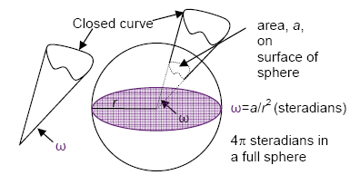

**Figure 4: defining a radian and a steradian.**

**4- Flux**

A flux density, F, called a *flux*, define as the transfer of a quantity per unit area per unit time. The area is taken perpendicular (normal) to the direction of flux movement. Examples with metric (SI) units are mass flux (kg· m–2·s–1) and heat flux, ( J·m–2·s–1). Using the definition of a watt (1 W = 1 J·s–1), the heat flux can also be given in units of (W·m–2). A flux is a measure of the amount of inflow or outflow such as through the side of a fixed volume, and thus is frequently used in Eulerian frameworks (Fig. 5).



**Figure 5: an area A into one side of a volume.**

Because flow is associated with a direction, so is flux associated with a direction. You must account for fluxes Fx, Fy, and Fz in the x, y, and z directions, respectively. A flux in the positive x-direction (eastward) is written with a positive value of Fx, while a flux towards the opposite direction (westward) is negative. The total amount of heat or mass flowing through a plane of area A during time interval Δt is given by:

$$Amount = F·A·Δt (1)$$

For heat, Amount ≡ ΔQH by definition. Fluxes are sometimes written in kinematic form, F, by dividing by the air density,

$$F=\frac{ F }{ρ_{air}} (2)$$

Kinematic mass flux equals the wind speed, M. Kinematic fluxes can also be in the 3 Cartesian directions: **Fx**, **Fy**, and **Fz**.

Heat fluxes FH can be put into kinematic form by dividing by both air density ρair and the specific heat for air Cp, which yields a quantity having the same units as temperature times wind speed (K·m·s–1).



The reason for sometimes expressing fluxes in kinematic form is that the result is given in terms of easily measured quantities. For example, while most people do not have “Watt” meters to measure the normal “dynamic” heat flux, they do have thermometers and anemometers. The resulting temperature times wind speed has units of a kinematic heat flux (K·m·s–1). Similarly, for mass flux it is easier to measure wind speed than kilograms of air per area per time. Heat fluxes can be caused by a variety of processes. Radiative fluxes are radiant energy (electromagnetic waves or photons) per unit area per unit time. This flux can travel through a vacuum. Adjectives flux is caused by wind blowing through an area, and carrying with it warmer or colder temperatures. For example a warm wind blowing toward the east causes a positive heat-flux component FHx in the x-direction. A cold wind blowing toward the west also gives positive FHx. Turbulent fluxes are caused by eddy motions in the air, while conductive fluxes are caused by molecules bouncing into each other.

