The Third Experiment
INVESTIGATION OF THE STEFAN-BOLTZMANN LAW
The Objective of the experiment:
Investigation of Stefan Boltzmann's law of thermal radiation, and to find the Stefan-Boltzmann constant.
The Used Equipments:
- Wooden box wrapped inside with black fabric
- a lamp
- Voltmeter
- Ammeter
- Power supply
- Thermometer
- Stopwatch

The Theoretical Part:
All bodies emit thermal radiation “electromagnetic radiation” by virtue of their temperature.
In general, the emissivity of the surface of a material is its effectiveness in emitting energy as thermal radiation as both visible and infrared radiation. The amount of energy emitted by the objects depends on the rate of what the object absorbs from the total energy falling on it and it is called Absorptivity α. A black body is an idealized physical body that absorbs all incident electromagnetic radiation, regardless of frequency or angle of incidence, and it has absorptivity equal to one for every wavelength, α_{λ} = 1. Thus black bodies must emit thermal radiation, which is the black body emission or Emissivity.
For general bodies we can define an emissivity which expresses the emission as a fraction of the black body emission. The emissivity of a body is defined as the ratio of the emitted thermal radiation from a surface to the emitted radiation from an ideal black body at the same temperature as given by the Stefan–Boltzmann law. The ratio varies from 0 to 1. The surface of a perfect black body (with an emissivity of 1) emits thermal radiation at the rate of approximately 448 w/m² at room temperature (25 °C, 298.15 K); all real objects have emissivity less than 1.0, and emit radiation at correspondingly lower rates.

In equilibrium, the absorptivity = emissivity which gives Kirchhoff’s law, and it states that at equilibrium the emissivity and the absorptivity of a surface have to be the same at each wavelength, but those two quantities generally change with the radiation wavelength (λ). A body may appear black in relation to visible rays, and it may be gray in relation to infrared rays, and vice versa, so if we applied radiation on a body, its temperature rises at the beginning and then reaches a certain degree (the degree of equilibrium), then what it absorbs of energy is equal to what it emits.
Stefan and Boltzmann found that the power of total radiation per unit area, W, is directly proportional to (T⁴)
W = e σ T⁴ …….. (1)
Where:
e: emissivity
T: body temperature
σ : Stefan-Boltzmann constant
Because the e =1 for black body, then
W= σ T⁴ …….. (2)
and if the black body is in the form of a box with a surface area (A) and its initial temperature (T₀), then
P_{o} = W A = σ T_{o}⁴ A …………(3)
If an electric lamp is placed inside the box and a voltage difference (V) is applied to it and the current magnitude passing through the lamp wire is (I), then the power of the lamp is:
P_{o} = I V ………(4)
And since the lamp is inside the box, the power must be radiated by the body, so the body temperature will rise until it reaches the equilibrium temperature T, where at this temperature energy will generate inside the box equal to lost power as:
P = σ T⁴A …….. (5)
where P is the sum of the lamp power and energy absorption power from the outer field, i.e:
P = P_{o} + P_{e}= σ T⁴A ……..(6)
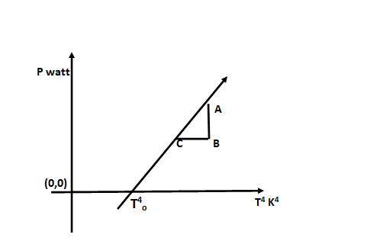
P_{e} = σ T⁴ A – σ T_{o}⁴A …….(7)
Using equation (7), a graphic relationship is drawn between (P_{e}) on the y-axis and (T⁴) on the x-axis, and from the graph we find the slope = P_{e}/T⁴ as shown in Figure (1), where
$$Slope=\frac{AB}{CB}=\frac{P_{0}}{T^{4}}$$

and then we find Stefan-Boltzmann constant σ = $\frac{slope}{A}$ , where
A is the body area and equal to 954 cm² , and
σ is of units (watt/m²K⁴).

The Procedure:

The electrical circuit used in the experiment is as shown in the following figure.

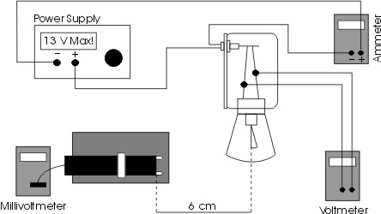

- Record the initial temperature (T₀).
- Apply a voltage on the lamp to light it and then wait until it reaches the state of thermal equilibrium.
- Record the body temperature after it becomes stable, and then record (I) and (V).
- Continue to increase the potential to certain values and within periods, then wait until the state of thermal equilibrium reaches, then record (T), (I) and (V) for each time.
- Arrange your results as shown in the table:

I_{amp} | V_{volt} | P_{e}=(IV)_{watt} | T=(T+273)K⁰ | T⁴.(k⁰⁴)

- Draw a graphic relationship between P_{e} and T⁴.
- Find the value of (σ) for the Stefan–Boltzmann constant as using
σ = $\frac{slope}{A}$
- Find the value of (T₀) from the graph and then compare it with the value measured at the beginning of the experiment.

Example:
From the information in the table below, find the Stefan-Boltzmann constant. Note that the area of the black box A = 9.45 cm² and the initial temperature = 23.5°C.
Solution:
I_{amp} | V_{volt} | P_{e}=(IV)_{watt} | T=(t+273)K⁰ | T | T⁴.(k⁴)
0.56 | 5.0 | 2.8 | (24.3+273) | 297.3 | 7812
0.69 | 7.5 | 5.175 | (25+273) | 298 | 7886
0.84 | 10.0 | 8.4 | (25.9+273) | 298.9 | 7981
0.98 | 12.5 | 12.25 | (26.2+273) | 299.2 | 8013
1.13 | 15.0 | 16.95 | (26.8=273) | 299.8 | 8078

slope = 0.01 watt/k⁴ σ = $\frac{SLOPE}{A}$

Assignment:
From the information in the table below, find the Stefan-Boltzmann constant, Note that the area of the black box A = 9.45 cm² and the initial temperature = 29.2°C.

I_{amp} | V_{volt} | P_{e}=(IV)_{watt} | T=(t+273)K⁰ | T | T⁴.(k⁴)
0.45 | 5.0
0.63 | 7.5
0.78 | 10.0
0.86 | 12.5
0.99 | 15.0

