The Fourth Experiment
DEPENDENCE OF TEMPERATURE ON THE VOLUME OF A GAS AT CONSTANT PRESSURE

The Objective of the experiment:
Calculating the dependence of temperature on the volume of a gas at constant pressure (Charles Law investigation)
The Used Equipments:
- Electric heater
- Temperature sensor
- Graduated glass tube
- Beaker

The Theoretical Part:

The state of a quantity of n moles of an ideal gas is completely described by the measurable quantities pressure, volume and temperature. The relation between these three quantities is given by the general gas law:

P . V = n . R. T ……(1)

Where
p: pressure
V: volume
T: temperature
n: quantity of an ideal gas in moles
R: is the universal gas constant, and is equal to 8.31 J/K/mol

If one of the quantities p, V or T remains constant, then the other two quantities cannot be varied independently of each other.
when the temperature of a gas of a certain mass is fixed, its pressure can be changed while the temperature remains constant, but this does not happen in practice without changing the volume V occupied by the gas, or vice versa, as it is possible to change the volume of the gas under a constant temperature and this leads to pressure change.
Thus we conclude that both pressure and volume are interrelated with each other, but each of them is independent of temperature. This statement is also true for pressure and temperature when volume is constant, and temperature and volume when pressure is constant, this means:
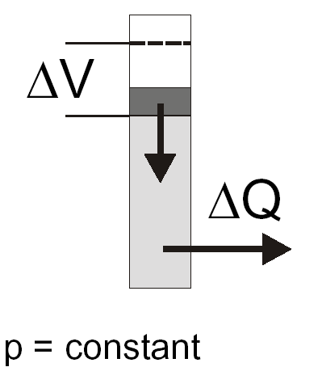
- The three variables (P, V, T) cannot be all independent at the same time, but only two of them.
- The third variable can be expressed in terms of the other two independent variables by finding a mathematical relationship between them which is represented by equation (1).
- At constant pressure, the relation between the two other variables is called Charles Law:
V α T …..(2)
- In this experiment, a gas thermometer is used to verify equation (2).

The Procedure:
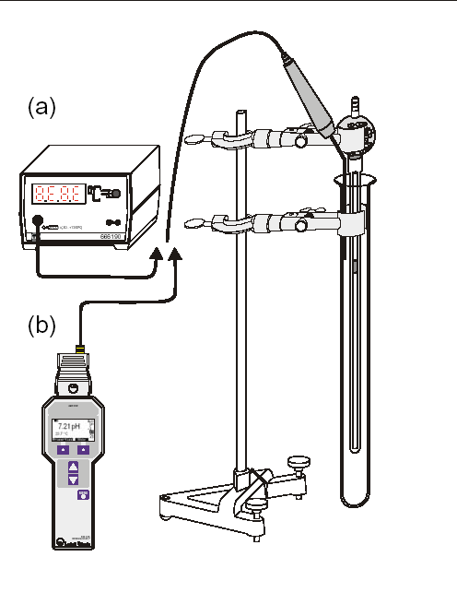
- Put 200 ml of water in a beaker and heat it to a temperature of 90 ° C.
- Add hot water into the graduated glass tube so that the tube is submerged.
- Take the relationship between the height of mercury (h) and the temperature (θ) by cooling and then calculate the volume (V) from the relationship V = π (d² h /4) where d represents the radius of the graduated tube, and it is equal to 2.7mm.

Measurements and Calculations:

- Arrange the results as shown in the table below:

h(mm) | θ °C | V = π ( d²h/4) mm³
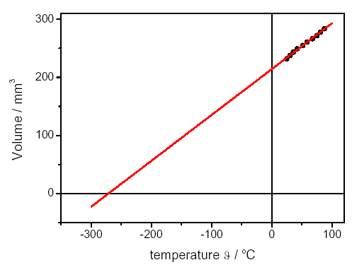
- Draw a graph between the temperature θ°C on the x-axis and the volume V (mm³) on the y-axis so that it cuts the x-axis in the negative direction at the absolute temperature -273 °K, as shown in the figure.
- Discuss the graphic relationship, what do you infer from the diagram?

Example:
Through the following data, find the volume and draw a graph between volume and temperature?

θ °C | h(mm) | V = π ( d²h/4) mm³
30 | 20.5
40 | 20.3
50 | 19.7
60 | 18.6
70 | 17.4

Assignment:

By using the values in the table below, calculate the volume, and draw a graph between temperature θ °C and volume V mm³ and discuss the graph.

θ °C | h(mm) | V = π ( d²h/4) mm³
30 | 20
40 | 19.5
50 | 19.2
60 | 18.5
70 | 18.3
80 | 17.6
90 | 16.9

