**Analytical Chemistry**

**Is a branch of chemistry which is concerned with identifying the constituents of the chemical and the possibility of quantification or qualitative.**

**Analytical chemistry is divided into two branches:**

**1. Qualitative analytical chemistry:**

**It is concerned with the knowledge of constituent elements types of the compound, It also looks at how the elements or materials are separated and identified and is concerned with the external appearance of the compound such as color and smell.**

**2- Quantitative Analytical Chemistry:**

**It is concerned with quantifying the elements or compounds in a sample.**

**Which in turn are classified into two parts:**

**A.Volumetric analysis:**

It is one of the ways by which the amount of elements or compounds in a sample solution is estimated (it is better to say how it is estimated).

**B. Quantitative weight analysis:**

It is based on the estimate of the material by weighing it or by any other method. The material is estimated as a weight in grams or its parts or percentage in a particular model and is divided into:

1. **Precipitation method.**

**2- Evolution volatilization.**

**3- Specific gravimetric methods.**

**4 - Methods of electrostatic deposition Electro gravimetric methods.**

***NOTE :***

**we prefer the methods of volumetric analysis more than the methods of weight analysis, knowing that the latter is more accurate than the previous one this is due to the slow of the weight analysis.**

**The precipitation method is the best method used in weight analysis.**

**The sample is transferred to the solution to be analysed in a suitable manner. The element to be evaluated is precipitated as a non-dissoluble compound, after which the precipitate is filtered and washed well and then burned and dried.**

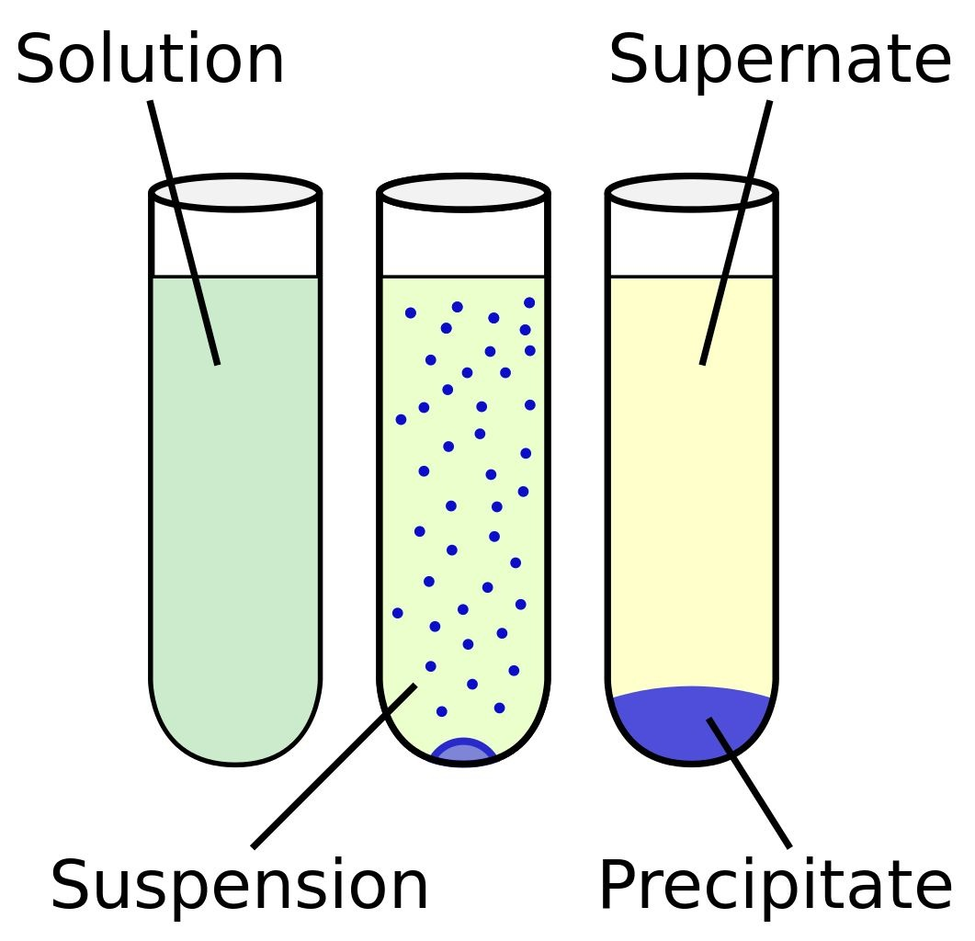

**Properties of precipitants in the methods of weight analysis:**

1. **Must be known chemical formula.**
2. **The solubility of precipitant is very low.**
3. **The crystals of the precipitant of an appropriate size (large).**
4. **The precipitate shall be free of contaminants that cannot be washed or removed during drying of the precipitate.**
5. **The precipitate shall remain stable at the drying temperature (any thermal constant).**
6. **The Molecular weight of the precipitant is large compared with the material to be estimated to avoid the experimental error.**

**The precipitate factor**

**Is the chemical factor that causes the precipitation of the soluble matter to be estimated, forming precipitant or low soluble salts in the water .**

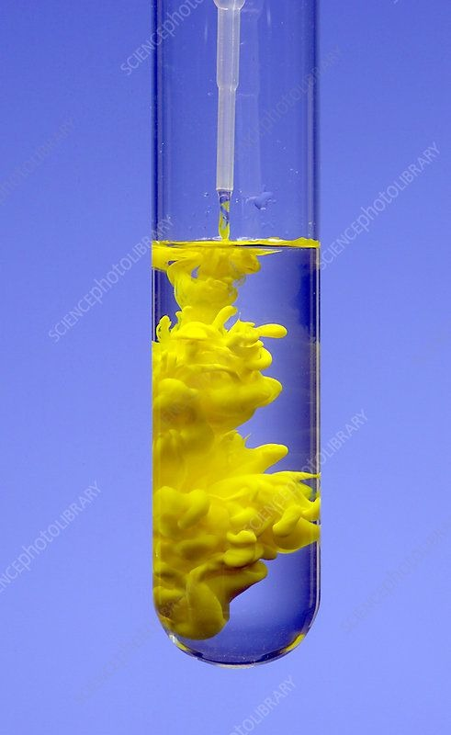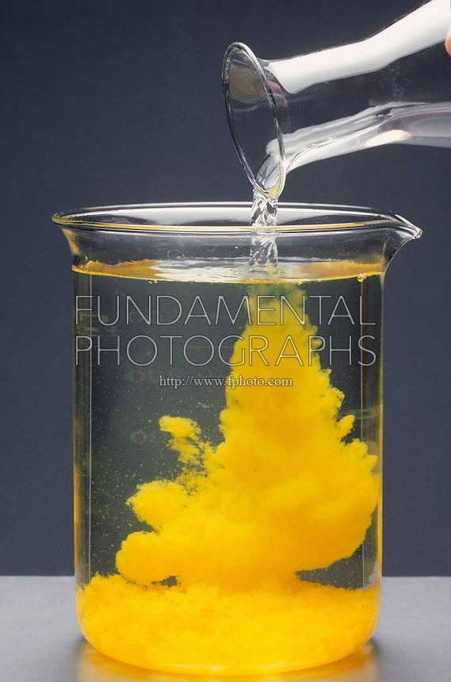

**The precipitate factor is consists of two types:**

2- Specificity Works on depositing only one ion without other substances.

1- Selectivity **Works on the deposition of a**

**group of ions**

**.**

**Quantitative weighting steps:**

1. **Preparation of sample and dissolution.**
2. **Precipitation of analyte.**
3. **Digestion or aging of the solution.**
4. **Filtration of precipitate .**
5. **Washing of precipitate.**
6. **Drying and ignition.**
7. **Weighing and calculation.**

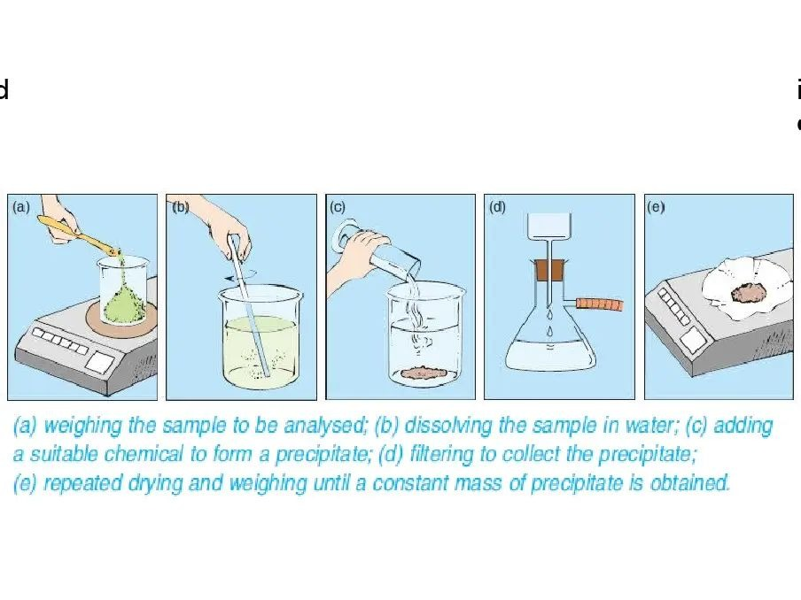

**1- Preparation of solution**

**This is done by selecting a suitable weight from the sample to be estimated and then dissolving the sample by selecting the appropriate solvent, As well as to create a suitable conditions for the experiment, such as pH of solution and solution temperature.**

1. **Precipitation of analyte :**

**The precipitation process of the selected components from the rest of the components in the solution is done by adding the precipitant factor.**

**The precipitate process consists of two steps :**

**First :**

**The formation of small particles (1-100) nm, called nuclei.**

**Second:**

**The nuclei growth into large particles. The nuclei do not appear directly after the addition of the precipitated agent but often is noticed after a period called the induction period. The duration of the sediment varies with the sediment difference and ranges from the second parts of silver chloride to a few minutes in the case of barium sulphate**.

**3. Digestion of precipitation:**

**It is the process of heating the precipitant with the standard solution (usually 90 or 95 Cₒ and leaving it a period of time.**

**Interest from digestion of precipitation :**

1. **Increased the solubility of small particles (Help the crystals growth).**
2. **Leave the precipitate with the standard solution for a period of time allowing these particles to be precipitate on the large particles.**
3. **helps the grouping of colloidal precipitant.**

**4 – Filtration of precipitant :**

**The purpose of the filtration process is to separate the precipitation from the standard solution and the filtration process is easier and faster if the precipitation crystals are large while this process becomes more difficult as the crystals are small.**

**It is used for this purpose:**

1. **Ashless few ash leaves.**
2. **the base of asbestos furnished on the inner bottom of the crucible.**
3. **crucible have porosity for filtration.**

**The fast filtration is best to prevent post filtration, which considers one of the types of contaminants.**

**5- Washing of precipitant:**

**Precipitation processes are usually carried out by solutions containing undesirable ions other than the ions that are to be precipitate.**

**Therefore, the precipitants that are mostly polluted so the precipitant washing process are necessary to remove the undesirable ions from the surface of the precipitation.**

**6- Drying and burning:**

**Drying processes are often carried out at temperatures below 250 Cₒ almost between (110-150 Cₒ ) with a drying oven.**

**The burning process takes place at a temperature higher than 250 Cₒ and up to 1200 Cₒ. Here, a gas lamp is used, and then a burner with a temperature of 1200 Cₒ.**

**7- Weight:**

**After finishing the process of burning or drying the precipitant, transfer the precipitate to the desiccator and leave it in the desiccator until it is cooled and have taken the laboratory temperature of.**

**General rules for obtaining a precipitate with large crystals :**

1. **precipitation from diluted solutions.**
2. **Make the acidic function of the solution suitable for the precipitation process because some materials prefer to be deposited in the acidic middle, while other materials prefer precipitation in the middle of the base.**
3. **Slow addition with continuous stirring for the purpose of avoiding the occurrence of a condition above the local saturation.**
4. **In the precipitation of hydroxides, it is preferable to use buffer solutions for the purpose of avoiding the development of high local PH centers and this can be avoided by precipitation from homogeneous solutions.**
5. **It is preferable to digest the precipitant if there is no risk of post- precipitation.**
6. **Wash the precipitant with a suitable solution do not react with the precipitate and do not increase its solubility and prefer to wash the precipitant on several small batches.**

**Precipitation From Homogenous Solution :**

1. **Is one of the precipitation methods in which the precipitation agent is composed slowly, uniformly and homogeneously in the solution either through the hydrolysis of a substance or the interaction of two substances with each other such as:**
2. **Oxalates are generated from the hydrolysis of dimethyl or diethyl oxalate, which is used as a precipitating agent for calcium.**



1. **Sulfates where sulfate ion can be generated from hydrolysis of sulfuric acid.**



**Disadvantages of precipitation of a homogeneous solution :**

**Advantages of precipitation**

**of a homogeneous solution :**

1. **The crystals are slowly deposited so that they are large and regular so that they can be easily filtered.**
2. **The formed Precipitate is thermally stable so it is easy to dry.**
3. **The deposit shall be Empty of impurities.**
4. **Precipitation requires a homogeneous solution for a long time compared to normal Precipitation methods.**
5. **Ahigh-cost method because Precipitators and solvents are used compared to what method normal Precipitation.**

**Contamination of precipitation  
When there are substances with a foreign solution having a solubility product equal to or similar to the material to be precipitate if these strange materials precipitate with the material to be estimated, leading to contamination of the precipitation.**

**It gets in two cases:**

**2- post precipitation**

**Which is the Contamination of the precipitation after its formation. The precipitate is composed of pure and solid crystals during precipitation and then it is contaminated by precipitator of another substance. This type of contamination can be eliminated by filtration immediately after precipitation.**

**1- Co precipitation**

**Includes all Contaminants obtained during the composition of the precipitation required to be analyzed and includes:**

1. **True precipitation.**
2. **Occlusion.**
3. **Adsorption.**

**Calculation**

**The calculations for weighted analysis Depends on two things:**

1. **The sample.**
2. **Material to be estimated.**

**The two are then linked to find the percentage and concentration of the material required.**





**Gravimetric Factor**

**Is the weight of the formula or the atomic weight of the material to be analyzed to the weight of the formula of the known weight precipitate and does not depend on the weight of the original form which is a fixed quantity.**



***Note:***

**If there is a common atom in the ridge and the place (except oxygen), we must multiply the numerator or the place or both with a number or two different numbers so that the number of this common atom is equal in the numerator and denominator.**

**Q-1- What is the weight for the indium sample if you know that the percentage for the indium that precipitate in the form of In2O3 is ( 34.5%) , the gravimetric factor for the indium is( 0.82) and the weight of the precipitate is (1g)? A.wt for In =114.8 , O=16.**

**Wt of In = G.F × Wt of In2O3**

**A.Wt of In 2 114.8× 2**

**= × × 1 g = =0.82 g**

**M.wt of In2O3  1 114.8 ×2 + 16×3**

**Wt of In 0.82**

**% In = × 100 34.5 / 100 =**

**Wt of Sample Wt of sample**

**Wt of Sample = 2.3 g**

**Q-2- If the weight of the lead sample is (3 g) was precipitated in the form of the PbSO4 and the weight of the precipitate is (2 g) , what is the percentage for the precipitated substance in form of PbSO4 ? If you know that the atomic weights of Pb= 207.2, S = 32 And O = 16**

**Wt of Pb = G.F × Wt of Pb SO4**

**A.Wt of Pb Wt of Pb**

**= × 2 g = 1.36 g , %Pb = × 100**

**M.Wt of PbSO4  Wt of Sample**

**% Pb = 1.36 ×100 = 45.5 %**

**3**

**Q-3- What is the gravimetric factor for the substance that have a weight (0.37 g) if you know that the weight of the precipitate is (0.5) grams?**

**Wt of Substance = G.F × Wt of precipitate**

**0.37 = G.F × 0.5 G.F = 0.74**

**Q-4- Calculate the weight of the chloride ion that was precipitated on the form of the silver chloride if you know that the weight of the precipitate is (0.53 g) ,atomic weights of the silver (108) and the chlorine (35.5)?**

**Wt of Cl = G.F × Wt of AgCl**

**A.Wt of Cl**

**= × 0.53g = 0.13 g**

**M.Wt of AgCl**

**Q-5- A sample of non-pure sulfate salt 4 g was precipitated in the form of barium sulphate after it was dissolved in (100 ml) of distilled water and added the precipitated agent. Calculate the molarity of the sulfate ion in the non -pure salt ,If you know that the weight of the precipitate is (2.5 g), Atomic weights for S= 32, O= 16 and Ba= 137.3?**

**Wt of SO4 = G.F × Wt of BaSO4**

**M.Wt of SO4**

**= × 2.5 g 1.02 g**

**M.Wt of BaSO4**

**Wt SO4  1000**

**M for SO4 = × = 0.10**

**M.Wt SO4  V(Ml)**

***Example:***

**An impure sample of barium weighs (1 gm ) that was precipitated as barium chloride after adding the precipitate, so the weight of the precipitate after burning processes (0.3 gm ) Calculate the percentage of barium in the sample?**

**%Ba = Wt of Ba / Wt of Sample × 100**

**Wt of Ba = G.F × Wt of BaCl2**

**= 137.3 / 137.3 + 2 × 35.5 × 0.3 = 0.19 gm**

**% Ba= 0.19 / 1 × 100 = 19.8%**

**Determination the ratio of water of hydration in**

**crystalied BaCl2.XH2O**

**Experiment No.1**

**Introduction**

**The water crystallization can be determined using sample weight change as a result of its water content ejection by heating it.**

**This method can be only used in the following cases:**

1. **When water is the primary part to be volatilized only.**

1. **When the precipitation weight does not change as a result of Oxidation or hydrolysis.**

**The Barium chloride salt loses all crystallized water at a temperature range from (100-120) centigrade, hight temperatures can be used for this purpose considering that the salt does not break at high temperatures up to (800-900) centigrade.**



**Barium dichloride crystals shows a little tendency to absorb water in the spaces of the molecules of the substance, which means that any change in weight represents a great precision water of crystallization.**

**Crystallization water can be determinte for each of the following salts:**

**Na2HPO4.12H2O**

**Na2B4O7.10H2O**

**MgSO4.7H2O**

**Materials and tools used**

**1- Crucible.**

**2- Desiccator.**

**3- Oven & Furnace.**

**4- Barium Chloride crystals BaCl2.XH2O .**

**Procedure**

1. **Heat the crucible inside the oven and then leave for a (30) minutes , cool in a desiccator for (15) minutes and then weigh after cooling.**
2. **Put in the crucible (0.5) gm of the sample and weigh it again**

**( aqueous Barium Chloride BaCl2.XH2O ).**

1. **Put the crucible inside the burning furnace for half an hour.**
2. **Let the crucible and its contents to be cooled in a desiccator and then weight it.**
3. **From weight loss after burning process, calculate the prcentage of water in** **aqueous Barium Chloride and Calculate the water molecule number in aqueous Barium Chloride (BaCl2.XH2O) .**

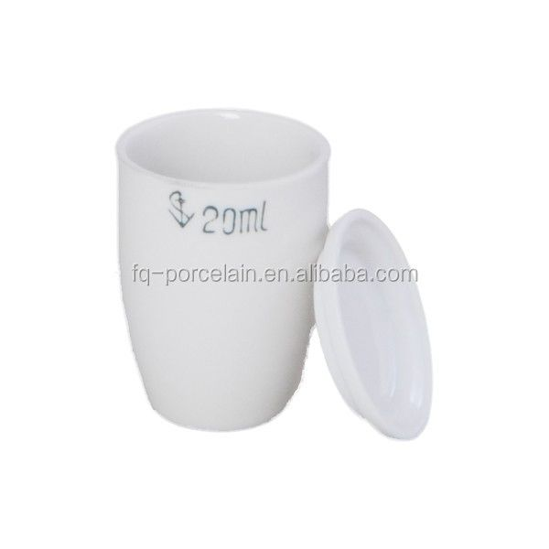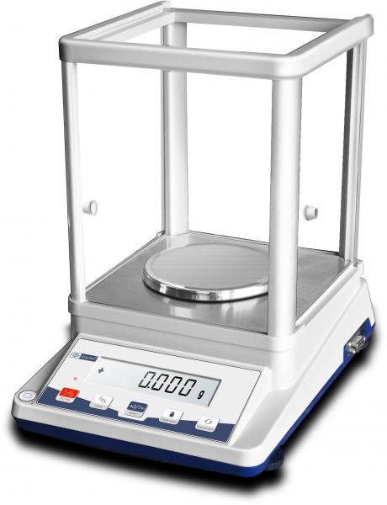

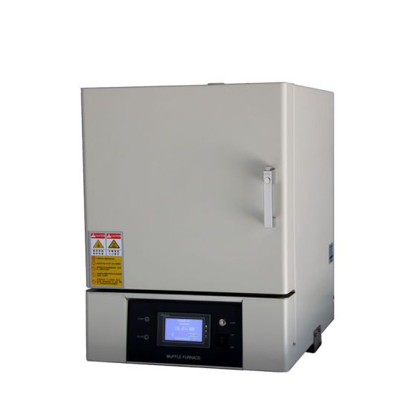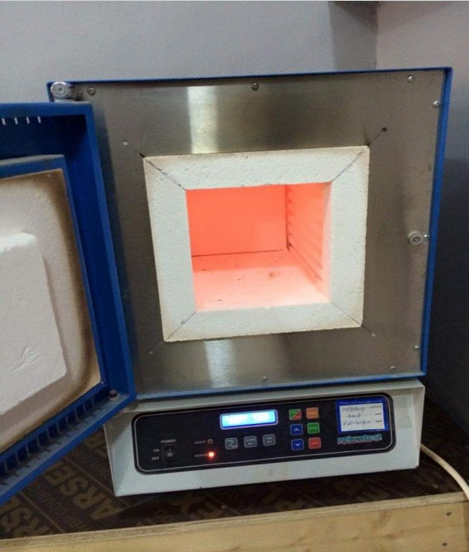

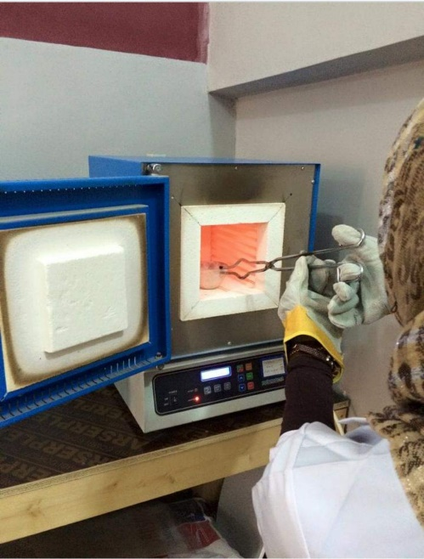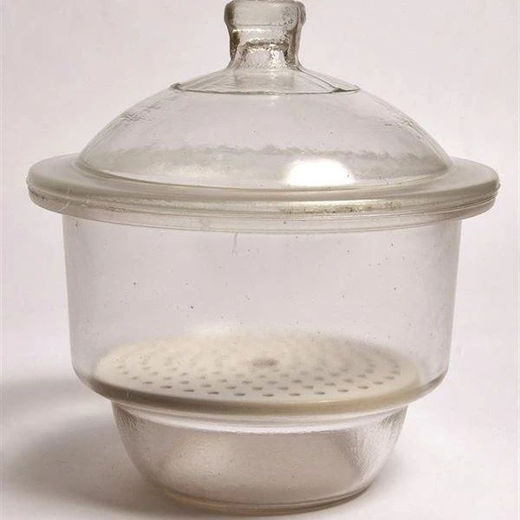

**Calculation:**

**% of H2O = Wt of H2O / Wt of Sample × 100 (الملح المائي)**

**wt of analyte with crucible befor heating wt of analyte with crucible after heating**

**= × 100**

**wt of analyte with crucible befor heating – wt of empty crucible**

**1 gm – 0.8 gm / 1 gm × 100 = 20 %**

**to calculate the number of water molecules we used the following law :**

**wt of salt (BaCl2.XH2O) wt of salt ( BaCl2)**

**=**

**M.wt M.wt**

**1 gm/ 208 +18 X = 0.8 gm / 208**

**X= 2.3**

***Important notice***

***The wt of BaCl2.XH2O its coming from :***

**Wt salt with crucible befor heating - wt of empty crucible**

***And the wt of BaCl2 its coming from :***

**Wt salt with crucible after heating - wt of empty crucible**

**Discussion Questions**

1. **What are the conditions required in a materials that water crystallization can be determinted? Give an example.**
2. **Why empty Crucibles need to be heated?**
3. **Define crystallized materials? Can some of them be used in chemical analyzes?**
4. **What is the purpose of the crucible cooling after heating in a desiccator?**

**Experiment No.2**

**Determination of Chloride as Silver Chloride**

**Introduction**

**The chloride can be determined in a soluble form in water by adding an increase of silver nitrate (AgNO3) solution to the chloride solution diluted with diluted nitric acid (HNO3) and then the precipitated (AgCl) weight after filtration, washing, and drying :**



**The purpose of nitric acid addition to the solution is to prevent the deposition of some silver salts such as Silver carbonate (Ag2CO3) and silver phosphate (Ag3PO4), which are deposited from the neutral or base solution. If the CO3-2 and PO4-3 ions are found in the solution, the acid solution Obtainable filtrate (AgCl) easily. The heating and stirring of the solution containing AgCl; precipitates the colloidal particles formed in principle and the solution becomes clear after it has been reversed.**

**The properties of precipitate are white salt that is low in solubility and water solubility (about 0.0014 g / L) at room temperature but increases with temperature increase. This salt is sensitive to light and to reducing factors.**



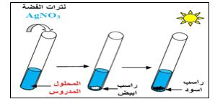

**Materials**

1 - Dissolved chloride salt in water.

2- Diluted nitric acid (1: 1).

3 - Silver nitrate solution (0.1N)

4- Diluted Nitric acid (0.015 N).

**.**

**Procedure**

**والادوات المســــــــــــتعملة**

1. **Accurately weigh (1.0 g) of chloride sample. Transfer weight to a Baker (250 ml) with a glass rod and glass watch as a cover, add about 75 ml of distilled water and dissolved salt by stirring.**
2. **Add about (1.0 mL) of diluted nitric acid (1: 1). The experiment should be conducted in a dark place (dim light).**
3. **Deposition of chloride in the form of silver chloride is achieved by adding about (20 mL) of silver nitrates (0.1 M), the addition should be slow with continuous stirring of the cold solution.**
4. **Heat the mixture quickly until it reaches near boiling point with continuous stirring.**
5. **Remove the baker from the heat and leave the precipitate stabilized (2 - 3 minutes), make sure that the precipitation process is complete by adding a few drops of silver nitrate solution to the pure liquid. If no additional deposit is shown, the baker is placed in a dark place and the solution is left to settle for one hour before filter.**
6. **Prepare the filtration apparatus, filter the solution, wash the precipitate (on the filter paper) with cold diluted nitric acid (0.015N, 5ml) and add small amount until the silver nitrate is removed and then wash the precipitate by a little quantity of distillled water .**
7. **Dry the precipitate at 110-130 oc and then weigh it. Calculate the weight of chloride and then the percentage.**

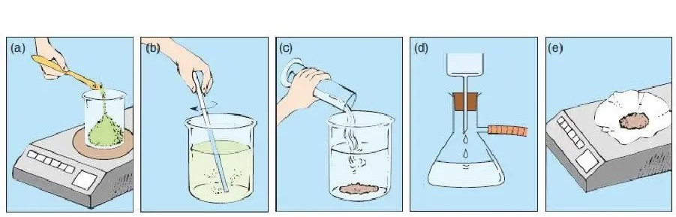

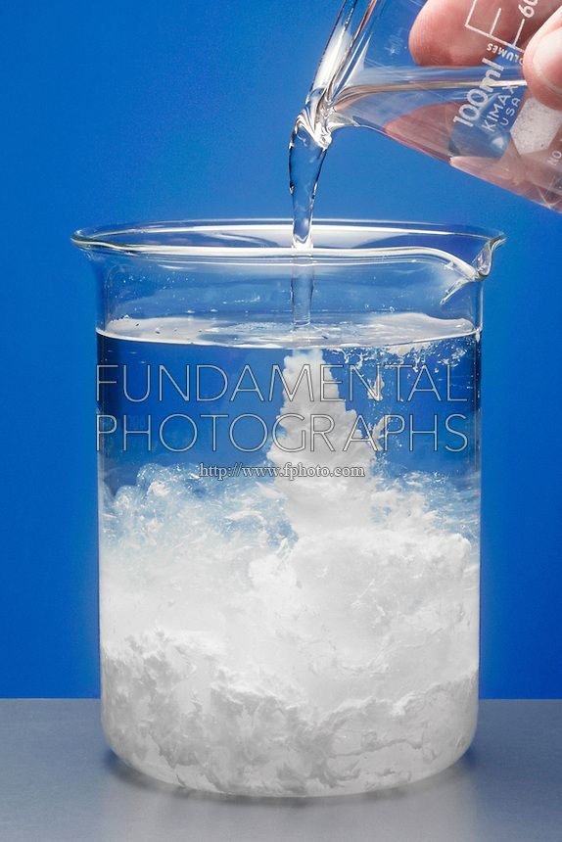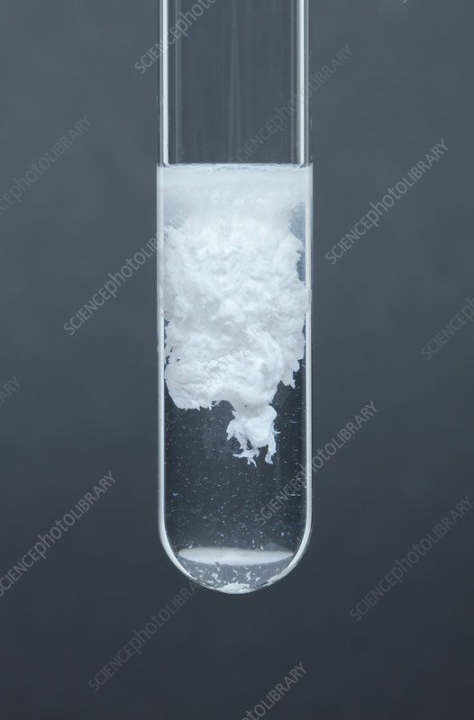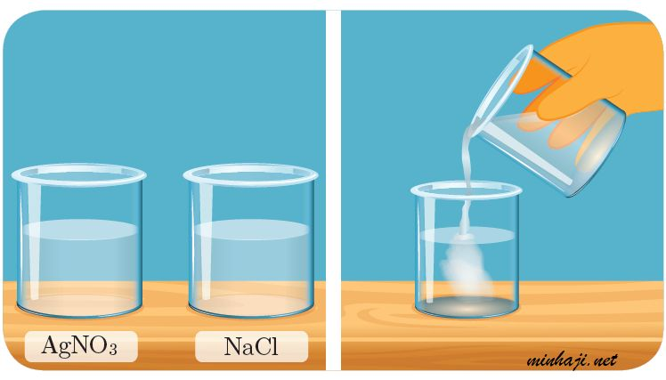

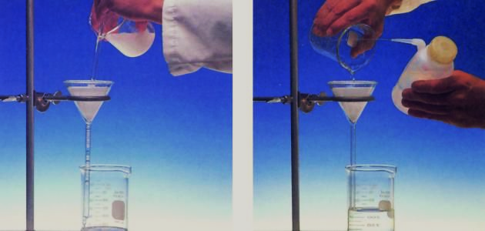

**Calculation**

**Wt of Sample = 1.0 gm**

**Wt of precipitate AgCl = 0.6 gm**

**If you know A.wt of Ag= 108 , Cl = 35.5**

**Calculate the percentage of Cl in the sample ?**

**% Cl = Wt of Cl / Wt of Sample × 100**

**Wt of Cl = G.F × Wt of AgCl**

**= 35.5/108+35.5 × 0.6 = 0.247x 0.6= 0.148gm**

**%cl = 0.148 / 1.0 × 100 = 14.82 %**

**Discussion**

**والادوات المســــــــــــتعملة**

1. **Why the experiments are done in a dark place?**
2. **The diluted nitric acid is used as a washing agent for the residue and does not use diluted hydrochloric acid?**
3. **What are the specifications of the formed silver chloride precipitate?**
4. **The precipitate filtration is done at room temperature or less?**
5. **Calculate the weight of silver chloride residue that can be obtained from a solution (100 mL) dissolved in (0.2 g) of magnesium chloride?**
6. **Why wash the precipitate with distilled water before the drying ?**

**Experiment NO. 3**

**Determination of Nickel as Dimethyl glyoxime complex.**

**Introduction**

It is considered one of the most older Organic precipitation and The optimum of them .

It is a weak acid (CH3C = NOH)2 and dissolves slightly in water and gives one ion of hydrogen when ionized:



This Detector is dissolved in alcohol so alcohol solution is used Specially to precipitate nickel quantitatively.

Ni+2 is precipitated by unites with two molecules of DMG and releasing two of hydrogen ions that is equivalent with an increase of ammonium hydroxide according to the following reaction:

**2C4H8N2O2 +Ni+2 +2NH4OH→ (C4H7N2O2)2Ni+2NH4++2H2O**

The precipitate is red color and its solubility in water very low.

we can dry it in (110-120 ° C) but is dissolves in dilute mineral acids .

Hydrogen released at the Reagent Union with nickel due to increased solubility of precipitate .

**Materials**

**1- Sample containing nickel.**

**2 - Dilute ammonia solution.**

**3 - Diluted hydrochloric acid (1:1).**

**Procedure**

1. Carefully weigh (0.5g) of Nickel in the beaker of 400 ml with a glass rod and Dissolves in the least amount of distilled water and stirring the solution To the dissolve.
2. Add (2 mL) of dilute hydrochloric acid (1: 1) and add distilled water to 75 ml.
3. Heat the solution on the heater and add (25 )ml of the precipitate agent (DMG) hot solution. Add the dilute ammonia solution quickly as a dropes with a ontinuous stirring until is fully precipitation.
4. Put the beaker with its content on the heater for a quarter of an hour until a red precipitate appears.
5. Prepare filtration device , and weigh the empty filter paper,

then filtered the solution and wash it with cold water.

1. Dry the paper with the precipitate and then weigh it and calculate the percentage of Nickel.



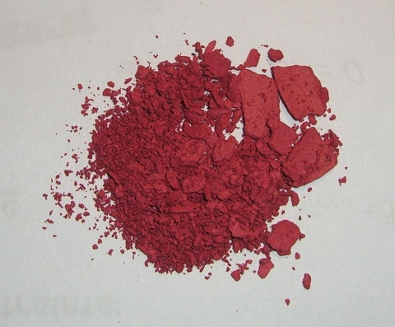 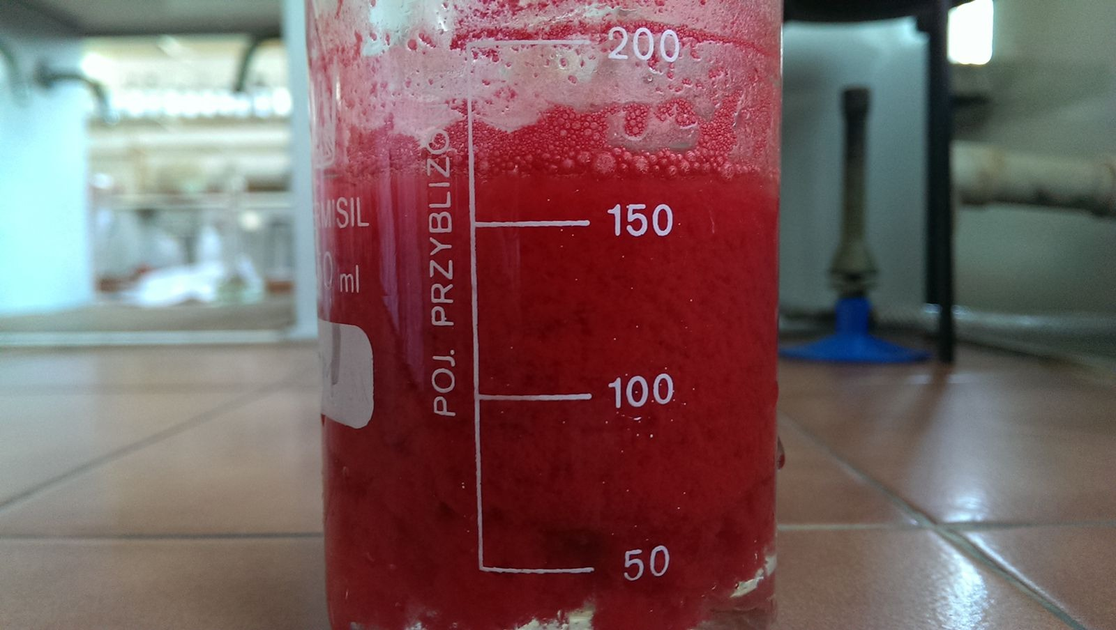

**Calculation**





**Wt of Sample = 0.5 gm**

**Wt of precipitate Ni(C4H7N2O2)2= 0.3 gm**

**If you know A.wt of Ni= 59, C=12 ,H=1,O=16, N=14**

**Calculate the percentage of Ni in the sample ?**

**% Ni = Wt of Ni/ Wt of Sample × 100**

**Wt of Ni = G.F × Wt of Ni(C4H7N2O2)2**

**= 0.20314 × 0.3 = 0.06gm**

**%Ni = 0.06 / 0.5 × 100 = 12.2 %**

**Questions of discussion**

1. What are DMG properties? And why it is used as a precipitating factor ?
2. What are Ni (DMG) 2 specifications?
3. What is the effect of the acidic function on the Ni (DMG) 2 complex?
4. What is the effect of chloride ion on precipitation?
5. What is the chemical composition of the Ni (DMG) 2 precipitate?

**Experiment NO. 4**

**Determination of Aluminum as Oxinate**

**Introduction**

The 8-hydroxyquinolineis considered an organic precipitated reagent for various metallic ions, that can be converting from selective reagent to specific reagentby controlling on an experimental conditions such as pH or temperature, the aluminum possibly precipitating from solution content magnesium by using 8-hydroxyquinoline as specific reagent, the aluminum will be precipitate as complex chelating with three molecules of oxine at pH (4-5),this technique can be consider a gravimetric method to determining the aluminum, this method producing a complex chelating precipitating in this media because of it has a poor solubility. The precipitate is crystalline, can be easily filtered and readily dried between (102-120°C).



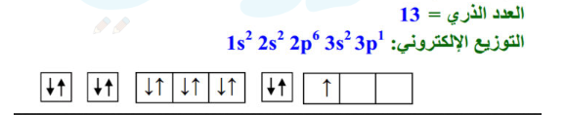

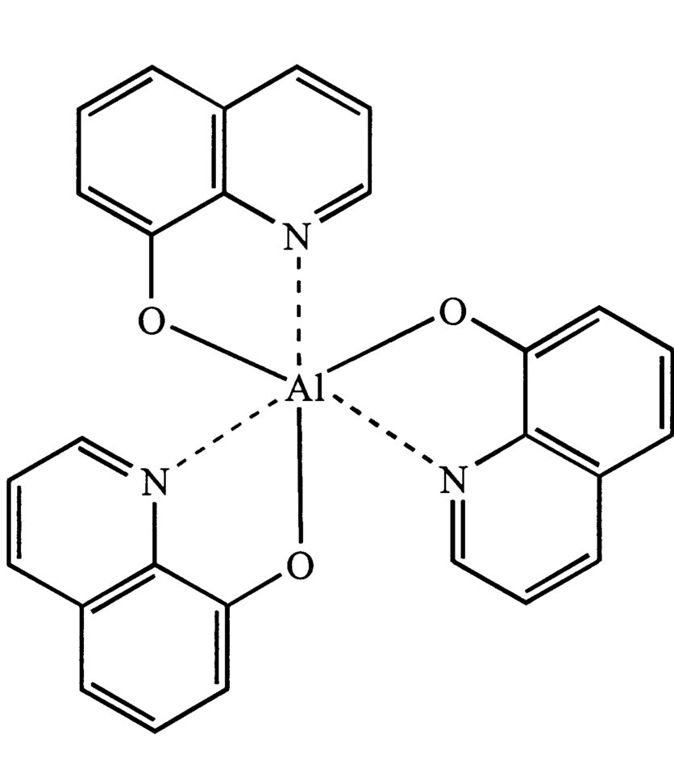

**Materials**

1. Oxine solution: dissolve (14.5)g of oxyin in (75)ml of acetic acid then complete the volume to 1 liter or (2% of oxyin dissolved (2N) of acetic acid).
2. Ammonium acetate solution (2%).
3. Aluminum sulphate.

**Procedure**

1. **Dissolve aluminum salt (1.5g) with 100mL of distilled water then heat the solution.**
2. **Add gradually with stirring (15mL) solution of oxine (8-hydroxyquinoline) until appearance precipitate.**
3. **Then add 1 ml of a 2% solution of ammonium acetate slowly while continuing to heat for a quarter of an hour for the purpose of completing the precipitation**
4. **Prepare the filter**
5. **Filter precipitate then wash the precipitate used cold distilled water.**
6. **Dry filter paper at (120-150C°) for (10min), and then weigh filter paper with precipitate and calculate the weight and percentage of Al.**



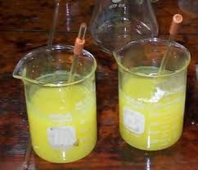

**Calculation**

$$Al\%=\frac{Wt Al}{Wt.of Sample} ×100$$

$$Wt Al=G.F × Wt Al(C_{9}H_{6}ON)_{3}$$

**Wt of Sample = 1.5 gm**

**Wt of precipitate Al (C9H6ON)3= 1.2 gm**

**If you know A.wt of Al= 27 , C= 12 , O= 16 ., H= 1 ,N=14**

**Calculate the percentage of Al+3 in the sample ?**

**% Al+3 = Wt of Al+3 / Wt of Sample × 100**

**Wt of Al+3 = G.F × Wt of Al (C9H6ON)3**

**G.F =AWT of Al+3 / MWT of Al (C9H6ON)3**

**=27 / 27+3( 9X12+6X1+14+16) = 0.0588**

**Wt of Al+3 = 0.0588× 1.2 = 0.07gm**

**% Al+3 = 0.07/ 1.5 × 100 = 4.7 %**

**Discussion**

1. **What is the purpose of the ammonium acetate in the experiment?**
2. **Draw the structure of the aluminum complex of oxine and what is the structure (8-hydroxyquinoline)?**
3. **What are the characteristics of compounds of oxine?**
4. **What is the effect of PH on oxine?**
5. **The effect of continuous stirring with heating on the composition of the precipitation?**

**Experiment No.5**

**Determination of Sulphate as Barium Sulphate**

**Introduction**

The estimation method of Sulphate as Barium Sulphate is based on the slow addition of dried BaCl2 barium chloride solution to the hot sulphate solution in an acidic media using HCl acid.



The acid concentration was 0.05 N following **the below reasons:**

**1- Large particles of the precipitate can be obtained**

**2- Precipitation particles are pure**

.

**In a solution of HCl (0.1 N), the solubility of barium sulphate is approximately 10 mg / L in (20°C), where as, in 1N solution, the solubility is approximately 87 mg / L .**

**The precipitation in an acidic medium of 0.05N with a moderate concentration of barium chloride will reduce the dissolution of barium sulfate to a large extent so that it can be ignored.**

**To dry barium sulphate precipitate, the precipitator should always be burned for at temperature (110-115°C) because the crystallization water is strongly attached to the crystalline network of the precipitation. This water can be disposed at a high temperature only. Therefore, barium sulphate should be burned at a temperature higher than (500°C) to precpitate of water as this salt is stable even at high temperatures.**



The precipitation may be reduced at higher temperatures by using filter paper. In addition to the possible dissociation of salt into barium oxide and sulfur oxides**:**



But good results can be obtained when filter paper carbonization is at the lowest possible temperature without burning.

A slight disintegration of barium sulfide (BaS) can be obtained with precipitation cooling and crucible after burning, adding some drops of dilute H2SO4 and re-heating to remove the unused acid into the reaction in the form of vapors:



**Materials**

1. **Sample sulphate salt.**
2. **Concentrated hydrochloric acid**
3. **Barium chloride solution (10%).**
4. **Sulfuric acid diluted (10%).**

**Procedure**

1. Carefully weigh 1.0 g of sulfur salt in a (400 ml) beaker equipped with a stirrer. Add 1 ml of concentrated hydrochloric acid and then dilute the solution to 100 ml as final volume.
2. Heat the solution until boiling and add slowly with the continuous stirring (40 ml) of the barium chloride hot solution at a concentration of 10%. Heat the solution until it reaches boiling and (show the bubbles) and leaves it for 10 min.
3. Install the filtration apparatus and filter. Wash the precipitate with hot distilled water then let the precipitate dry up. Fold the filtration paper containing the precipitate and placed in a previously balanced crucible
4. Charcoal filter paper first slowly above the flame lamp and after it has been burned into white ash; two drops of concentrated sulfuric acid are added.
5. Place the crucible containing the burnt paper in a furnace muffle (9000C) and then reheat slowly to remove the excess acid.
6. Transfer the crucible to a desiccator and weight the crucible and precipitate after it cools.

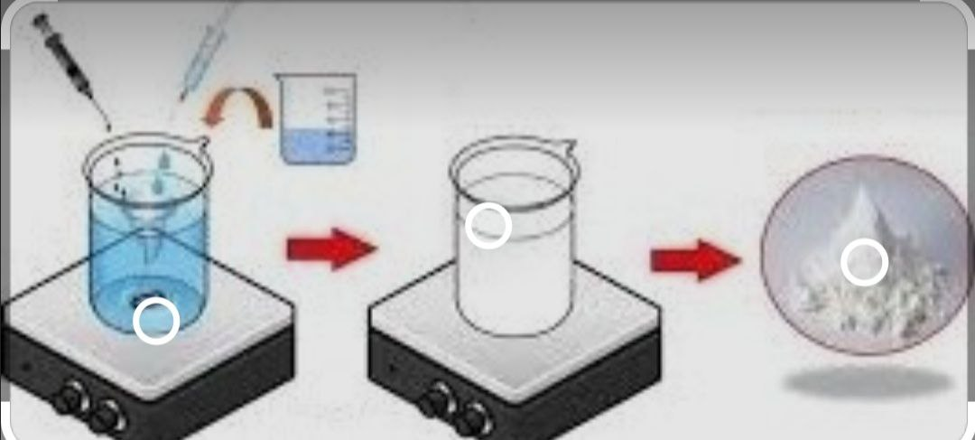

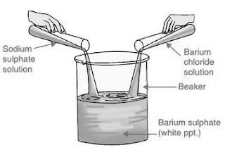 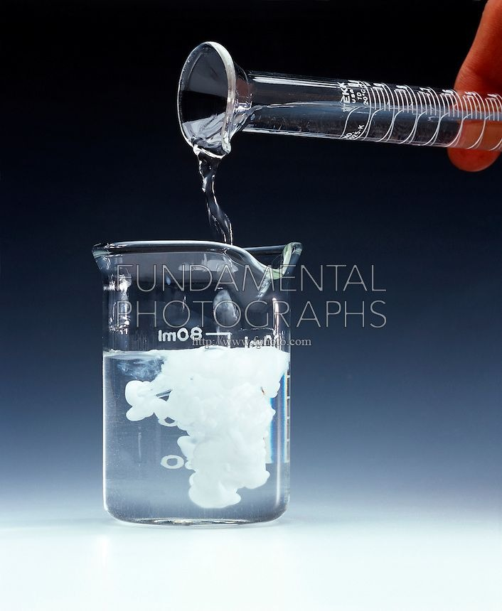

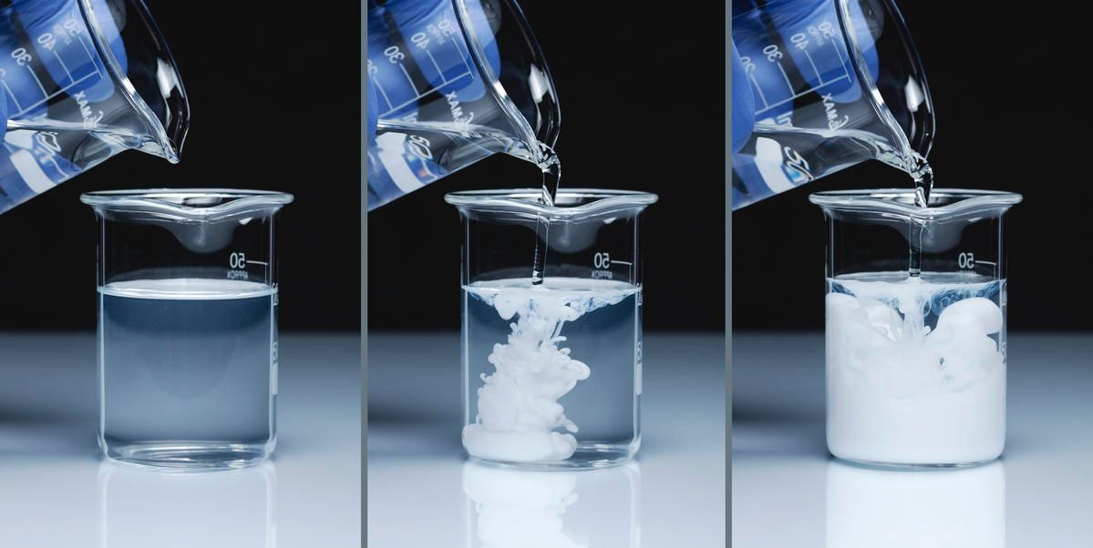

**Calculation**

**Calculation**

**Wt of Sample = 1.0 gm**

**Wt of precipitate BaSO4= 0.5 gm**

**If you know A.wt of Ba= 137 , S= 32 , O= 16**

**Calculate the percentage of SO4 in the sample ?**

**% SO4-2 = Wt of SO4 / Wt of Sample × 100**

**Wt of SO4-2 = G.F × Wt of BaSO4**

**G.F =MWT.(SO4-2) / MWT. BaSO4**

**=32+4X16 / 137+ 32+4X16 = 0.412**

**Wt of SO4 -2= 0.412× 0.5 = 0.2gm**

**% SO4-2 = 0.2 / 1.0 × 100 = 20.6 %**

**Discussion**

1. sulphates are precipitate in an acidic medium (0.05 N)? why?
2. Why barium sulfate precipitate is burned to a temperature of about 9000C?
3. Sulfuric acid is added to the crucible after burning the barium sulphate precipitate?
4. What are the main sources of barium sulphate precipitate contamination?