**Experiment No. (5)**

**((wind rose))**

**A- Graphical style:**

The wind rose: It is a method for representing wind data (speed and direction), especially surface winds, and trying to understand and interpret that data and benefit from it for a specific purpose.

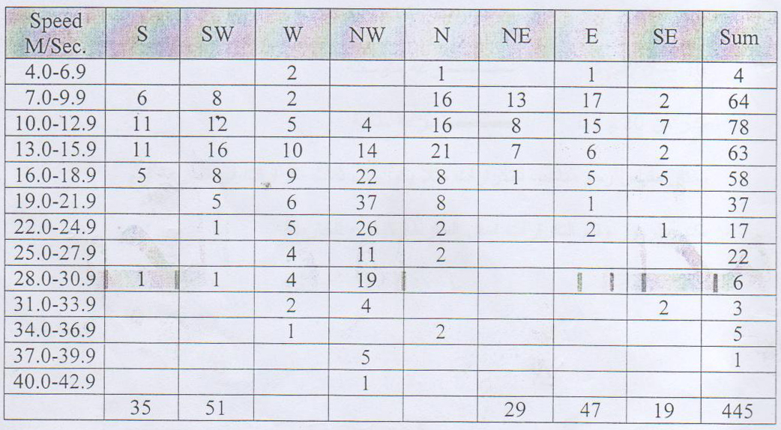

1- Like the above data in the form of a wind rose.

2- Interpret the results.

3- Briefly talk about the application of the results of the above issue in the case of building an airport runway or other civil and agricultural applications.

**The method of work:**

1- A circle is drawn in the center of the coordinates representing the station, in which is written the number of static days (wind speed = zero).

2- Draw the eight coordinates and .

3- Determine the speed values as follows:

Zero .... 9.9 m/s _________ normal speed

10 .... 19.9 m/s **_________** medium speed

greater than 20 m/s _________ perfect speed

We choose a scale for iterations, for example, every three iterations of speed is a name.

- Write symbols and values of repetitions at the bottom of the map as a key to the map.

**B - The style of contour lines:**

**The method of work:**

1- A circle is drawn in the center of the coordinates representing the station, in which is written the number of static days (wind speed = zero).

2- Draw the eight coordinates and .

3- The three directions are divided into a regular scale of velocity, for example 20, 15, 10, 5...

4- Give the symbols for the speed shown below:

|  |  |
| --- | --- |
| السرعة و / ثا | الرمز |
|  |  |
|  |  |
|  |  |
|  |  |
|  |  |
|  |  |
|  |  |
|  |  |

5- Connect the contour lines of equal speed

6- The symbols and values for speed are placed at the bottom of the map as a key to the map.