Lecture 1

GENETICS is the study of inherited traits and their variation. Sometime people confuse genetics with genealogy, which considers relationships but not traits. Genetics is a life sciences.
- Heredity is the transmission of traits between generations, and genetics is the study of how that happens.
The science of heredity or genetics is the study of two contradictory aspects of nature : heredity and variation. The process of transmission of characters from one generation to next, either by gametes–sperms and ova–in sexual reproduction or by the asexual reproductive bodies in asexual reproduction, is called inheritance or heredity.
Heredity is the cause of similarities between individuals. This is the reason that brothers and sisters with the same parents resemble each other and with their parents. Variation is the cause of differences who do resemble each other are still unique individuals. Thus, we have no trouble in recognizing the differences between sisters, for example, and even ‘identical’ twins are recognized as distinctive individuals by their parents and close friends.
The science of genetics attempts to explain the mechanism and the basis for both similarities and differences between related individuals. It also tries to explain the phenomenon of evolution and cytodifferentiation
The science of genetics is the study of heredity which is the cause of similarities; and variation which is the cause of differences between individuals
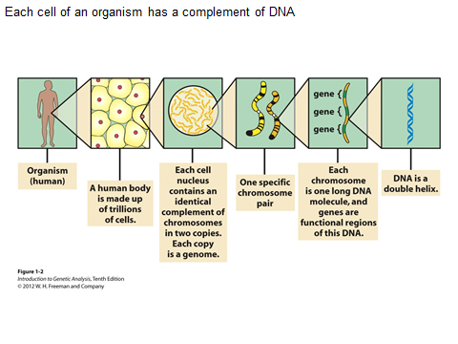
Level of genetics
Genetics considers the transmission of information at several level. It begins with molecular level and broad through cells, tissue and organs ,individuals ,families and finally to population and evolution of species.
Cells are the fundamental structural and functional units of every known living organism. Instructions needed to direct activities are contained within a DNA (deoxyribonucleic acid) sequence. DNA from all organisms is made up of the same chemical units (bases) called adenine, thymine, guanine, and cytosine, abbreviated as A, T, G, and C. In complementary DNA strands, A matches with T, and C with G, to form base pairs. The human genome (total composition of genetic material within a cell) is packaged into larger units known as chromosomes—physically separate molecules that range in length from about 50 to 250 million base pairs. Human cells contain two sets of chromosomes, one set inherited from each parent. Each cell normally contains 23 pairs of chromosomes, which consist of 22 autosomes (numbered 1 through 22) and one pair of sex chromosomes (XX or XY). However, sperm and ova normally contain half as much genetic material: only one copy of each chromosome.
Each chromosome contains many genes, the basic physical and functional units of heredity. Genes are specific sequences of bases that encode instructions for how to make proteins. The DNA sequence is the particular side-by-side arrangement of bases along the DNA strand (e.g., ATTCCGGA). Each gene has a unique DNA sequence. Genes comprise only about 29 percent of the human genome; the remainder consists of non-coding regions, whose functions may include providing chromosomal structural integrity and regulating where, when, and in what quantity proteins are made. The human genome is estimated to contain 20,000 to 25,000 genes.(the complete set of genetic instructions charactonseristic of an organism including protein coding genes and other DNA sequences ,constitutes a genome)
Although each cell contains a full complement of DNA, cells use genes selectively. For example, the genes active in a liver cell differ from the genes active in a brain cell because each cell performs different functions and, therefore, requires different proteins. Different genes can also be activated during development or in response to environmental stimuli such as an infection or stress.

Cytogenetic :
Cytogenetics is a field of genetics dealing with species or cell specific number of chromosomes, and their structure and characteristic segments, their functional roles, and all the differences - namely the chromosomal mutations - related to them. Chromosome mutations are changes in the structure or in the number of chromosomes, and since they are relatively rare in this respect they differ from normally occurring common, harmless chromosome polymorphisms. Since both types of chromosome aberrations affecting many genes, and since the size of chromosomes or their affected segments are within the limits of
microscopic resolution therefore they can be examined by light microscope, as opposed to gene mutations only be identified by molecular biological techniques. However, the application of modern hybridization based (FISH and CGH) techniques allow the identification of small structural changes (e.g. microdeletions or CNVs) previously unrecognized by light microscope.

The structure of chromosomes and genes
A chromosome is an organized structure of DNA and protein that is found in cells. A chromosome is a single piece of coiled DNA containing many genes, regulatory elements and other nucleotide sequences. Chromosomes also contain DNA-bound proteins, which serve to package the DNA and control its functions. (The word chromosome comes from the Greek chroma - color and soma - body due to their property of being very strongly stained by particular dyes.) Chromosomes vary widely between different organisms.
Viral Chromosomes
The chromosomes of viruses are called viral chromosomes. They occur singly in a viral species and chemically may contain either DNA or RNA. The DNA containing viral chromosomes may be either of linear shape (e.g., T2, T3, T4, T5, bacteriophages) or circular shape (e.g., most animal viruses and certain bacteriophages). The RNA containing viral chromosomes are composed of a linear, single-stranded RNA molecule and occur in some animal viruses (e.g., poliomyelitis virus, influenza virus, etc.); most plant viruses, (e.g., tobacco mosaic virus, TMV) and some bacteriophages. Both types of viral chromosomes are either tightly packed within the capsids of mature virus particles (virons) or occur freely inside the host cell.
Prokaryotic Chromosomes
The prokaryotes usually consists of a single giant and circular chromosome in each of their nucloids. Each prokaryotic chromosome consists of a single circular, double-stranded DNA molecule; but has no protein and RNA around the DNA molecule like eukaryotes. Different prokaryotic species have different sizes of chromosome.
Eukaryotic Chromosomes
The eukaryotic chromosomes differ from the prokaryotic chromosomes in morphology, chemical composition and molecular structure. The eukaryotes (plants and animals) usually contain much more genetic informations than the viruses and prokaryotes, therefore, contain a great amount of genetic material, DNA molecule which here may not occur as a single unit, but, as many units called chromosomes. Different species of eukaryotes have different but always constant and characteristic number of chromosomes. In eukaryotes, nuclear chromosomes are packaged by proteins into a condensed structure called chromatin.
A single molecule of DNA within a chromosome may be as long as 8.5 centimeters (3.3 inches). To fit within a chromosome, the DNA molecule has to be twisted and folded into a very complex shape. Each chromosome has a constriction point called the centromere, which divides the chromosome into two sections, or “arms.” The short arm of the chromosome is labeled the “p arm.” The long arm of the chromosome is labeled the “q arm.” The location of the centromere on each chromosome gives the chromosome its characteristic shape, and can be used to help describe the location of specific genes. Furthermore, cells may contain more than one type of chromosome; for example, mitochondria in most eukaryotes and chloroplasts in plants have their own small chromosomes. The following are the different types of chromosomes Morphologically l chromosome described metacentric, submetacentirc , or acrocentric
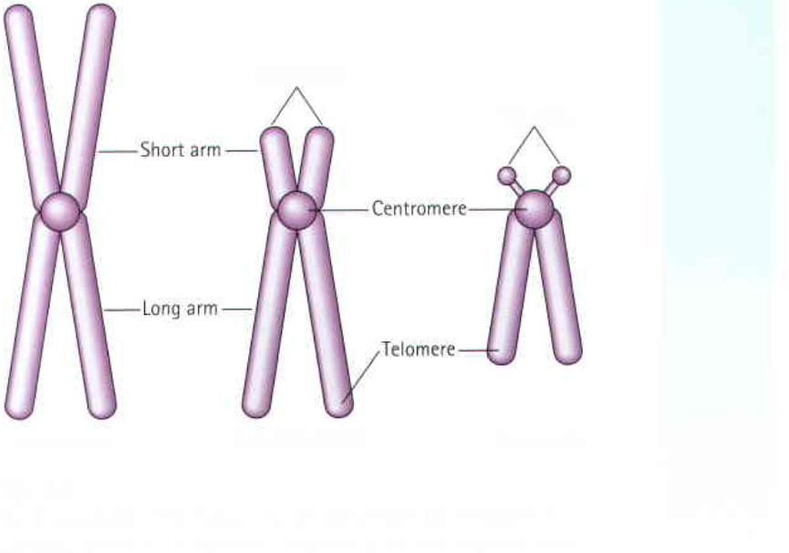
Figure : (1) Metacentric Sub metacentric acrocenrtic
Chemical Structure of Chromosomes
Chemically, the eukaryotic chromosomes are composed of
1-deoxyribonucleic acid (DNA),
2-ribonucleic acid (RNA)
3 - histone and non-histone proteins (The histone proteins have basic properties and have significant role in controlling or regulating the functions of chromosomal DNA. The non-histone proteins are mostly acidic and have been considered more important than histones as regulatory molecules. Some non-histone proteins also have enzymatic activities. The most important enzymatic proteins of chromosomes are phosphoproteins, DNA polymerase, RNA-polymerase, DPN-pyropbosphorylase, and nucleoside triphosphatase.
4- and certain metallic ions. (The metal ions as Ca+ and Mg+ are supposed to maintain the oragnization of chromosomes intact).
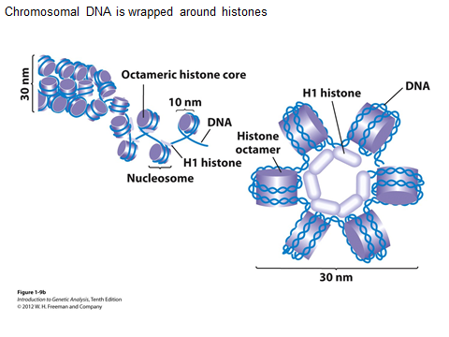

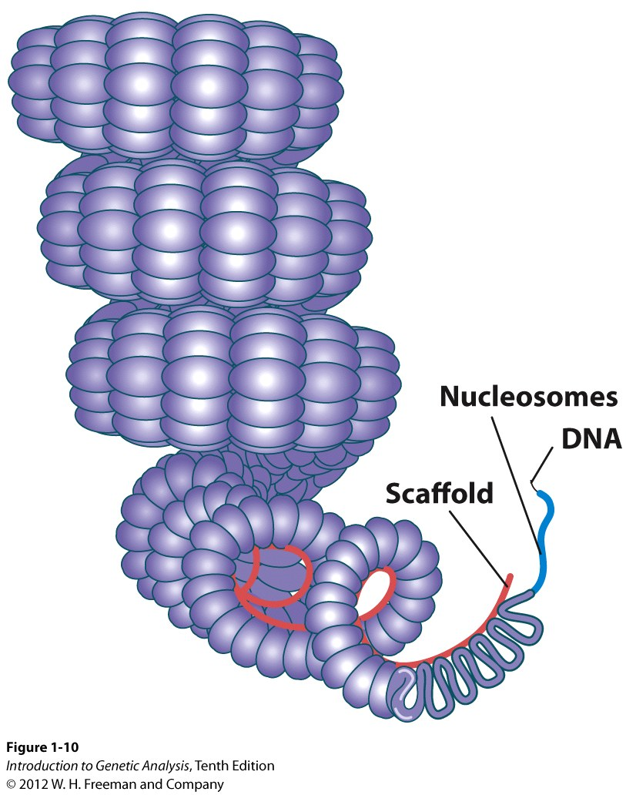

- DNA Packaging
A-Long sequence of DNA must be stored within the geometry of a nucleus human chromosome 22, (48 million bp Extends to length of ~1.5 cm) Measures 2 m in mitosis Packaging ratio on the level of 10⁴ in mitosis
B-Packaging ratio ~500 in interphase•
C- Packaged DNA must provide controlled access to regions required for gene expression.
- The first level of packing
Winding of DNA around a protein core to produce a "bead-like" structure called a nucleosome.( nucleosome is a structure unit of chromosome ) This structure is invariant in both the euchromatin and heterochromatin of all chromosomes. The protein core is composed of 8 histone proteins, two each of H2A, H2B, H3 and H4. Histone H1 forms the linker between to nucleosomes. 146 bp of DNA is wrapped around each nucleosome.
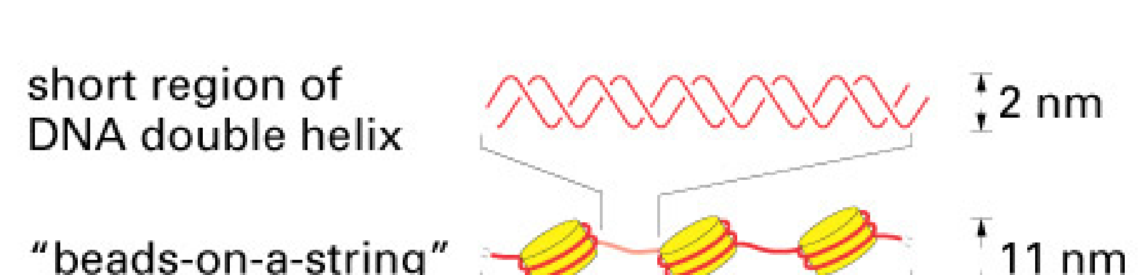
2-The second level of packing Coiling of beads in a helical structure called the 30 nm fiber that is found in both interphase chromatin and mitotic chromosomes. Coiling of beads in a helical structure called the 30 nm fiber that is found in both interphase chromatin and mitotic chromosomes.

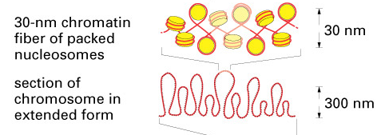

3-The final level of packing :the fiber organized in loops, scaffolds and domains that give a final packing ratio That give final package ratio about 1000 in interphase chromosome and about 10,000 in mitotic chromosome The final level of packaging is characterized by 700 nm structure seen in the
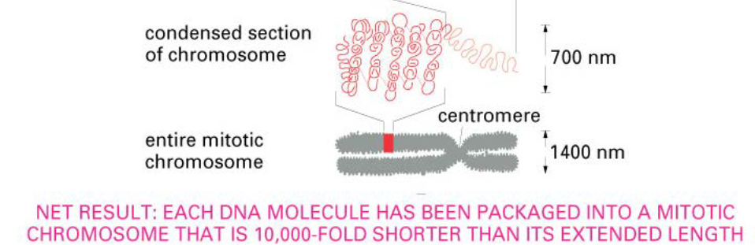
Figure 2

- 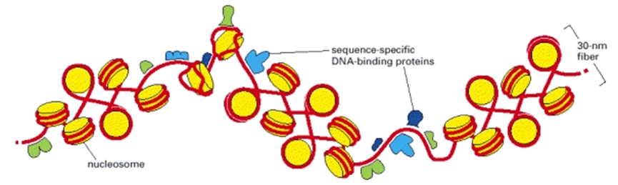.
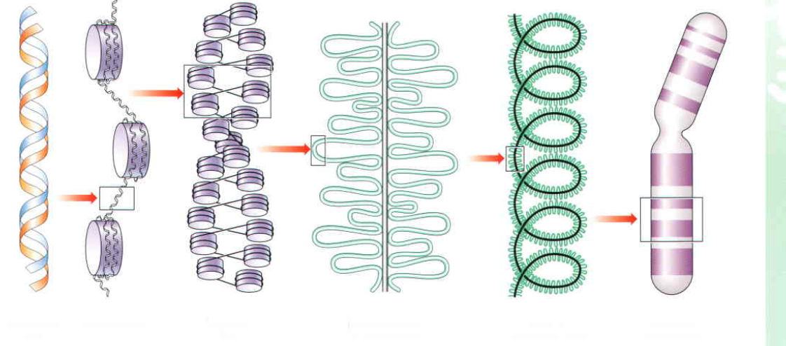
nucleosome
30 nm fiber that is fo
Figure 3 :The shortest human chromosome contains 4.6 x 107 bp of DNA. This is equivalent to 14,000 μm of extended DNA. In its most condensed state during mitosis, the chromosome is about 2 μm long. This gives a packing ratio of 7000 (14,000/2). The DNA is packaged stepwise into the higher order chromatin structure and this is known as “hierarchies of chromosomal organization”.

Kinds of Chromosomes
The eukaryotic chromosomes have been classified into autosomes and sex chromosomes. The autosomes have nothing to do with the determination of sex and exceed in number than sex chromosomes. The sex chromosomes determine the sex of their bearer They are usually two in number and are usually of two kinds: X chromosomes and Y chromosomes.
Genetic Significance of Chromosomes
The chromosomes are considered as the organs of heredity because of following reasons:
(i) They form the only link between two generations.
(ii) A diploid chromosome set consists of two morphologically similar (except the X and Y sex
chromosomes) sets, one is derived from the mother and another from the father at fertilization.
(iii) The genetic material, DNA or RNA is localized in the chromosome and its contents are
relatively constant from one generation to the next.
(iv) The chromosomes maintain and replicate the genetic informations contained in their DNA
molecule and this information is transcribed at the right time in proper sequence into the specific
types of RNA molecules which directs the synthesis of different types of proteins to form a body
form like the parents.

