Lect. 3

Nomenclature of human chromosome
A successful attempt to count the number of human chromosomes was made in 1912 by Winiwarter who proposed that human chromosomes are 48 in women and 47 in man; men having one X chromosome and women having two X chromosomes. Painter, in 1923, while examining the testicular material of man, observed a heteromorphic pair of sex chromosomes and proposed the XY mechanism of sex determination in man. Tjio and Levan (1956) cultured somatic cells from fibroblasts of human embryos and counted the human chromosome number as 46. This chromosome number was confirmed by Ford and Hamerton while working with testicular material in the same year. Tjio and Levan provided greatly improved techniques for chromosome preparations. Moorhead et al., (1960) described a simple method of culturing of lymphocytes from human blood. Karyotyping human chromosomes. For karyotyping of human chromosomes venous blood is taken and blood leucocytes are stimulated to divide (by mitosis) in vitro by the addition of phytohaemagglutinin. Colchicine is added to arrest cell division at metaphase stage. It is further treated with hypotonic saline solution which results in swelling of cells and dispersal and better clarity of chromosomes for counting and morphological study. There after, the material is stained (e.g., with Giemsa technique) to demonstrate the banding patterns of chromosomes. Finally, a suitable metaphase spread is photographed through a high power microscope. The individual chromosomes are cut out from the photograph. The chromosomes are then arranged in an orderly fashion in homologous pairs, to produce a standard arrangement, the karyotype.
To characterize a chromosome in the karyotype, the following parameters are used :

1. Shape of chromosome ;
2. Length of chromosome ;
3. Centromeric index, i.e., this index is expressed in the form of ratio of the short arm length to
the total chromosome length :
Centromeric index = Short arm length
Total chromosome length For example, centromeric index in a metacentric chromosome is 0.5.

4. Proportion of the arms, i.e., it is ratio between the long arm and short arm of the chromosome. This ratio is 1 : 1 in a typical metacentric chromosome.

Classification. The human were first of all classified by a conference of cytogeneticists at Denver, Colorado in 1960 and is known as the Denver classification. To follow this classification, each of the 22

pairs of autosomes has been numbered from 1 to 22 according to their decreasing size. Patau (1960)
divided the human chromosomes into the following seven groups designated A to G :
1. A group : 1 to 3 pairs — Metacentric (large metacentric)
2. B group : 4 to 5 pairs — Submetacentric (Large submetacentric)
3. C group : 6 to 12 pairs — Submetacentric ( Medium
Submetacentric)
4. D group : 13 to 15 pairs — Acrocentric (Medium acrocentric)
5. E group : 16 to 18 pairs — Submetacentric (16 is metacentric) Short
sub metacentric)
6. F group : 19 to 20 pairs — Metacentric (Short metacentric)
7. G group : 21 to 22 pairs — Acrocentric (Short acrocentric)
Group A consists of longest metacentric chromosomes.
Group G consists of the shortest acrocentric chromosomes. These chromosomes have satellites
that correspond to nucleolar organizers. Chromosomes of group D also contains satellites. In males,
group G includes a variable Y chromosome which lacks the satellites.
The X chromosome is the member of group C and can be identified by special banding or staining
methods.

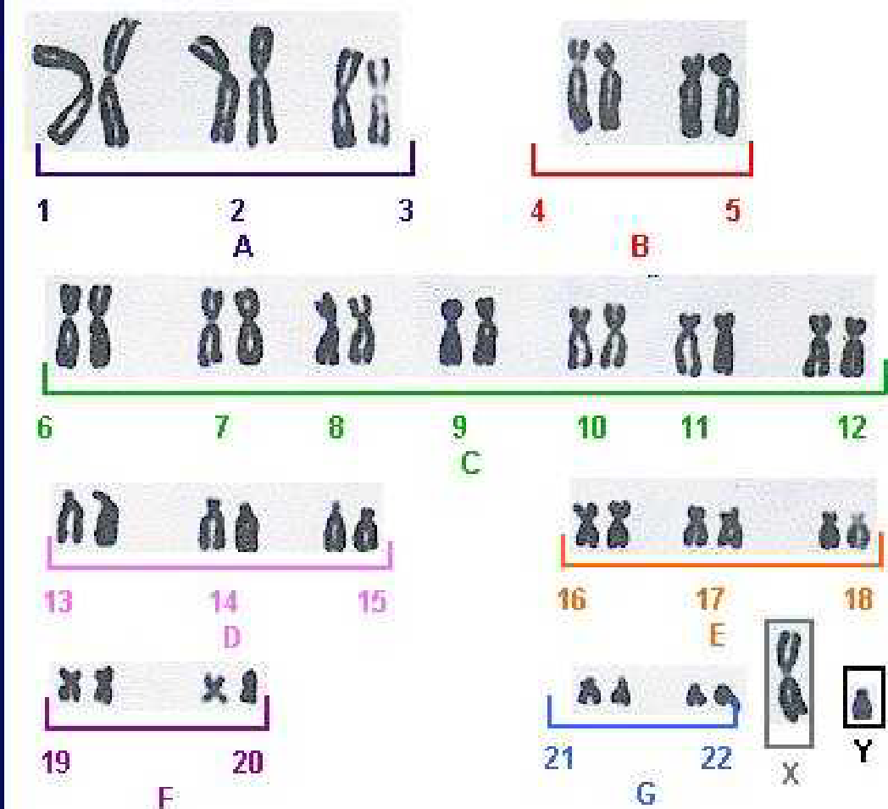

Banding Techniques

Recently banding techniques reveals structural details of chromosomes. The main banding
techniques are identified by letters such as Q, G, C, R, T, F and N bands:

- Q banding. It uses fluorescent dyes(such as quinacrine mustard) and identifies the so called Q bands.( in this method regions of the genome which relatively rich in the bases adenine and thymidine fluoresce brightly with Q – banding and each human chromosome pair gives a uinqe pattern of band.

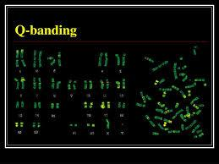

2. G banding. It uses Giemsa stain and identifies the G bands. With G banding three major types of chromatin can be recognized— euchromatin, centromeric and intercalary heterochromatin.( it is the most frequently used method of banding for human cytogenetic involve trypsin digestion of the metaphase chromosome followed by staninig with Giemsa a dark blue stain which can be easily seen
With standaered light microscope the dark regions tend to be heterochromatin, late replicating and AT rich . The light regions tend to be euchromatic early- replicating and GC rich .
The Q and G bands are generally similar and correspond to intercalary heterochromatin.

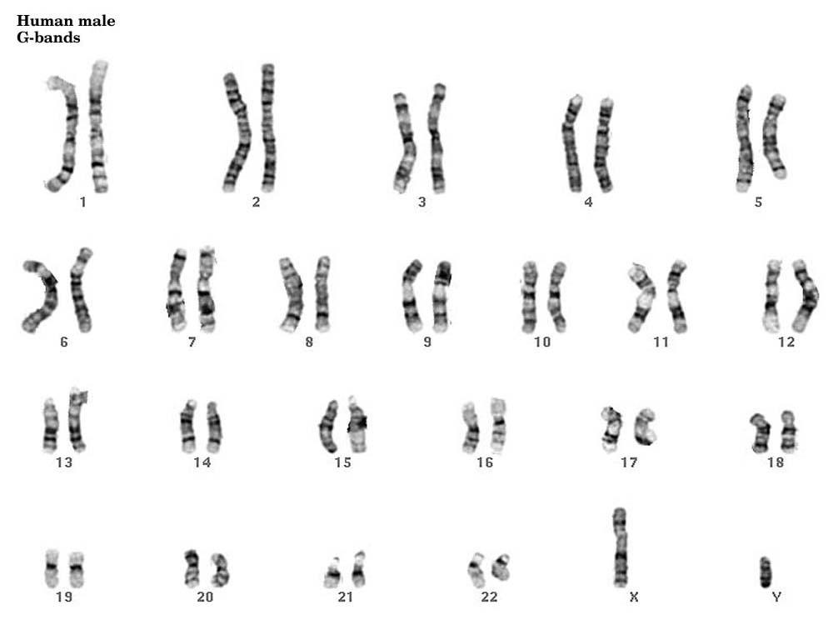

Chromosome spread with chromosomes
shown by bright
field G-banding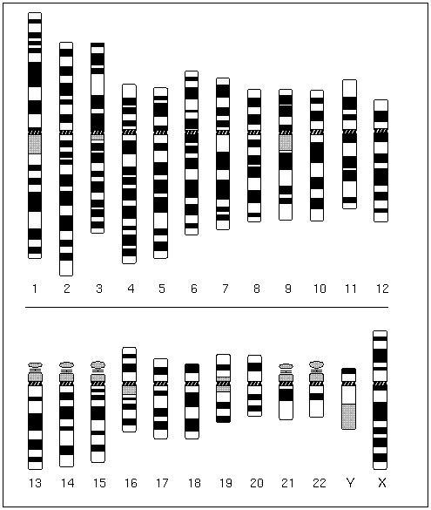
Idiogram of G-banded chromosome

3. C banding. It stains specifically centromeric constitutive heterochromatin.

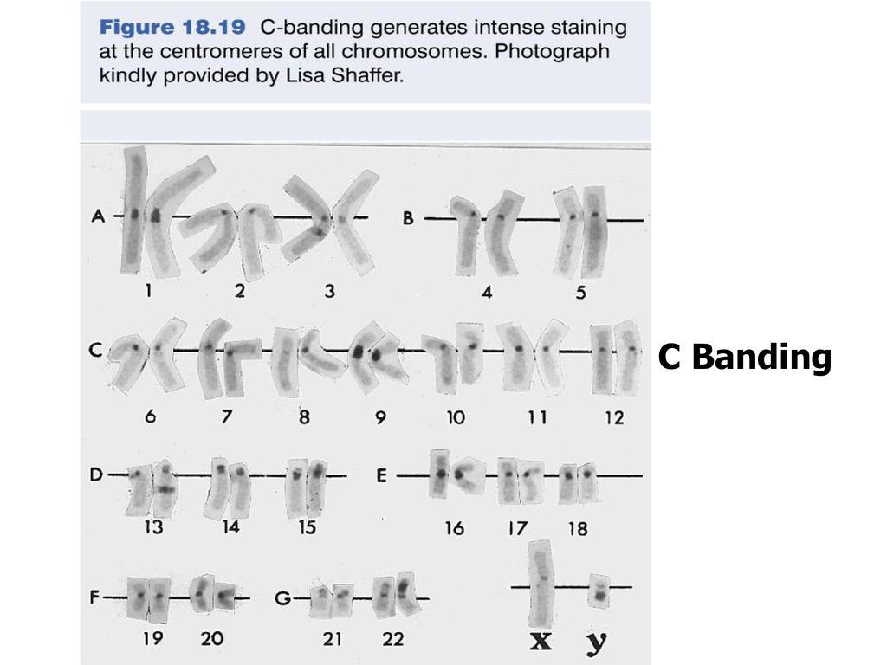

4. R banding. It gives a pattern that is the reverse of that of Q and G banding.( the dark regions are euchromatine and light region are heterochromatin )

5. T banding. It stains telomeres of chromosomes.

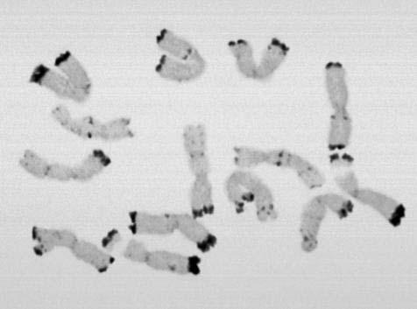

TELOMERE BAND

Other banding techniques uses the Feulgen stain (F bands) and one selectively stains the Other banding techniques uses the Feulgen stain (F bands) and one selectively stains the nucleolar organizers (N bands) which are localized in the satellite of chromosomes 13, 14, 15, 21 and 22. G banding has become important tool in the analysis of mammalian, avian, reptilian and amphibian chromosomes; distinct G bands have not
been found in plant chromosomes.

Clinical importance of chromosome banding. Since banding patterns are unique and constant
for each normal chromosomes, in case of a large number of chromosomal abnormalities, such as loss of a very small part, insertion of an additional segment and addition of whole chromosome can be easily
recognized, e.g., cat-cry syndrome due to loss of small part of chromosome 5 ; Down syndrome due
to an extra chromosome 21.

Banding nomenclature

Each chromosome has a constriction point called the centromere, which divides the chromosome into two sections, or “arms.”

 The short arm of the chromosome is labeled the “p arm.”
 The long arm of the chromosome is labeled the “q arm
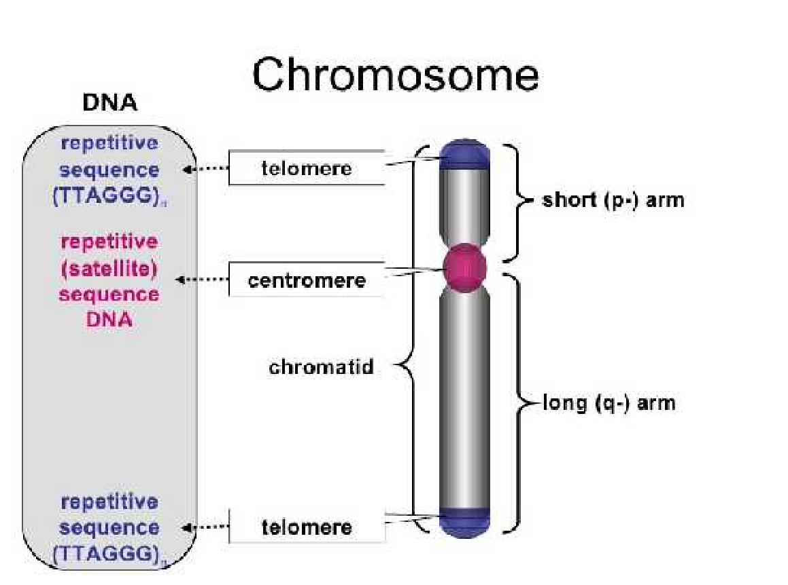

The location of the centromere on each chromosome gives the chromosome its characteristic shape, and can be used to help describe the location of specific genes. Each chromosome arm is divided into regions, or cytogenetic bands, that can be seen using a microscope and special stains. The cytogenetic bands are labeled p1, p2, p3, q1, q2, q3, etc., counting from the centromere out toward the telomeresAt higher resolutions, sub-bands can be seen within the bands. The sub-bands are also numbered from the centromere out toward the telomere.
For example, the cytogenetic map location of the CFTR gene is 7q31.2, which indicates it is on chromosome 7, q arm, band 3, sub-band 1, and sub-sub-band 2. The ends of the chromosomes are labeled ptel and qtel. For example, the notation 7qtel refers to the end of the long arm of chromosome 7.

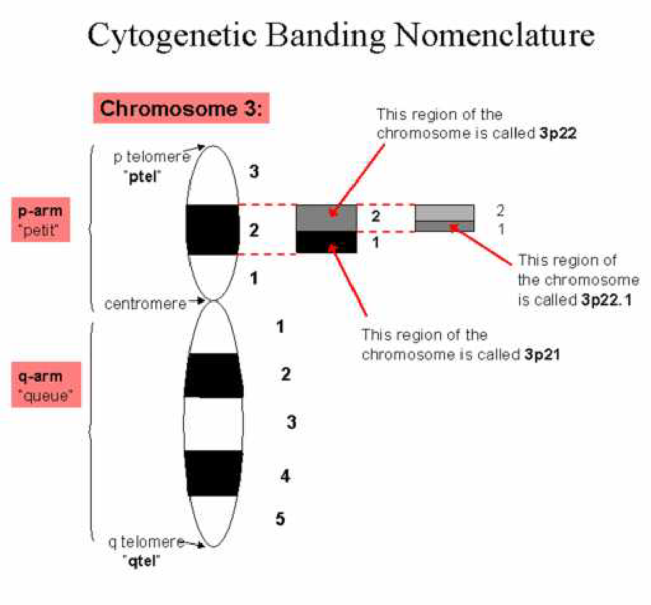

Chromosome Aberrations

Two aspects of the chromosomal abnormalities are regarded crucial: when and where they happen. While chromosome mutations may be formed during both mitosis and meiosis, those may occur in meiosis, lead to defective gamete formation, and to the birth of affected offspring. Thus their medical significance is greater than that of mitotic chromosome aberrations.

From the point of mitotic chromosomal abnormalities it is also important when
during development and in what kind of cell they are formed. Mutations occurred during the early cleavage divisions may have serious consequences for the entire organism, while aberrations occurred in a continuously proliferating cell type (e.g. epithelial cells) in adulthood may have negligible role. However, certain chromosomal mutations may have a role in the formation and subsequent rapid proliferation of tumor cells.
Two chromosomal regions have special importance in the formation of chromosome
aberrations: the centromeres and the telomeres.

1-The centromere is primary constriction of chromosomes where sister chromatids are connected, situated in strictly imposed position of the chromosome. The kinetochore and through that kinetochore microtubules bind to it. Its significance in the segregation of sister chromatids or chromosomes during anaphase, therefore it plays role mainly in the formation of numerical chromosome mutations. Chromosome pieces without centromere (acentric fragments) do not reach the right pole of the cell, but lost in successive divisions. There are many repetitive GC-rich sequences around the centromere, and the centromere itself includes the latest replicating DNA(heterochromatine)

2-The chromosome ends, the telomeres are rich in TTAGGG repetitive sequences, and ensure the integrity and stability of the chromosome structure and play a role in cell aging, in tumorigenicity and the formation of structural chromosome aberrations, since in the absence of a telomere the chromosome structure becomes unstable and fragments without telomeres easily adhere, opening the way for a wide variety of disorders.

4.1. Structural chromosome aberrations
The prerequisite of structural chromosome aberrations is breakage of chromosome/s which can be spontaneous or induced. The classification of structural aberrations is based on 1-the number and the location of breaks within chromosomes (Figure 4.1).
Figure 4.1. The classification of structural chromosome aberrations

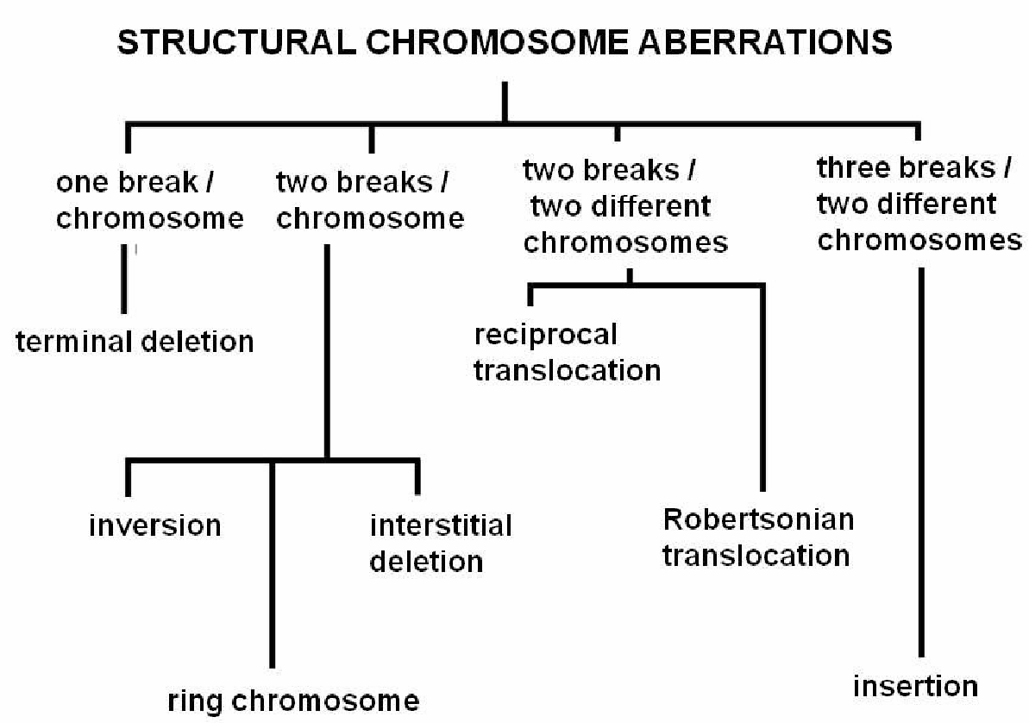

4.1.1. Deletions
If a chromosome is broken, and the broken piece lost, we are talking about deletion. Then the genetic information carried by the broken piece will be absent from the cell involved, whereupon the cell does not function normally or die. Since the deletions eliminate certain functions therefore certain proteins for example enzymes are not produced. By the help of deletions the location of the gene eliminated can be mapped - it was one of the earliest methods of gene mapping, the deletion mapping.

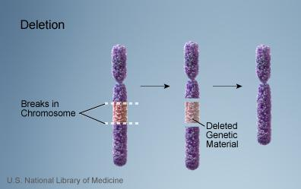

- If the break is close to the end of the chromosome, a terminal deletion is generated. In this in addition to other genes telomere is lost, too and this also contributes to the severity of symptoms, to early lethality case, The best known example of a terminal deletion is the cat cry(cri du chat) syndrome

: the short arm of chromosome 5 is deleted (5p-). The disease is named after the affected newborns characteristic mewing cry.

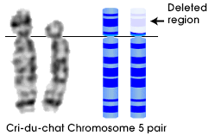

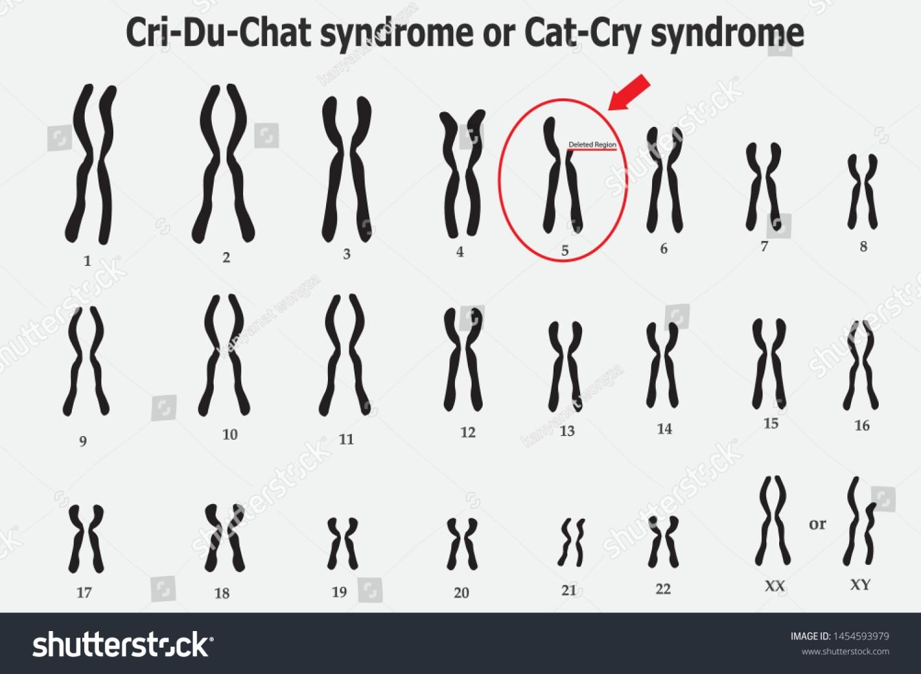

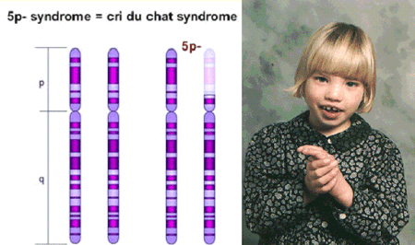

2-There are two breaks within one chromosome in the case of interstitial deletion, and the intermediate piece is lost. Such lesions usually may cause severe physical and mental disabilities, spontaneous abortion, premature death depending on the chromosome involved. The best known interstitial deletion affects the long arm of chromosome 15: del15 (q11-13). This is one of the causes of Prader-Willi or Angelman syndrome and genomic imprinting). In the former case(Prader-Willi syndrome) paternal deletion, in the latter one maternal deletion is found.
Also interstitial, but small, so-called microdeletions are in background of Williams and DiGeorge syndromes (del7q11.23 and del22q11.2) as well.

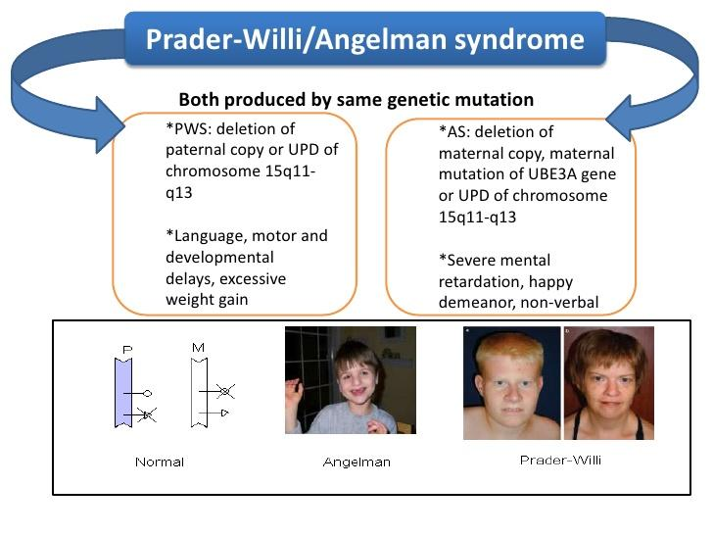

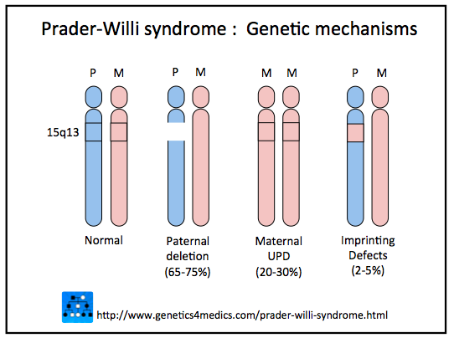

4.1.2. Duplications

During duplication a chromosomal segment is duplicated. It's either a replication error or due to meiotic unequal crossing over. In both cases the repetitive sequences occurring in the affected region may explain the "slipping" of the replication apparatus or the non-exact pairing of the non-homologous chromosomes (skipping). Like deletions, duplications are also used to identify the chromosomal location of a gene or group of genes, so to map a gene.

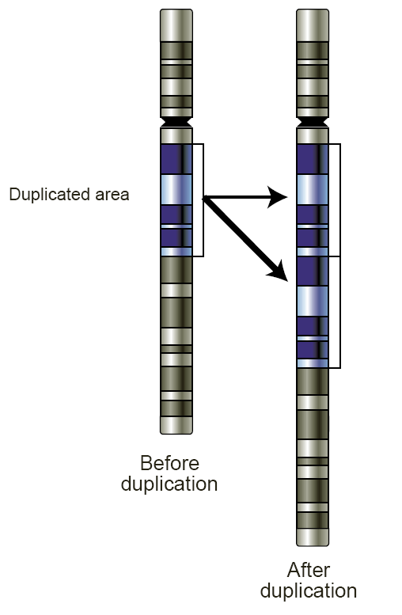

4.1.3. Translocations
For the formation of translocations more than one, usually 2 or 3 breaks are needed. The broken part /s are transferred to another chromosome. Depending on the origin of the broken piece or on the number of fragments translocated there are different sub-groups of the translocations.

4.1.3.1. Reciprocal translocations
At least two breakpoints are expected in the reciprocal translocations, which may be in two homologous chromosomes or in two completely different non-homologous ones. The broken fragments of chromosomes are exchanged then join to a new location. As a result, two chromosomes of altered structure are created. However, this does not cause phenotypic changes, i.e. symptoms or disease in most cases. This is the case of balanced translocation. This phenomenon can be explained by just changing the position of the affected genes, not the genes themselves. Breakpoints are usually in non-coding regions,

as the proportion of the coding regions of the human genome is <3%. In cases where the breakpoint is within a gene, following the translocation the gene itself is affected, so the abnormal product - with different function, activity or amount, or perhaps unable to function - is responsible for the appearance of pathological traits, e.g. tumor
formation.
The best example of reciprocal translocations leading to the formation of the Philadelphia chromosome (Ph1), is between 9 and 22 chromosomes, its cytogenetic abbreviation is t(9;22)(q34;11). This translocation occurs in chronic myeloid (CML) or acute lymphocytic leukemia (ALL). The breakpoint in chromosome 22 is in the BCR (breakpoint cluster region) gene, while the breakpoint of chromosome 9 affects in the ABL (Abelson murine leukemia)
proto-oncogene. Since the ABL gene encodes a tyrosine kinase as the result of the
translocation a bcr / abl fusion protein is produced which not only has a greater molecular
weight than the original enzyme, but also a higher activity. In fact, during this translocation
the well-regulated promoter of ABL gene is lost, and the gene permanently overexpressed.
Finally this leads to uncontrolled cell proliferation, i.e. the development of the tumor

. 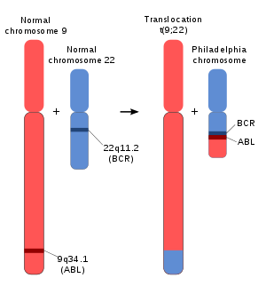
Schematic of the Philadelphia chromosome formation

regulation of independent production (CML) is responsible for tumor formation.
If three instead of two breakpoints occur, insertional translocation or insertion takes place. Then one piece of the broken chromosome (2 breaks) is incorporated, inserted to the other chromosome (one break).
Since human chromosome set consists of 46 chromosomes, and any piece of any of these chromosomes may change places, so it is obvious that the number of translocations is almost infinite.

The special case of translocations is the Robertson's translocation or centric fusion
(Figure 4.2). In these structural chromosomal abnormalities only acrocentric chromosomes can be involved so in humans only one of the 13, the 14, the 15, the 21 and the 22 chromosomes. Not only the types of chromosomes involved, but at the breakpoints are strictly determined: a break is always in the centromere or near to centromere. In this way abnormal - fusion - chromosomes can be formed, one of which initially can contain two centromeres (dicentric), but ultimately only one centromere remains active, the other is without a centromere, therefore it is lost during the subsequent divisions and thus the number of chromosomes is reduced .

If the break is exactly in the centromere, a two centromeric, although rearranged chromosome is formed. As the result of the rearrangement from the initial acrocentrics two different sized, a larger and a smaller metacentric or submetacentric chromosome is created. The small submetacentric containing NOR (nucleolar organizer) regions on both arms is lost during successive divisions.
However, since there are 10 NOR regions in the human genome, on the short arms of the acrocentric chromosomes therefore any loss of two does not lead to phenotypic change, that is, the centric fusion is balanced.

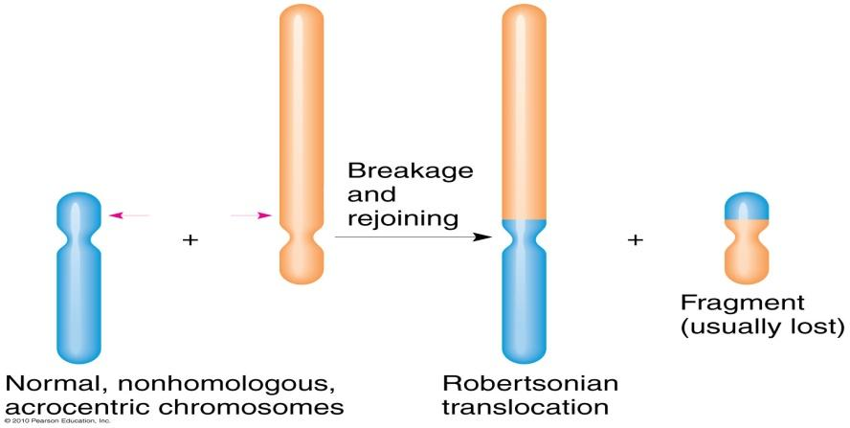

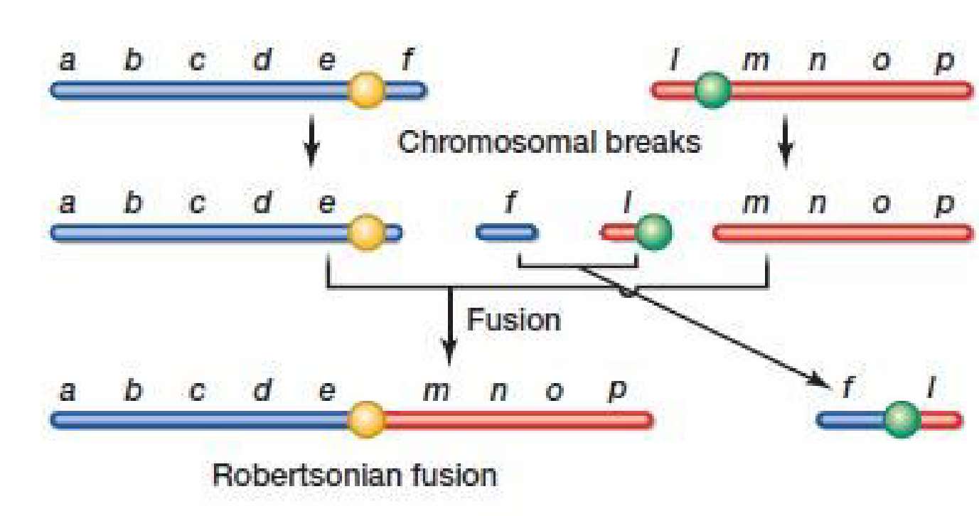

Figure 4.2. Robertsonian translocation or centric fusion

The centric fusion not only results in an abnormal chromosome structure, but the chromosome number is reduced from 46 to 45.

4.1.4. Inversions
The inversion is a structural chromosome aberration in which the same chromosome breaks twice and the fragment between the breakpoints turns 180 degrees. There are two types:

1 / pericentric
2 / paracentric inversion

1 / In pericentric inversion the chromosome breakages are on both arms, that is on both sides of the centromere. The pericentric inversion of chromosome 9 is relatively common and found frequently in couples with recurrent abortions.

2 / In paracentric inversion breakpoints are on the same arm of the chromosome, thus in the
turn of the fragment the centromere is not involved.
For both the para- as well as the pericentric inversion is true that the breakpoints are normally
in non-coding regions, so the carriers have normal phenotype.

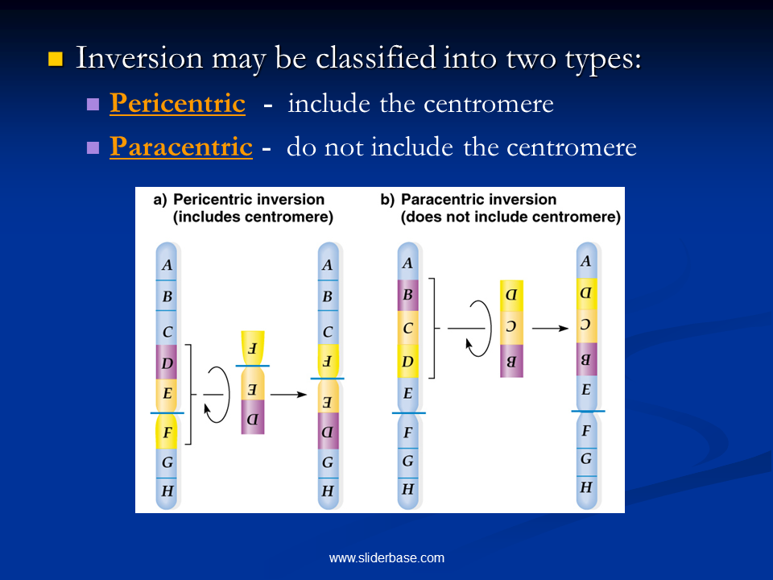
4.1.5. Ring (ring) chromosome
In this case, there are breaks on both arms of the chromosome - usually near the telomeres - then broken ends fold and a ring chromosome is formed. The fragments broken are lost during successive divisions, so the information encoded by their genes as well. The carriers depending on the chromosome involved and the size of the region lost are more or less severely affected. The somatic retardation - a physical developmental retardation - can be

explained by the fact that the DNA replication of the ring chromosome is often erroneous: devil ring, giant ring (due to duplication), rearranged (recombinant) chromosome, or even two ring chromosomes within a cell, i.e. change in chromosome number will be the end result.

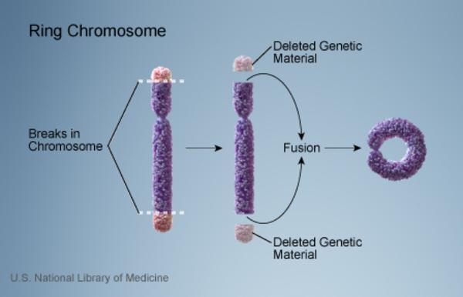

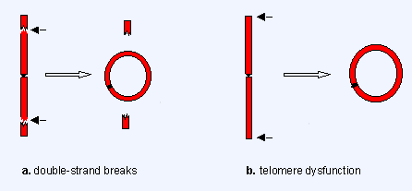

4.1.6. Isochromosome
The isochromosome is an abnormal chromosome containing the same genes on both arms. Upon formation the sister chromatids are not separated parallel to the long axis of the chromosome, and migrate towards the poles of the cell, but the plane of their separation is perpendicular to the longitudinal axis.
Thus aberrant chromosomes ultimately cells containing them are formed which contain either the short arm or the long arm specific information only on both arms and the information of the other arm is lost Since a chromosome arm is rich in many genes, so the surplus or the lack of these lead to severe, often lethal consequences

