Lec(2) Advanced Serology
Prof.Dr.Ekhlass Noori Ali
Antibody function
Immune Complexes
The non covalent combination of antigen with its respective specific antibody is called an immune complex. An immune complex may be of the small (soluble) or large (precipitating)type, depending on the nature and proportion of antigen and antibody. Under conditions of antigen or antibody excess, soluble complexes tend to predominate. If equivalent amounts of antigen and antibody are present, a precipitate may form .However, all antigen-antibody complexes will not precipitate, even at equivalence .Antibody can react with antigen that is fixed or localized in tissues or that is released or present in the circulation. Once formed in the circulation, the immune complex is usually removed by phagocytic cells through the interaction of the Fc portion of the antibody with complement and cell surface receptors. Under normal circumstances, this process does not lead to pathologic consequences and it may be viewed as a major host defense against the invasion of foreign antigens. It is only in unusual circumstances that the immune complex persists as a soluble complex in the circulation, escapes phagocytosis, and is deposited in endothelial or vascular structures—where it causes inflammatory damage, the principal characteristic of immune complex disease—or in organs (e.g., kidney), or inhibits useful immunity (e.g., tumors, parasites). The level of circulating immune complex is determined by the rate of formation, rate of clearance and, most importantly, nature of the complex formed. Detection of immune complexes and identification of the associated antigens are important to the clinical diagnosis of immune complex disorders.

MOLECULAR BASIS OF ANTIGEN-ANTIBODY REACTIONS
The basic Y-shaped Ig molecule is a bi functional structure. The V regions are primarily concerned with antigen binding. When an antigenic determinant and its specific antibody combine, they interact through the chemical groups found on the surface of the antigenic determinant and on the surface of the hype rvariable rgions of the Ig molecule. Although the C regions do not form antigen-binding sites, the arrangement of the C regions and hinge region give the molecule segmental flexibility, which allows it to combine with separated antigenic determinants.
Types of Bonding
Bonding of an antigen to an antibody results from the formation of multiple, reversible, intermolecular attractions between an antigen and amino acids of the binding site. These forces require proximity of the interacting groups. The optimum distance separating the interacting groups varies for different types of bond; however, all these bonds act only across a very short distance and weaken rapidly as that distance increases.
The bonding of antigen to antibody is exclusively non covalent. The attractive force of non covalent bonds is weak compared with that of covalent bonds, but the formation of multiple non covalent bonds produces considerable total binding energy. The strength of a single antigen-antibody bond (antibody affinity) is produced by the summation of the attractive and repulsive forces. The four types of non covalent bonds involved in antigen-antibody reactions are hydrophobic bonds, hydrogenbonds, van der Waals forces, and electrostatic forces.
1-Hydrophobic Bonds
The major bonds formed between antigens and antibodies are hydrophobic. Many of the nonpolar side chains of proteins are hydrophobic. When antigen and antibody molecules come together, these side chains interact and exclude water molecules from the area of the interaction. The exclusion of water frees some of the constraints imposed by the proteins, which results
in a gain in energy and forms an energetically stable complex.
2-Hydrogen Bonds
Hydrogen bonding results from the formation of hydrogen bridges between appropriate atoms. Major hydrogen bonds in antigen-antibody interactions are O––O, N–H–N, and O–H–N.
3-Van der Waals Forces
Van der Waals forces are nonspecific attractive forces generated by the interaction between electron clouds and hydrophobic bonds. These bonds result from minor asymmetry in the charge of an atom caused by the position of its electrons. They rely on the association of nonpolar hydrophobic groups so that contact
with water molecules is minimized. Although extremely weak,van der Waals orces may become collectively important in an
antigen-antibody reaction.
4-Electrostatic Forces
Electrostatic forces result from the attraction of oppositely charged amino acids located on the side chains of two amino acid residues. The relative importance of electrostatic bonds is unclear
Goodness of Fit:
The strongest bonding develops when antigens and antibodies are close to each other and when the shapes of the antigenic determinants and the antigen-binding site conform to each other. This complementary matching of determinants and
binding sites is referred to as goodness of fit (Fig1).A good fit will create ample opportunities for the simultaneous formation of several noncovalent bonds and few opportunities for disruption of the bond. If a poor fit exists, repulsive forces can overpower any small forces of attraction. Variations from the ideal complementary shape will produce a decrease in the total binding energy because of increased repulsive forces and decreased attractive forces. Goodness of fit is important in
determining the binding of an antibody molecule for a particular
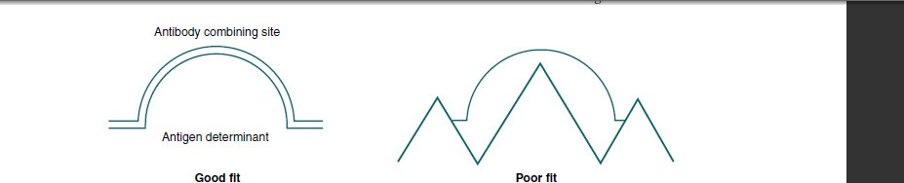
Fig1: Goodness of fit.:
Detection of Antigen-Antibody Reactions
In vitro tests detect the combination of antigens and antibodies.Agglutination is the process whereby particulate antigens (e.g.,cells) aggregate to form larger omplexes in the presence of aspecific antibody. Agglutination tests are widely used in immunology detect and measure the consequences of antigen antibody interaction. Other tests include the following:
1• Precipitation reactions combine soluble antigen with soluble antibody to produce insoluble complexes that are visible.
2• Hemolysis testing involves the reaction of antigen and antibody with a cellular indicator (e.g., lysed RBCs).
3• The enzyme-linked immunosorbent assay (ELISA)
measures immune complexes formed in an in vitro system. Detection and quantitation of immunoglobulins is important in the laboratory investigation of infectious diseases and immunologic disorders (Table 1).

Table 1:Role of Specific Immunoglobulins in Diagnostic Tests
IgG IgM IgA
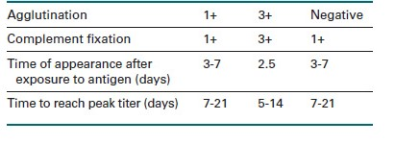
Influence of Antibody Types on Agglutination
Immunoglobulins are relatively positively charged and, after sensitization or coating of particles, they reduce the zeta potential, which is the difference in electrostatic potential between the net charge at the cell membrane and the charge at the surface of shear (Fig. 1). Antibodies can bridge charged particles by extending beyond the effective range of the zeta potential, which results in the erythrocytes closely approaching each other, binding, and agglutinating.
Antibodies differ in their ability to agglutinate. IgM-type antibodies, sometimes referred to as complete antibodies, are more efficient than IgG or IgA antibodies in exhibiting in vitro agglutination when the antigen-bearing erythrocytes are suspended in physiologic saline (0.9% sodium chloride solution).Antibodies that do not exhibit visible agglutination of saline suspended erythrocytes, even when bound to the cell’s surface membrane, are considered to be non agglutinating antibodies and have been called incomplete antibodies. Incomplete antibodies
may fail to exhibit agglutination because the antigenic determinants are located deep within the surface membrane or may show restricted movement in their hinge region, causing them to be functionally monovalent
Antibody Type. Immunoglobulin M (IgM) antibodies are more efficient at agglutination because their large size and multivalency permit more effective bridging of the space between cells caused by zeta potential. IgG antibodies are too
small to overcome electrostatic forces between cells. The use of AHG forms cross-links between antibody molecules that have bound to the surface of RBCs. This promotes this formation of agglutination and allows for visual observation of an antigen antibody reaction.
Antigen-Antibody Ratio. Under conditions of antibody excess, there is a surplus of molecular antigen-combining sites not bound to antigenic determinants. Precipitation reactions depend on a zone of equivalence, the zone in which optimum precipitation occurs, because the number of multivalent sites
of antigens and antibodies are approximately equal. For a precipitation reaction to be detectable, the reaction must occur in the zone of equivalence. In this zone, each antibody or antigen excess antigen and no lattice formation is established. Excess
antigen can block the presence of a small amount of antibody. To correct the post zone phenomenon, a repeat blood specimen should be collected 1 or more weeks later. If an active antibody reaction is occurring in vivo, the titer of antibody will increase and should be detectable. Repeated negative results generally suggest that the patient has the specific antibody being tested
for by the procedure.
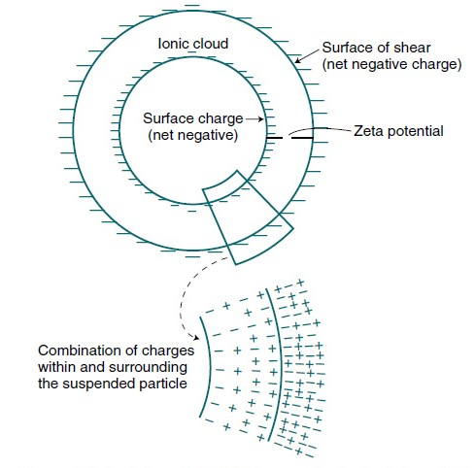
Fig2: Zeta potential. Difference in electrostatic potential between net charge at cell membrane and charge at surface of shear.

Table: Techniques to Reduce Zeta Potential

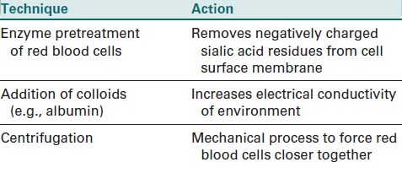
Law of Mass Action
All antigen–antibody binding is reversible and is governed by the law of mass action. This law states that free reactants are in equilibrium with bound reactants. The equilibrium constant represents the difference in the rates
of the forward and reverse reactions according to the
following equation:

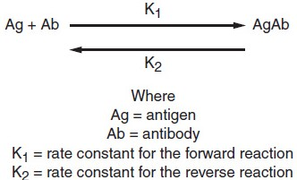
2.The equilibrium constant is thus
K _ K1/K2 _ [AgAb]/[Ab][Ag],
where [AgAb] _ concentration of the antigen–antibody complex (mol/L)
[Ab] _ concentration of antibody (mol/L)
[Ag] _ concentration of antigen (mol/L)
This constant can be seen as a measure of the goodness of fit.
3 Its value depends on the strength of binding between antibody and antigen. As the strength of binding, or avidity, increases, the tendency of the antigen–antibody complexes to dissociate decreases, and the value of K2 decreases.This increases the value of K1. The higher the value of K,the larger the amount of antigen–antibody complex and the more visible or easily detectable the reaction is. The ideal conditions in the clinical laboratory would be to have an antibody
with a high affinity, or initial force of attraction, and ahigh avidity, or strength of binding. The higher the values are for both of these and the more antigen–antibody complexes that are formed, the more sensitive the test will be.
PRECIPITATION CURVE
Zone of Equivalence
In addition to the affinity and avidity of the antibody involved, precipitation depends on the relative proportions of antigen and antibody present. Optimum precipitation occurs in the zone of equivalence, in which the number of
multivalent sites of antigen and antibody are approximately equal. In this zone, precipitation is the result of random,reversible reactions whereby each antibody binds to more than one antigen and vice versa, forming a stable net workor lattice.
4 The lattice hypothesis, as formulated by Marrack,is based on the assumptions that each antibody molecule must have at least two binding sites, and antigen must be multivalent. As they combine, this results in a multi molecular lattice that increases in size until it precipitates out of solution. Heidelberger and Kendall performed the classic quantitative precipitation reactions that established proof
for this theoryAs illustrated by the precipitin curve shown in Figure 3when increasing amounts of soluble antigen are added to fixed amounts of specific antibody, the amount of precipitation increases up to the zone of equivalence. Then when the amount of antigen overwhelms the number of antibody combining
sites present, precipitation begins to decline.Prozone and Postzone As can be seen on the precipitation curve, precipitation declines on either side of the equivalence zone due to an excess of either antigen or antibody. In the case of antibody
excess, the prozone phenomenon occurs, in which antigen combines with only one or two antibody molecules,and no cross-linkages are formed. This is because usuallyonly one site on an antibody molecule is used, and manyfree antibody molecules remain in solution.At the other side of the zone, where there is antigen
excess, the postzone phenomenon occurs, in which small aggregates are surrounded by excess antigen, and again no lattice network is formed.1 In this case, every available antibody site is bound to a single antigen, and no cross-links are formed.
4 Thus, for precipitation reactions to be detectable,they must be run in the zone of equivalence.The prozone and postzone phenomena must be considered in the clinical setting, because negative reactions occur in both. A false-negative reaction may take place in the prozone due to high antibody concentration. If it is suspected
that the reaction is a false negative, diluting out antibody and performing the test again may produce a positive result .In the post zone, excess antigen may obscure the presence of a small amount of antibody. Typically, such a test is repeated with an additional patient specimen taken about a week later. This would give time for the further production of antibody. If the test is negative on this occasion, it is
unlikely that the patient has that particular antibody.

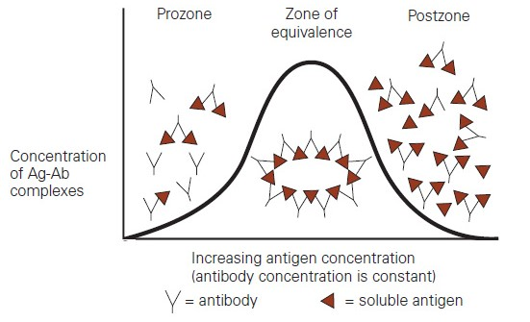
Fig3: Precipitin curve. The precipitin curve shows how the amount of precipitation varies with varying antigen concentration when the antibody concentration is kept constant. Excess antibody is called the prozone, and excess antigen concentration is called the postzone.
Serum protein electrophoresis Serum Protein Electrophoresis
Principle:
Serum protein electrophoresis is used to separate and quantitate serum proteins based on electrophoretic mobility on cellulose acetate .Proteins are large molecules composed of amino acids. Depending on electron distributions resulting from covalent or ionic bonding of structural subgroups, proteins have different electrical charges at a given pH. Based on electrical charge ,serum proteins can be ractionated into five fractions:
albumin,alpha-1 (α1), alpha-2 (α2), beta (β), and gamma (γ) proteins.
For the following method, the pH is 8.8. After the proteins are separated, the plate is placed in a solution of sulfosalicylic acid and Ponceau S to stain the protein bands. The intensity of the stain for each band is related to protein concentration.

