Lec(6) Advanced Serology
Prof. Dr.Ekhlass N. Ali
CHARACTERISTICS OF LABELED ASSAYS
The need to develop rapid, specific, and sensitive assays to determine the presence of important biologically active moleculesus hered in a new era of testing in the clinical laboratory. Labeled immunoassays are designed for antigens and antibodies that may be small in size or present in very low concentrations. The presence of such antigens or antibodies is determined indirectly by using a labeled reactant to detect whether or not specific binding has taken place.The substance to be measured is known as the analyte.Examples include bacterial antigens, hormones, drugs,tumor markers, specific immunoglobulins, and many other
substances. Analytes are bound by molecules that react specifically with them. Typically, this is antibody. One reactant,either the antigen or the antibody, is labeled with a marker so that the amount of binding can be monitored.Labeled immunoassays have made possible rapid quantitative measurement of many important entities such as viral antigens in patients infected with HIV. This ability to detect very small quantities of antigen or antibody has revolutionized the diagnosis and monitoring of numerous diseases and has led to more prompt treatment for many such conditions.
Competitive versus Noncompetitive Assays
Current techniques include the use of fluorescent, radioactive,chemiluminescent, and enzyme labels. The underlying principles of all these techniques are essentially the same.There are two major formats for all labeled assays: competitive
and noncompetitive. In a competitive immunoassay,
all the reactants are mixed together simultaneously, and labeled antigen competes with unlabeled patient antigen for a limited number of antibody-binding sites. The amount of bound label is inversely proportional to the concentration of the labeled antigen. This means that the more label detected, the less there is of patient antigen.
In a typical noncompetitive immunoassay, antibody,often called capture antibody, is first passively absorbed to a solid phase. Unknown patient antigen is then allowed to react with and be captured by the antibody. After washing to remove unbound antigen, a second antibody with a label is added to the reaction. In this case, the amount of label measured is directly proportional to the amount of patient antigen.In both types of assays, the label must not alter the reactivity of the molecule, and it should remain stable for the shelf life of the reagent. radioactivity, enzymes, fluorescent compounds, and chemiluminescent substances have all been
used as labels.
Antibodies
In any assay, it is essential for the antibody used to have a high affinity for the antigen , affinity is the strength of the primary interaction between a single antibody-combining site and an antigenic determinant or epitope. In competitive binding assays, there is random interaction between individual antigen and antibody molecules. Therefore, the higher the affinity of antibody for antigen, the larger the amount of antigen bound to antibody and the more accurately specific binding can be measured. The ultimate sensitivity of the immunoassay, in fact, depends largely on the magnitude of affinity.
The antibody used should also be very specific for the antigen involved in the reaction. The discovery of monoclonal antibodies has made available a constant source of highly specific antibody that has increased the ability to detect small amounts of analyte with great accuracy.
Standards or Calibrators
Standards, also known as calibrators, are unlabeled analytes that are made up in known concentrations of the substance to be measured. They are used to establish a relationship between the labeled analyte measured and any unlabeled analyte that might be present in patient specimens.
Differing amounts of standards are added to antibody–antigen mixtures to ascertain their effect on binding of the labeled reagent. Most instruments then extrapolate this information and do a best-fit curve (one that is not absolutely linear) to determine the concentration of the unknown analyte.
Separation Methods
In most assays, once the reaction between antigen and antibody has taken place, there must be a partitioning step, or a way of separating reacted from unreacted analyte.Currently, most immunoassays use a solid-phase vehicle for separation. Numerous materials, such as polystyrene test tubes, micro titer plates, glass or polystyrene beads, magnetic beads, and cellulose membranes, have been used for
this purpose. Antigen or antibody is attached by physical adsorption, and when specific binding takes place, complexes remain attached to the solid phase. This provides a simple way to separate bound and free reactants .If a separation step is employed in an assay, the efficiency of the separation is critical to the accuracy of the results.
The bound and unbound fractions are usually separated by physical means, including decanting, centrifugation, or filtration.This is followed by a washing step to remove any remaining unbound analyte. Great care must be taken to perform this correctly, because incomplete washing leads to incomplete removal of the labeled analyte and inaccurate results.
Detection of the Label
The last step common to all immunoassays is detection of the labeled analyte. For radio immunoassays, this involves a system for counting radioactivity, while for other labels such as enzymes, fluorescence, or chemiluminescence, typically
a change in absorbance in a substrate is measured by spectrophotometry.
All systems must use stringent quality controls.
Quality Control
When measuring analytes that are present in very limited quantities, it is essential to establish quality-control procedures .Because the goal of testing is to determine whether patient levels are increased or decreased over normal values, test performance must be monitored to limit random errors. One means of doing this is to run a blank tube, usually phosphate-buffered saline, with every test. This is not
expected to have any detectable label but serves as a check for nonspecific adsorption and for inadequate washing between steps. Any readings indicative of label in the blank are known as background. If the background is too high, wash
steps need to be made more efficient.A negative control and a high and a low positive control should be run in addition. This serves as a check on the quality
of the reagents to make sure the label is readily detectable
under current testing conditions. All controls and the patient sample are usually run in duplicate. If any controls are out of range, test values should not be reported. Automated procedures have cut down on many performance variables.
Individual testing procedures are now considered in the following sections.
RADIOIMMUNOASSAY
Competitive Binding Assays
The first type of immunoassay developed was radioimmunoassay (RIA), pioneered by Yalow and Berson in the late 1950s. It was used to determine the level of insulin–anti-insulin complexes in diabetic patients.
radioactive substance is used as a label. Radioactive elements have nuclei that decay spontaneously, emitting matter and energy. Several radioactive labels, including 131I; 125I; and triturated hydrogen, or 3H, have been used, but 125I is the most popular. It has a half-life of 60 days, and because it has a higher counting rate than that of 3H, the total counting time is less. It is easily incorporated into protein molecules, and it emits gamma radiation, which is detected by a gamma counter. Very low quantities of radioactivity can be easily measured.
RIA was originally based on the principle of competitive binding. Thus, the analyte being detected competes with a radiolabeled analyte for a limited number of binding sites on a high-affinity antibody. The concentration of the radioactive
analyte is in excess, so all binding sites on antibody will be occupied. If patient antigen is present, some of the binding sites will be filled with unlabeled analyte, thus decreasing the amount of bound radioactive label (Fig. 1). When bound
and free radiolabeled antigens are separated and a washing step has occurred, the amount of label in the bound phase is indirectly proportional to the amount of patient antigen present. This can be illustrated by the following equation:
6Ag* _ 2Ag _ 4Ab → 3Ag*Ab _ 1AgAb _ 3Ag* _ 1Ag
In this example, labeled and unlabeled antigens occur in a 3:1 ratio. Binding to a limited number of antibody sites will take place in the same ratio. Thus, on the right side of the equation, three of the four binding sites are occupied
by labeled antigen, while one site is filled by un labeled antigen. As the amount of patient antigen increases, fewer binding sites will be occupied by labeled antigen, as demonstrated by the next equation:
6Ag* _ 18Ag _ 4Ab → 1Ag*Ab _ 3AgAb _ 5Ag*_ 15Ag
In this case, the ratio of labeled to unlabeled antigen is 1:3. Binding to antibody sites takes place in the same ratio,and the amount of bound label is greatly decreased in comparison to the first equation. In this type of RIA, use of a
constant amount of radiolabeled antigen with standards of known concentration will result in a standard curve that can be used to extrapolate the concentration of the unknown patient antigen. The detection limits of competitive assays are largely determined by the affinity of the antibody. These limits have been calculated to be as low as 10 fmol/L, or 600,000 molecules in a sample volume of 100 L.1
Advantages and Disadvantages of Radioimmunoassay
Examples of substances that are measured by RIA include thyroid-stimulating hormone and total serum IgE.
RIA is an extremely sensitive and precise technique for determining trace amounts of analytes that are small in size.However, chief among the disadvantages of all RIA techniques is the health hazard involved in working with radioactive substances. Laboratories have found it more and more difficult and expensive to maintain a license and to comply with federal regulations. In addition, disposal problems, short shelf life, and the need for expensive equipment has caused laboratorians to explore other techniques for identifying analytes in low concentration.
Enzyme immunoassays have largely replaced RIA because of their comparable sensitivity and the availability of automated instrumentation that allows for processing of a large number of samples in less time.
ENZYME IMMUNOASSAY
Enzymes are naturally occurring molecules that catalyze certain biochemical reactions. They react with suitable substrates to produce breakdown products that may be chromogenic, fluorogenic, or luminescent. Some type of spectroscopy can then be used to measure the changes involved. As labels for immunoassay, they are cheap and readily available, have a long shelf life, are easily adapted to automation, and cause changes that can be measured using inexpensive equipment. Sensitivity can be achieved without disposal problems or the health hazards of radiation.Because one molecule of enzyme can generate many molecules
of product, little reagent is necessary to produce high sensitivity. Enzyme labels can either be used qualitatively to determine the presence of an antigen or antibody or quantitatively to determine the actual concentration of an analyte in an unknown specimen. Assays based on the use of enzymes can be found in such diverse settings as clinical laboratories, doctors’ offices, and at-home testing.
Enzymes used as labels for immunoassay are typically chosen according to the number of substrate molecules converted per molecule of enzyme, ease and speed of detection ,and stability. In addition, availability and cost of enzyme
and substrate play a role in the choice of a particular enzyme as reagent. Typical enzymes that have been used as labels in colorimetric reactions include 1-horseradish peroxidase2-,glucose-6-phosphate dehydrogenase,3- alkaline phosphatase,and 4-↓-D-galactosidase5-.1,4 Alkaline phosphatase and horseradish peroxidase have the highest turnover (conversion of substrate) rates, high sensitivity, and are easy to detect, so they are most often used in such assays.Enzyme assays are classified as either heterogeneous or homogeneous on the basis of whether a separation step is necessary.
Heterogeneous enzyme immunoassays require a
step to physically separate free from bound analyte. In homogeneous immunoassays, on the other hand, no separation step is necessary, because enzyme activity diminishes when binding of antibody and antigen occurs. The principles under lying .
Heterogeneous Enzyme Immunoassay
Competitive EIA
The first enzyme immunoassays (EIAs) were competitive assays based on the principles of RIA. Enzyme-labeled antigen competes with unlabeled patient antigen for a limited number of binding sites on antibody molecules that are
attached to a solid phase. After carefully washing to remove any nonspecifically bound antigen, enzyme activity is determined. Enzyme activity is inversely proportional to the concentration of the test substance, meaning that the more
patient antigen is bound, the less enzyme-labeled antigen can attach. In this manner, a sensitivity of nan ograms(10-9 g)/mL can be achieved. This method is typically used for measuring small antigens that are relatively pure, such as insulin and estrogen.
Noncompetitive EIA
Although competitive tests have a high specificity, the tendency in the laboratory today is toward the use of noncompetitive assays, because they have a higher sensitivity.1 Many such assays are capable of detecting concentrations
of less than 1 pg/mL, achieving a sensitivity actually higher than most RIAs.3 Noncompetitive assays are often referred
to as indirect enzyme-linked immune sorbent assays
(ELISA), because the enzyme-labeled reagent does not participate in the initial antigen–antibody binding reaction. This type of assay is one of the most frequently used immunoassays in the clinical laboratory due to its sensitivity, specificity,
simplicity, and low cost. Either antigen or antibody maybe bound to solid phase. A variety of solid-phase supports are used, including micro titer plates, nitrocellulose membranes ,and magnetic latex beads. When antigen is bound to
solid phase, patient serum with unknown antibody is added and given time to react. After a wash step, an enzyme-labeled antiglobulin is added. This second antibody reacts with any patient antibody that is bound to solid phase. If no patient
antibody is bound to the solid phase, the second labeled antibody will not be bound. After a second wash step, the enzyme substrate is added. The amount of enzyme label detected is directly proportional to the amount of antibody in the specimen (Fig2).
This type of assay has been used to measure antibody production to infectious agents that are difficult to isolate in the laboratory and has been used for autoantibody testing. Viral infections especially are more easily diagnosed by this method than by other types of testing.1 This technique remains the preferred screening method for detecting antibody to HIV,hepatitis A, and hepatitis C. ELISA-based tests are also used to identify Epstein-Barr–specific antibodies produced. in infectious mononucleosis.
Capture Assays
If antibody is bound to the solid phase, these assays are often called sandwich immunoassays, or capture assays.Antigens captured in these assays must have multiple epitopes.Excess antibody attached to solid phase is allowed to combine with the test sample to capture any antigen present.After an appropriate incubation period, enzyme-labeled antibody is added. This second antibody recognizes a different epitope than the solid-phase antibody and completes the “sandwich.” Enzymatic activity is directly proportional to the amount of antigen in the test sample (Fig. 3). Capture assays are best suited to antigens that have multiple determinants, such as antibodies, polypeptide hormones,proteins, tumor markers, and microorganisms,especially viruses. When used with microorganisms, the epitope must be unique to the organism being tested, and it must be present in all strains of that organism. Use of monoclonal antibodies has made this a very sensitive test system. Rotavirus in stool and respiratory syncytial virus in respiratory tract secretions are two examples of capture assays. In addition, recently developed ELISAs have made it much easier to detect parasites such as Giardia lambli aand Cryptosporidium in the stool. Antigen-detection tests have also proved useful for identifying fungi such as Aspergillus, Candida, and Cryptococcus. Another major use of capture assays is in the measurement of immune globulins, especially those of certain classes. For instance, the presence of IgM can be specifically determined thus indicating an acute infection. Measurement of IgE, including allergen-specific IgE, which appears in minute quantities in serum, can also be accomplished with this system. When capture assays are used to measure immune globulins, the specific immunoglobulin class being detected is actually acting as antigen, and the antibody is antihuman immunoglobulin.
Indirect ELISA tests are more sensitive than their direct counterparts, because all patient antigen has a chance to participate in the reaction. However, there is more manipulation than in direct tests, because there are two incubations and two wash steps.
Heterogeneous enzyme assays, in general, achieve a sensitivity similar to that of RIA.1 In sandwich assays, capture antibody on solid phase must have both a high affinity and a high specificity for this test system to be effective. However, there may be problems with nonspecific protein binding or the presence of antibodies to various components of the testing system. If this is suspected, serum can be pretreated to avoid this problem. Sandwich assays are also subject to the hook effect, an unexpected fall in the amount of measured analyte when an extremely high concentration is present. This typically occurs in antigen excess, where the majority of binding sites are filled, and the remainder of patient antigen has no place to bind. If this condition is suspected, serum dilutions must be made and then retested.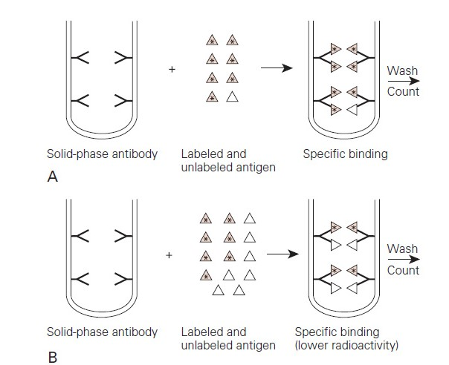
Fig1: Principle of RIA. Labeled antigen competes with patient antigen for a limited number of binding sites on solid-phase antibody. (A) Very little patient antigen is present, making radio activity of the solid phase high. (B) More patient antigen is present, and the radioactivity of the solid phase is reduced in proportion to the amount of patient antigen bound.

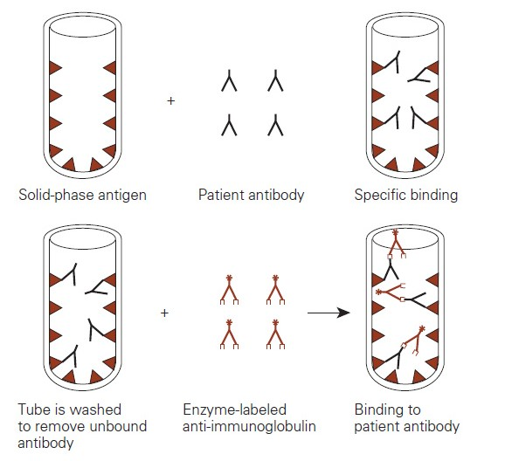
Fig2: Noncompetitive ELISA. Patient antibody is incubated with solid-phase antigen. After a wash step, enzyme-labeled anti immunoglobulin is added. This will bind to the patient antibody on solid phase. A second wash step is performed to remove any unbound anti-immunoglobulin, and substrate for the enzyme is added. Color development is directly proportional to the amount of patient antibody
present
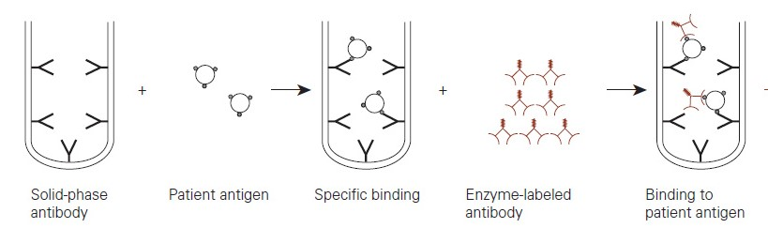
Fig3: Noncompetitive ELISA: sandwich technique with solid-phase antibody. Patient antigen is incubated with solid-phase antibody. After washing, enzyme-labeled immunoglobulin is added, which combines with additional determinant sites on the bound patient antigen. After a second wash step, substrate for the enzyme is added. Colordevelopment is directly proportional to the amount of patient antigen present.

