**Introduction to nanotechnology**

**Feynman’s speech**

The concept of nanotechnology is attributed to Nobel Prize winner Richard Feynman, who gave a very famous, visionary speech in 1959 (published in 1960) during one of his lectures, saying: “The principles of physics, as far as I can see, do not speak against the possibility of maneuvering things atom by atom”.

At the time, Feynman’s words were received as pure science fiction. Today, we have instruments that allow precisely what Feynman had predicted: creating structures by moving atoms individually.

The term Nanotechnology was first used in 1974 by Norio Taniguchi to refer to a precise and accurate tolerances required for machining and finishing.

In 1981 K. E. Drexler talked about molecular manipulation and molecular engineering.

**The nanometer scales**

The nanometer scale is conventionally defined as 1 to 100 nm.

One nanometer is one billionth of a meter (10-9 m).

The size range is normally set to a minimum of 1 nm to avoid single atoms or very small groups of atoms being designated as nano-objects**.**

Therefore, nanoscience and nanotechnologies deal with clusters of atoms of 1 nm in at least one dimension.

The upper limit is normally 100 nm, but this is a ‘fluid’ limit: often objects with greater dimensions (even 200 nm) are defined as nanomaterials.

A valid question a student might ask is ‘Why 100 nm and not 150 nm?’, or even ‘Why not 1 to 1 000 nm?’

The reason why the ‘1 to 100 nm range’ is approximate is that the definition itself focuses on the effect that the dimension has on a certain material — for example the uprising of a quantum phenomenon — rather than at what exact dimension this effect arises.

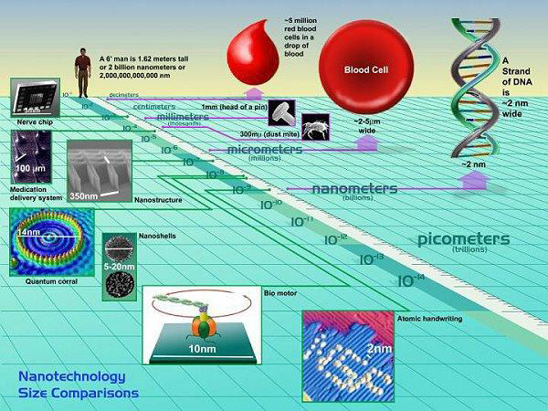

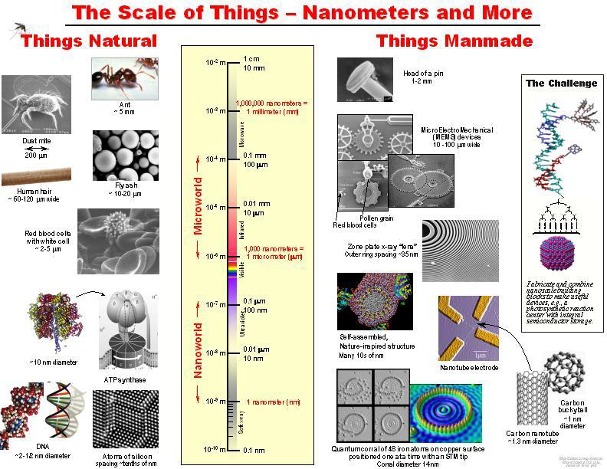

**Nanoscience**

The most common working definition of nanoscience is:

‘**Nanoscience** is the study of phenomena and manipulation of materials at atomic, molecular and macromolecular scales, where properties differ significantly from those at a larger scale’

**Bulk materials** (the ‘big’ pieces of materials we see around us) possess continuous (macroscopic) physical properties.

The same applies to micron-sized materials (e.g. a grain of sand).

But when particles assume nanoscale dimensions, the principles of classic physics are no longer capable of describing their behavior (movement, energy, etc.): at these dimensions, the principles of quantum mechanics principles.

The same material (e.g.gold) at the nanoscale can have properties (e.g.optical, mechanical and electrical) which are very different from (and even opposite to!) the properties the material has at the macroscale (bulk).

**Nanotechnologies are defined thus:**

‘Nanotechnologies are the design, characterisation, production and application of structures, devices and systems by controlling shape and size at the nanometre scale.

**Agglomerate:** Collection of weakly bound particles where the resulting external surface area is similar to the sum of the surface areas of the individual components. The forces are weak forces, for example van der Waals forces.

**Aggregate:** Particle comprising strongly bonded where the resulting external surface area significantly smaller than the sum of the individual components. The forces are strong forces, for example covalent bonds.

**What is a nanomaterial?**

A nanomaterial is an object that has at least one dimension in the nanometer scale (approximately 1 to 100 nm).

Nanomaterials are categorized according to their dimensions.

Nanomaterials can be of two types:

‘**non-intentionally-made nanomaterials’,** which refers to nano-sized particles or materials that belong naturally to the environment (e.g. proteins, viruses, nanoparticles produced during volcanic eruptions, etc.) or that are produced by human activity without intention (e.g. nano-particles produced from diesel combustion);

‘**intentionally-made’ nanomaterials,** which refers to nanomaterials produced deliberately through a defined fabrication process.



**What makes ‘nano’ special**

Nano’ means small, very small; But why is this special? There are various reasons why nanoscience and nanotechnologies are so promising in materials, engineering and related sciences.

First, at the nanometer scale, the properties of matter, such as energy, change.

This is a direct consequence of the small size of nanomaterials, physically explained as quantum effects.

The consequence is that a material (e.g. a metal) when in a nano-sized form can assume properties which are very different from those when the same material is in a bulk form.

For instance, bulk silver is non-toxic, whereas silver nanoparticles are capable of killing viruses upon contact.

Properties like electrical conductivity, color, strength and weight change when the nanoscale level is reached.

The second exceptional property of nanomaterials is that they can be fabricated atom by atom by a process called bottom-up.

Finally, nanomaterials have an increased surface-to-volume ratio compared to bulk materials.

This has important consequences for all those processes that occur at the surface of a material, such as catalysis and detection.

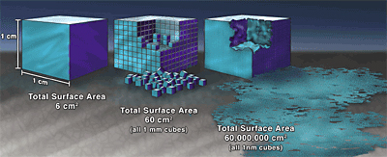

**What is a nanomaterial?**

A nanomaterial is an object that has at least one dimension in the nanometer scale (approximately 1 to 100 nm). Nanomaterial’s are categorized according to their dimensions. Nanomaterials can be of two types:

**1-‘non-intentionally-made nonmaterial’,**

which refers to nano-sized particles or materials that belong naturally to the environment.

**2-intentionally-made’ nanomaterials,**

which refers to nanomaterials produced by design through a defined fabrication process.

**Nanoscience in nature: a great starting point**

Even though nanoscience is often perceived as a science of the future, it is actually the basis for all systems in our living and mineral world. We see hundreds of examples of nanoscience right in front of our eyes every day — from geckos that can walk upside down on a ceiling, apparently against gravity, to butterflies with iridescent colors, to fireflies that glow at night.

In nature, we encounter some outstanding solutions to complex problems in the form of fine nanostructures with which precise functions are associated.

In recent years, researchers have had access to new analytical tools to see and study those structures and related functions in depth.

This has further stimulated research in the nanoscience area and has catalysed nanotechnologies. So, in a sense, natural nanoscience is the basis and inspiration for nanotechnologies.

Naturally occuring nanomaterials exist all around us, such as in smoke from fire, volcanic ash, and sea spray, etc.

Hemoglobin, the oxygen-transporting protein found in red blood cells, is 5.5 nanometers in diameter.

The structure viruses (capsid), the wax crystals covering a lotus leaf, spider-mite silk, and even our own bone matrix are all natural organic nanomaterials.

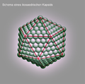

**Viral** [**capsid**](https://en.wikipedia.org/wiki/Capsid)  **Lotus effect", hydrophobic effect gecko's foot**

The field of materials engineering devoted to trying to fabricate artificial materials that mimic natural ones is conventionally called **biomimetics.**

**Nanoscience is a fundamental component of biomimetics.**

**Biomimetic material ………………………inspired from**

Polymers Substructure of nacre

Structural elements Wood, ligaments and bone

Electrical conduction Eels and nervous system

Photoemission Deep-sea fish and glow-worms

Photonic crystals Butterfly and bird wings

Hydrophobic surfaces Lotus leaves and human skin

Adhesives Geckos’ feet

High tensile strength fiber Spider silk

Artificial intelligence and computing Human brain

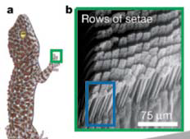

**Nano structures generations**

**First Generation: passive nanostructures** in coatings, nanoparticles, bulk materials (nanostructured metals, polymers, ceramics): **~ 2001 –**

**Second Generation: active nanostructures** such as transistors, amplifiers, adaptive structures: **~ 2005 –**

**Third Generation: 3D nanosystems** with heterogeneous nanocomponents and various assembling techniques **~ 2010-**

**Fourth Generation: molecular nanosystems** with heterogeneous molecules, based on biomimetics and new design **~ 2020 (?)**

**Risks of nanomaterial**

**Health Risks**

• Ultrafine particles can catalyze chemical reactions in the body.

• Carbon nanotubes can cause infections of lungs.

• They could easily cross the blood-brain barrier, a membrane that protects the brain from harmful chemicals in the bloodstream.

**Environmental Risks**

Air, water and soil pollution.

**Lab Safety**

**Personal Protective Equipment:**

Wear gloves, lab coats, safety goggles, long pants, closed-toe shoes, and face shields, as appropriate dependent on the nature of the materials and procedure.

***Selection of Nanomaterials:***

Whenever possible, handle nonmaterial in solutions or attached to substrates to minimize airborne release.

**Safety Equipment:**

Know the location and proper use of emergency equipment, such as safety showers, fire extinguishers, and fire alarms.

***Cleaning:***

Wet wipe and or HEPA-vacuum work surfaces regularly.

***Labeling :***

Store in a well-sealed container, preferable one that can be opened with minimal agitation of the contents.

Label all chemical containers with the identity of the contents (avoid abbreviations/ acronyms); include term "nano" in descriptor .

Use cautious judgment when leaving operations unattended.

***Transporting:***

Use sealed, double-contained container when transporting nonmaterial inside or outside of the building.

***Buddy System:***

Avoid working alone in the laboratory when performing high-risk operations.

***Hygiene:***

Do not consume or store food and beverages, or apply cosmetics.

Do not use mouth suction for pipetting.

Wash hands frequently to minimize potential nanoparticle exposure.

Remove gloves when leaving the lab., so as not to contaminate doorknobs.

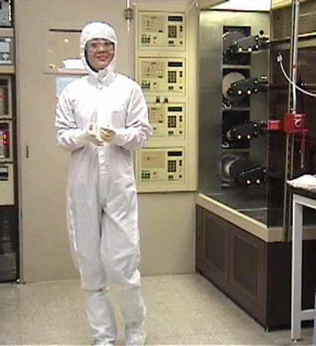

**References**

1- Nanotechnologies, Principles, Applications, Implications and Hands-on Activities .2013

2-An Introduction to Nanoscience and Nanotechnology. 2008

**3-**NANO: The Essentials Understanding Nanoscience and Nanotechnology. 2007