Laboratory of Analytical
Surface and level map analysis pressure in the upper atmosphere

(Second Semester)
ASD / 2nd Stage
2021 – 2022

Lecturers: L. Ruaamazin , L. Hasanmahmood, A.L. Yasaminqusay

Preparing by:L. Ruaa M. Ibraheem

Surface map analysis
The purpose of the experiment: Analyzing the surface air map and showing the atmospheric pressure distributions and determining the fronts, thus we can use the map to forecast the atmosphere.
The theoretical part : The surface map is one of the most important weather maps, as it gives a description of the weather elements over a large area and shows the distributions of atmospheric pressure and fronts, and it is drawn in globally agreed standard times (00,03,06,12,15,21GMT). Special symbols are used to denote the systems. The height of the air is symbolized by the letter (H) and the low (L), and the value of the atmospheric pressure is fixed on all lines.
After completing the surface mapping process (plotting), comes the analysis process, which is accomplished by the weather forecaster, where he passes isobars lines with appropriate intervals (2,4,8 mb) between stations of equal pressures using the Bayesbalot law, which It states (that if you put the wind behind your back, the areas of high pressure will be on the right and low pressure areas on the left). Surface maps are mapped on a large (synoptic) scale over several hundreds of kilometers so that pressure systems and regions are reasonably well located.
The practical part:
1- Examine the surface map before analyzing it for a short period by noting the atmospheric elements, especially the wind directions and the atmospheric pressure values, which are located in the upper right corner, where writing the value is abbreviated, as in the following example: 1024.5 245.
2-Start by drawing isobars with a pencil using the Bayesalot law at equal intervals (4mb), with an emphasis on the presence of the 1000mb line, and when all the pressure values ​​present are greater than 1000mb, it is considered the basis for the increase, i.e. the values ​​of the lines are as follows (1004,1008,1012 ,1016 etc).
3- The isobar lines never touch and never intersect and the pressure gradient must be taken into account.
4- Try to start by passing the lines from the densely populated areas in the air stations, because the line pattern will be clearer, which leads to the ease of drawing other lines that are smooth.
5- After completing each line, its pressure value is fixed, and upon completion of the drawing of all lines, mark the heights and depressions with the letters H, L, respectively.
6- Remember that it cannot exceed two separate heights or exceed two separate depressions. If this happens, there must be an error in drawing the lines.
Note: During the drawing process, it is necessary to take into account the effects of surface friction resulting from the surface terrain, as they are drawn at angles when the curved runoff depends on the intensity of the wind and the roughness of the surface. Over the seas and oceans, the angles range between (20-10) while between (45-25) over the land. Certainly, upon initial drawing, isobaric lines will appear irregular and zigzag, As in the figure below, so it is preferable to modify the zigzag lines so that they become smooth permanently.
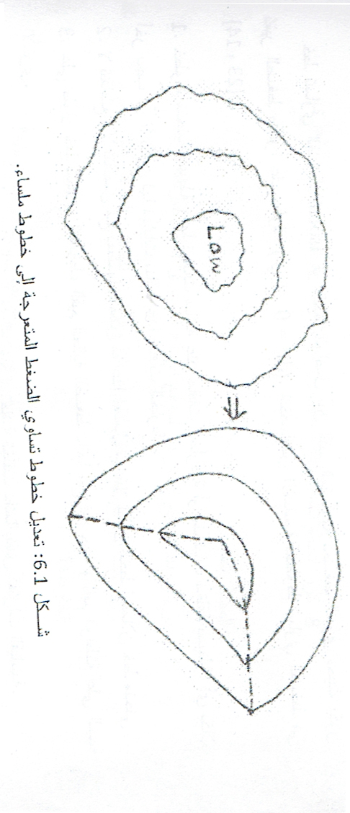

Discussion:
1- Explain the nature of the pressure systems you obtained and the nature of the current atmosphere in Iraq.
2- Why do the isobar lines approach each other in the region where there are high-speed winds? Is there an anaerobic equation that can be used to answer?
3- What is the difference that will appear when drawing isobar lines with intervals of 2mb?
4- Realistically, the isobar lines are not completely parallel to the wind direction on the surface map. Why?

