The Fourth Experiment
The Objective of the experiment:
Using the skew-T/log-P thermodynamic diagram to predict the relative humidity from Radiosonde Observation (RAOB).
Materials:
- Skew-T/log-P thermodynamic diagram.
- Upper air data for pressure, temperature and dew point as provided in table (1).
- A pencil.
- Graph paper.

Introduction:
As mentioned before in experiment (1), we can define Relative humidity as the ratio of the amount of water vapor actually in the air to the maximum amount of water vapor required for saturation at that particular temperature (and pressure), it is the ratio of the air’s water vapor content to its capacity, or it is the ratio between the mixing ratio and the saturation mixing ratio at the same temperature and pressure, and it is expressed as a percentage through following equation:
$$RH=\frac{w}{w_{s}}*100\%……(1)$$
The mixing ratio (w) is the ratio of the mass of water vapor (M_{v}) to the mass of dry air (M_{d}):
w = M_{v} / M_{d} ……. (2)
The mixing ratio is expressed in parts per thousand, usually grams of water vapor per kilogram of dry air.
The mixing ratio differs from the saturation mixing ratio in that it measures the actual amount of water vapor present, while the saturation mixing ratio measures the amount of water vapor that would be present at saturation.
The relative humidity must change according to the change in the amount of water vapor and temperature. Humidity changes inversely with the temperature so that the temperature decreases to make the value of the relative humidity 100%, then the air will be saturated and the temperature will reach the dew point.

In order to compute the relative humidity, we need first to determine the mixing ratio (w) and the saturation mixing ratio (w_{s}) as follows:
The Procedure:
- Create temperature and dewpoint curves on a skew-T as shown in experiment 3 according to the sounding data in Table (1) for Mafraq station/Jordan with the following information (Station: OJMF, Date: 00Z 24 MAR 2022, WMO ident: 40265, Latitude: 32.37, Longitude:36.25, Elevation: 687 m), enter the station index number (or location identifier), station name, time (UTC), and date in the identification box.
Pressure | Hight | Temp. | Dewpoint | Mixing Ratio  W | Saturation Mixing Ratio (W_{s}) | Relative Humidity
hPa | m | C | C | g/kg | g/kg | %
1000 | 153 | - | -
937 | 687 | 3.6 | 2.1
925 | 791 | 5.6 | -0.4
882 | 1179 | 4.2 | -4.8
874 | 1253 | 3.6 | -4.4
850 | 1478 | 1.8 | -6.2
828 | 1689 | 0 | -7
700 | 3006 | -11.3 | -13.3
627 | 3842 | -15.7 | -22.7
600 | 4172 | -18.1 | -28.1
550 | 4818 | -20.5 | -36.5
524 | 5176 | -21.3 | -50.3
500 | 5520 | -22.9 | -46.9
413 | 6895 | -33.5 | -53.5
400 | 7120 | -33.9 | -58.9
351 | 8023 | -39.1 | -74.1
300 | 9090 | -41.5 | -75.5
278 | 9609 | -41.5 | -75.5
265 | 9934 | -41.7 | -75.7
250 | 10330 | -41.9 | -75.9

- Using a pencil, find and make a point mark for the first dewpoint value at the corresponding pressure level on the Skew-T/log-P diagram.
- Find the mixing ratio for this point on a plotted sounding, read the value, either directly or by interpolation, the mixing-ratio value is where the dew point temperature line crosses the mixing ratio line.
- Using a pencil, find and make a point mark for the first temperature value at the corresponding pressure level on the Skew-T/log-P diagram.
- Find the saturation mixing ratio for this point on a plotted sounding, read the value, either directly or by interpolation, the saturation mixing-ratio value is where the temperature line crosses the mixing ratio line.
- Calculate the relative humidity using equation (1).
- Repeat the previous steps to the rest of the pressure levels. Record your results as in table (1).
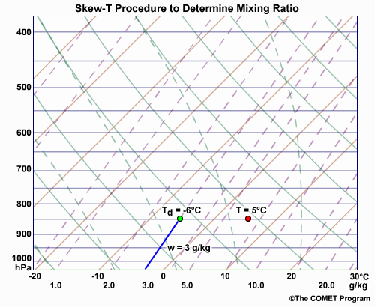
Examples:
To find the mixing ratio (w) for a given pressure on the plotted sounding, read the value, either directly or by interpolation, of the saturation mixing-ratio line that crosses the T_{d} curve at that pressure. In this example, a parcel of air at 850 hPa with a dewpoint of -6°C has a mixing ratio of 3 g/kg.
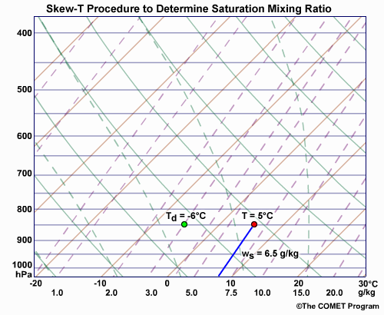
To find the saturation mixing ratio(w_{s}) for a given temperature and pressure on a plotted sounding, read the value, either directly or by interpolation, of the saturation mixing-ratio line that crosses the T curve at that pressure. In this example, a parcel of air at 850 hPa with a temperature of 5°C has a saturation mixing ratio of 6.5 g/kg.
Discussion:
1. Determine the type of relationship between temperature and relative humidity by plotting the values of temperature on the x-axis and relative humidity on the y-axis.
2. Determine the type of relationship between the dew point temperature and relative humidity by plotting the values of the dew point temperature on the x axis and the relative humidity values on the y axis.
3. Plot the vertical profile of relative humidity values with the pressure levels and discuss it.

