Lab (7)
Kingdom: Protista
Subkingdom: Protozoa
Phylum: Sarcomastigophora
Class: Ampicomplexa (sporozoa)
Order: Eucoccidia
Genus: 1-Toxoplasma gondii
2- Cryptosporidium parvum
3- Isospora belli

1-Toxoplasma gondii
Disease name: Toxoplasmosis
Site of infection: brain, eye, skeletal muscle, neural tissue
Definitive host: Cats
Morphology:
1-Tachyzoite: pear shaped organisms
2- Bradyzoites
3- Oocysts: contain 4sporozoites (infective stage)

Life cycle:
Infection occur by ingestion of Oocyst from contaminated hands or food, sporozoites released from oocyst in the small intestine penetrate the intestinal mucosa and find their way into macrophages where they divide very rapidly (hence the name tachyzoites) and form a cyst which may occupy the whole cell. The infected cell burst and release the tachyzoites to enter muscle and nerve cells where they are protected from the host immune system and multiply slowly (bradyzoites).these cysts are infectious to carnivores (including man).cats get infected by ingestion of cysts in flesh. Decystation occurs in the small intestine the organisim penetrates the submucosal epithelial cell where they undergo mitosis, resulting micro (male) and macro (female) gametocytes. Fertilized macro-gametocytes develop into Oocyst that are discharged into the gut lumen and excreted.
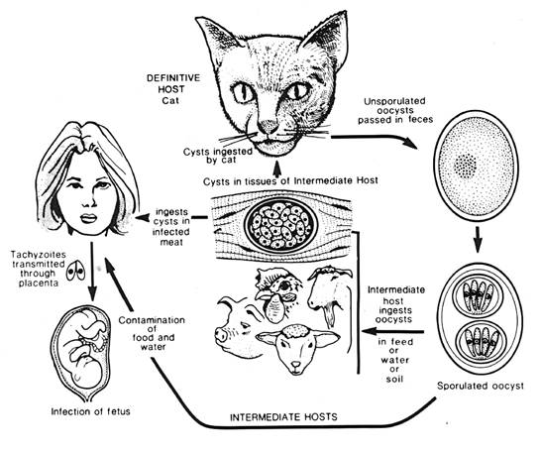
Symptoms
Abortion, Hydrocephalus or Microcephaly, Blindness
Laboratory Diagnosis
1. Serological Techniques
2. Isolation parasites techniques.
3. Direct identification of the parasite from peripheral blood, amniotic fluid or in tissue section.

2-Cryptosporidium parvum
Disease name: Cryptosporidiosis
Site of infection: Epithelial cells of the small intestine
Infective stage: Oocyst

Life cycle

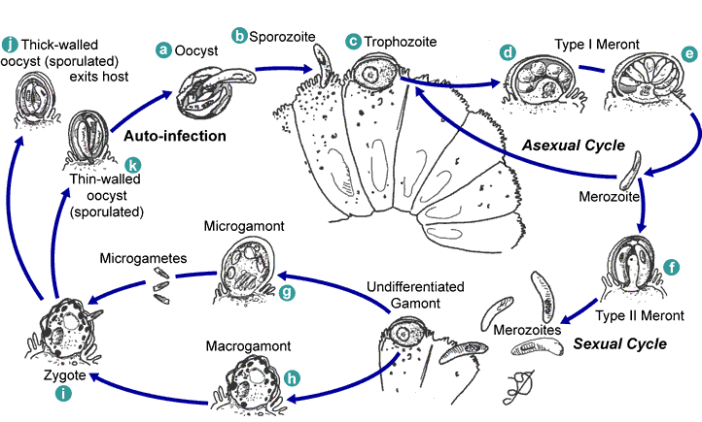

Symptoms
Persistent watery offensive diarrhea accompanied with abdominal pain, nausea, vomiting and anorexia
Diagnosis:
- Demonstration of oocyst in the stool.
- Intestinal fluid or small bowel biopsy specimens
- Antigen in stool (ELISA)
-Molecular methods (PCR.)
-Serological test
3-Isospora belli
Disease name: Isosporiasis
Site of infection: Epithelial cells of the small intestine.
Infective stage: Oocyst
Life Cycle
This organism can be acquired by the ingestion of sporulated oocysts found in contaminated food or water. The Oocyst is thin walled, transparent, ovoid in shape and much larger than the oocysts of Cryptosporidium parvum. Oocysts of I. belli can survive for years in the environment.

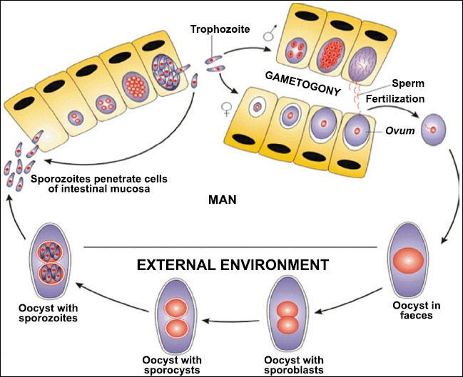

Symptoms

In chronic infections, severe non-bloody diarrhea with cramp-like abdominal pain can last for weeks and result in fat malabsorption and weight loss. Eosinophilia may be presents (atypical of other protozoa infections).

Laboratory Diagnosis:
Oocysts can be detection in stool samples. Alternatively, oocysts can be seen in a fecal smear stained by a modified Ziehl-Neelsen method, where they stain a granular red color against a green background, or by phenolauramine.

