Lab (5)
Trypanosoma spp.
Trypanosomes are hemoflagellates and three species of the genus Trypanosoma are responsible for disease in humans
1- African trypanosomiasis (sleeping sickness)
There are two clinical forms of African trypanosomiasis:
A – Trypanosoma brucei gambiense causes (Gambian trypanosomiasis chronic sleeping sickness).
B- Trypanosoma brucei rhodesiense causes (Rhodesians trypanosomiasis acute sleeping sickness).
Site of infection: blood, lymph, spleen, liver, cerebrospinal fluid (CSF)
Vector: Tsetse fly, genus: Glossina spp.
The parasite undergo several forms depending on the host
In vertebrate host (human), definitive host: trypomastigote
In invertebrate host (insect), intermediate host: trypomastigote, and epimastigote
Morphology:
The parasite is an elongated cell with single nucleus which usually lies near the center of the cell, single flagellum which appears to arise from a small granule kinetoplast. Two forms of trypomastigote can be seen in peripheral blood: one is long slender, (30μm) in length, and is capable of multiplying in the host, the other is stumpy, not dividing, (18μm) in length.
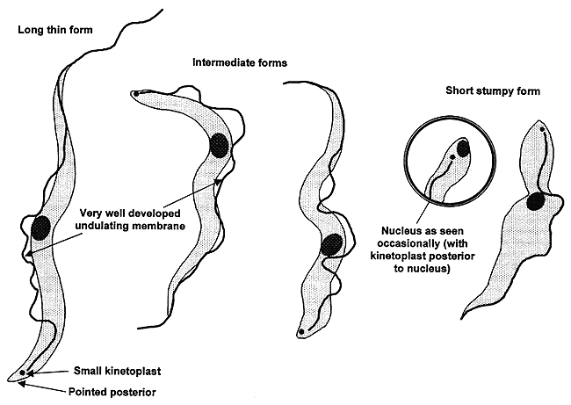
Life Cycle:
Transmission from one vertebrate to another is carried out by blood-sucking invertebrates, usually an insect (vector). Metacyclic (infective) trypomastigotes are inoculated through the skin when a Tsetse fly takes a blood meal. The parasites develop into long slender trypomastigotes which multiply at the site of inoculation where ulceration occurs. The trypanosomes continue to develop and then may invade the lymphatic tissues, the heart, various organs and in later stages, the central nervous system. Trypomastigotes are taken up by the tsetse fly (male and female) during a blood meal. The parasites develop in the midgut of the fly where they multiply. 2-3 weeks later the trypomastigotes move to the salivary glands transforming from epimastigotes into metacyclic S-shape (infective) trypomastigotes. These are known as salivarian trypanosomes as they complete their development in the salivary system (anterior portion of the vector). The tsetse fly remains infective for life (about three months).

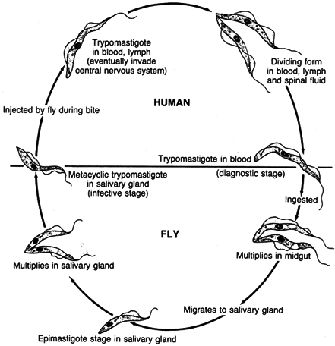

Symptoms:
The early stages of African trypanosomiasis may be asymptomatic and there is a low-grade parasitemia. This period may last for several weeks to several months. The disease may terminate untreated at this stage or go on to invade the lymph glands. Invasion of the lymph glands is usually accompanied by a high irregular fever with shivering, sweating, and an increased pulse rate. Trypanosomes may invade the central nervous system giving symptoms of meningoencephalitis, confusion, apathy, excessive sleeping, and incontinence.

Laboratory diagnosis of African Trypanosomiasis is by:
• Examination of blood for the parasites
• Examination of aspirates from enlarged lymph glands for the parasites
• Examination of the CSF for the parasite
• Detection of trypanosomal antibodies in the serum
2-American trypanosomiasis
Trypanosoma cruzi causes (Chagas disease).
Site of infection: muscle, kidneys, thyroid gland, sexual organs
Vector: Bug, genus: Tritoma
Morphology:
Trypanosoma cruzi has a single form (monomorphic), about 20μm in length, and is characteristically curved (C-shape). The kinetoplast is large, considerably larger than the Trypanosoma brucei species. The flagellum is medium in length. Trypanosoma cruzi in man only occurs in the amastigote phase in muscular tissue and cells.

Lifecycle of Trypanosoma cruzi

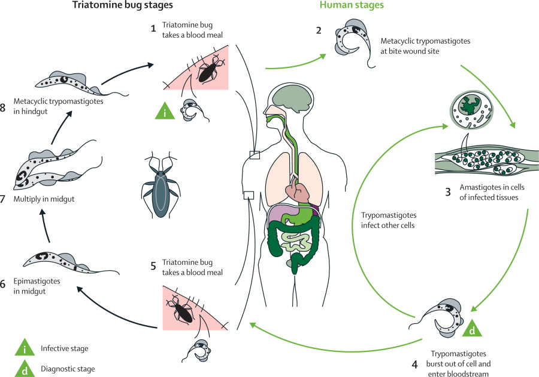

Symptoms:
In an acute infection, there may be fever, malaise, increased pulse rate, and enlargement of lymph glands, liver, and possibly spleen. Chronic infection includes signs of cardiac muscle damage leading to heart failure.
Laboratory diagnosis of South American trypanosomiasis is by:
• Examination of blood.
• Xenodiagnosis
• Blood culture
• Serology

