Lab One :.
Antibiotics:
is a product produced by a microorganism or a similar substance with molecular weight 250-5000 Dalton produced wholly or partially by chemical synthesis, which in low concentrations, inhibits the growth of other microorganisms.
Or is a chemical substance produced by various species of microorganisms that is capable in small concentrations of inhibiting the growth of other microorganisms.
Production of antibiotics
The production of antibiotics has been widespread since the pioneering efforts of Florey and Chain in 1938. The importance of antibiotics to medicine has led to much research into their discovery and production:
- Actinomycetes & Streptomyces which produce 80% of antibiotics like streptomycin, tetracycline, erythromycin.
- Fungi like penicillium & cephalosporium which produce Ampicillin, cephalothin.
- Bacillus like Bacillus Polymyxa which produce polypeptide like polymyxin & colistin.
Uses of Antibiotics:
- Antibiotics are widely used in veterinary medicine to treat sick animals, to control the spread of disease, and to prevent infections.
- Used to justify widespread prophylactic use of antibiotics in aquaculture. Antibiotics are generally given as part of feed but may not be wholly consumed by the fish on a farm.
- Used to treatment the diseases which resulting from injury microscopic organisms, especially tuberculosis and cholera Malta fever, meningitis.
- Antibiotics are used as tools of research that the ability of antibiotics to inhibit certain molecule makes it useful in understanding the functions of this molecule in cellular metabolism, as well as the importance of antioxidants in research on the genetic draw maps and set gene sites to microorganisms.
- Some antibiotics are used as preservatives for some food, especially canned food to keep them from damage and decay, where antibiotics are widely engaged in the field of food processing and features antibiotics used in this area not to toxicity.
Antibiotic Mechanisms of Action:
Antibiotics Used to kill or inhibit the growth of bacteria, Classified as bacteriocidal (Kill bacteria directly) or bacteriostatic (Prevent cell division), so are classified according to site of action:
1- Inhibitors of cell wall synthesis: Penicillins, Cephalosporins.
2-Drugs altering cell membranes: polymyxin & colistin.
3- Inhibitors of protein synthesis: Aminoglycosides, Tetracycline.
4- Inhibitors of nucleic acid synthesis: Fluoroquinolones, Metronidazole, Rifampin.
Features of Antibiotics:
- Not Allergic Reactions: some people develop hypersensitivities to antibiotics.
- Not Toxic Effects: some antibiotics toxic at high concentrations or cause adverse effects
- Not Suppression of normal flora: when normal flora killed, other pathogens may be able to grow to high numbers

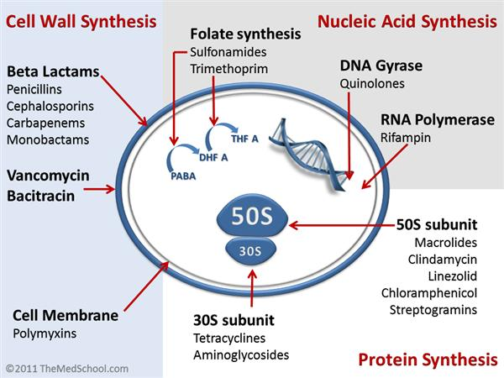
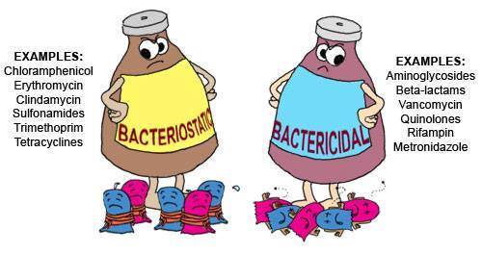
The Criteria of the Ideal Antibiotic:
- Electively toxic to microbe but nontoxic to host.
- Soluble in body- tissue distribution – BBB.
- Remains in body long enough to be effective - resists excretion and breakdown.
- Don’t have side effect .
- Cost not excessive.
- Hypoallergenic.
- Microbiocidal rather than microbiostatic.
- Concerns suppression of normal flora - antibiotic associated colitis with Clostridium difficule and it’s toxins or Candida albicans.
- Don’t effect to phagocytosis and don’t produce antibody.

