Lab Four:.
Prepare antibiotics discs:
Antibiotics may be received as powders or tablets. It is recommended to obtain pure antibiotics from commercial sources, and not use injectable solutions. Powders must be accurately weighed and dissolved in the appropriate diluents to yield the required concentration, using sterile glassware.
Preparation of dried filter paper discs Whatman filter paper no. 3 is used to prepare discs approximately 5-8mm in diameter, which are placed in a Petri dish and sterilized in a hot air oven. The loop used for delivering the antibiotics is made of 20-gauge wire and has a diameter of 2 mm. This delivers 0.01 ml (10 microliter) of antibiotics to each disc.
Procedure:
- Prepare dicks were then autoclaved at 15lbs pressure for 30 minutes.
- Standard antibiotic powders were obtained commercially. Known weight of antibiotic powder was dissolved in sterile distilled water to obtain the stock solution.
- The stock solution was diluted at the time of disc preparation to obtain the working solution.
- A paper disc of 6mm diameter can absorb 0.001ml or 10μl of solutions. The concentrations of antibiotic solutions were expressed in μg/μl.
- Impregnation of the discs: Sterile discs were placed in petri dishes approximately 5mm apart. Using a mechanical pipette, a fixed volume of 10μl was loaded on each disc one by one, taking precautions that the tip was in slight contact with the disc.
- Drying and Storage: Without covering the petri dishes, the discs were allowed to dry in a clean incubator at 37°C for 10-15 min. Now it's ready to use in sensitivity test
Calculate of concentrations of antibiotic:
- Ampicillin = 10 μg\ disk
10 = N$×$ $\frac{10}{1000}$
N = $\frac{10}{0.01}$ = μg\mL 1000
1mL

250mg 9mL

25mL
10mg\mL 1mg\mL
10000 μg\mL 1000 μg\mL

Prepare ampicillin with cons. 1000 μg\mL which had pulled him (10 μL (0.01 mL will carried cons. 10 μg\ disk.
- carbenicillin = 100 μg\ disk
15 = n $×$ 10
= N $\frac{15}{10}$ = N 0.01 mg \mL
0.01 $×$ 1000 = 10 μg\mL

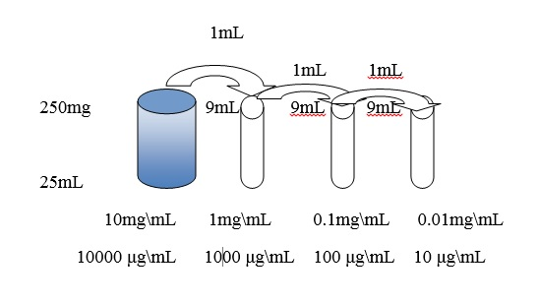

- 15 μg\ disk= Erythromycin……. Home work ????

