Lab Seven :.
Combination action of Antibiotic:
Its refers to mix two or more than antibiotics and study the effects on microorganisms. Typically, these terms refer to using multiple therapies to treat a single disease.

Rationale for Combination Therapy:
- Synergy or additives.
- Decrease resistance.
- Broaden spectrum.
- Decrease toxicity of antibiotics, so if it use the sub MIC of two antibiotics it have the same effect when it use the single antibiotic.
The cases of Combination:
- For urgent treatment to many infections and before completing the culture of bacteria.
- To prevent or delay mutant strains.
- To obtain synergism effect for antibiotics.
- For treat unknown infection, or chronic infection specially Vascular Disease.
- In the Mixed infection like septicemia.
- To lead delay the mutation for any antibiotics in chronic infection so we use two antibiotics like tuberculosis.
Disadvantages
• Antagonism
• Risk of adverse effects
• Drug- drug interactions
• Risk for super infection
• Increased costs.

In general, the presence of two anti or more will lead to the occurrence of the following cases:
- Additive (indifferent) effect: the activity of two drugs in combination is equal to the sum (or a partial sum) of their independent activity when studied separately.
against Staph. aureu Gentamicin + Linezolide.
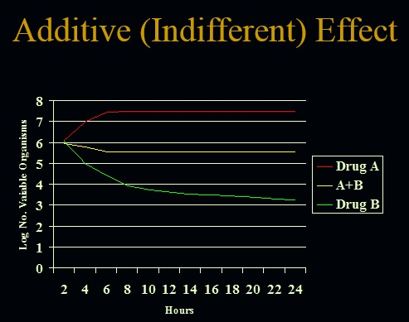

- Synergistic effect: the activity of two drugs in combination is greater to the sum of their independent activity when studied separately.
Aminoglycoside+ Penicillins against Niesseria gonorrhoeae.

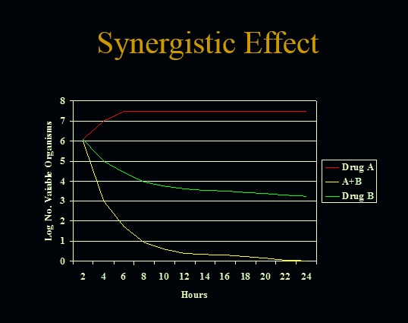

- Antagonistic effect: the activity of two drugs in combination is less to the sum (or a partial sum) of their independent activity when studied separately.
Ciprofloxacin + Gentamicin against Proteus mirabilis.
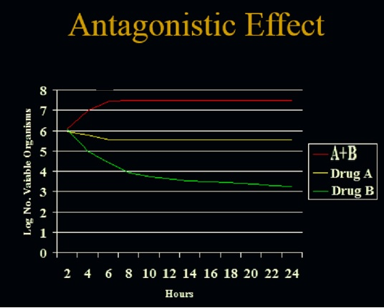

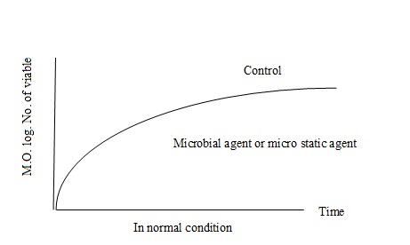
The activity of combination antibiotics depends on the Own characteristics in terms of:
- Bactericidal.
- bacteriostatic
** The use of antibiotics penicillin + tetracycline against bacteria Pneumonia meningitis led to a high mortality rate from 22% to 79%?
Formed state of influencing Antagonism, which led to the inhibition of the work of one another.

You should to fellow these steps when we use combination of antibiotics:
- Get the effectiveness of one antibiotic which use for treatment in the event that the treatment effectively eliminates the causative organism, and here, there is no need for the use of combination, but when there is a variety resistant to more than one cause patients and require mixing.
- In case combination of antibiotics, you should get the MIC separately of each antibiotics and use the dose of under the MIC for one antibiotics or both and called the sub MIC.
- Attention to the type of effectiveness of antibiotics which use in combination which may not be one of antibiotic killer or murderer and other inhibitor, But it should affected by the same type of effect.
In addition, according to the following:
- Combined bacteriostatic action : (Bacteriostatic – Bacteriostatic ):
Like when we use trimethoprim+ sulphonamide antibiotics so the first one inhabit the Dihydrofolate reductase its one of enzymes that involve to synthesis Folic acid and the second one inhabit the BAPA, and use this combination against Proteus.
- Combined Bactericidal actions : (Bactericidal- Bactericidal ):
Such as the use of Amikacin + Pipracillin for the treatment of inflammatory endocarditis, meningitis caused by bacteria G-ve bacteria and infection caused by Pseudomonas aeruginosa , when penicillin work on the cell wall and amikacin work on protein synthesis and this is the common killer.
- Combined action between (Bacteriostatic + Bactericidal ):
Such as, use the bactericidal antibiotic like penicillin with bacteriostatic antibiotic like Chloramphenicol or Erythromycin so the first works on the cell wall so it needs to cells in the process of reproduction, while the second works on the inhibition protein synthesis, thus you will get an overlap or interaction in the work of antibiotics and inhabit each other's work.
Procedure:
- Prepare serial dilution of antibiotics, which required in test and get the require concentration which if we take 0.1ml (100 µl) from it this volume will be carried the same concentration which we needed.
- Cultured MHA plates with required bacteria by using lawn streaking.
- Making wells in MHA plates by using cork borer and loaded by require concentration.
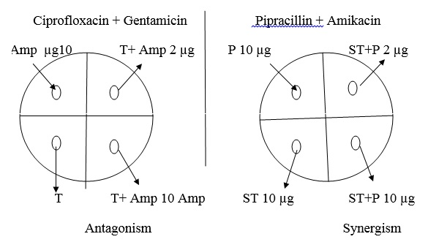
- Incubate the plates at 37ºC for 24 hours, and read the results.

Penicillin and Streptomycin↓
Penicillin or Ampicillin ( 10 µg, 2 µg )
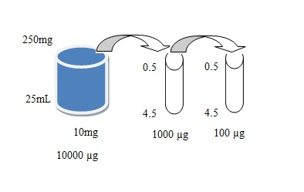
10= n* 100 (1
N= 0.1 mg\mL
0.1 * 1000=100 µg\ mL

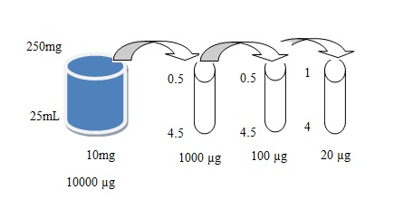
(2 100*n= 2
N= 0.02mg\mL
0.02* 1000=20 µg\mL

Streptomycin (10 µg )
100*n=10
N=0.1 mg\mL
0.1* 1000= 100 µg\ mL

Amikacin against staph. G+ ve + Ticarcillin

