Lec(1) Immunology Biotechnology
Prof. Dr.Ekhlass Noori Ali
Syllabus:
- Historical Background,Innate immunity (Barriers)
- Immune cells & recognition Receptor.
- Complement component,Cellular innate immunity(Inflamation I.R &Phagocytosis)
- The Adaptive Immune System (Immunoglobulins)
- Cells and Organs
- Major Histocompatibility Complex (Molecules of cellular interaction).
- Antigens and Receptors.
- Lymphocyte Activation& Lymphocyte Effector functions
- Humeral Immunity &Cell- Mediated Immunity.
- Tolerance
- Hypersensitivity Reaction.
References:
Lippincotts Illustrated Reviews Immunology (2013) 2nd
Edition,Harvey, R.A et al

Suggested References:

- Immunology 2003( Goldsby,R.A.Kuby.J et. al,)
- Essential of Clinical Immunology 5th ed 2006. Snowden, N. et .al,)
- Medical Immunology 10th ed 2001.( Stites,D. P.)
- Basic Immunology 2nd ed 2007( Abbas, A. K.; Lichtman, A. H.)

Immunology is a broad branch of biomedical science that covers the study of all aspects of the immune system in all organisms. It deals with, among other things, the physiological functioning of the immune system in states of both health and disease; malfunctions of the immune system in immunological disorders (autoimmune diseases, hypersensitivities, immune deficiency, allograft rejection); the physical, chemical and physiological characteristics of the components of the immune system in vitro and in vivo. Immunology has various applications in several disciplines of science, and as such is further divided.
Immunity state of having sufficient biological defenses to avoid infection, disease, or other unwanted biological invasion. Immunity involves both specific and non-specific components. The non-specific components act either as barriers or as eliminators of pathogens to stop infection by micro-organisms before they can cause disease. Other components of the immune system adapt themselves to each new disease encountered and are able to generate pathogen-specific immunity
Timeline of immunology:
1798 - First demonstration of vaccination smallpox vaccination (Edward Jenner)
1857-1870 - Confirmation of the role of microbes in fermentation (Louis Pasteur)
1862 - phagocytosis (Ernst Haeckel)
1876 - First demonstration that microbes can cause disease-anthrax (Robert Koch)
1877 - Mast cells (Paul Ehrlich)
1878 - Confirmation and popularization of the germ theory of disease (Louis Pasteur) .

1880 - 1881 -Theory that bacterial virulence could be attenuated by culture in vitro and used as vaccines. Proposed that live attenuated microbes produced immunity by depleting host of vital trace nutrients. Used to make chicken cholera and anthrax "vaccines" (Louis Pasteur)
1883 - 1905 - Cellular theory of immunity via phagocytosis by macrophages and microphages (polymorhonuclear leukocytes) (1885 - Introduction of concept of a "therapeutic vaccination". First report of a live "attenuated" vaccine for rabies (Louis Pasteur).
1888 - Identification of bacterial toxins (diphtheria bacillus) (Pierre Roux and Alexandre Yersin)
1888 - Bactericidal action of blood (George Nuttall)
1890 - Demonstration of antibody activity against diphtheria and tetanus toxins. Beginning of humoral theory of immunity. (Emil von Behring) and (Shibasaburo Kitasato)
1891 - Demonstration of cutaneous (delayed type) hypersensitivity (Robert Koch)
1893 - Use of live bacteria and bacterial lysates to treat tumors-"Coley's Toxins" (William B. Coley)
1894 - Bacteriolysis (Richard Pfeiffer)
1900 - Antibody formation theory (Paul Ehrlich)
1901 - blood groups (Karl Landsteiner)
1902 - Immediate hypersensitivity anaphylaxis (P. Portier) and (C. Richet)
1903 - Intermediate hypersensitivity the "Arthus reaction" (M. Arthus)
1903 - Opsonization
1905 - "Serum Sickness" allergy (Clemens von Pirquet and (Bela Schick)

1917 - hapten (Karl Landsteiner)
1921 - Cutaneous allergic reactions (Carl Prausnitz and Heinz Kustner)
1924 - Reticuloendothelial system
1938 - Antigen-Antibody binding hypothesis (John Marrack)
1940 - Identification of the Rh antigens (Karl Landsteiner and Alexander Weiner)
1942 - Anaphylaxis (Karl Landsteiner and Merill Chase)
1942 - Adjuvants (Jules Freund and Katherine McDermott)
1944 - hypothesis of allograft rejection
1948 - antibody production in plasma B cells
1949 - growth of polio virus in tissue culture, neutralization with immune sera, and demonstration of attenuation of neurovirulence with repetitive passage (John Enders) and (Thomas Weller) and (Frederick Robbins)
1949 - immunological tolerance hypothesis
1951 - vaccine against yellow fever
1953 - Graft-versus-host reaction
1953 - immunological tolerance hypothesis
1957 - Clonal Selection theory (Frank Macfarlane Burnet)
1957 - Discovery of interferon
1958-1962 - Discovery of human leukocyte antigens
1959-1962 - Discovery of antibody structure
1959 - Discovery of lymphocyte circulation (James Gowans) 4

1960 - Discovery of lymphocyte "blastogenic transformation" and proliferation in response to mitogenic lectins-phytohemagglutinin (PHA) (Peter Nowell)
1961-1962 Discovery of thymus involvement in cellular immunity (F.C.A.P. Miller)
1961- Demonstration that glucocorticoids inhibit PHA-induced lymphocyte proliferation (Peter Nowell)
1963 - Development of the plaque assay for the enumeration of antibody-forming cells in vitro (Neils Jerne) (Albert Nordin)
1964-1968 T and B cell cooperation in immune response
1965 - Discovery of the first lymphocyte mitogenic activity, "Blastogenic Factor" (Shinpea Kasakura) and (Louis Lowenstein) (J. Gordon) and (L.D. MacLean)
1965 - Discovery of "immune interferon" (gamma interferon) (E.F. Wheelock)
1965 - Secretory immunoglobulins
1967 - Identification of IgE as the reaginic antibody (Kimishige Ishizaka)
1969 - The lymphocyte cytolysis Cr51 release assay (Theodore Brunner) and (Jean-Charles Cerottini)
1971 - Peter Perlmann and Eva Engvall at Stockholm University invented ELISA
1972 - Structure of the antibody molecule
1974 - T-cell restriction to major histocompatibility complex (Rolf Zinkernagel and (Peter Doherty)
1975 - Generation of the first monoclonal antibodies (George Kohler) and (Cesar Milstein) 5

1976 - Identification of somatic recombination of immunoglobulin genes (Susumu Tonegawa)
1979 - Generation of the first monoclonal T cells (Kendall A. Smith)
1980-1983 - Discovery and characterization of the first interleukins, 1 and 2 IL-1 IL-2 (Kendall A. Smith)
1981 - Disovery of the IL-2 receptor IL2R (Kendall A. Smith)
1983 - Discovery of the T cell antigen receptor TCR (Ellis Reinherz) (Philippa Marrack) and (John Kappler) (James Allison)
1983 - Discovery of HIV (Luc Montagnier)
1984 - The first single cell analysis of lymphocyte proliferation (Doreen Cantrell) and (Kendall A. Smith)
1985-1987 - Identification of genes for the T cell receptor
1986 - Hepatitis B vaccine produced by genetic engineering
1986 - Th1 vs Th2 model of T helper cell function (Timothy Mosmann)
1988 - Discovery of biochemical initiators of T-cell activation: CD4- and CD8-p56lck complexes (Christopher E. Rudd)
1990 - Gene therapy for SCID
1994 - 'Danger' model of immunological tolerance (Polly Matzinger)
1995 - Regulatory T cells (Shimon Sakaguchi)
1996-1998 - Identification of Toll-like receptors
2001 - Discovery of FOXP3 - the gene directing regulatory T cell development
2005 - Development of human papillomavirus vaccine (Ian Frazer) 6
Innate immunity
Barriers to Infection
Introduction
We live in a microbial world. Our bodies are constantly surrounded by astronomical numbers of microbes (Table 3.1). In addition to the microbes themselves, the molecules they produce and some molecules from other environmental sources (e.g.,venoms) can also injure body cells and tissues. The body has several mechanical, chemical, and biologic barriers that provide the first line of defense against the entry of microbes into the aseptic, nutrient-rich environment of our tissues. These barriers can be thought of as the moats and thick walls that provided the initial protection to the inhabitants of castles under
enemy attack.
1. Physical Barriers
The initial mechanical barriers that protect the body against invasive microbes include the epidermis and keratinocytes of the skin; the epithelium of the mucous membranes of the gastrointestinal, respiratory, and urogenital tracts; and the cilia in the respiratory tract (Fig. 1.1). These mechanical barriers also incorporate a number of chemical and biologic barriers that minimize or prevent entry of potential pathogenic organisms into the body.
A. Skin
The epidermis or outer layer of skin varies in thickness from 0.05 to 1.5 mm depending upon location (Fig. 13.2). The outermost of the five layers of the epidermis, or stratum corneum, is composed of dead, tightly layered, and cornified squamous cells.Produced by keratinocytes of the lower four layers, cells of the stratum corneum provide a water-tight barrier that both
prevents our dehydration and provides a microbe-inhospitable dry environment on the surface of our skin. Continuously dividing keratinocytes and constant sloughing of the superficial epidermal layer removes microbes attached to cutaneous surfaces. The skin is protected in part by several antimicrobial peptides secreted by a variety of cell types found within the skin. Among these are α-defensins, β-defensins, and cathelicidin. All are able to inhibit microbial growth by direct
action upon the microbes, perhaps by damaging the microbial membranes and causing lysis. They can also act a s chemoattractants for cells of the innate immune system and facilitate the ingestion and destruction of microbes by
phagocytes. Fatty acids released by some of the commensal microbes that are present on the skin also act to inhibit growth by some other bacteria.
Other molecules with enzymatic activity are present in the skin as well. Sweat contains lysozyme, an enzyme that breaks down peptidoglycan (a constituent of most bacterial cell walls). Also present in the skin are molecules that act
on the RNA and DNA of a wide range of microbes. RNases and DNases, in fact, are powerful enough to require the wearing of protective gloves while performing molecular biology procedures—not to protect the hands, but to protect the material that is being manipulated from destruction by the enzymes on the skin. Finally, the evaporation of sweat creates a slightly salty nvironment that inhibits growth of many bacteria.
. pH
Most pathogens are very sensitive to an acidic environment, where an acid pH (less than 6) inhibits the growth of potential pathogens.
Skin: The skin contains oil and sweat glands (sebaceous and sudoriferous glands, respectively), some of whose products are slightly acidic. In general, the skin has a pH of about 5.5. Sebum is a mix of lipids produced by the sebaceous glands. Excessive sebum secretion is often associated with oily skin and acne, particularly in adolescents,as it can clog skin pores (entrapping and retaining microbes) and create less favorable pH levels.

B. Mucous membranes
The epithelium of mucous membranes lines all of the body's cavities that come into contact with the environment, such as the respiratory, gastrointestinal, and urogenital tracts (Fig. 1.3). This epithelium contains goblet cells that secrete mucus. It is estimated that 4 liters of mucus are secreted within the gastrointestinal tract alone on a daily basis (although much of it is resorbed in the large intestine). In the respiratory tract, the mucus traps inhaled bacteria, fungi, and other particles. In the gastrointestinal tract, the mucus and mucous membranes help to protect the epithelial cells and underlying tissues from damage by digestive enzymes and to propel ingested matter through the tract. Mucosal surfaces of the moist epithelium facilitate the exchange of molecules with the environment while also resisting microbial invasion. Additionally, the sloughing of the intestinal epithelial cells has a protective effect similar to that from the sloughing of keratinocytes in the skin.
Table 3.1 Our Microbial Environment

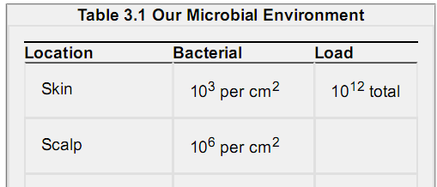
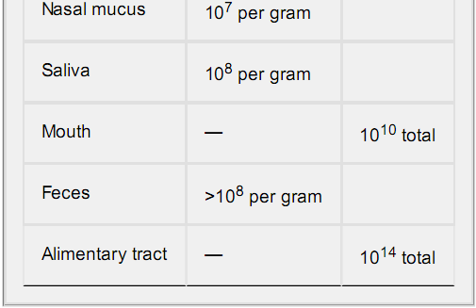

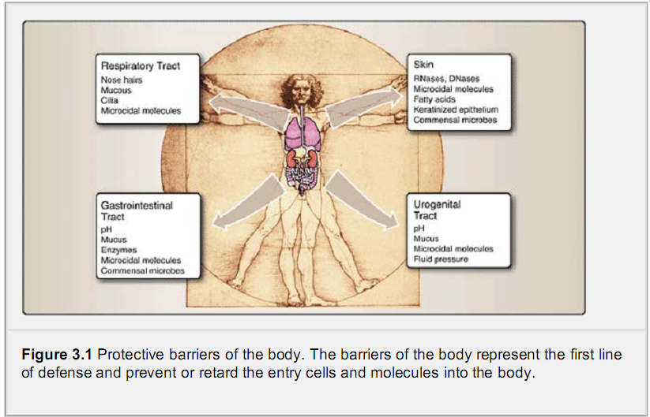

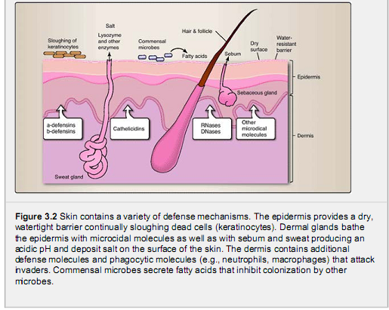

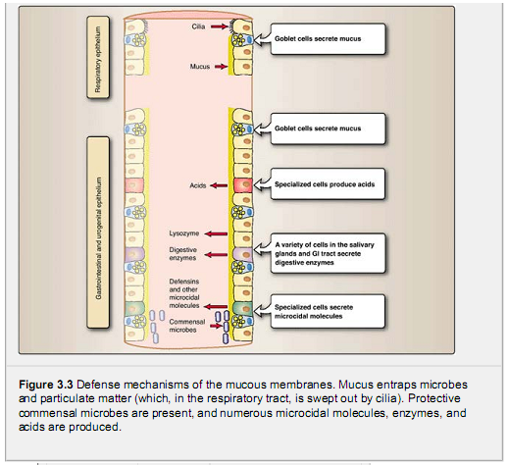

C. Respiratory tract
Air turbulence caused by hairs within the nostrils deposits particles larger than 10 μm in the nasal mucosa. The hairlike cilia of the epithelia lining the respiratory tract passages help the tract clean by moving the secretions containing trapped microbes and particles outward for expulsion by coughing and sneezing. The rhythmically beating cilia of the respiratory epithelium is commonly disrupted by chronic smoking and chronic alcohol consumption, leading to an increased risk of respiratory infections. To protect the mucosal surfaces of the lungs, some cells of the respiratory epithelium secrete microcidal molecules such as β-defensins. These and other molecules in the respiratory tract can attach to microbes
and make them more susceptible to ingestion and destruction by phagocytic cells.

D. Urinary tract
Similar to the outward movement of secretions of the respiratory tract, urination helps to inhibit movement of microbes from the environment up into the bladder and kidneys. The periodic voiding of sterile urine provides an externally directed fluid pressure that inhibits the inward movement of microbes along the urinary tract. This simple protective mechanism can be disrupted by the therapeutic insertion of a catheter, which increases the risk of urinary tract infections by facilitating entry of microbes into the urinary tract. Urinary tract infections due to catheterization account for nearly half of all hospital nosocomial infections. The female urogenital tract is also protected by the acidic secretions of the vagina and the presence of microcidal molecules secreted by the mucous membranes.
2.. Chemical and Environmental Barriers
The acidic pH of the skin, stomach, and vagina serves as a chemical barrier against microbes. Microcidal molecules, such asα-defensins, β-defensins, cathelicidin, RNases, DNases, and lysozyme, which are secreted by a variety of cell types, also provide protective environment barriers.
3. Vagina: The acidic environment of the vagina and cervical us in healthy women is normally pH 4.4 to 4.6. This acidic environment is the result of lactic acid production by the commensal bacteria Lactobacilli spp. (see Section IV).
B. B. Microcidal action of secreted molecules
Several tissues that are in contact with the environment synthesize and secrete a variety of microcidal molecules that act to inhibit or kill microbes that are attempting to colonize. A few of the primary microcidal molecules
3. Gastrointestinal tract:
. Stomach: Compared to the colon, the stomach has very few bacteria because of the highly acidic environment (normal pH of 1.0 to 3.0). The acidic environment of the stomach prevents the colonization of the intestines by ingested microbes.

The gastrointestinal tract defends against pathogens in many ways. In addition to the low pH of the stomach, some epithelial cells secrete microcidal molecules such as α-defensins and cryptidin that help to destroy many potential pathogens. Approximately 22 different digestive enzymes are released from the salivary glands,stomach, and small intestine. Among these is lysozyme found in saliva. These enzymes help the digestive process but are also effective in killing and degrading many potential pathogens that may be ingested.

4. Lacrimal secretions: Lacrimal glands are small almond-shaped structures, located above the outer corner of the eye,that produce tears. As part of protecting the eyes, the secretions of lacrimal glands contain lysozyme.

IV. Biologic Barriers: Commensal Microbes
Commensal microbes are those that exist in a symbiotic relationship with the body. The skin and the gastrointestinal tract are colonized by over 500 commensal bacterial and other microbial species that are estimated to make up over 95% of the cells present in a normal human body (Table 3.2). Commensal microbes colonizing the skin and gastrointestinal tracts “defend” their
territory and inhibit the establishment of other potentially pathogenic microbes. In the gastrointestinal tract, these microbes also assist in the digestive process.
Commensal microbes are not pathogenic (disease-causing) except under special circumstances. For example, commensal microbes can cause disease in people who are immunocompromised (i.e., their immune systems do not function effectively).The introduction of medical devices, such as catheters, into the body can also cause commensal bacteria from the skin to enter areas of the body that are normally sterile. Any disruption of the normal flora of the body may lead to disease.Pseudo membranous colitis is a condition caused by Clostridium difficile, a pathogenic bacterium that produces a toxin that damages the gastrointestinal tract and causes watery diarrhea, abdominal cramps, and fever. The condition may occur after a course of broad-spectrum antibiotic therapy. One explanation for the condition is that use of antibiotics reduces the levels of normal commensal bacteria of the gastrointestinal tract, thus permitting the establishment and overgrowth by Clostridium difficile.

Chapter Summary:
The body has several mechanical, chemical, and biologic barriers that provide the first line of defense against the entry of microbes and toxic molecules.
The initial mechanical barriers that protect the body against invasive microbes include the epidermis and keratinocytes of the skin; the epithelium of mucous membranes of the gastrointestinal, respiratory, and urogenital tracts; and the cilia in respiratory tract.The slightly acidic pH of the skin and vagina is inhibitory to microbial growth. The high acidity of the stomach is highly inhibitory.
Microcidal molecules inhibit microbial growth. Present in the skin are molecules such as RNases and
DNases, defensins, and cathelicidin. Some cells of the respiratory epithelium secrete β-defensins; some epithelial cells secrete α-defensins and cryptidins.
Commensal microbes are those that exist in a symbiotic relationship with the body. Commensal microbes colonizing the skin and gastrointestinal tracts inhibit the establishment of other potentially pathogenic microbes

