Lec(4) Immunology Dr.EkhlassNoori

Biotechnology

Cells and Organs
Introduction
In contrast to the morphologically distinct cells of the innate immune system, lymphocytes of the adaptive immune system generally look alike except for size, ranging from small (4 to 7 µm) to medium (7 to 11 µm) to large (11 to 15 µm).
Lymphocytes may be broadly categorized by the antigen-specific receptors they generate through gene rearrangement and by the organs in which they develop. These cells may be likened to the soldiers of the adaptive immune system. Like soldiers, they often display combinations of additional surface molecules that serve essentially as molecular “badges” of rank and function. Also, cells of the adaptive immune response undergo “basic training” in specialized training centers (thymus or bone marrow), “bivouac” in specialized areas (spleen, lymph nodes, and lymphocyte accumulations), may be “promoted” (differentiation), and are transported from one anatomic site to another via the bloodstream or in their own lymphatic circulatory system.
. Lymphocytes
The immune system must be able to distinguish its own molecules, cells, and organs (self) from those of foreign origin (nonself). The innate immune system does this by expressing germline-encoded pattern recognition receptors (PRRs) on the surfaces of its cells, receptors that recognize structures on potentially invasive organisms . The adaptive immune system, on the other hand, utilizes somatically generated epitope-specific T cell and B cell receptors (TCRs and BCRs). These receptors are created anew and randomly within each individual T and B lymphocyte by gene recombination prior to antigen encounter. No two individuals, even identical twins, have identical adaptive immune systems. Lymphocytes are usually defined by where they undergo “basic training”: in the thymus (thymus-derived lymphocytes or T cells, and natural killer T or NKT cells) or in the bone marrow (B lymphocytes or B cells). They are also defined by the type of receptors they display on their cell surfaces: TCR (T cells and NKT cells), BCR or immunoglobulins (B cells), or neither (natural killer or NK cells).

A. Thymus-derived cells
T cells are the key players in most adaptive immune responses. They participate directly in immune responses as well as orchestrating and regulating the activities of other cells. T cells arise from hematopoietic stems cells in the bone marrow.
Immature T cells called prothymocytes migrate to the thymus, where, as thymocytes, they develop TCRs and are screened for their ability to distinguish self from nonself. Although most thymocytes fail the screening process and are eliminated, those that pass scrutiny and survive are able to further differentiate and mature to become thymus-derived lymphocytes or T cells and enter the circulation. The developmental pathways for T cells .Although T cells show a wide diversity in adaptive immune function . all can be identified by the presence of the CD3 (cluster of differentiation–3) molecule that is associated with the TCR on the T cell surface. Two other CD molecules are also used to identify CD3+ T cell subsets, CD4+ and CD8+, and to readily distinguish their potential immune function.
1. CD4+ T cells (T helper cell): These cells account for approximately two thirds of mature CD3+ T cells. CD4 molecules displayed on the surfaces of these T cells recognize a nonpeptide-binding portion of MHC class II molecules (Fig.1). As a result, CD4+ T cells, also known as helper T (Th) cells, are “restricted” to the recognition of pMHC class II complexes.

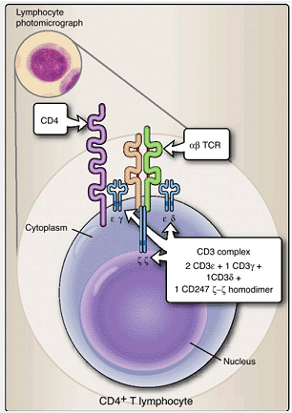
Figure.1 Comprising approximately two thirds of all T lymphocytes, CD4+ T cells are the workhorses of the adaptive immune system. They display T cell receptors (TCRs), associated CD3 signalling complex molecules, and CD4 molecules on their cell surfaces.

2. CD8+ T(T cytotoxic): cells account for approximately one third of all mature CD3+ T cells. CD8 molecules displayed on the surfaces of these T cells recognize the nonpeptide-binding portion of MHC class I molecules. As a result, CD8+ T cells are “restricted” to the recognition of pMHC I complexes (Fig..2). Functionally, CD8+ T cells are also known as cytotoxic T (Tc) and suppressor T (Ts) cells. Tc cells identify body cells that are infected with intracellular organisms, such as viruses and intracellular bacteria, and eliminate the cells harboring these organisms. Ts cells function to downregulate and thus control adaptive immune responses.
B. Bone marrow-derived cells
Not all lymphocytes of bone marrow origin are destined for thymic education. Certain cells of lymphoid lineage remain and develop within the bone marrow and are the precursors of immunoglobulin-producing lymphocytes. These bone marrow–derived lymphocytes, also known as B lymphocytes or B cells, synthesize immunoglobulin and display it on their surfaces, where it functions as their BCR. Plasma cells are derived from differentiated, mature B cells and both synthesize and secrete immunoglobulin.
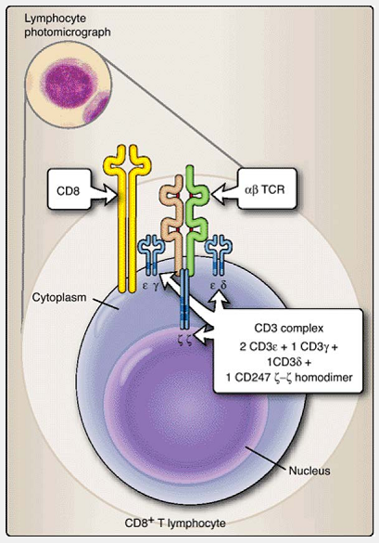
Figure.2 Approximately one third of the T cells found in peripheral blood, CD8+ T cells display T cell receptors (TCRs), associated CD3 molecules, and CD8 dimers on their cell surfaces.

1. B cells arise from pluripotent hematopoietic stem cells in the bone marrow. They do not migrate to the thymus but develop within the bone marrow. B cells arise from two distinct lineages: B-1 and B-2 cells. So named because they are the first to develop embryologically, B-1 cells are a self-renewing population that dominate the plural and peritoneal cavities. In contrast, conventional or B-2 cells arise during and after the neonatal period, are continuously replaced from the bone marrow, and are widely distributed throughout the lymphoid organs and tissues. Each B cell is specific, that is, it produces immunoglobulin of only one antibody specificity that recognizes only one epitope. Like T cells, it is the extreme diversity among B cells, each producing a single form of immunoglobulin, that generates the overall diversity of the immunoglobulin (or antibody) response (Fig. 3).
2. Plasma cells derive from terminally differentiated B cells and are immunoglobulin-producing and -secreting cells. They cease to use immunoglobulin as a membrane receptor and instead secrete it into the fluids around the cells. Plasma cells, with increased size and metabolic activity, are factories that produce large quantities of immunoglobulin during their short lifespan of less than 30 days. They are characterized by basophilic cytoplasm, a nucleus that has a stellate (starlike) pattern within it, and nonstaining Golgi (Fig..4).
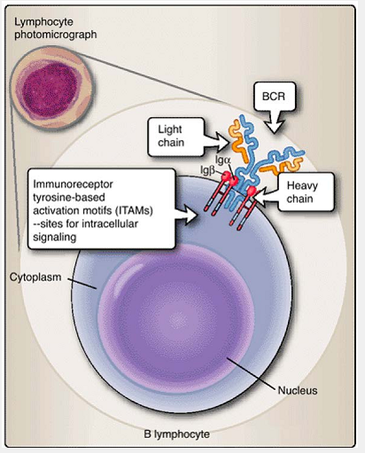
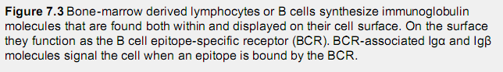
C. Natural killer cells
Approximately 5% to 10% of peripheral blood lymphocytes lack both T cell (CD3) and B cell (surface immunoglobulin) markers. These cells are known as natural killer (NK) cells to reflect their ability to kill certain virally infected cells and tumor cells without prior sensitization . Their granular appearance is due to the presence of cytoplasmic granules that can be released to damage the membranes of the cells they attack. NK cells develop within the bone marrow and lack TCR produced by rearrangement of TCR genes . However, they do bear another set of receptors called killer activation receptors (KARs) and killer inhibition receptors (KIRs) that allow them to recognize host cells that might need to be destroyed (Fig. 5, left). In addition, a unique subset of T cells, designated NKT because they share some functional characteristics with NK cells, develop within the thymus and express a rearranged TCR of extremely limited repertoire (Fig. 5, right). Unlike conventional T cells, NKT cells respond to lipids, glycolipids, or hydrophobic peptides presented by a specialized, nonclassical MHC class I molecule, CD1d, and secrete large amounts of cytokines, especially interleukin-4 (IL-4).
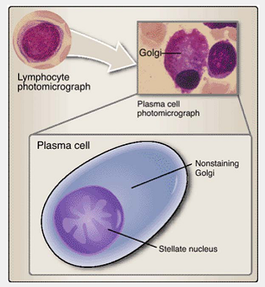
Figure 7.4 Plasma cells are terminally differentiated B cells that both synthesize and secrete immunoglobulin. Anatomically distinguishable from lymphocytes, their cytoplasm reflects increased ribosomes and endoplasmic reticulum. Immunoglobulin molecules are assembled within their (nonstaining) Golgi prior to export to the fluids surrounding the cell.
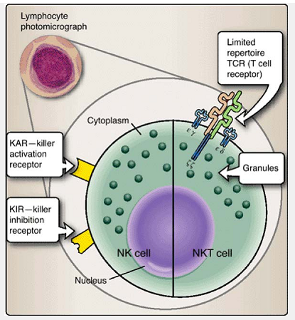
Figure.5 Natural killer (NK) and natural killer T (NKT) cells bridge both adaptive and innate immune systems. NK cells are characteristically large granular lymphocytes that express neither TCRs nor BCRs and bear receptors for stress molecules (killer activation receptors or KARs) and for MHC class I molecules (killer inhibition receptors or KIRs).
Unlike NK cells, NKT cells express low levels of TCRs with extremely limited repertoires.

III. Lymphoid Tissues and Organs
Leukocytes may be found in the body distributed as single cells in the tissues and circulation, as lymphoid accumulations (e.g., Peyer's patches), or within lymphoid organs (e.g., thymus, spleen, lymph nodes) (Fig. 6). Lymphoid organs are classified as primary or secondary. Lymphocytes develop within the
primary organs: thymus and bone marrow.
secondary lymphoid organs (e.g., spleen, lymph nodes, lymphoid accumulations) trap and concentrate immunogens and provide sites where large numbers of circulating immune cells can make contact with each another. Specific immune reactions are initiated with the interactions that occur in secondary lymphoid organs.
A. Primary organs
The primary lymphoid organs, the thymus and bone marrow, serve as lymphocyte educational centers. While all lymphocytes originate within the bone marrow, those destined to become T cells are sent at an early age to the thymus for “advanced education” in distinguishing self from nonself. Other lymphocytic lineage cells are “home schooled” and remain within the bone marrow, destined to become B cells. Stromal cells within the thymus and bone marrow closely regulate the development of T and B lymphocytes. Developmental details of B and T cells are described in upcoming chapters.
1. Thymus: The bilobed thymus is the first lymphoid organ to develop. It increases in size during fetal and neonatal life and progressively involutes following puberty. Stem cells of bone marrow origin called prothymocytes that are committed to the T cell lineage migrate via the circulation to the thymic cortex. In this new environment, they are called cortical thymocytes (see Fig. 8. and acquire a nascent TCR, as well as CD4 and CD8 surface molecules.
One of the first tests that these so-called double positive (DP, because they express both CD4 and CD8 molecules) thymocytes encounter, called positive selection, is the recognition of MHC class I (by CD8) or MHC class II (by CD4) (Fig. 7). Failure to do so appropriately means the demise of the DP thymocyte. Thymocytes that “pass” positive selection cease to express both CD4 and CD8 to become single positive (SP) CD4+ or CD8+ cells. SP thymocytes move into the medulla, where they encounter antigen-presenting cells. At this stage, termed negative selection, those that show strong interaction with MHC or pMHC are fated to die by programmed cell death (apoptosis). Tremendous numbers of thymocytes are processed by the thymus, but fewer than 5% of the thymocytes successfully complete this process. We will revisit the processes of positive and negative selection in greater detail in Chapter 9.
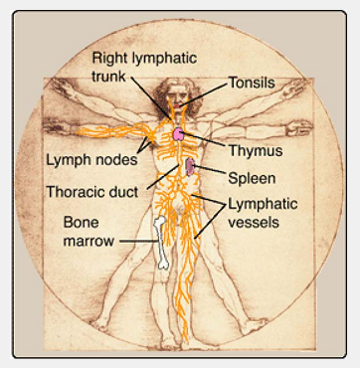
Figure 76 Lymphatics, lymphoid organs, and tissues. The lymphatics serve as a drainage system to remove cellular debris and microbes from the body's tissues to the lymph nodes. Lymphatic trunk vessels join to form the thoracic duct, which returns fluid (lymph) to the cardiovascular circulation.
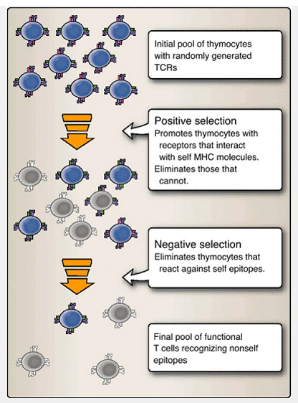
Figure 7. Thymic education: Many are “admitted,” but few “graduate.” “Freshman” thymocytes are called double positive (DP) because they express both CD4 and CD8 molecules in addition to T cell receptors (TCRs). Positive selection:
Thymocytes that recognize MHC class I (using CD8) or MHC class II (CD4) pass their first exam are promoted; those that don't do this die. Negative selection: Thymocytes that show strong interaction with MHC or peptide-MHC combinations fail and meet an apoptotic death. Those few cells that pass the negative selection are destined to “graduate” from the thymus as T cells.
2. Bone marrow: Lymphocytic lineage cells fated to become immunoglobulin-producing lymphocytes undergo their early stages of differentiation within the bone marrow. They develop their BCRs by DNA rearrangement, express auxiliary molecules such as Igα and Igβ, and begin to display IgM on their surfaces prior to leaving the bone marrow. As with T cells in the thymus, interactions with stromal cells of the bone marrow serve to carefully regulate the development of B cells. While still within the bone marrow, the randomly generated BCRs of some B cells may recognize and bind molecules in their local environment. By definition, these B cells would be self-reactive. At this early stage of development, the binding of BCRs triggers the cells bearing them to undergo apoptotic death. This mechanism removes self-reactive cells.

B. Secondary lymphoid tissues and organs
Cellular interactions are critical for the development of adaptive immune responses. The secondary lymphoid tissues function as
1-filtration devices
2- removing foreign matter, dead cells
3- protein aggregates from the circulation. Blood vessels and lymphatic vessels that facilitate movement of lymphocytes, monocytes, and dendritic cells into and out of these organs richly supply secondary lymphoid tissues. Specialized regions of the vasculature, called high endothelial venules(HEV), permit the movement of cells between the blood and the tissues or organs through which they are passing. The leukocyte-rich nature of the secondary lymphoid tissues facilitates cellular interaction, providing leukocytes an environment in which they can “compare notes,” exchange regulatory signals, undergo further development, and proliferate before reentering the circulation. The major secondary lymphoid organs are the spleen and lymph nodes. The tonsils and Peyer's patches also act as secondary lymphoid accumulations.
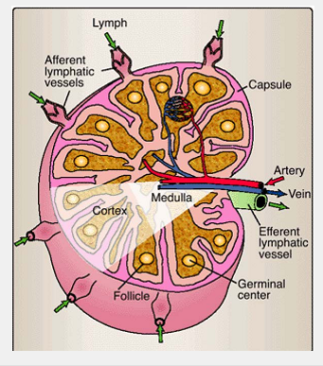
Figure 8 Circulation of lymph through a lymph node. Afferent lymphatic vessels enter the cortical portion of the lymph node. Leukocyte- and debris-rich lymph percolates through the body of the lymph node where it encounters phagocytic cells (macrophages and dendritic cells) that remove dead and dying cells, cellular debris, and microorganisms from the lymph. The “scrubbed” lymph exits the lymph node via an efferent lymphatic vessel. The vessels of the cardiovascular system transport leukocytes to and from the lymph node.
1. Spleen: The largest lymphoid organ, the spleen clears particulate matter from the blood and concentrates blood-borne antigens and microbes. In addition to B and T lymphocytes and other leukocytes, the spleen contains large numbers of plasma cells secreting immunoglobulins into the circulation. It is histologically divided into the lymphocyte-rich white pulp and erythrocyte-rich red pulp. The white pulp surrounds small arterioles.
2. Lymph nodes: Small round or oval -shaped peripheral or secondary lymphoid organs, lymph nodes are leukocyte accumulations occurring periodically throughout the lymphatic circulatory system (see Fig. 7.6). They function as filters to purify lymph, the fluid and cellular content of the lymphatic circulatory system, and provide sites for mingling of lymphocytes, monocytes, and dendritic cells for initiation of immune responses. Anatomically, a lymph node is divided into the cortex and medulla (Fig. 8). The reticulum or framework of the organ is composed of phagocytes and specialized kinds of reticular or dendritic cells. Lymphocytes are distributed mainly in two areas of the cortex (Fig9).
The superficial cortex is closely packed with clusters of lymphocytes forming nodules or follicles. It is sometimes called the thymus-independent area and contains mostly B cells. When an immune response takes place, the follicles develop a central area, with large proliferating cells, termed a germinal center. The deep cortex is the T cell–rich area. Circulating cells enter the outer cortical area through blood or lymphatic vessels and then filter down through the deep cortex and into the medulla before leaving the lymph node and moving on.
3. Mucosa-associated lymphoid tissues(MALT): In addition to the spleen and lymph nodes, other sites that facilitate interaction among circulating leukocytes include tonsils in the nasopharynx and Peyer's patches in the submucosal surfaces of the small intestine (Fig. 10). These secondary lymphoid tissues defend the mucosa surfaces and are located at potential portals of microbial entry. Peyer's patches function similarly to lymph nodes and the spleen, with cells entering at the cortical end, promoting the intermingling of antigen-presenting cells, B cells, and T cells and the exit of cells at the medullary end.
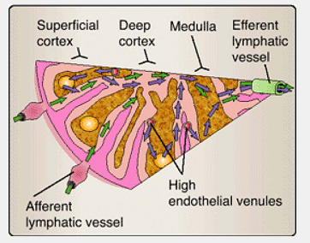
Figure.9 Section from lymph node in Figure 8 (see white triangle). Specialized high endothelium vessels provide a portal for leukocyte entry into the lymph node from the cardiovascular system. B cell–rich areas (superficial cortex and germinal centers) are anatomic sites of immunoglobulin production. The deep cortex and medullary regions are sites for T cell homing and activation.
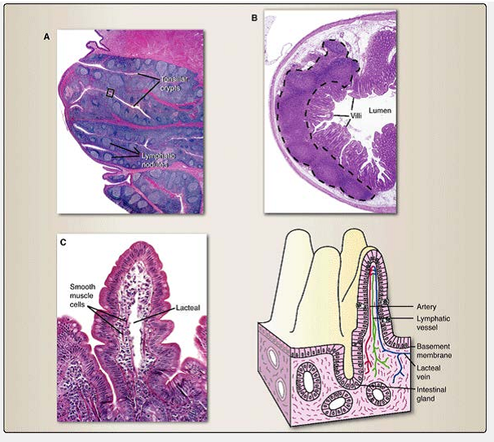
Figure 10 Mucosa-associated lymphoid tissues are anatomically placed at strategic areas of potential microbial entry. A. Tonsils are located as a defensive ring around the nasopharynx at the portal of entry for both the respiratory and gastrointestinal systems. B. Peyer's patches are lymphoid accumulations lying underneath the villi of the small bowel (within the area delineated by the dotted line). C. Intestinal villi contain intraepithelial lymphocytes, interstitial leukocytes, and draining lymphatics (lacteals) that serve to both sample the intestinal environment and defend the bowel from microbial invasion.

C. Lymphatic circulatory system
Leukocytes and their products use two circulatory systems. One, the cardiovascular system, is responsible for the circulation of blood (both its soluble and cellular components) throughout the body. The other system, the lymphatic circulatory system (see Fig. 6), is an extensive capillary network that collects lymph, a watery clear fluid containing leukocytes and cellular debris, from various organs and tissues. Lymphatic vessels within small intestine villi, designated lacteals, contain a milk-white fluid, chyle, produced by digestion. The lymphatic capillaries drain into large lymphatic vessels that drain into lymph nodes for filtration. Ultimately, the lymphatic trunk vessels join to form the thoracic duct that conveys lymph into the subclavian artery.

Chapter Summary
- CD4+ T cells account for approximately two thirds of mature CD3+ T cells. CD4 molecules displayed on the surfaces of these T cells recognize a nonpeptide-binding portion of MHC class II molecules.
- CD8+ T cells account for approximately one third of all mature CD3+ T cells. CD8 molecules displayed on the cell surfaces of these T cells recognize the non peptide-binding portion of MHC class I molecules.
- B cells form two distinct lineages: B-1 and B-2 cells. B-1 cells develop before B-2 cells. Each B cell is specific; that is, it produces immunoglobulin of only one antibody specificity that recognizes only one epitope.
- Plasma cells derive from terminally differentiated B cells and are immunoglobulin-producing and secreting cells.
- Approximately 5% to 10% of peripheral blood lymphocytes lack T cell (CD3) and B cell (surface immunoglobulin) markers. These cells are known as natural killer (NK) cells to reflect their ability to kill certain tumor cells without prior sensitization.
- Lymphoid organs are classified as primary or secondary. Lymphocytes develop within the primary organs: the thymus and bone marrow. The secondary lymphoid organs (e.g., spleen, lymph nodes, lymphoid accumulations) trap and concentrate immunogens and provide sites where large numbers of circulating immune cells can make contact with each another. The largest lymphoid organ, the spleen, clears particulate matter from the blood and concentrates blood-borne antigens and microbes In addition to the spleen and lymph nodes, other sites that facilitate interaction among circulating leukocytes include tonsils in the nasopharynx and Peyer's patches in the submucosal surfaces of the small intestine
- Lymph nodes are located along lymphatic vessels that contain lymph, a watery mixture containing cellular debris and leukocytes. The lymph nodes act as filters to remove cellular debris and microorganisms from the lymph prior to its return to the cardiovascular circulatory system.

