Antioxidants lec.4
Antioxidants is Free radicals are highly reactive, short-lived, toxic molecules that have one or more unpaired electrons and can damage DNA, proteins, lipids, and carbohydrates within the tissue, leading to many common diseases like early aging, atherosclerosis, cancer and many others .

A number of antioxidants are known to provide protection against several diseases. Several medicinal plants, spices, vegetables, fruits and fungi have been researched as sources of potentially safe natural antioxidants. Many plants contain large amounts of antioxidants
- like Ascorbic acid (vitamin C),
- α-Tocopherol (vitamin E), and
- phenolic compounds,
- Glutathione, Lipoic acid ,
- Uric acid
- Carotenes
- Ubiquinol (coenzyme Q).

Classification of antioxidants

Antioxidants are classified into two broad divisions, depending on whether they are soluble in water (hydrophilic) or in lipids (lipophilic).
In general, water-soluble antioxidants react with oxidants in the cell cytosol and the blood plasma, while lipid-soluble antioxidants protect cell membranes from lipid peroxidation. These compounds may be synthesized in the body or obtained from the diet.

Antioxidant metabolite | Solubility
Ascorbic acid (vitamin C) | Water
Glutathione | Water
Lipoic acid | Water
Uric acid | Water
Carotenes | Lipid
α-Tocopherol (vitamin E) | Lipid
Ubiquinol (coenzyme Q | Lipid

Types of antioxidants:
There are three primary types of antioxidants:
- Phyto-chemicals
- Vitamins
- Enzymes

Most of them are found in plants.
Enzymes: Enzymes are antioxidants that are synthesized in our body. For example: superoxide dismutase (SOD), glutathione peroxidase, glutathione reductase, and catalases. They are made from the protein and minerals in the food we eat. It is important to have good quality protein and minerals in our daily food.
Vitamins: The human body does not produce vitamins. So, it is essential to include them in our daily food through foods or supplements. Common antioxidant vitamins include vitamins A, C, E, folic acid, and beta-carotene. Vitamins need to be supplemented every day, without fail.
Phytochemicals: Phytochemicals are type of antioxidants that are produced by plants to protect themselves against free radicals. For example: Carotenoids, Flavonoids, Allyl sulphides, Polyphenols etc.

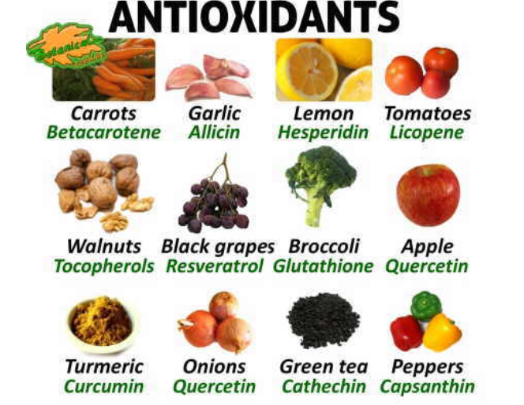

The major components displayed in fruits or vegetables with antioxidant value ,we have :
- Carotenoids are organic pigments found in the chloroplasts and chromoplasts of plants.
They are also found in some organisms such as algae, fungi, some bacteria, and certain species of aphids. there are over 600 known carotenoids. they are split into two classes, xanthophylls and carotenes.
Xanthophylls are carotenoids with molecules containing oxygen, such as lutein and zeaxanthin.

Carotenes are carotenoids with molecules that are unoxygenated, such as α-carotene, β-carotene and lycopene.^{[23]} In plants, carotenoids can occur in roots, stems, leaves, flowers, and fruits. Carotenoids have two important functions in plants. First, they can contribute to photosynthesis. They do this by transferring some of the light energy they absorb to chlorophylls, which then uses this energy for photosynthesis. Second, they can protect plants which are over-exposed to sunlight.

- Beta-carotene .is a carotenoid , this is plant pigment that once ingested turns into the liver and small intestine in vitamin A.it is antioxidant component that favors the non-appearance of cancer, especially in the lungs, mouth and stomach, also prevent of heart disease.

Food with beta-carotene are the following , purslane عشبة الرجلة (portulaca oleracea L.) ,Carrot (Daucus carota L) , Spinach (spinacia oleracea L.) , Water cress نبات البقلة (Nasturtium officinate ), basil )الريحان Ocimom basilicum L.), Tomato (Lycopersicon esculentum ) ect.

- Vitamin C (Ascorbic acid).
addition to its antioxidant properties, this vitamin is also important for the proper absorption of iron, calcium or other amino acids.
Food rich with vitamin c we have : peppers, on of plant that has more quantity, Barbados cherry (Malpighia glabral) , also citruses are very high in it (oranges, lemons ,grapefruit). Etc

- Lycopene , component that gives tomatoes their red color have properties similar to beta carotene which has anticancer properties.

- Glutathione: is another component with antioxidant appears most in broccoli, garlics, potatoes, spinach ,maize.

- Chlorophyll : is one of the best antioxidants capable of neutralizing the negative effects of free radicals in the body.

- Delphinidin (also delphinidine⁾ is an anthocyanidin, a primary plant pigment, and also an antioxidant. Delphinidin gives blue hues to flowers in the genera Viola and Delphinium. It also gives the blue-red color of the grape that produces Cabernet Sauvignon, and can be found in cranberries and Concord grapes as well as pomegranates, and bilberries.

- Vitamin E: protects cell membranes from oxidation by protecting it fatty acids, vegetables rich in oil are richest in this vitamin such as : purslane, asparagus ,peas, lettuce, sun flower seed.

- Copper : it boosts the immune system and it is necessary for the growth of infants. ex. Soybean

- Zinc : in addition to its antioxidant properties zinc in involved in the maturation of the reproductive organs to increase testosterone, ex. Celery, asparagus, borage لسان الثور , figs تين , potatoes, eggplant, peaches, etc ..

- Selenium : ex: Brazil nuts , Oatmeal , brown rice or peachesخوخ .

.

