LECTURE 3 (2022-2023)
Introduction TO stool Analysis
Stool analysis is a series of tests done on a stool (feces) sample to help diagnose certain conditions affecting the digestive tract. These conditions can include infection (such as from parasites, viruses, or bacteria), poor nutrient absorption, or cancer.

General view of digest system:
The digestive tract is a hollow tube that extends through the center of the body from the mouth to the anus.
The walls are lined with a diverse number of epithelial cells that functions are secretion, absorption and maintain the barrier (the mucosal surface and a population of resident immune cells) that protects the host from microbial pathogens.

Anatomyof the Digestive System
The digestive system consists of two main parts:
1-The gastrointestinal tract (GIT)
This tract is divided into the upper and lower gastrointestinal tracts:
Upper Gastrointestinal Tract
The upper gastrointestinal tract includes:
- Oral cavity(Mouth)
- Pharynx
- Esophagus
- Stomach
- Duodenum:
Lower Gastrointestinal Tract
The lower gastrointestinal tract includes most of the small intestine and all of the large intestine. According to some sources, it also includes the anus.
-The small intestine has three parts:

- Duodenum: Here the digestive juices from the pancreas (digestive enzymes) and the gallbladder (bile) mix together.
- Jejunum: This is the midsection of the intestine, connecting the duodenum to the ileum.
- Ileum: Has villi, where all soluble molecules are absorbed into the blood (capillaries and lacteals).
-The large intestine has four parts:
- Cecum: The vermiform appendix is attached to the cecum.
- Colon: Includes the ascending colon, transverse colon, descending colon, and sigmoid flexure. The main function of the colon is to absorb water, but it also contains bacteria that produce beneficial vitamins like vitamin K.
- Rectum
- Anus

2-Accessory glands

Organs that are indirectly involved are known as the accessory digestive organs. The accessory glands consist of the salivary gland, liver, pancreas and gall bladder.

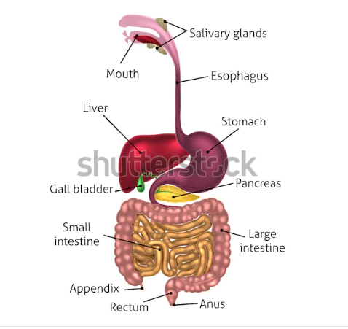

Function of digestive system
- Consuming and digesting foodstuffs, absorbing nutrients, and expelling waste.

Immune barrier: the gastrointestinal tract is also a prominent part of the immune system.
-The low pH (ranging from 1 to 4) of the stomach is fatal for many microorganisms that enter it.
-Mucus (containing IgA antibodies) neutralizes many of these microorganisms.
-Other factors in the GI tract help with immune function as well, including enzymes in saliva and bile

- Normal Gastrointestinal Microbiota (normal flora)
Bacteria make up most of the flora in the colon and up to 60% of the dry mass of feces. Somewhere between 300 and 1000 different species live in the gut. Fungi and protozoa also make up a part of the gut flora, but little is known about their activities.
The microorganisms perform a host of useful functions, such as:

-fermenting unused energy substrates,
-training the immune system, preventing growth of harmful, pathogenic bacteria,
- regulating the development of the gut,
-producing vitamins for the host (such as biotin and vitamin K),
-and producing hormones to direct the host to store fats.

Stool or Feces
Define as: A wastes of food digestion which did not absorbed.
Normal stool characteristics:
Brown in colour, soft, homogenized, do not contain blood, mucus, pus, bacteria, fungi, parasites or viruses, looks like cylinder , PH=7-7.5, contain less than 2-5mg/g stool reducing factors and its quantity around 200g/day.
Diseases of digestive system
There are a number of diseases and conditions affecting the gastrointestinal system, including:
- Infection: Gastroenteritis is an inflammation of the intestines. It occurs more frequently than any other disease of the intestines.
Infections in the digestive system are classified in two groups:
 Exogenous infections –pathogens that come into the body. They are brought in with contaminated food or water.
 Endogenous infections – they are caused by organisms that are part of the normal microbial flora
- Cancer: may occur at any point in the gastrointestinal tract, and includes mouth cancer, tongue cancer, esophageal cancer, stomach cancer, and colorectal cancer.
- Inflammatory conditions: Ileitis is an inflammation of the ileum; Colitis is an inflammation of the intestine, Appendicitis: Is inflammation of the vermiform appendix located at the caecum.
- Diverticular disease: Diverticulosis occurs when pouches form on the intestinal wall. Once the pouches become inflamed it is known as diverticulitis, (the patients stool is red and bloody).
- Cholelithiasis, gallstones in the gallbladder
- Peptic ulcer, open sore in the lining of the stomach or duodenum
- Anal fistula, abnormal tube-like passageway near the anus.
- Dysentery, painful, inflamed intestines commonly caused by bacterial infection.
- Hemorrhoids, swollen, twisted, varicose veins in the rectal region

Symptoms

Several symptoms are used to indicate problems with the gastrointestinal tract:
- Nausea
- Vomiting,which may include regurgitation of food (due to GIT inflammation, acute pain, drugs, pregnancy, emotions) or the vomiting of blood (as in upper GIT bleeding (Haematomesis).
- Melena, black, tarry stools; feces containing digested blood (which isa sign of upper GIT bleeding).
- Diarrhoea, the passage of liquid or more frequent stools (watery), more than three times in a day and more than 200g/day, and with incontinence. There are two types of diarrhea: Acute and chronic diarrhea.
-Acute Diarrhoea : short in time , do not need any medication unless the patient is immunecomprised. Most cases (90%) are due to ingestion of contaminated food with bacteria or its toxin, viruses and parasites, the rest (10%) are due to medication drugs like antibiotics.
-Chronic Diarrhoea: long in time (more than one month), need medication for dehydration because of losing K, Mg, Na salts which may cause death. The causes of chronic Diarrhoea are colitis, malabsorption, colon cancer, irritation of small intestine with some drugs.
- Constipation, which refers to the passage of fewer and hardened stools (difficulty in passing stools (feces)), due to: pregnancy, GIT obstructions with tumors, diverticulum and hemorrhoids, Age.
- Dysphagia, difficulty in swallowing
- Eructation, gas expelled from the stomach through the mouth
- Flatus, gas expelled through the anus.
- Jaundice (icterus), yellow-orange coloration of the skin and whites of the eyes caused by high levels of bilirubin in the blood (hyperbilirubinemia)
- Statorrhea, fat in the feces; frothy, foul-smelling fecal matter, due to malabsorption which result from pancreatic diseases.
Laboratory examination of feces (General Stool Examination) (GST)

Collection of the stool specimen:
For a stool analysis, a stool sample is collected in a clean container and then sent to the laboratory. Laboratory analysis includes microscopic examination, chemical tests, and microbiologic tests
To ensure that good specimens are provided for examination, it is important to note the following:
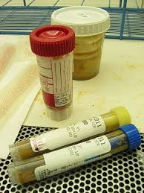
1. A clean dry container must be used for the collection of fecal samples .Avoid Urine and water in order not to destroy trophoziot, if present.
2. Ideally the specimen should be brought to the lab as soon as it is passed, to avoid deterioration of protozoa and alterations of the morphology of protozoa and helminthes.
3. The specimen container should be clearly labeled with the patient's name, date, and time of passage of the specimen.
4. An amount of stool adequate for parasite examination should be collected and a repeat sample requested if too little is supplied.
5. Diarrhoea specimens, or those containing blood and mucus, should be examined promptly on arrival in the laboratory.

The specimens may contain motile amoebic or flagellate trophoziot and may round up and thus be missed if examination is delayed.
-Where amoebic dysentery is suggested, the laboratory should be informed that a "hot stool" is being supplied so that it can be examined within twenty minutes of being passed.

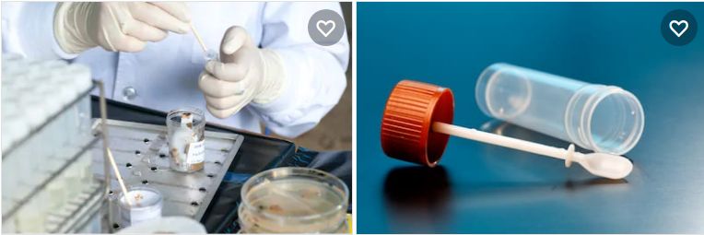

Rectal swabs
Only when it is not possible to obtain feces, should a specimen be collected by using a cotton wool swab. The swab should be inserted in the rectum for about 10 seconds.

The adhesive tape method
This is useful for the detection of the eggs of Vermicularis. The eggs can be collected by wrapping a strip of clear adhesive tape (e.g. cellotape, scotch tape) around the anus. After collecting the eggs, the tape should be sticked lengthways, face down on a microscope slide.

Transport of the specimen
• The specimen must reach the laboratory within 30 minutes of passing of the stool, since the motile organisms, for example, Vibrio and amoebic trophoziot are heat sensitive and they can die or become unrecognizable after that period.
• Transport media such as the Cary-Blair medium can be used for Salmonella, Shigella and Yersinia.
• When cholera is suspected, about 1 ml of specimen should be transferred into 10 ml of alkaline peptone water, which will act as an enrichment as well as transport medium.
• When worms or tapeworm segments are present, these should be transferred to a container of physiological saline and sent to a laboratory for identification.

Macroscopic observation of the fecal sample:

The stool will be checked for colour, consistency, amount, shape, odour, and the presence of mucus.
Macroscopic appearance of the stool can give a clue to the type of organisms present.
- Consistency: Normal stools are well formed. In diarrhea and dysentery the stools are semi solid or watery in nature. The cysts have been mostly found in the formed stools, while trophoziot have been most abundantly found in watery stools.
- Color: the normal adult stool is brown due to bile pigments, and the color of stool is affected by the type of food. Infant feces are yellow-green and semi formed

Abnormal types of feces color:
1-Watery (like rice water): The patient infected with cholera (Vibrio cholerae)
2- Clay or white colored : Obstructive jaundice or presence of barium sulfate
3- Reddish colored: Blood from lower gastrointestinal tract, beef consumption
4- Black: Bleeding from upper gastrointestinal tract (melena), Iron, charcoal.
5- Green: Ingestion of Spinach, antibiotics

- The presence of blood, mucus or pus.
Blood and mucus, it is a case of amoebic dysentery caused by Entameoba histolytica
Blood and pus, the case is bacillary dysentery, caused by Shigella, Compylobacter or E. coli.
Only blood, the diarrhea caused by Salmonella or E. coli or Clostridium difficile

- The presence of adult worms can also be seen in a freshly passed stool eggs adult stages of Ascaris lumbricoides and Enterobius vermicularis. Proglottid of Taenia species can also be seen.

