Tinea pedis(Athlete's Foot)
Infections by anthropophilic dermatophytes are usually caused by the shedding of skin scales containing viable infectious hyphal elements [arthroconidia] of the fungus. Tinea pedis is a dermatophyte infection of the feet.
Tinea pedis is the most common dermatophytosis because moisture from foot sweating facilitates fungal growth.
The feet, especially the soles and toe webs, are most frequently involved in tinea pedis. The more chronic agents of tinea pedis are T. rubrum, T. mentagrophytes and E. floccosum.

Tinea cruris (Jock Itch)
Tinea cruris is a dermatophyte infection of the groin. Common organisms include T. rubrum or T. mentagrophytes. The primary risk factors are associated with a moist environment (ie, warm weather, wet and restrictive clothing, obesity causing skin folds). Men are affected more than women Typically, a pruritic, ringed lesion extends from the crural fold over the adjacent upper inner thigh. infection occur more often during summer.

Tine aunguium (dermatophyte onychomycosis)
Onychomycosis refers to the invasion of the nail plate by a fungus. The infection may be due to dermatophyte a yeast, or non dermatophyte mould. The term "tinea unguium" is used specifically to describe invasive dermatophytic onychomycosis

Clinical Manifestation
To better understand the clinical varieties of onychomycosis, it is important to review the anatomy of the fingernail and surrounding tissues (the "nail unit"). The matrix is where the cells multiply and keratinize before being incorporated into the nail plate. This tissue starts about 5mm proximal to the nail fold and covers all the area called "lunula" or "half moon". The matrix is protected from infection by the cuticle, a fold of modified stratum corneum proximal to the nail plate

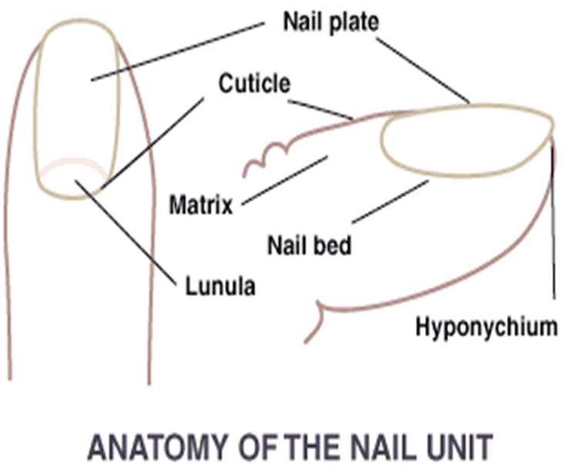

In all forms of onychomycosis, the nail becomes variously disfigured and distorted. hyperkeratosis, onycholysis, leukonychia(white nails or milk spots).
Based on the form of infection and the associated clinical appearance, onychomycosis is classified in this way:

1-Distal subungual onychomycosis (DSO) T. rubrum
2-Proximal subungual onychomycosis (PSO) T. rubrum
3-White superficial onychomycosis (WSO) Trichophyton mentagrophytes

Tinea corporis(Body Ringworm)
Tinea corporis is a dermatophyte infection of the face, trunk, and extremities.
Common causes are T. mentagrophytes, T. rubrum, and M. canis.
Tinea corporis causes pink-to-red annular patches and plaques with raised scaly borders that expand peripherally and tend to clear centrally.

Tinea Barbae
(Barber's Itch)
Tinea barbae is a dermatophyte infection of the beard area most often caused by Trichophyton mentagrophytes or T. verrucosum.
Tinea barbae manifests as superficial annular lesions, but deeper infection similar to folliculitis may occur. It may also occur as an inflammatory kerion that can result in scarring hair loss.
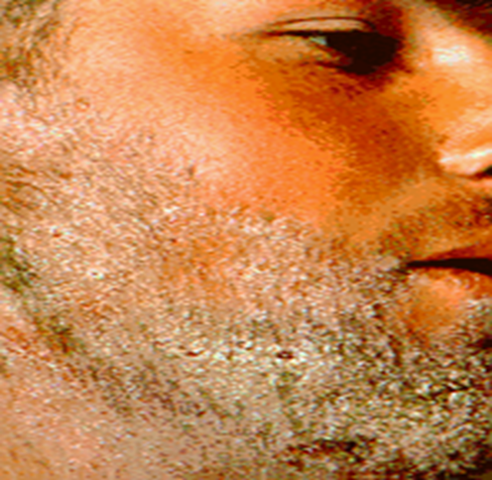

Tinea capitis(Scalp Ringworm)
Tinea capitis refers to dermatophytosis of the scalp. Three types of in vivo hair invasion are recognised:
1-Ectothrix invasion is characterized by the development of arthroconidia on the outside of the hair shaft. The cuticle of the hair is destroyed and infected hairs usually fluoresce a bright greenish yellow colour under Wood's ultraviolet light. Common agents include M. canis, and T. verrucosum.
2-. Endothrix hair invasion is characterised by the development of arthroconidia within the hair shaft only. The cuticle of the hair remains intact and infected hairs do not fluoresce under Wood's ultraviolet light. All endothrix producing agents are anthropophilic T. tonsurans.

3-. Favus usually caused by T. schoenleinii, produces favus-like crusts and corresponding hair loss.
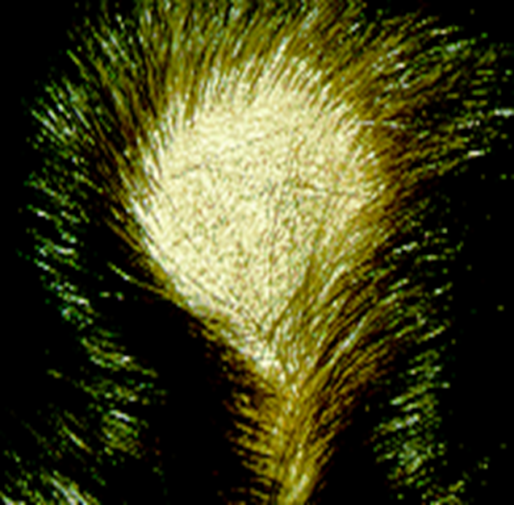

Tinea Manuum
The palmar and interdigital areas of the hand are usually involved in tinea manuum, most frequently presenting as unilateral diffuse hyperkeratosis with accentuation of the flexural creases. Most infections are caused by T. rubrum

Table 2. Oral treatment options for cutaneous fungal infections
Infection | Recommended
Tinea unguium  [Onychomycosis] | Terbinafine 250 mg/day  6 weeks for finger nails,  12 weeks for toe nails.
Tinea capitis | Griseofulvin 500mg/day  [not less than 10 mg/kg/day]  until cure [6-8 weeks].
Tinea corporis | Griseofulvin 500 mg/day until  cure [4-6 weeks], often  combined with a topical  imidazole agent.
Tinea cruris | Griseofulvin 500 mg/day  until cure [4-6 weeks].
Tinea pedis | Griseofulvin 500mg/day  until cure [4-6 weeks].

