Lab. Meteorological
Statistics ........ Fourth stage

(First Semester)
Department of Atmospheric Sciences
2022 – 2023

Lecturers :
Assist. Prof. Zahra salah , L. Ruaa mazin
L. Luma Mahdi , L. Salwa salman

Preparing by: L. Ruaa mazin , L. Luma Mahdi

(( Fifth Lecture ))
D- The harmonic mean: It is a measure of central tendency, and it is the reciprocal
of the arithmetic mean of the reciprocal of these values. It is preferred to use it to find the rate of velocity and rates of change and it cannot be used in the case if one of these values is equal to zero symbolizes it( HM).
HM= $\frac{n}{\sum{\frac{1}{x_{1}}+\frac{1}{x_{2}}+…+\frac{1}{x_{n}}}}$

1-Calculation of the harmonic mean for Unclassified data:
For example\\ calculate the harmonic mean of the following data?
[ 18,37,25,46,57,77,20]
First You write the data in Excel, then we choose the harmonic mean function = Harmean (beginning of the cell: end of the cell)
HM=31.13151
2- Calculation of the harmonic mean of the classified data:

HM=
∑
fi
∑
fi/

xi

For example\\ calculate the harmonic mean of the following data?
fi | xi | Fi\xi
8 | 55
10 | 65
16 | 75
14 | 85
10 | 95
SOLUE\\
HM= 58 \ 0.782603 HM=74.11164
E-The geometric mean is defined as the geometric mean of a set of data as the nth root of the product of these values and is symbolized by the symbol (GM). It is used when calculating the average values of a number of percentages, and it is distinguished from the arithmetic mean by being less affected than the arithmetic mean by outliers or anomalous values, and also it cannot be calculated if the values contain zeros or negative values.
** Calculation of the geometric mean for data:
G = $\sqrt[n]{x_{1}x_{2}x_{3}……x_{n}}$

For example\\ calculate the geometric mean of the following data?

[ 62, 80, 75, 30]
First \\You write the data in Excel, then we choose the geometric mean function
= Geomean (beginning of the cell: end of the cell)
GM= 57.79843

H.W\\ Calculate the geometric mean and the harmonic mean of the following data?

X
2
5
3
4
7
8
8

F- the weighted mean : It is the most accurate measure of results and investments that are related to each other, and this is usually the case with investment portfolios, study results and other statistics, and is symbolized by the symbol (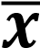W)
** Calculation of the weighted mean for data:

̅

=

∑

$\overline{x}$=$\frac{\sum{w_{x}}}{\sum{w}}=\frac{ x_{1}w_{1+x_{2}w_{2} +x_{3}w_{3}…. }}{w_{1}+w_{2}+w_{3}…….}$

For example\\ calculate the weighted mean of the following data?
mark | weights
90 | 1
85 | 3
70 | 1

Solue\\
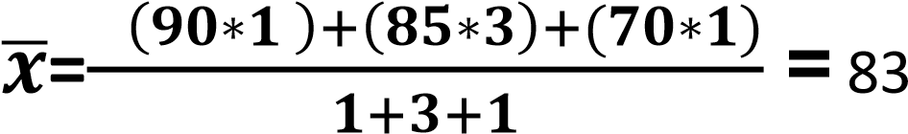

H.W \\ calculate the weighted mean of the following data?
Grade | weight
75 | 0.25
55 | 0.50
97 | 0.25
61 | 0.25

H.W\\ calculate the harmonic mean of the following data?
Class | fi
50- | 8
60- | 10
70- | 16
80- | 14
90- | 10
100- | 5
110-120 | 2

