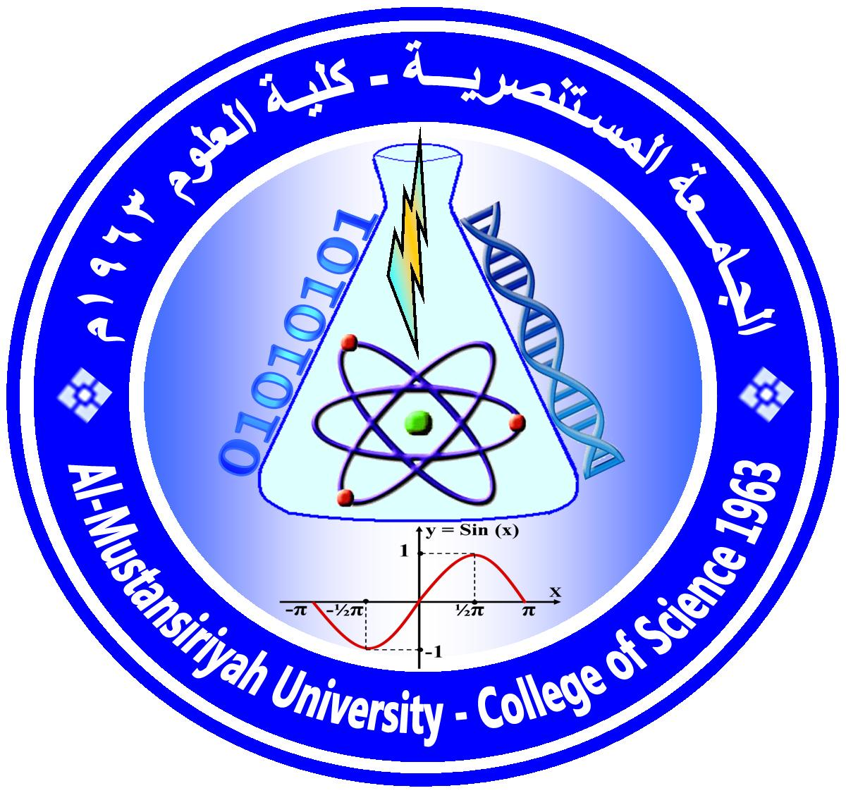
Ministry Of Higher Education and Scientific Research
Mustansiriyah University / College of Science / Department of Mathematics
(الخطة الدراسية للمساق)
Course Plan

Course No.: Time Division: 4hr Theoretical
Course Name: Function Analysis1 Semester & Year: First, 2022/ 2023

Course Website:ان وجد

Course Description:
( 4 credit hours)
The aim of this course is to teach the students the concept of metric spaces, linear spaces, general properties of linear spaces, linear subspaces, normed space and Banach space, and take some important inequality for example,Holders and Minkowski inequality . A linear transformations and their properties, continuous linear transformations, topological isomorphism, equivalent norms, linear transformation and aconvexity, will be given and finally the open mapping theorem, the closed graph theorem, will be prove.

Course Intended Outcomes:
At the end of the Course, students are expected to be able to understand mathematical analysis and functional analysis properly.

Course Outline:

Week | Topics Covered
1 | Metric spaces, linear spaces
2 | General properties of linear spaces, linear subspaces
3 | Some theorems and examples of metric space
4 | Normed space
5 | Examples of normed spaces
6 | Holders and Minkowski inequalities
7 | Banach space
8 | Examples and theorems of Banach spaces
9 | Linear transformations and their properties
10 | Continuous linear transformations
11 | Topological isomorphism, equivalent norms
12 | Closed linear transformtion
13 | The Banach theorem
14 | The open mapping theorem
15 | The closed graph theorem

Textbooks:
[1] Kreyszin E. (1978), Introduction Functional Analysis with applications, New York.
[2] Rudin W. (1991), Function Analysis, 2nd Edition, New York.
[3] Functional Analysis,J.N.Sharma, A.R.Vasishtha
[4] Introduction to Functional Analysis, Daniel Daners, 2006.

Suggested references:
[1] Siddiqui J.
A. (1986), Functional Analysis with applications, New Delhi.
[2] Taylor A. E. (1958), Introduction to Functional Analysis, New York.

Marking:

First Semester |  |  |  | Final Exam
1st exam | 2nd exam | Practical | Activity
10 | 10 | 5 | 5 | 70

Assignment/ Project | Description | Due Date | Marking
Homework | Solve exercises | 20/11/2022 | 5
Test question | For test the understanding | 18/12/2022 | 5

Instructor(s) information [معلومات الأستاذ]

Section: (Mathematics) ; Lecture Room:[ 201,202] ; Office No.: ( 3 )

Instructor's Name: Prof. dr. Arkan Jassim Mohammed
E-Mail: drarkanjassim@uomustansiryiah.edu.iq

Office Hours: Sun. : (10:10– 11:50 )
Tus:08:30-11:30
thursady : (08:30 – 10:10 )

NOTES:
-Office Hour: Other office hours are available by appointment.
-The content of this syllabus not be changed during the current semester.

ARKAN

Prof. dr. Arkan Jassim Mohamme
Lecturer Signature Chairman Signature

