Lab. Meteorological Statistics ........ Fourth stage

(First Semester)
Department of Atmospheric Sciences
2022 – 2023

Lecturers: A.Prof . Zahraa Salah , L. Ruaa mazin ,
L. Luma Mahdi , L. Salwa salman

Preparing by: L. Ruaa mazin , L. Luma mahdi
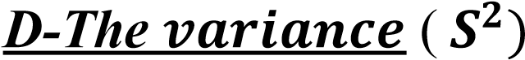: The variance depends on the dispersion and the
divergence of the data from its mean, so the variance is large if the data is divergent from its mean and vice versa.
1-Calculation the variance for unclassified data:
${ S}^{2}$= $\frac{\sum{{x_{i}}^{2}}}{n}$ - ${\left(\frac{\sum{x_{i}}}{n}\right)}^{2}$ ${ S}^{2}$ = $\frac{\sum{{x_{i}}^{2}}}{n}$ - ${ \overline{x}}^{2}$
For example\\ calculate the variance deviation of the following data?
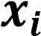 | 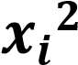
3 | 9
3.5 | 12.25
4 | 16
4.5 | 20.25
5 | 25
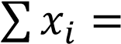20 | 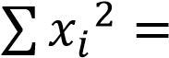 82.5

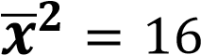
${ S}^{2}$ = $\frac{\sum{{x_{i}}^{2}}}{n}$ - ${\overline{x}}^{2}$
${ S}^{2}$= $\frac{82.5}{5}$ – 16 ${ S}^{2}$=0.5
NOTS: the standard deviation can be extracted by the second method.
- the standard deviation=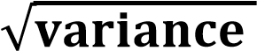
SD = $\sqrt{{ S}^{2} }$ SD = $\sqrt{\frac{\sum{{x_{i}}^{2}}}{n} - { \overline{x}}^{2}}$

For example\\ S.D.= 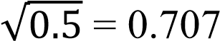 whereas: 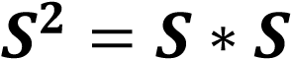=
0.707*0.707= 0.5
2- Standard Deviation = SQRT (Variance )
SD = SQRT (0.5)

2- Calculation the variance for classified data:
${ S}^{2}$ = $\frac{\sum{{x_{i}}^{2}f_{i}}}{\sum{f_{i}}}$ - ${ \overline{x}}^{2}$
For example\\ calculate the variance deviation of the following data?

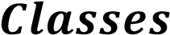 | 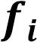 | 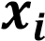 | 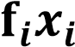 | 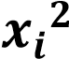 | 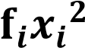
15-19 | 3 | 17 | 51 | 289 | 867
20-24 | 5 | 22 | 110 | 484 | 2420
25-29 | 7 | 27 | 189 | 729 | 5103
30-34 | 15 | 32 | 480 | 1024 | 15360
35-39 | 10 | 37 | 370 | 1369 | 13640
40-44 | 6 | 42 | 252 | 1764 | 10584
45-49 | 4 | 47 | 188 | 2209 | 8836
 | 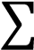 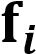 = 50 |  | 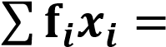1640 |  | 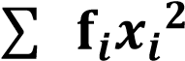=56860

$\overline{x}$= $\frac{\sum{f_{i}x_{i}}}{\sum{f_{i}}}$ = $\frac{1640}{50}$= 32.8 ${\overline{x} }^{2}$=32.8*32.8=1075.84
$1-{ S}^{2}$ = $\frac{\sum{{x_{i}}^{2}f_{i}}}{\sum{f_{i}}}$ - ${\overline{x}}^{2}$ ${ S}^{2}$=$\frac{56860}{50}- 1075.84$ $S^{2}$=61.36

2- S = $\sqrt{\frac{\sum{f_{i}{(x_{i}-\overline{x})}^{2}}}{\sum{f_{i}}}}$ S = $\sqrt{1137.2- 1075.84 }$= 7.833

$S^{2}$ = ${\left(7.833\right)}^{2}$=61.36

H.W (1) \\ find The Standerd deviation and the variance of the following data
Classes |  | 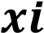
2-4 | 2 | 3
4-6 | 3 | 5
6-8 | 6 | 7
8-10 | 2 | 9
10-12 | 1 | 11
 | 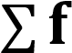=14

H.W(2) \\ find the variance and The Standerd deviation of the following data :

Class | fi
10-14 | 6
15-19 | 5
20-24 | 12
25-29 | 9
30-34 | 8

