Lab. Meteorological Statistics ........ Fourth stage

(First Semester)
Department of Atmospheric Sciences
2022 – 2023

Lecturers: A.Prof . Zahraa Salah , L. Ruaa mazin ,
L. Luma Mahdi , L. Salwa salman

Preparing by: L. Ruaa mazin , L. Luma mahdi
D. Mean Center :
the mean was discussed as an important measure of central tendency for a set of data. If this concept of central tendency is extended to locational point data in two dimensions (X and Y coordinates), the average location, called the mean center, can be determined. the only stipulation is that the phenomenon can be displayed graphically as a set of points in a two-dimensional coordinate system.
The directional orientation of the coordinate axes and the location of the origin are both arbitrary.
Once a coordinate system has been established and the coordinates of each point determined, the mean center can be calculated by separately averaging the X and Y coordinates, as follows:
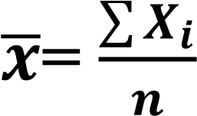 , 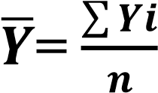
where:
= mean center of X
= mean center of Y
Xi = X coordinate of point i Yi = Y coordinate of point i
n = number of points in the distribution

for example\ Calculate the central mean of the following data
Point | Xi | Yi
A | 61 | 33
B | 80 | 20
C | 10 | 18
D | 12 | 14
E | 20 | 12

H.W\
- Calculate the central mean of The following points represent weather stations centers.
weather stations centers | X | Y
1 | 10 | 4
2 | 16 | 8
3 | 8 | 9
4 | 24 | 12
5 | 18 | 16
6 | 28 | 13
7 | 11 | 10
8 | 30 | 20

