Lec(2) Immunotechnology
Prof .Dr. Ekhlass N. Ali
IMMUNOFIXATION ELECTROPHORESIS
Immunofixation electrophoresis (IFE), or simply immunofixation,has replaced IEP in the evaluation of monoclonal gammopathies because of its rapidity and ease of interpretation.IFE is a two-stage procedure, agarose gel protein electrophoresis
and immunoprecipitation. The test specimen may be serum, urine, cerebrospinal fluid (CSF), or other body fluids.The primary use of IFE in clinical laboratories is for the characterization of monoclonal immunoglobulins.
Clinical Applications
Although IFE was first described in 1964, it was introduced as a procedure for the study of immunoglobulins in 1976. IEP and IFE are complementary techniques best used in the workup of a patient with a suspected monoclonal gammopathy. The laboratory protocol for ruling out monoclonal gammopathy should include high-resolution electrophoresis, IEP of both serum and urine, and a quantitative immunoglobulin assay. These procedures are usually sufficient to detect and characterize monoclonal proteins with a serum concentration of 1 g/dL or more.
The following three protein variables can be determined using IFE:
1. Antigenic specificity
2. Electrophoretic mobility
3. Quantity or ratio of test and control proteins
COMPARISON OF TECHNIQUES
IEP is technically simpler and less subject to antigen excess phenomenon than IFE. If high concentrations of monoclonal protein with IFE give no visible reactions, IEP is considered to be a better technique for typing large monoclonal gammopathies.
Immunofixation electrophoresis can be optimized to give greater sensitivity and resolution than IEP. IFE should be reserved for anomalous proteins, which are difficult to characterize by IEP. These include small bands, such as those exhibited
in the early stages of monoclonal gammopathies or L-chain disease, and any multiple, closely spaced bands. The results of IFE are easier to interpret than those of IEP because interpretation is based on examination of a precipitate pattern
directly analogous to routine electrophoresis; IFE does not depend on detecting slight deviations in the shape of a precipitin arc (Fig. 1; Table 1).
Table1: Comparison of Immunoelectrophoresis and Immunofixation Electrophoresis .
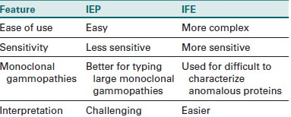
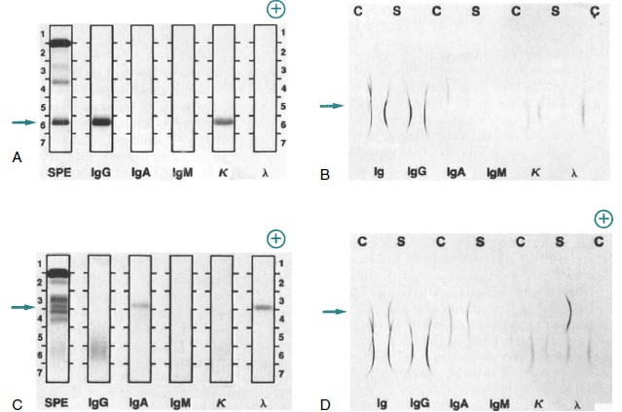

Fig1: Comparison of immunofixation electrophoresis (IFE) and immunoelectrophoresis (IEP) for two patients with monoclonal gammopathies.
A, Patient specimen with an IgG (κ) monoclonal protein, as identified by IFE. Note the position of the monoclonal protein (arrow). After electrophoresis, each track except serum protein electrophoresis (SPE) is reacted with its respective antiserum; then, all tracks are stained to visualize the respective protein bands. Immunoglobulins G, A, and M (IgG, IgA, IgM); kappa (κ); and lambda (λ) indicate antiserum used on each track. B, Same specimen as in A, with proteins identified by IEP. Note the position of the monoclonal protein (arrow). Normal control (C) and patient sera (S) are alternated. After electrophoresis, antiserum is added to each trough, as indicated by the labels Ig, IgG, IgA, IgM, κ, and λ. The
antisera react with separated proteins in the specimens to form precipitates in the shape of arcs. The IgG and κ arcs are shorter and thicker than
those in the normal control, showing the presence of the IgG (κ) monoclonal protein. The concentrations of IgA, IgM, and λ light chains also are reduced. C, Patient specimen with an IgA (λ) monoclonal protein identified by the IFE procedure, as described in A. D, Same specimen as in C,
with proteins identified by IEP, as described in B. The abnormal IgA and λ arcs for the patient specimen indicate an elevated concentration of amonoclonal IgA (λ) protein.
Separation Techniques Used in CapillaryElectrophoresis
Capillary Zone Electrophoresis
Capillary zone electrophoresis (CZE) is the most widely used type of CE because of its simplicity and versatility. As long as a molecule is charged, it can be separated by CZE.Also, CZE is simple to perform because the capillary is only
filled with buffer. Separation occurs as solutes migrate at different velocities through the capillary. Another advantage of CZE is that it separates anions and cations in the same run, which is not done in other CE methods. However,CZE cannot separate neutral molecules.
Isotachophoresis define or talk about
Isotachophoresis (ITP) is a focusing technique based on the migration of the sample components between the leading and terminating electrolytes. Solutes with mobilities intermediate to those of the leading and terminating electrolytes
stack into sharp focused zones. Although used as a mode of separation, transient ITP has been used primarily as a sample concentration technique.
Capillary Isoelectric Focusing
Capillary isoelectric focusing (CIEF) is a separation method that allows amphoteric molecules, such as proteins, to be separated by electrophoresis in a pH gradient generated between the cathode and anode. A solute will migrate to a point at which its net charge is zero. At the solute’s isoelectric point (pI), migration stops, and the sample is focused into a tight zone. In CIEF, once a solute has focused at its pI,the zone is mobilized past the detector by either pressure or chemical means. CIEF is often employed in protein characterization as a mechanism to determine a protein’s pI.
CAPILLARY ELECTROPHORESIS
In capillary electrophoresis (CE) the classic separation techniquesof zone electrophoresis, isotachophoresis, isoelectric focusing,and gel electrophoresis are performed in small-bore (10- to 100-μm), fused silica capillary tubes, 20 to 200 cm in length
The CE method is efficient, sensitive, and rapid. High electrical field strengths are used to separate molecules based on differences in charge, size, and ydrophobicity. Sample introductionis accomplished by immersing the end of the capillary into a samplevial and applying pressure, vacuum, or voltage.
Table2: Comparison of Traditional Capillary Electrophoresis and Microchip Capillary Electrophoresis
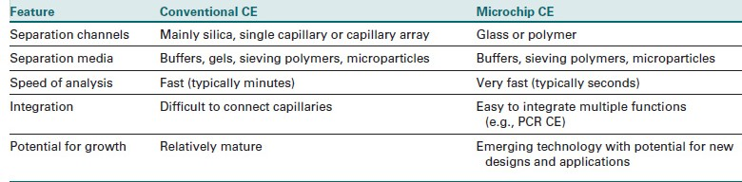
Microchip CE was developed in the early 1990s. The advantages of microchip CE include high speed, reduced reagent consumption, integration analysis, and miniaturization. The applications of microchip CE are diverse and include immune
disorders. Conventional CE revolutionized DNA analysis and was vital to the Human Genome Project. Microchip CE is still in the early stages of development but has demonstrated distinct advantages compared with traditional CE(table2)
Principle
is intended for the identification of monoclonal gammopathies in serum, urine, or CSF using high-resolution protein electrophoresis and immunofixation.In the first step of the IFE procedure, a single specimen is applied to six different positions on an agarose plate and the proteins are separated according to their net charge by electrophoresis.In the second phase, monospecific antisera are applied to five of the electrophoresis patterns: IgG, IgA, IgM, and κ and γ antisera. A protein fixative solution is applied to the sixth pattern to produce a complete protein reference pattern. The plate is incubated for 10 minutes.If complementary antigen is present in the proper proportions in the test sample, antigen-antibody complexes form and
precipitate. The formation of a stable antigen-antibody precipitate fixes the protein in the gel. After fixation, the gel is washed in deproteinization solution (e.g., dilute NaCl) and nonprecipitated proteins are washed out of the agarose, leaving only the
antigen-antibody complex. The protein reference pattern and the antigen-antibody precipitation bands are stained with a protein-sensitive stain.

Western blot technique
proteins are separated electrophoretically, transferred to membranes, and identified through the use of labeled antibodies specific for the protein of interest (Fig. 3).
Western blot: technique detects antibodies to specific epitopes of antigen subspecies. Electrophoresis of antigenic material results in the separation of the antigen components by molecular weight (MW). Blotting the separated antigen to
nitrocellulose, retaining the electrophoretic position, and causing it to react with patient specimen will result in the binding of specific antibodies, if present, to each antigenic band. Electrophoresis of known MW standards allows for the determination of the MW of each antigenic band to which antibodies may be produced. These antibodies are then detected using EIA reactions that characterize antibody specificity.The Western blot technique is often used to confirm the
specificity of antibodies detected by enzyme-linked immunosorbent assay (ELISA) screening procedures.

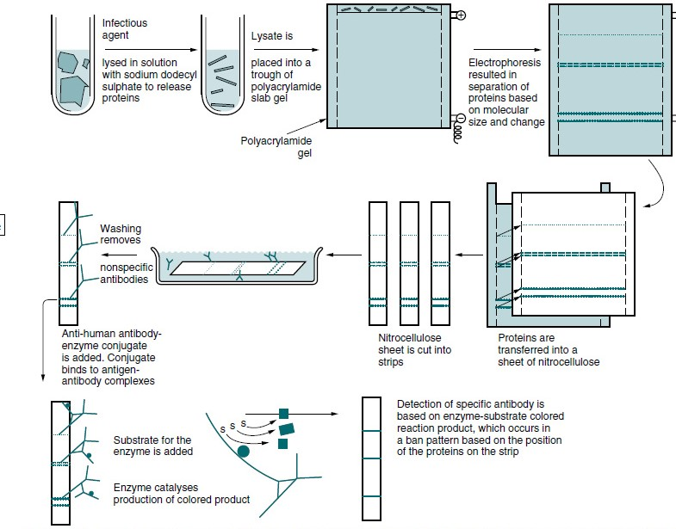
Fig3: Western blot immunoassay
Direct and Indirect Methods
Direct detection uses a labeled primary antibody. Because incubation with a secondary antibody is eliminated, this strategy is performed in less time than a classical Western blot. Additionally, background signal from secondary antibody cross reactivity is eliminated. Direct detection also enables probing for multiple targets simultaneously. Labeling a primary antibody, however, sometimes has an adverse effect on its immune reactivity, and even in the best of circumstances, a labeled primary antibody cannot provide signal amplification. Consequently, the direct method is generally less sensitive than indirect detection and is best used only when the target is relatively abundant. One option is biotinylating the primary antibody, which is an indirect method that both amplifies the signal and eliminates the secondary antibody. Labeling with
biotinylation reagents typically results in more than one biotin moiety per antibody molecule. Each biotin moiety is capable of interacting with an enzyme-conjugated avidin, streptavidin or Thermo Scientific Neutr Avidin Protein. These multiple enzymes catalyze the conversion of appropriate substrate to amplify the signal. Essentially, the avidin conjugate replaces a secondary antibody and its appropriate molar concentration is the same as if a secondary antibody were used.
Blocking buffer
Many different blocking reagents are available for Western blotting. Because no blocking reagent is appropriate for all systems, empirical testing is essential.
The system’s antibodies or target. For example, using 5% non fat milk as a blocking reagent when using avidin/biotin systems results in high background because milk contains variable amounts of endogenous biotin, which binds the a vidin.
Western Blotting Protocol
1. Separate the proteins in the sample by gel electrophoresis.
2. Prepare the transfer buffer: Use Tris-glycine transfer buffer dissolved in 400 ml of ultrapure water plus 100 ml methanol (25 mM Tris, 192 mM glycine, pH 8.0, 20% methanol). Use and store the transfer buffer at 4°C.
3. Construct a gel “sandwich” (Figure 3) for wet transfer. For semi-dry transfer, prepare the sandwich in the same order between the anode and cathode.
4. Transfer proteins from the gel to a membrane. For wet transfer using a mini transfer apparatus designed for a 8 × 10 cm gel, transfer at 40 V for 90minutes keeping the buffer temperature at 4°C. For semi-dry transfer use 15 V for 90 minutes.
5. Remove the membrane and block nonspecific binding sites with a blocking
buffer for 20-60 minutes at room temperature (RT) with shaking.
6. Incubate the blot with the primary antibody solution (see Table 2) containing 10%blocking solution with rocking for 1 hour.If desired, incubate the blot overnight a 2-8°C.
7. Wash the membrane three times for 5 minutes each with Tris-buffered saline (TBS), phosphate-buffered saline (PBS) or other physiological wash buffer containing 0.05% Tween-20. If using an enzyme-conjugated primary antibody, proceed to Step 10.
8. Incubate blot with the enzyme conjugate (see Table 3) containing 10% blocking solution for 1 hour with rocking at RT.
9. Wash the membrane five times for 5 minutes each in wash buffer to remove any non bound conjugate. It is crucial to thoroughly wash the membrane after incubation with the enzyme conjugate.
10. Prepare the substrate. Use a sufficient volume to ensure that the blot is completely wetted with substrate and the blot
does not become dry (0.1 ml/cm2).
11. Incubate the blot with substrate for 1 minute when using Pierce ECL or 5 minutes when using Super Signal Substrates.
12. Remove the blot from the substrate and place it in a plastic membrane protector. A plastic sheet protector works well,although plastic wrap also may be used. Remove all air bubbles between the blot and the surface of the membrane protector.
13. Image the blot using film or a cooled CCD camera.

