Lec(4) Immunotechnolgy
Prof.Dr.Ekhlass N. Ali
Q/ Compare between Direct immunofluorescent assays& Indirect immunofluorescent assays

Direct immunofluorescent assays | Indirect immunofluorescent assays
involve antigen detection through a specific antibody that is labeled with a fluorescent tag | the original antibody is un labeled.Incubation with antigen is followed by addition of a second labeled anti-immunoglobulin that detects antigen–antibody complexes.

Cell Flow cytometry
Principle
The first true flow cytometers were developed in the 1960s,primarily for research purposes. However, in the early 1980s,physicians started seeing patients with a new mysterious disease characterized by a drop in circulating helper T cells,and flow cytometry was brought into the clinical laboratory. Since that time, flow cytometry has been routinely used to identify infection with HIV, and immunophenotyping cells—identifying their surface antigen expression—has
become a major component of the workload in most clinical immunology laboratories.Cell flow cytometry is an automated system in which single cells in a fluid suspension are analyzed in terms of their intrinsic light-scattering characteristics and are simultaneously evaluated for extrinsic properties (i.e., the
presence of specific surface proteins) using fluorescent labeled antibodies or probes. By using several different fluorochromes,cytometers can simultaneously measure multiple cellular properties.
Q/ Whats important of cell flow cytometry?
Answer By using several different fluorochromes,cytometers can simultaneously measure multiple cellular properties;1- Another significant advantage of flow cytometry is that because the flow rate of cells within the cytometer is so rapid,
2-thousands of cells can be analyzed in seconds, allowing for the accurate detection of very rare cells.
Q/The major components of a flow cytometer :include the fluidics, the laser light source, the optics and photodetectors, and a computer for data analysis and management
Q/ Define of the FLOW Cytometry ,whats the important?
Answer: Flow cytometry is a powerful tool to identify and enumerate various cell populations. It was first used in clinical laboratories to perform CD4_ T-cell counts in HIVinfected individuals. A flow cytometer measures multiple properties of cells suspended in a moving fluid medium. As each cell or particle passes single file through a laser light source, it produces a characteristic light pattern that is measured by multiple detectors for scattered light (forward and 90 degrees) and fluorescent emissions (if the cell is stained with a fluorochrome).
Q/ Compare between forward & Side scatter
Forward scatter | Side scatter
is a measure of cell size | determines a cell’s internal complexity,  or granularity.

Instrumentation
1-Fluidics
For cellular parameters to be accurately measured in the flow cytometer, it is crucial that cells pass through the laser one at a time in single file. Cells are processed into a suspension ,and the cytometer draws up the cell suspension and
injects the sample inside a carrier stream of isotonic saline (sheath fluid) to form a laminar flow. The sample stream is constrained by the carrier stream and is thus hydronamically focused so that the cells pass single file through the intersection of the laser light source (Fig. 1).
2- Laser Light Source Each cell is interrogated by a light source that typically consists of one or more small air-cooled lasers. The wavelength of monochromatic light emitted by the laser in turn dictates
which fluorochromes can be used. A fluorochrome, or fluorescent molecule, is one that absorbs light across a spectrum of wavelengths and emits light of lower energy
across a spectrum of longer wavelengths. Each fluorochrome has a distinctive spectral pattern of absorption (excitation) and emission.
Q/ WHY Not all fluorochromes can be used with all lasers?
Answer: because each fluorochrome has distinct spectral characteristics.Therefore, the choice of fluorochromes to be used in an assay depends on the light source used for excitation (Table 1). Most clinical flow cytometers have at least one laser, typically argon, that emits at 488 nm.
Newer cytometers also have a second laser, helium-neon (He-Ne),that emits at 633 nm.Q/ whats the important? This allows more fluorochromes to be analyzed in a single tube at one time. As a result of a cell passing through the laser, light is scattered in many directions.
The amount and type of light scatter (LS) can provide valuable information about a cell’s physical properties. Light at two specific angles is measured by the flow cytometer:
forward-angle light scatter (FSC), and orthogonal right angle light scatter, or 90-degree-angle light scatter (SSC).
Q/ What light source is used in most flow cytometers?
Table1: Fluorochromes communly used in clinical flow cytometry
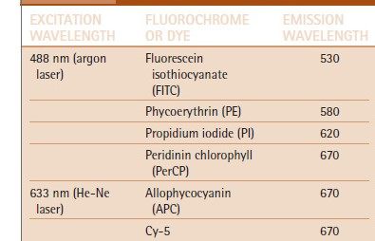
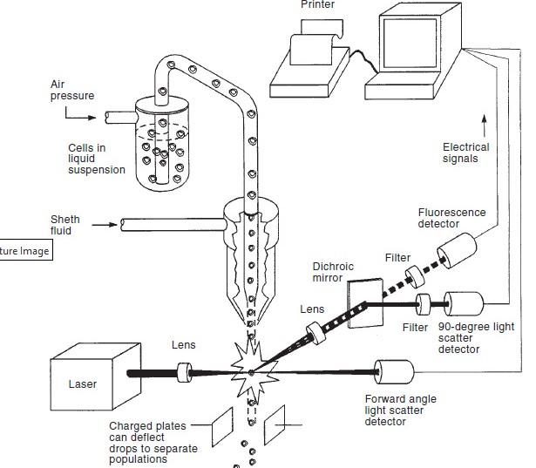
Fig1: Flow cytometry. Components of a laser-based flow cytometer include the fluidics system
for cell transportation, a laser for cell illumination, photo detectors for signal detection, and a computer- based management system .Both forward and 90-degree LS are measured, indicating cell size and type
FSC, or light scattered at less than 90 degrees, is considered an indicator of size, while the SSC signal is indicative of granularity or intracellular complexity of the cell. Thus , these two values, which are considered intrinsic parameters, can be used to characterize different cell types. If one looks at a sample of whole blood on a flow cytometer, where all the red blood cells have been lysed, the three major populations of white blood cells (lymphocytes, monocytes, and granulocytes) can be roughly differentiated from each other based solely on their intrinsic parameters (FSC and SSC;Fig. 2).Unlike FSC and SSC, which represent light-scattering
properties that are intrinsic to the cell, extrinsic parameters require the addition of a fluorescent probe for their detection. Fluorescent labeled antibodies bound to the cell are interrogated by the laser. By using fluorescent molecules with various emission wavelengths, the laboratorian can simultaneously evaluate an individual cell for several extrinsic properties. The clinical utility of such multicolor analysis
is enhanced when the fluorescent data are analyzed in conjunction with FSC and SSC
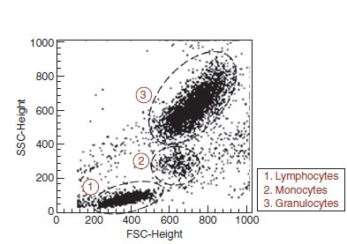

Fig2: Peripheral blood leukocyte analysis by simultaneous evaluation of forward-angle light scatter (FCS) and 90-degree LS (SSC). Based on the intrinsic characteristics of size (FSC) and
granularity (SSC) only, the three main populations of white cells(lymphocytes, monocytes, and granulocytes) can be discriminated into individual populations.

3-Optics
The various signals (light scatter and fluorescence) generated by the cells’ interaction with the laser are detected by photomultiplier tubes and detectors. The number of fluorochromes capable of being measured simultaneously is limited by the number of photodetectors in the flow cytometer.The specificity of each photodetector for a given band length of wavelengths is achieved by the arrangement of a series of optical filters that are designed to maximize collection
of light derived from a specific fluorochrome while minimizing collection of light from other fluorochromes used to stain the cells. The newer flow cytometers actually use fiber-optic cables to direct light to the detectors. Most clinical flow cytometers in use today are capable of three to six-color detection using one to two lasers.When fluorescent light reaches the photomultiplier tubes, it creates an electrical current that is converted into a voltage pulse. The voltage pulse is then converted (using various methods depending on the manufacturer) into a digital
signal. The digital signals are proportional to the intensity of light detected. The intensity of these converted signals is measured on a relative scale that is generally set into 1 to 256 channels, from lowest energy level or pulse to the highest level.
Data Acquisition and Analysis
Once the intrinsic and extrinsic cellular properties of many cells (typically 10,000 to 20,000 “events” are collected for each sample) have been collected and the data digitalized, it is ready for analysis by the operator. Each parameter can be analyzed independently or in any combination. Graphics of the data can be represented in multiple ways. The first level of representation is the single-parameter istogram,
which plots a chosen parameter (generally fluorescence) on the x-axis versus the number of events on the y-axis, so only a single parameter is analyzed using this type of graph (Fig3). The operator can then set a marker to differentiate between cells that have low levels of fluorescence (negative) from cells that have high levels of fluorescence (positive) for a particular fluorochrome labeled antibody.
The computer will then calculate the percentage of “negative” and “positive” events from the total number of events collected. The next level of representation is the bivariant histogram, or dual-parameter dot plot, where each dot represents an individual cell or event. Two parameters, one on each axis,are plotted against each other. Each parameter to be analyzed is determined by the operator. Using dual-parameter dot plots, the operator can then draw a “gate” around a population
of interest and analyze various parameters (extrinsic and intrinsic) of the cells contained within the gated region (Fig. 4). This allows the operator to screen out debris and isolate subpopulations of cells of interest.

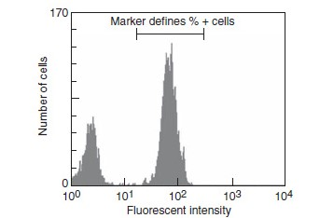
Fig3: Example of a single parameter flow histogram. The y-axis consists of the number of events. The x-axis is the parameter to be analyzed, which is chosen by the operator, usually an extrinsic parameter, such as a fluorescent labeled antibody. The operator can then set a marker to isolate the positive events. The computer will then calculate the percent positive events within the designated markers

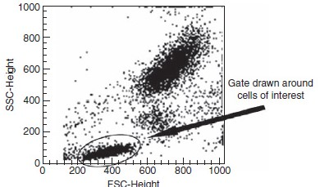
Fig4: A dual-parameter dot plot. Both parameters on the x- and y-axes are chosen by the operator. In this case, lysed whole blood is analyzed on FSC (x-axis) and SSC (y-axis). The operator then draws a “gate” or isolates the population of interest (e.g., lymphocytes)for further analysis.

characteristics of the gated population can be analyzed—that is, lymphocytes can be gated, and then the subpopulations of T cells (CD3_ and CD4_ or CD2_) and B cells (CD2_,CD19_) can be analyzed The absolute count of a particular cell type—for instance, CD4_ Tlymphocytes—is obtained by multiplying the absolute cell count of the population of interest (e.g., lymphocytes)
derived from a hematology analyzer by the percentage of the population of interest in the sample (CD3_ and CD4_lymphocytes).1,
Sample Preparation
Q/What type of biological sample is best suited for flow cytometric analysis?
Samples commonly used for analysis include Answer: whole blood,bone marrow, and fluid aspirates.
Whole blood should be collected into ethylene di aminetetra acetic acid (EDTA), the anticoagulant of choice for samples processed within30 hours of collection. Heparin can also be used for whole blood and bone marrow and can provide improved stability in samples over 24 hours old. Blood should be stored at
room temperature (20ºC to 25ºC) prior to processing and should be well mixed before being pipetted into staining tubes. Hemolyzed or clotted specimens should be rejected. Peripheral blood, bone marrow, and other samples with large numbers of red cells require erythrocyte removal to allow for efficient analysis of white cell s.Historically, density gradient centrifugation with Ficoll-Hypaque (Sigma, St. Louis, MO) was used to generate a cell suspension enriched for lymphocytes or blasts. However this method results in selective loss of some cell populations. Alternatively, there are numerous erythrocyte lysis techniques available, both commercial and noncommercial. Tissue specimens are best collected and transported in tissue culture medium (RPMI 1640) at either room temperature or 4ºC, if analysis will be delayed. The specimen is then disaggregated to form a single cell suspension, either by mechanical dissociation or by enzymatic digestion.Mechanical disaggregation, or “teasing,” is preferred and is accomplished by the use of either a scalpel and forceps, a needle and syringe, or wire mesh screen Antibodies are then added to the resulting cellular preparation and processed for analysis. The antibodies used are typically monoclonal, each with a different fluorescent tag.

Q/ Clinical Applications
Routine applications of flow cytometry in the clinical laboratory include
1-immunophenotyping of peripheral blood lymphocytes, enumeration of CD34_ stem cells in peripheral blood and bone marrow for use in stem cell transplantation,
and immune phenotypic characterization CD19 of acute leukemias, non-Hodgkin’s lymphomas, and other lymphoproliferative disorders.Immunophenotyping by flow cytometry has become an important component of initial evaluation and subsequent post-therapeutic monitoring in leukemia and lympho mamanagement. Flow cytometric findings have been incur poratedinto current leukemia and lymphoma classifications ,beginning with the Revised European-American Lymphoma classification in 1994 and, more recently, in the proposed World Health Organization (WHO) classifications. One of the most important components of flow cytometric analysisis the stratification of hematopoietic malignancies by their lineage (i.e., B cell, T cell, or myeloid) and the degree of differentiation. Some of the more common cell differentiation antigens Immuno phenotyping by flow cytometry, in what ever capacity that it is used, is not possible without the use of
fluorescent-labeled monoclonal and polyclonal antibodies .Q/ WhyMonoclonal antibodies specific for various surface antigens are preferable to using polyclonal antibodies.
Answer; The ability to produce monoclonal antibodies through hybridoma and recombinant DNA techniques has contributed greatly to the accuracy of flow cytometry and has widened its use.
Lymphocytes are identified using monoclonal antibodies directed against specific
surface antigens. Reactions can be identified manually by employing a fluorescence microscope or by immune enzyme staining methods. However, flow cytometry is the most commonly used method for immunophenotyping of
lymphocyte populations.

