Lec(1) Sera & Vaccines
Prof. Dr. Ekhlass Noori Ali

The History Of Vaccines And Immunization:
campaign started in 1998 and, led largely by the WHO and several large philanthropic donors, has reduced the number of polio cases worldwide by over 99%. Worldwide vaccination campaigns can also be credited with the control of at least 10 other major infectious diseases (measles, mumps, rubella, typhoid, tetanus, diphtheria, pertussis, influenza, yellow fever, and rabies), many of which previously affected and killed many, mostly babies and young children.
Still, a need remains for vaccines against many other diseases, including AIDS, among others. More work is needed for existing vaccines as well: to improve the safety and efficacy of some, or to lower the cost and ensure delivery of existing vaccines to those most in need, especially in developing countries.
Immunization is the process of eliciting a state of protective immunity against a
disease-causing pathogen. Exposure to the live pathogen followed by recovery is one route to immunization. However, while highly effective, this can also be dangerous.
Vaccination, or intentional exposure to modified forms or parts of a pathogen that do not cause disease (a vaccine), is another. In an ideal world, both will engage antigen specific lymphocytes and result in the generation of memory cells, providing long-lived protection. However, vaccination does not always ensure immunity. Thus, vaccination is an event, whereas immunization (the development of a protective memory response)is a potential outcome of that event.
Passive immunization: the transfer of antibodies from mother to fetus or the injection of antiserum against a pathogen or a toxin to provide.
Without the development of memory B or T cells specific to the organism, however, this state of immunity is only temporary.
Edward Jenner and Louis Pasteur are recognized as the pioneers of vaccination for their documented attempts to induce active immunity,
passive immunity. These latter two investigators were the first to show that immunity elicited in one animal can be transferred to another by injecting serum taken from the first.
Passive immunization, in which preformed antibodies are transferred to a recipient ,occurs naturally when maternal IgG crosses the placenta to the developing fetus .Maternal antibodies to diphtheria, tetanus, streptococci, measles, mumps, and poliovirus all afford passively acquired protection to the developing fetus and for months in the newborn.
Maternal antibodies present in breast milk can also provide passive immunity to the infant in the form of maternally produced IgA. The latter ,however, enters the baby’s digestive tract and therefore has a different and complementary effect to maternal IgG circulating in the blood.
Passive immunization can also be achieved by injecting a recipient with preformed antibodies, called antiserum, from other immune individuals. Before vaccines and antibiotics became available, passive immunization was the only effective therapy for some otherwise fatal diseases, such as diphtheria, providing much needed humoral defense
Currently, several conditions still warrant the use of passive immunization, including the following:
1-Immune deficiency, especially congenital or acquired B-cell defects
2-Toxin or venom exposure with immediate threat to life
3-Exposure to pathogens that can cause death faster than an effective immune
response can develop
Babies born with congenital immune deficiencies are frequently treated by passive immunization, as are children experiencing acute respiratory failure caused by respiratory syncytial virus (RSV). Passive immunity is used in unvaccinated individuals exposed to the organisms that cause botulism, tetanus, diphtheria, hepatitis, measles, and rabies, or to protect travelers and health care workers who anticipate or experience exposure to pathogens for which they lack protective immunity.
Antiserum also provides an antidote against the poisonous venom in some snake and insect bites. In all these instances, it is important to remember that passive
immunization does not activate the host’s natural immune response. It serves as a buffer between the pathogen, or a toxin, and the host but generates no memory
response, so protection is transient.

Although passive immunization may be effective, it should be used with caution
because certain risks are associated with the injection of preformed antibody. If the antibody was produced in another species, such as a horse (one of the most common animal sources), the recipient can mount a strong response to the isotypic determinants of the foreign antibody, or the parts of the antibody that are unique to the horse species (typically constant-region domains). This anti-isotype response can cause serious complications. Some individuals will produce IgE antibody against horse specific determinants. High levels of these IgE–horse antibody immune complexes can induce pervasive mast-cell degranulation, leading to systemic anaphylaxis
Other individuals produce IgG or IgM antibodies specific for the foreign antibody, resulting in complement-activating immune complexes. The deposition of these complexes in the tissues can lead to type III hypersensitivity reactions. Even whenpurified human antiserum or human gammaglobulin is used (a mixture of IgG from many different human B cells), the recipient can generate an anti-allotype response.
Active Immunization to Induce Immunity and Memory
Active immunization is to trigger the adaptive immune response in a waythat will elicit protective immunity and long-lived immunologic memory. When active immunization is successful, a subsequent exposure to the infectious agent elicits a secondary immune response that successfully eliminates the pathogen or prevents disease mediated by its products.
Active immunization can be achieved by 1-natural :exposure to the infectious agent or a similar agent (e.g., cowpox exposure can protect against smallpox) or it can be 2-acquired artificially by administration of a vaccine.
An example of the former might be the “chickenpox parties,Chickenpox in adults can be more serious with more complications, so immunity, as the name implies, the immune system plays an active role—proliferation of antigen-reactive T and B cells is induced and results in the formation of protective memory cells. This is the primary goal of vaccination.
Vaccination programs have played an important role in the reduction of deaths from infectious diseases, especially among children. In the United States, vaccination of children begins at birth. The American Academy of Pediatrics sets nationwide recommendations (updated in 2017) for childhood immunizations in this country, as outlined in Table 1. The program recommends or requires 10 vaccines for children from birth to age 6.
TABLE :1 Recommended childhood immunization schedule in the United States, 2017
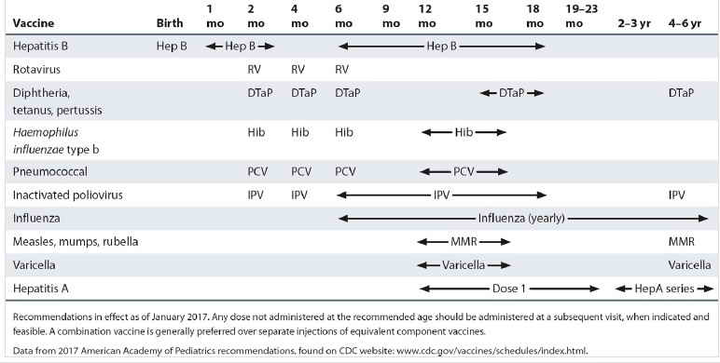

In adolescents between the age of 11 and 12, vaccination against the sexually
transmitted human papillomavirus (HPV), the primary cause of cervical cancer in women, is also recommended . Vaccines against meningitis, as well as boosters for tetanus and influenza, are recommended for all on a regular schedule throughout adulthood

As illustrated in Table 1, children typically require boosters (repeated
vaccinations or inoculations) at appropriately timed intervals to achieve protective immunity against many of the common pathogens. In the first months of life, the reason for this may be persistence of circulating maternal antibodies in the young infant. For example, passively acquired maternal antibodies can bind to epitopes on the DTaP vaccine and block adequate activation of the immune system; therefore, in order to achieve protective immunity this vaccine must be given more than once after we expect all maternal antibody has been cleared from an infant’s circulation (6–12months). Passively acquired maternal antibody is also known to interfere with the effectiveness of the measles vaccine; for this reason, the combined measles/mumps/rubella (MMR) vaccine is not given before 12 months of age.However, in some developing countries, the measles vaccine is administered at 9months, a little early to ensure clearance of all maternal antibodies but crucial because 30% to 50% of young children in these countries contract the disease before 15 months of age. Multiple immunizations with the polio vaccine are required to ensure that an
adequate immune response is generated to each of the strains of poliovirus that make up the vaccine.
herd immunity. The appearance of some recent measles epidemics, such as among college students or preschool-age children, is a testament to the power of herd immunity and likely occurred partly thanks to decreased vaccination rates in these populations. One recent example is a measles outbreak centered around an amusement park in California during the 2014-15 holiday season, highlighting the potential fallout from rising numbers of unvaccinated
individuals and falling levels of herd immunity.
Passive immunity, which is only temporary and does not engage the host’s immune response or generate memory, can be acquired naturally (e.g., in utero trans placental IgG) or delivered artificially to protect individuals from subsequent infectious disease or recent venom exposures, and in those who lack humoral responses.
Active immunity :can be triggered by either natural infection or artificial exposure to some form of a pathogen, such as a vaccine, with a goal of inducing a memory response that will be protective in the future.
The introduction of vaccine campaigns, especially in children, has vastly reduced the risk of death from infectious disease worldwide.

