1. Disaster management cycle
Disaster management aims to:
1. Reduce, or avoid, the potential losses from hazards.
2. Assure prompt and appropriate assistance to victims of disaster.
3. Achieve rapid and effective recovery.

The Disaster management cycle illustrates the ongoing process by which governments, businesses, and civil society plan for and reduce the impact of disasters, react during and immediately following a disaster, and take steps to recover after a disaster has occurred. Appropriate actions at all points in the cycle lead to greater preparedness, better warnings, reduced vulnerability or the prevention of disasters during the next iteration of the cycle. The complete disaster management cycle includes the shaping of public policies and plans that either modify the causes of disasters or mitigate their effects on people, property, and infrastructure.
The mitigation and preparedness phases occur as disaster management improvements are made in anticipation of a disaster event. Developmental considerations play a key role in contributing to the mitigation and preparation of a community to effectively confront a disaster. As a disaster occurs, disaster management actors, in particular humanitarian organizations, become involved in the immediate response and long-term recovery phases. The four disaster management phases illustrated here do not always, or even generally, occur in isolation or in this precise order. Often phases of the cycle overlap and the length of each phase greatly depends on the severity of the disaster.

- Mitigation - Minimizing the effects of disaster.
Examples: building codes and zoning; vulnerability analyses; public education.
- Preparedness - Planning how to respond.
Examples: preparedness plans; emergency exercises/training; warning systems.
- Response - Efforts to minimize the hazards created by a disaster.
Examples: search and rescue; emergency relief.
- Recovery - Returning the community to normal.
Examples: temporary housing; grants; medical care.

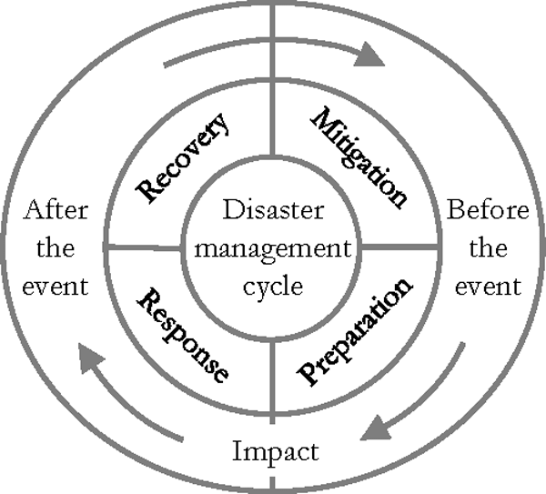
Sustainable Development
Developmental considerations contribute to all aspects of the disaster management cycle. One of the main goals of disaster management, and one of its strongest links with development, is the promotion of sustainable livelihoods and their protection and recovery during disasters and emergencies. Where this goal is achieved, people have a greater capacity to deal with disasters and their recovery is more rapid and long lasting. In a development oriented disaster management approach, the objectives are to reduce hazards, prevent disasters, and prepare for emergencies. Therefore, developmental considerations are strongly represented in the mitigation and preparedness phases of the disaster management cycle. Inappropriate development processes can lead to increased vulnerability to disasters and loss of preparedness for emergency situations.

1.1 Mitigation
Mitigation efforts are attempts to prevent hazards from developing into disasters altogether or to reduce the effects of disasters. The mitigation phase differs from the other phases in that it focuses on long-term measures for reducing or eliminating risk. Mitigation measures can be structural or non-structural. Structural measures use technological solutions like flood levees. Non-structural measures include legislation, land-use planning (e.g. the designation of nonessential land like parks to be used as flood zones), and insurance. Mitigation is the most cost-efficient method for reducing the affect of hazards although not always the most suitable. Mitigation includes providing regulations regarding evacuation, sanctions against those who refuse to obey the regulations (such as mandatory evacuations), and communication of risks to the public.

1.2 Preparedness
Preparedness is a continuous cycle of planning, organizing, training, equipping, exercising, evaluation and improvement activities to ensure effective coordination and the enhancement of capabilities to prevent, protect against, respond to, recover from, and mitigate the effects of natural disasters.

In the preparedness phase, emergency managers develop plans of action to manage and counter their risks and take action to build the necessary capabilities needed to implement such plans. Common preparedness measures include:
- communication plans with easily understandable terminology and methods.
- proper maintenance and training of emergency services, including mass human resources such as community emergency response teams.
- development and exercise of emergency population warning methods combined with emergency shelters and evacuation plans.
- stockpiling, inventory, and maintain disaster supplies and equipment.
- develop organizations of trained volunteers among civilian populations.

1.3 Response
The aim of emergency response is to provide immediate assistance to maintain life, improve health and support the morale of the affected population. Such assistance may range from providing specific but limited aid, such as assisting refugees with transport, temporary shelter, and food, to establishing semi-permanent settlement in camps and other locations. It also may involve initial repairs to damaged infrastructure. The focus in the response phase is on meeting the basic needs of the people until more permanent and sustainable solutions can be found. Humanitarian organizations are often strongly present in this phase of the disaster management cycle.

1.4 Recovery
The aim of the recovery phase is to restore the affected area to its previous state. It differs from the response phase in its focus; recovery efforts are concerned with issues and decisions that must be made after immediate needs are addressed. Recovery efforts are primarily concerned with actions that involve rebuilding destroyed property, re-employment, and the repair of other essential infrastructure. Efforts should be made to "build back better," aiming to reduce the pre-disaster risks inherent in the community and infrastructure.

