8- Electron Theory
All matter is composed of molecules which are made up of a combination of atoms. Atoms have a nucleus with electrons orbiting around it. The nucleus is composed of protons and neutrons (not shown). Most atoms have an equal number of electrons and protons. Electrons have a negative charge (-). Protons have a positive charge (+). Neutrons are neutral. The negative charge of the electrons is balanced by the positive charge of the protons. Electrons are bound in their orbit by the attraction of the protons. These are referred to as bound electrons.
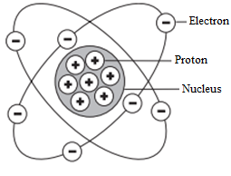

8-1 Free Electrons:
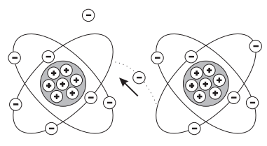
Electrons in the outer band can become free of their orbit by the application of some external force such as movement through a magnetic field, friction, or chemical action. These are referred to as free electrons. A free electron leaves a void which can be filled by an electron forced out of orbit from another atom. As free electrons move from one atom to the next an electron flow is produced. This is the basis of electricity.

8-2 Conductors, Insulators and Semiconductors
8-2-1 Conductors:
An electric current is produced when free electrons move from one atom to the next. Materials that permit many electrons to move freely are called conductors. Copper, silver, aluminum, zinc, brass, and iron are considered good conductors. Copper is the most common Metal used for conductors and is relatively insive.
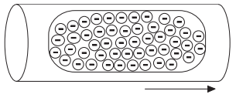

8-2-2 Insulators:
Materials that allow few free electrons are called insulators. Materials such as plastic, rubber, glass, mica, and ceramic are good insulators
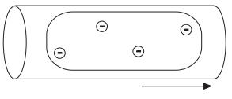

An electric cable is one example of how conductors and insulators are used. Electrons flow along a copper conductor to provide energy to an electric device such as a radio, lamp, or a motor. An insulator around the outside of the copper conductor is provided to keep electrons in the conductor.

8-2-3 Semiconductors:
Semiconductor materials, such as silicon, can be used to manufacture devices that have characteristics of both conductors and insulators. Many semiconductor devices will act like a conductor when an external force is applied in one direction. When the external force is applied in the opposite direction, the semiconductor device will act like an insulator. This principle is the basis for transistors, diodes, and other solid-state electronic devices.
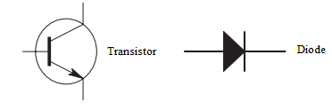

8-3 Electric Charges:
8-3-1 Neutral State of an Atom
Elements are often identified by the number of electrons in orbit around the nucleus of the atoms making up the element and by the number of protons in the nucleus. A hydrogen atom, for example, has only one electron and one proton. An aluminum atom (illustrated) has 13 electrons and 13 protons. An atom with an equal number of electrons and protons is said to be electrically neutral.
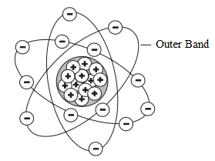

8-3-2 Positive and Negative Charges:
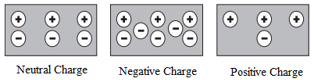
Electrons in the outer band of an atom are easily displaced by the application of some external force. Electrons which are forced out of their orbits can result in a lack of electrons where they leave and an excess of electrons where they come to rest. The lack of electrons is called a positive charge because there are more protons than electrons. The excess of electrons has a negative charge. A positive or negative charge is caused by an absence or excess of electrons. The number of protons remains constant.

8-4 Attraction and Repulsion of Electric Charges:
The old saying, “opposites attract,” is true when dealing with electric charges. Charged bodies have an invisible electric field around them. When two like-charged bodies are brought together, their electric field will work to repel them. When two unlike-charged bodies are brought together, their electric field will work to attract them. The electric field around a charged body is represented by invisible lines of force. The invisible lines of force represent an invisible electrical field that causes the attraction and repulsion. Lines of force are shown leaving a body with a positive charge and entering a body with a negative charge.

