11- An Electric Circuit:
A fundamental relationship exists between current, voltage, and resistance. A simple electric circuit consists of a voltage source, some type of load, and a conductor to allow electrons to flow between the voltage source and the load. In the following circuit a battery provides the voltage source, electrical wire is used for the conductor, and a light provides the resistance. An additional component has been added to this circuit, a switch. There must be a complete path for current to flow. If the switch is open, the path is incomplete and the light will not illuminate. Closing the switch completes the path, allowing electrons to leave the negative terminal and flow through the light to the positive terminal.
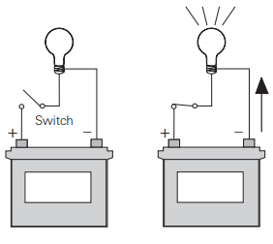
11-1 An Electrical Circuit Schematic:
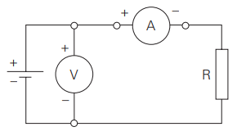
The following schematic is a representation of an electrical circuit, consisting of a battery, a resistor, a voltmeter and an ammeter. The ammeter, connected in series with the circuit, will show how much current flows in the circuit. The voltmeter, connected across the voltage source, will show the value of voltage supplied from the battery. Before an analysis can be made of a circuit, we need to understand Ohm’s Law.

11-2 Ohm’s Law:( Georg Simon Ohm and Ohm’s Law)
The relationship between current, voltage and resistance were studied by the 19th century German mathematician, George Simon Ohm. Ohm formulated a law which states that current varies directly with voltage and inversely with resistance. From this law the following formula is derived.

I=$\frac{E}{R}$ or Current =$\frac{Voltage}{Resistance}$
Ohm’s Law is the basic formula used in all electrical circuits. Electrical designers must decide how much voltage is needed for a given load, such as computers, clocks, lamps and motors. Decisions must be made concerning the relationship of current, voltage and resistance. All electrical design and analysis begin with Ohm’s Law. There are three mathematical ways to express Ohm’s Law. Which of the formulas is used depends on what facts are known before starting and what facts need to be known
I=$\frac{E}{R}$ E= I x R R =$\frac{E}{ I}$

11-2-1 Ohm’s Law Triangle:
There is an easy way to remember which formula to use. By arranging current, voltage and resistance in a triangle, one can quickly determine the correct formula.

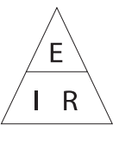

Using the Triangle:
To use the triangle, cover the value you want to calculate. The remaining letters make up the formula.

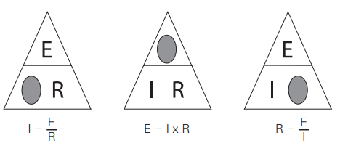
Ohm’s Law can only give the correct answer when the correct values are used. Remember the following three rules:
- Current is always expressed in amperes or amps
- Voltage is always expressed in volts
- Resistance is always expressed in ohms

11-2-2 Examples of Solving Ohm’s Law
- Using the simple circuit below, assume that the voltage supplied by the battery is 10 volts, and the resistance is 5 Ω
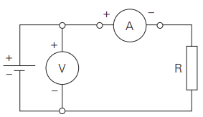
To find how much current is flowing through the circuit, cover the “I” in the triangle and use the resulting equation.
I=$\frac{E}{R}$ → I =$\frac{ 10 volts}{5 Ω}$ = 2mps

- Using the same circuit, assume the ammeter reads 200 mA and the resistance is known to be 10 Ω. To solve for voltage, cover the “E” in the triangle and use the resulting equation.

E = I x R → E = 0.2 x 10 → E = 2 volts
Remember to use the correct decimal equivalent when dealing with numbers that are preceded with milli (m), micro (µ) or kilo (k). In this example had 200 been used instead of converting the value to 0.2, the wrong answer of 2000 volts would have been calculated.

11- 3 DC Series Circuit
11-3-1 Resistance in a Series Circuit:
A series circuit is formed when any number of resistors are Series Circuit connected end-to-end so that there is only one path for current to flow. The resistors can be actual resistors or other devices that have resistance. The following illustration shows four resistors connected end-to-end. There is one path of current flow from the negative terminal of the battery through R4, R3, R2, R1 returning to the positive terminal.
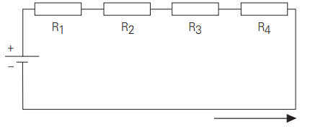
11-3-2 Formula for Series Resistance:
The values of resistance add in a series circuit. If a 4 Ω resistor is placed in series with a 6 Ω resistor, the total value will be 10 Ω. This is true when other types of resistive devices are placed in series. The mathematical formula for resistance in series is:

R_{t} = R₁ + R₂ + R₃ + R₄ + R₅

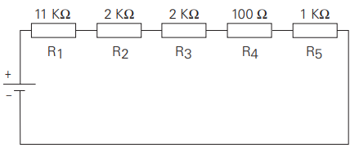
R_{t} = R₁ + R₂ + R₃ + R₄ + R₅
R_{t} = 11000 + 2000 + 2000 + 100 + 1000
R_{t} = 16100 Ω
11- 4 Current in a Series Circuit:
The equation for total resistance in a series circuit allows us to simplify a circuit.
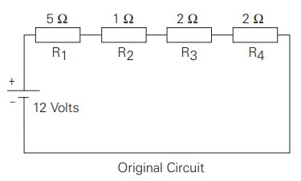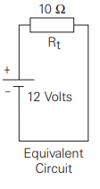
Using Ohm’s Law, the value of current can be calculated. Current is the same anywhere it is measured in a series circuit.
I=$\frac{E}{R}$ → I =$\frac{ 12volts}{10 Ω}$ = 1.2 Amps

11-5 Voltage in a Series Circuit:
Voltage can be measured across each of the resistors in a circuit. The voltage across a resistor is referred to as a volt age drop. A German physicist, Kirchhoff, formulated a law which states the sum of the voltage drops across the resistances of a closed circuit equals the total voltage applied to the circuit. In the following illustration, four equal value resistors of 1.5 Ω each have been placed in series with a 12-volt battery. Ohm’s Law can be applied to show that each resistor will “drop” an equal amount of voltage.
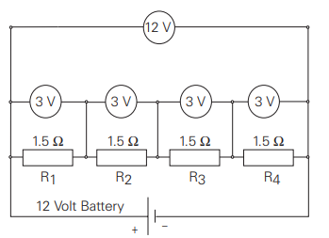
- First, solve for total resistance:
R_{t} = R₁ + R₂ + R₃ + R₄
R_{t} = 1.5 + 1.5 + 1.5 + 1.5 → R_{t =} 6 Ω
- Second, solve for current:
I=$\frac{E}{R}$ → I=$\frac{12 volts}{6 Ω}$ I = 2 Amps
- Third, solve for voltage across any resistor:
E = I x R → E = 2 x 1.5 → E = 3 Volts
If voltage were measured across any single resistor, the meter would read three volts. If voltage were read across a combination of R₃ and R₄ the meter would read six volts. If voltage were read across a combination of R₂, R₃, and R₄ the meter would read nine volts. If the voltage drops of all four resistors were added together the sum would be 12 volts, the original supply voltage of the battery.
11- 6 Voltage Division in a Series Circuit:
It is often desirable to use a voltage potential that is lower than the supply voltage. To do this, a voltage divider, similar to the one illustrated, can be used. The battery represents E_{in} which in this case is 50 volts. The desired voltage is represented by E_{out}, which mathematically works out to be 40 volts. To calculate this voltage,
- First solve for total resistance.
R_{t} = R₁ + R₂ R_{t} = 5 + 20 R_{t} = 25 Ω
- Second, solve for current:
I=$\frac{E_{in}}{R_{t}}$ → I=$\frac{50}{25}$ → I = 2Amps
- Finally, solve for voltage:
E_{out} = I x R₂ → Eout = 2 x 20 →E_{out} = 40 Volts

