Immunotechnology
Lec 1 MSC / Biotechnology (2021-2022) Prof.Dr. Ekhlass N.Ali
Syllabus:
1-Major histocompatibility complex
2-Immunoglobulin and Immunoglobulin genes.
3-Isotype
4-NK cell
5-B-cells develop.
6-T-cells
7- Monoclonal Antibodies.
8-Immune response
9-Cytokines.
10- Inflammatory Response.
11- Diagnostic Immunology.
References:
Cabriel Virella(2007) Medical Immunology 6 ^{th}ed , informa healthcare, USA.

Major histocompatibility complex
Grafting of tissues or organs between genetically unrelated individuals is usually followed by rejection of the grafted tissue or organ. On the other hand, if tissues or organs are transplanted between genetically identical individuals, rejection does not take place. Development of inbred strains of mice was a prerequisite to designing experiments to advance our understanding of the factors controlling graft rejection or acceptance. Inbred strains are obtained after 20 or more generations of brother/sister mating, and all individuals of a strain are virtually identical genetically. Skin-grafting experiments using inbred mice have shown that ability to accept or reject a graft is under genetic control, and that it is subject to the general immunological rules of specificity and memory. When skin was grafted among animals of the same inbred strain, no rejection was observed. When grafting involved mice of different strains, the recipients rejected the graft; the speed and intensity of the rejection reaction were clearly dependent on the degree of genetic relatedness between the strains used in the experiment.
Further understanding of the genetic regulation of graft rejection/acceptance was obtained in studies involving first-generation hybrids (F1) produced by mating animals of two genetically different strains. Such hybrids did not reject tissues from either parent, while the parents rejected the skin graft from the hybrids. The acceptance of tissues from both parental strains by F1 hybrids was explained by the development of tolerance in these animals to all paternal and maternal antigens during embryonic differentiation. The animals of the parental strains rejected the tissues from the hybrids because the grafts express histocompatibility antigens of the other nonidentical strain to which they were not tolerant. Another important conclusion from these experiments was that the histocompatibility determinants are codominantly expressed.
Further studies, diagrammatically summarized in Figure 1, showed that graft rejection shares two important characteristics with the classical immune responses: specificity and memory. Animals repeatedly grafted with skin from a donor of one given strain show accelerated rejection, but if they receive a skin graft from an unrelated strain the rejection time is as long as that observed in a first graft.
MAJOR HISTOCOMPATIBILITY COMPLEX General Concepts
The genetic system that determines the outcome of a transplant is complex and highly polymorphic. It encodes for antigens of variable immunogenic strength. The major antigens are responsible for most graft rejection responses, and trigger a stronger immune response than the others, which are designated as minor. The aggregate of major histocompatibility antigens is known as major histocompatibility complex (MHC). It includes numerous components of widely diverse and related structure and function.
Human Major Histocompatibility Complex: Human Leukocyte Antigens
Historically, the human histocompatibility antigens were defined after investigators observed that the serum of multiparous women contained antibodies that agglutinated their husbands lymphocytes. These leukoagglutinins were also present in the serum of multitransfused
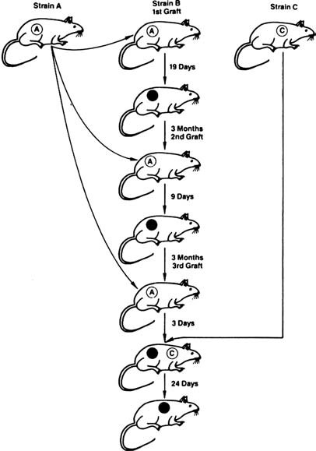

FIGURE 1 Diagrammatic representation of an experiment designed to demonstrate the memory and specificity of graft rejection. Memory is demonstrated by the progressive shortening of the time that takes a mouse of strain B to reject consecutive skin grafts from a strain A. Specificity is demonstrated by the fact that the mouse of strain B is already able to reject a graft from strain A in an accelerated fashion, and if given a graft from a third, unrelated strain (C), rejection will take as long as the rejection of the first graft from strain A. In other words, sensitization of mouse B to strain A was strain-specific and did not extend to unrelated strains.
individuals, even when the donors were compatible with the transfused individual for all known blood groups. The antigens responsible for the appearance of these antibodies were thus present on leukocytes and received the designation of human leukocyte antigen (HLA).
It is immune responsiveness to these antigens that underlies the rejection of tissues grafted between genetically unrelated individuals . The study of HLA antigens received its initial impetus from the desire to transplant tissues with minimal risk of rejection and from their interest to geneticists as the most polymorphic genetic system in humans. (Polymorphism is the presence of more than one allele at the same locus. A locus is considered polymorphic if the least frequent allele is present in more than 1% of the individuals in a population.)
It took several decades for a wider picture of the biological significance of HLA antigens to become obvious. Today, we know that these molecules are at the very core of the immune response and are the basis of the establishment of immune tolerance (lack of response) to self-antigens, as discussed later in this chapter, as well as in . CLASSIFICATION, STRUCTURE, AND DETECTION OF HLA GENES AND GENE PRODUCTS
Major Histocompatibility Complex and Human Leukocyte Antigen Classes
Six major loci of the human MHC (HLA) have been identified and are divided in two classes: class I (HLA-A, HLA-B, and HLA-C) and class II (HLA-DP, HLA-DQ, and HLA-DR). All loci are polymorphic at varying degrees, and the number of alleles identified at each locus is growing rapidly. For instance, at the end of 2005, 414 A, 728 B, and 210 C alleles have been identified. The class II loci are similarly polymorphic. In addition to these major loci, there are some minor loci in the HLA region that are not as well-defined: E, F, G, and H for class I and DM, DN, and DO for class II. Homologous MHC classes have been defined in other mammalian species (Table 1).

TABLE 1 Main Characteristics of Major Histocompatibility Complex Antigen Classes
Characteristics | Class I | Class II
Major loci (mouse) | K, D, L | I (-A,-E)
Major loci (man) | A, B, C | D class (DP, DQ, DR)
Nonclassic loci (man) | E, G, F
No. of allelesª | .100 | .100
No. of specificitiesª | 100 | .100
Bound peptides | 7–15 AA | 10–30 AA
Distribution of products | Classical: all nucleated cells; nonclassical: extravillous trophoblasts | APCs: Monocytes, dendritic cells, macrophages, B cells; activated T cells
ªFor major loci.
Abbreviation: APCs, antigen-presenting cells.
Structure of the Major Histocompatibility Complex Antigens

Class I Major Histocompatibility Complex Molecules
The HLA or H2 (MHC of mice) molecules are heterodimers formed by two nonidentical polypeptide chains: an a chain and a b chain. The heavier a chain of 43,000 to 48,000 daltons, encoded by genes in the MHC region on chromosome 6, has a long extracellular region folded in three domains, named a₁, a₂ and a₃. b₂-microglobulin, a 12,000-dalton protein coded by a gene located on chromosome 15, is postsynthetically and noncovalently associated with the major polypeptide chain.
Comparison of amino acid and nucleotide sequences of various domains of class I MHC shows that the a₁ and a₂ domains are highly variable, and that most of the amino acid and nucleotide changes responsible for the differences between alleles occur in these domains. It also shows areas in these domains that are relatively constant and closely related in different alleles. This explains why polyclonal antibodies raised against MHC molecules can recognize several epitopes, an occurrence designated as the existence of “public” specificities as opposed to the “private” specificities unique to each allele.
X-ray crystallography studies have determined the three-dimensional structure of HLA class I molecules (Fig. 2), and clarified the relation between the structure and the function of this molecule. The most polymorphic areas of the molecule are located within and on the edges of a groove formed at the junction of the helical a₁ and a₂ domains. This groove is usually occupied by a short peptide (10–11 residues), usually of endogenous origin. The a₃ domain shows much less genetic polymorphism and, together with b₂-microglobulin, is like a frame supporting the deployment in space of the more polymorphic a₁ and a₂ domains. In addition, the a₃ domain has a binding site for the CD8 molecule characteristic of cytotoxic T cells .
Class II Major Histocompatibility Complex Molecules
Although a remarkable degree of tertiary structure homology exists between class I and class II gene products (Fig. 3), there are important differences in their primary structure. First, class II gene products are not associated with b₂-microglobulin. The MHC-II molecules consist of two distinct polypeptide chains, a b chain (MW 28,000) that is highly polymorphic, and a less polymorphic, heavier chain, achain (MW 33,000). Each polypeptide chain has two extracellular domains (a₁ and a₂; b₁ and b₂). The NH2 terminal ends of the a₁ and b₁ domains contain hypervariable regions. Both chains are encoded by genes in the MHC region on chromosome 6.
The three-dimensional structure of class II antigens has also been established. The b₁ domains of class II MHC antigens resemble the a₂ domain of their class I counterparts. The junction of a₁ and b₁ domains forms a groove similar to the one formed by the a₁ and a₂ domains of class I MHC antigens, and it also binds antigen-derived peptides (usually of exogenous origin), but it is larger than the groove of MHC-1 indicating that the peptides bound to it are longer.

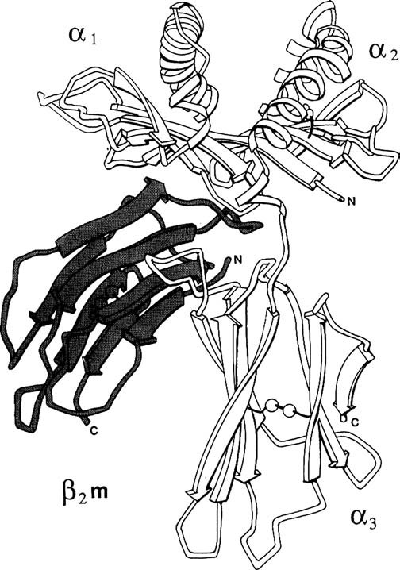
FIGURE 2 Schematic representation of the spatial configuration of the HLA-A2 molecule, based on X-ray crystallography data. The diagram shows the immunoglobulin-like domains (a₃, b₂m) at the bottom and the polymorphic domains (a₁, a₂) at the top. The indicated C terminus corresponds to the site of papain cleavage; the native molecule has additional intramembrane and intracellular segments. The a₁ and a₂ domains form a deep groove, which is identified as the antigen recognition site. Source: Modified from Bjorkman PJ, et al. Nature 1987; 329:506.
The b₁ domain also contains two important sites located below the antigen-binding site. The first acts as a receptor for the CD4 molecule of helper T lymphocytes (see Chapters 4, 10, and 11). The second site, which overlaps the first, is a receptor for the envelope glycoprotein (gp 120) of the

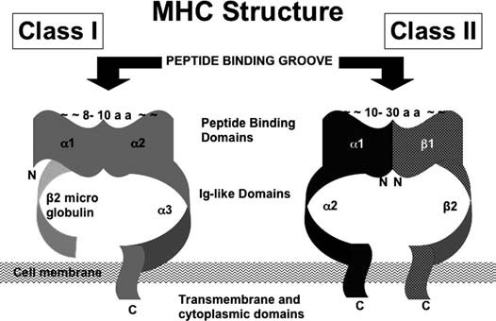

FIGURE 3 Diagrammatic representation of the structure of human class I and class II histocompatibility antigens. Source: From Dr JA Sleasman.

Identification of Human Leukocyte Antigen Antigens

HLA alleles are recognized by two main types of assays—serological technique and hybridization with sequence-specific oligonucleotides.
Serological Technique
The serological technique, which is the oldest and most widely used, is based on the lymphocytotoxicity of anti-HLA antibodies of known specificity in the presence of complement. The antibodies used for HLA typing were initially obtained from multiparous women or from recipients of multiple transfusions. Such antibodies are still in use, but monoclonal antibodies (see Chapter 10) are now available for most HLA specificities. These antibodies identify a broad constellation of HLA epitopes, designated as serologically defined antigens.
Some individuals express unknown specificities at some loci, which the typing laboratory reports as “blank.” Investigation of these “blank” specificities often leads to the discovery of new HLA antigens. To avoid confusion, they are assigned a numerical designation by regularly held workshops of the World Health Organization. At first, the designation is preceded by a w, indicating a provisional assignment. For example, DQw3 designates an antigenic specificity of the DQ locus that has been tentatively designated as w3 by a workshop. When worldwide agreement is reached that it is a new specificity, the w is dropped.
Hybridization with Sequence-Specific Oligonucleotides
Hybridization with sequence-specific oligonucleotides is particularly useful for typing MHC-II specificities. The MHC region has been completely sequenced. In case of MHC-I molecules, all alleles correspond to variations in the a chains; the b chain (b-2 microglobulin) is monomorphic. In case of HLA-DR molecules, the achain is invariant, but the bchain genes are extremely polymorphic. In contrast, HLA-DP and DQ molecules have polymorphic aand bchains, and thus are much more diverse than the DR molecules. As the sequences of HLA genes became known, it became possible to produce specific probes for different alleles. Typing usually involves DNA extraction, denaturation into single-stranded DNA, fragmentation with restriction enzymes, amplification by PCR, and finally hybridization with labeled cDNA probes specific for different alleles of the corresponding genes.
Such molecular typing has further subdivided the serologically defined alleles into more refined specificities based on their nucleotide sequences. For instance, serologically defined HLA-A2 antigen now has more than 56 members based on DNA sequence analyses. All these are collectively known as HLA-A02 alleles that code for the serologically defined HLA-A2 antigen. Similarly, nucleotide-defined alleles of HLA-B7 are designated as HLAB0702-0706. In the case of DQ and DP the nomenclature identifies both the polypeptide chain where the nucleotide sequence has been identified and the serological corresponding marker, if defined. For example, two DQ haplotypes, one of DQ03 (HLADQA10301DQB10302) and the other of DQ05 (DQA10501-DQB10201), are often mentioned in the literature because they are generally associated with susceptibility to develop type-1 diabetes
Cellular Distribution of the Major Histocompatibility Complex Antigens
Class I MHC molecules (HLA-A, B, and C alleles in humans and H2-K, D, and L alleles in mice) are expressed on all nucleated cells. They are particularly abundant on the surface of lymphocytes (1000 to 10,000 molecules/cell).
Class II MHC molecules (The I-A and I-E alleles of the mouse H2 complex and the DP, DQ, and DR alleles of the human HLA system) are primarily expressed in two groups of leukocytes: B lymphocytes and cells of the monocyte-macrophage family. The latter includes all antigen-presenting cells (Langerhans cells in the skin, Kupffer cells in the liver, microglial cells in the central nervous system, and dendritic cells in the spleen and lymph nodes). While resting T lymphocytes do not express MHC-II molecules, these antigens can be detected after cell activation.
Chromosomal Localization and Arrangement of the Major Histocompatibility Complex Genes

The MHC genes are located on chromosome 6 of humans and chromosome 17 of the mouse. A simplified map of human chromosome 6 is shown in Figure 4. The MHC genes can be grouped in the same classes as the antigens detected in cell membranes, that is, MHC class I and class II genes. The MHC region in humans spans about four million base pairs, whereas in mice it is only about two million base pairs long. In mice, the H2-K, D, and L loci (class Ia genes) are the most polymorphic; in contrast, class Ib genes, which include H2M3 and Qa1, are much less polymorphic. They are followed by the I region that includes two loci: I-A and I-E (class II genes). One related locus (locus S), located between the H-2K and H-2D loci, codes for the complement components C4, C2, and Bf.
The organization of the HLA gene complex in man is similar (Fig. 5). The class-I genes are also divided into two groups: Ia, which includes the polymorphic HLA-A, B, and C genes and Ib, which includes HLA-E, F, and G that are almost monomorphic. Class II genes (DP, DQ, and DR) in humans, located proximal to the centromere, are followed by genes coding for proteins related to the complement cascade such as Bf, C2, and C4. There are two C4 loci (C4A and C4B) separated from each other by the gene coding for the enzyme 21-ahydroxylase, which is involved in the synthesis of steroid hormones. This region also includes genes for tumor necrosis factor-a(TNF-a) and TNF-b, also known as lymphotoxin a.
FIGURE 4 Simplified map of the region of human chromosome 6, where the human leukocyte antigen (HLA) locus is located. The genes for 21 a and 21 b hydroxylase and for tumor necrosis factor a and b (lymphotoxin-a) have also been located to chromosome 6, but are not considered as part of the HLA complex.

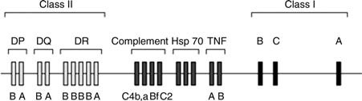

GENETICS OF THE MAJOR HISTOCOMPATIBILITY COMPLEX
HLA antigens are inherited as autosomal codominant (both alleles are expressed in a heterozygote) genes according to Mendelian laws. As mentioned before, the HLA system is extremely polymorphic, making it unlikely for two unrelated individuals to share all their HLA alleles. This is the basis for their use as genetic markers, which found a major practical application in paternity studies before DNA analysis became routine. Extensive HLA polymorphism, however, also presents a major obstacle to organ and tissue transplantation. As expected, related individuals share their HLA genes, and the proportion of shared genes depends on the degree of relatedness. For instance, there is a 25% chance of two siblings being HLA identical, making them ideal donor-recipient candidates for organ and tissue transplantation.
Because of the close proximity of HLA loci, the set of alleles present on a maternal or paternal chromosome 6 is usually transmitted en bloc, and such a group of closely linked alleles is called a haplotype. There are infrequent exceptions to this intact transmission of a haplotype from a parent to the child because of occasional (approximately 1%) meiotic crossing over between the loci in paternal or maternal chromosome 6 homologues.
Because all alleles of an individual are codominant, it follows that both haplotypes that form an individual genotype will be expressed in the cells of that individual. The sum of all the specificities coded by the genome of the individual is known as that individual’s HLA type. An example of the notation of a given individual’s phenotype is as follows: HLA- Al,2; B8,27; Dw3,-; DR23,-. The hyphen indicates that only one antigen of a particular locus can be typed; this can signify that the individuals are homozygous or they possesses an antigen that cannot be typed because appropriate reagents are not yet available.
Population genetics theory predicts that in a panmictic population (random mating), given enough time in evolution, alleles of a locus will be randomly associated with alleles of other loci (linkage equilibrium), and the probability of co-occurrence of any two alleles will be the product of their individual frequencies. For the HLA loci, however, this is not the case: certain alleles are found together more often than would be expected from the product of their individual frequencies in the population. This phenomenon is termed linkage disequilibrium. As an example, the HLA-A1 allele is found in the Caucasian population with a frequency of 0.158, and the HLA-B8 allele is found with a frequency of 0.092. The A1, B8 haplotype should, therefore, be found with a frequency of 0.158 0.092 ¼ 0.015. In reality, it is found with a frequency of 0.072. The linkage disequilibrium is expressed as the difference (D) between the observed and expected frequencies of the alleles, that is, 0.072 2 0.015 ¼ 0.057. The reasons for the extensive polymorphism and linkage disequilibrium in the HLA system are not known. It is possible that during our evolutionary history new alleles and particular combination of alleles have been differentially selected because of their role in conferring immunity to infectious pathogens.
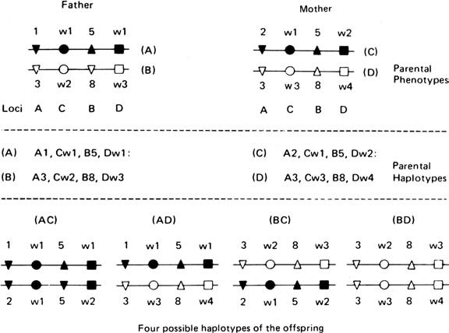
FIGURE 5 Diagrammatic representation of the genetic transmission of HLA halotypes. Each parent has two haplotypes (one in each chromosome). Paternal haplotypes are designated A and B and maternal haplotypes C and D. Each offspring has to receive one paternal haplotype and one maternal haplotype. In a large family, 25% of the children share both haplotypes, 50% share one haplotype, and 25% have no haplotype in common. Source: Reproduced from Hokama Y, Nakamura RM. Immunology and Immunopathology. Boston: Little Brown, 1982.

GENETICS OF THE MAJOR HISTOCOMPATIBILITY COMPLEX
HLA antigens are inherited as autosomal codominant (both alleles are expressed in a heterozygote) genes according to Mendelian laws. As mentioned before, the HLA system is extremely polymorphic, making it unlikely for two unrelated individuals to share all their HLA alleles. This is the basis for their use as genetic markers, which found a major practical application in paternity studies before DNA analysis became routine. Extensive HLA polymorphism, however, also presents a major obstacle to organ and tissue transplantation. As expected, related individuals share their HLA genes, and the proportion of shared genes depends on the degree of relatedness. For instance, there is a 25% chance of two siblings being HLA identical, making them ideal donor-recipient candidates for organ and tissue transplantation.
Because of the close proximity of HLA loci, the set of alleles present on a maternal or paternal chromosome 6 is usually transmitted en bloc, and such a group of closely linked alleles is called a haplotype. There are infrequent exceptions to this intact transmission of a haplotype from a parent to the child because of occasional (approximately 1%) meiotic crossing over between the loci in paternal or maternal chromosome 6 homologues.
Because all alleles of an individual are codominant, it follows that both haplotypes that form an individual genotype will be expressed in the cells of that individual. The sum of all the specificities coded by the genome of the individual is known as that individual’s HLA type. An example of the notation of a given individual’s phenotype is as follows: HLA- Al,2; B8,27; Dw3,-; DR23,-. The hyphen indicates that only one antigen of a particular locus can be typed; this can signify that the individuals are homozygous or they possesses an antigen that cannot be typed because appropriate reagents are not yet available.
Population genetics theory predicts that in a panmictic population (random mating), given enough time in evolution, alleles of a locus will be randomly associated with alleles of other loci (linkage equilibrium), and the probability of co-occurrence of any two alleles will be the product of their individual frequencies. For the HLA loci, however, this is not the case: certain alleles are found together more often than would be expected from the product of their individual frequencies in the population. This phenomenon is termed linkage disequilibrium. As an example, the HLA-A1 allele is found in the Caucasian population with a frequency of 0.158, and the HLA-B8 allele is found with a frequency of 0.092. The A1, B8 haplotype should, therefore, be found with a frequency of 0.158 0.092 ¼ 0.015. In reality, it is found with a frequency of 0.072. The linkage disequilibrium is expressed as the difference (D) between the observed and expected frequencies of the alleles, that is, 0.072 2 0.015 ¼ 0.057. The reasons for the extensive polymorphism and linkage disequilibrium in the HLA system are not known. It is possible that during our evolutionary history new alleles and particular combination of alleles have been differentially selected because of their role in conferring immunity to infectious pathogens.
MAJOR HISTOCOMPATIBILITY COMPLEX AND THE IMMUNE RESPONSE
A major advance in immunology occurred with the observation that CD8^{þ} cytotoxic T lymphocytes would only kill virus-infected cells if both (the cytotoxic T cell and the infected cell) shared identical class I MHC antigens. The T cells recognize a specific determinant formed by the association of a viral peptide with an autologous MHC-I molecule. Cells infected by the same virus, but expressing different MHC-I molecules will present a different MHC-Ipeptide complex, not recognizable by a cytotoxic T cell from an animal expressing different set of MHC-I molecules. Thus, cytotoxicity mediated by T lymphocytes is MHC-restricted and the MHC-I molecules are the “restricting elements.” This discovery provided a physiological function (recognition of self from nonself) for MHC molecules, which until then had been known only as major barriers to transplantation. The restriction of cytotoxic reactions represents an adaptation of the immune system to the need to differentiate “normal” cells from cells altered as a consequence of intracellular infections. The elimination of “nonself” material requires the recognition of nonself antigenic structures and the induction of an immune response through a set of cell–cell interactions involving macrophages, T lymphocytes and B lymphocytes. The effector mechanisms responsible for elimination of “nonself” may be mediated by antibodies or by cytotoxic Tcells. Viruses and other intracellular parasites present a special problem to the immune system due to their shielding from contact with immunocompetent cells recognizing antigenic structures on the infectious agents. To circumvent this, the immune system developed the ability to recognize and destroy the infected cells themselves.
The loading of peptides into MHC-I molecules is a complex process. To reach the cell membrane in a stable configuration, the MHC molecule must always be loaded with a peptide. In the absence of intracellular infection, peptides derived from autologous proteins occupy the peptidebinding groove and these fail to elicit an immune response due to the fact that they are self-peptides. During an infection, proteins synthesized by a replicating intracellular infectious agent are first cut by a proteasome, a multi-subunit proteolytic enzyme that yields fragments of 7 to 15 amino acids. The peptides are subsequently transported to the endoplasmic reticulum (ER) by molecules known as transporters associated with antigen-processing (TAP) that are located within the MHC. Once in the ER, the transported peptides replace endogenous peptides bound to newly synthesized MHC molecules and the complex is transported to the cell membrane allowing the immune system to recognize the self MHC-I/nonself peptide complex.
Major Histocompatibility Complex -II and Antigen Presentation to Helper T Lymphocytes
Tlymphocytescannotrespondtounmodifiedantigens.Theiractivationrequiresendocytosisand processing of the antigen by a specialized antigen-presenting cell. During “processing,” soluble antigens are broken down into peptides of 12 to 23 amino acids that become associated in the cytoplasm with the newly synthesized MHC-II molecules (the groove of the HLA-class-II dimer is longer than the groove of MHC-I molecules and accommodates slightly larger peptides). The peptide-MHC-II complex is then transported across the cytoplasm and inserted in the cell membrane. The MHC-II associated peptides can be recognized by CD4⁺helper T lymphocytes carrying a peptide-specific T cell receptor (TCR), but are not recognized by TCR on CD8⁺ lymphocytes. This is because the CD4 coreceptor binds to the b2 domain of MHC-IImolecules,whiletheCD8coreceptorbindstothea3domainoftheMHC-Iheavychain.
Regulation of Major Histocompatibility Complex Expression
Cellular restrictions concerning the expression of MHC-I and MHC-II molecules apply mainly to the resting cells. Activated leukocytes and nonleukocyte cells may express MHC molecules at higher levels than resting cells, or even express MHC molecules normally not expressed in their resting counterparts. Interferons play a crucial role in upregulating MHC expression. Class I Interferons (a/b) primarily increase the expression of MHC-I molecules, whereas the Class II interferon (g) upregulates the expression of MHC-II as well as MHC-I molecules.
Increased expression of MHC molecules on cell membranes requires prior peptide loading of these molecules. Interferons seem to stimulate the synthesis of the components needed to ensure the overexpression of MHC molecules, including the MHC molecules, proteasomes, and transport proteins (TAP1 and 2). The consequences of MHC upregulation may be both beneficial and harmful: on the one hand, it facilitates the induction of helper and cytotoxic T cell responses against pathogens; on the other hand, it may create optimal conditions for the activation of autoreactive T-cell clones (see Chapter 16).
Major Histocompatibility Complex Binding and the Immune Response
It appears that a limited number of MHC molecules are sufficient to bind a vast repertoire of peptides (on the order of 10⁸–10¹⁰). The peptides presented to T lymphocytes are helical structures with two parts (Fig. 6). The part of the peptide that protrudes above the surface of the groove and is accessible to the TCR is known as the “epitope.” The rest of the peptide interacts with the groove of the MHC molecule. This interaction is mediated by “anchoring residues,” shared by many peptides. Thus, a given peptide can bind to much different class I or class II HLA molecules, and a limited repertoire of these molecules can accommodate a wide diversity of peptides.

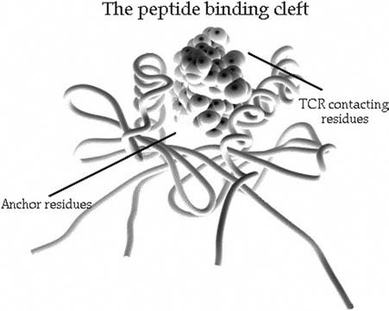

FIGURE 6 Diagrammatic representation of the interaction between an immunogenic peptide and an MHC-II molecule. The peptide binds to the major histocompatibility complex (MHC) molecule pouch through its “anchor residues,” enabling the interaction between the T cell receptors (TCR) binding residues, which form the epitope, and the TCR. Source: Modified from Lernmark A. Selecting culprits in type 1 diabetes b-cell killing. J Clin Invest 1999; 104:1487.
The anchoring residues determine the binding affinity of a given peptide to specific MHC alleles, which varies over two or three orders of magnitude between different alleles. These differences in binding affinity are believed to determine the strength of the response. A peptide bound with high affinity will be presented to the Tcells in optimal conformation determining a high response to this epitope. In contrast, if the binding is of low affinity the individual will be a low responder or a nonresponder. Thus, the magnitude of the immune response is determined by the close fit between peptides and MHC molecules.
Importance of Antigen Complexity and Major Histocompatibility Complex Heterozygosity

Even with a limited MHC repertoire, the probability of mounting a good response to a complex antigen is high. Such antigens are likely to generate many different peptides during processing, increasing the odds of generating some peptide(s) that are able to bind to the MHC molecules of an individual. Heterozygous individuals, with twice as many peptide-binding MHC motifs, can generate a more effective immune response than homozygotes.
Additional Antigen-Presenting Molecules
MHC molecules are not designed to bind strongly hydrophobic antigens such as lipids or carbohydrates. While the response to carbohydrates is elicited with minimal or no cooperation from helper T cells (thus circumventing the need for MHC presentation to helper T cells), the response to lipids and glycolipids involves presentation by a different set of molecules, generically designated as CD1. The CD1 molecules are structurally similar to the MHC-1 molecules, but are not coded by genes in the MHC region. The human CD1 molecules are coded by five closely linked genes on chromosome 1. A CD1 molecule consists of a large polypeptide chain with three domains (a1, a2, a3) that is noncovalently associated with b2 microglobulin. The a1 and a2 domains form a groove much deeper than the MHC-I groove. It is formed by hydrophobic residues likely to bind very hydrophobic ligands such as compounds derived from Mycobacterium tuberculosis, including mycolic acids, lipoarabinomannan, and glucose monomycolate. Lipopolysaccharides from gram-negative bacteria and lipotechoic acid from gram-positive bacteria are also likely to be presented by CD1.
HUMAN LEUKOCYTE ANTIGEN—DISEASE ASSOCIATIONS
General Considerations
There are two major approaches to determining the genetic etiology of a disease: linkage analysis and association analysis. The terms linkage and association are often mistakenly used synonymously. Linkage implies that the gene under consideration and the putative gene responsible for the disease are on the same chromosome. It is determined by cosegregation of the disease with a particular genetic variant in families consisting of affected and unaffected individuals. This approach has been useful in the identification of genes for diseases that follow simple Mendelian inheritance, like cystic fibrosis (autosomal recessive) and Huntington’s chorea (autosomal dominant), but not for complex diseases like diabetes and heart disease. Association implies that a specific allele is found more often (associated with susceptibility) or less often (associated with resistance) in a group of unrelated individuals with a disease than in subjects without that disease. This approach is more powerful than linkage in detecting the genes for complex diseases.
The Associations
Numerous diseases have been associated with particular HLA alleles, some more strongly than others. Most of the diseases associated with HLA are autoimmune in nature; some are infectious (e.g., malaria). A list of strong HLA-disease associations, which have been confirmed by many studies, is given in Table 2. Some HLA-disease associations are strong enough to be of diagnostic assistance. For instance, virtually all narcolepsy patients are positive for the HLA-DQB10602.

TABLE 2 Some Human Leukocyte Antigen and Disease Associations
Disease | HLA allele(s) | Relative risk of developing the diseaseª | Description of the disease
Inflammatory diseases Ankylosing spondylitis | B27 | 100–200 | Inflammation of the spine, leading to stiffening of vertebral joints
Reiter’s syndrome | B27 | 40 | Inflammation of the spine, prostate, and parts of eye (conjunctiva, uvea)
Juvenile rheumatoid arthritis | B27 | 10–12 | A multisystem inflammatory disease of children characterized by rapid onset of joint lesions and fever
Adult rheumatoid arthritis | DR4 | 9 | Autoimmune inflammatory disease of the joints often associated with vasculitis
Psoriasis | Cw6 | 7 | An acute, recurrent, localized inflammatory disease of the skin (usually scalp, elbows, associated with arthritis
Celiac disease | DQ2, DQ8 | 30 | A chronic inflammatory disease of the small intestine; probably a food allergy to a protein in grains (gluten)
Multiple sclerosis | DQ6 | 12 | A progressive chronic inflammatory disease of brain and spinal cord that destroys the myelin sheath
Endocrine diseases Addison’s disease | DR3 | 5 | A deficiency in production of adrenal gland cortical hormones
Diabetes mellitus | DQ8  DQ6 | 14 0.02 | A deficiency of insulin production; pancreatic islet cells usually absent or damaged
Miscellaneous diseases Narcolepsy | DQ6 | .40 | A condition characterized by the tendency to fall asleep unexpectedly
ªNumerical indicator of how many more times a disease is likely to occur in individuals possessing a given HLA allele relative to those who do not express the marker, determined by the following formula:
No. of patients with the marker No. of controls without the marker
Relative risk ¼
No. of patients without the marker No. controls with the marker
Epidemiologists term this value odds ratio (OR), which is usually accompanied by a 95% confidence interval (CI). The OR is considered significant if the CI does not include 1. Source: Modified from Hood LE, Weissman IL, Wood WB, Wilson JH. Immunology. 2nd Ed. Menlo Park, CA: Benjamin/Cummings, 1984.
allele.Hence, adiagnosisofnarcolepsycanbeexcludedin apatient who doesnothave this allele. One cannot, however, predict the development of narcolepsy by typing for this allele, as it is frequently present in the general population in the absence of the disease.
Mechanisms Underlying Human Leukocyte Antigen—Disease Associations
The mechanisms underlying most HLA-disease associations are not known. Several possible mechanisms (not mutually exclusive) have been proposed over the years, and some of these are briefly discussed below:
- Molecular mimicry between antigenic determinants in infectious agents and HLA antigens. This mechanism has been postulated to explain the relationship between Yersinia pseudotuberculosis and ankylosing spondylitis. This bacterium has been shown to contain epitopes cross-reactive with HLA-B27. Therefore, it could be speculated that an immune response directed against Y. pseudotuberculosis could lead to an autoimmune reaction against self. However, why this reaction would affect specific joints remains to be explained.
- MHC molecules may act as receptors for intracellular pathogens. Such pathogens would interact with specific HLA antigens in the cell membrane, and as a result infect the cells carrying those antigens. The infected cell would undergo long-lasting changes in cell functions, which would eventually result in disease. This could be the case in ankylosing spondylitis and related disorders (acute anterior uveitis, Reiter’s syndrome). Over 90% of the individuals with ankylosing spondylitis are HLA-B27 and about 75% of the patients developing Reiter’s syndrome are HLA-B27 positive. Reiter’s syndrome frequently follows an infection with Chlamydia trachomatis, and some evidence of persistent infection with this intracellular organism has been obtained, but it still remains controversial.
Linkage disequilibrium between HLA genes and disease-causing genes. Some HLA and disease associations involve diseases that have no immunological basis. Examples in this category include hemochromatosis and congenital adrenal hyperplasia. Genes responsible for these diseases are linked to the HLA loci. Significant association between these diseases and HLA arises because of linkage disequilibrium between particular HLA alleles and those of the genes causing the diseases.

