Lec4 Immunotechnology MSC/ Biotechnology
Prof.Dr. Ekhlass Noori Ali
The Immune Response
We now turn our attention to the protective reactions underlying acquired immunity, which are called immune responses. The acquired immune system differs profoundly from the innate system in its interactions with pathogens. Innate immunity mainly recognizes substances such as distinctive carbohydrates, lipids, and N-formylated peptides, that are foreign per se, but acquired immune responses are most commonly directed against proteins a class of molecules found both in pathogens and in the host. Nevertheless, the acquired immune system discriminates between self and nonself, so that it normally coexists peacefully with all of the proteins and other organic materials that make up the host but responds vigorously against foreign organisms, and even against cells or tissues from other people.

CLONAL ORGANIZATION & DYNAMICS OF LYMPHOCYTE POPULATIONS

Naive lymphocytes are continually released from the primary lymphoid organs into the periphery, each carrying surface receptors that enable it to bind substances called antigens. Antigen binding in B cells is mediated by surface immunoglobulin proteins, whereas in T cells it is mediated by T-cell receptors. The sequences of these two types of proteins are extremely diverse, so that as a group they can bind an enormous variety of antigens . Antigen binding, when accompanied by other stimuli, can lead to activation of a T or B cell. Naive lymphocytes that fail to become activated die within a few days after entering the periphery, but those that become activated survive and proliferate, yielding daughter cells that may then undergo further cycles of activation and proliferation.
All of the progeny cells derived from any single naive lymphocyte constitute a lymphocyte clone. Some members of each clone differentiate into effector cells, whereas the remainder are memory cells; apart from this, however, all cells within a clone are identical to one another in nearly all respects, reflecting their common ancestry. For example, B-cell
clones contain only B cells, and each T-cell clone is made up entirely of either CD4 or CD8 cells.
A fundamental property of lymphocytes is that all of the immunoglobulin or T-cell receptor proteins expressed by cells in a given clone are identical. Although each individual lymphocyte typically has thousands of such proteins on its surface, all of these have precisely the same amino acid sequence and are identical to those expressed by all other cells in the same clone. Since the sequence of an immunoglobulin or T-cell receptor protein determines which antigens it will bind, it follows that any single lymphocyte can recognize and respond to only a very small subset of the total universe of possible antigens. This same antigen specificity, moreover, is shared by all other cells in the clone (with the exception of occasional somatic mutants, Thus, each lymphocyte or clone of lymphocytes has a uniquely restricted specificity for antigens a phenomenon known as clonal restriction. The immune system as a whole is able to recognize many different antigens because it is made up of a vast number of different lymphocyte clones, each of which has very limited antigen specificity.
The antigen specificity of each naive lymphocyte is determined through an essentially random genetic process during the early stages of its development and is permanently fixed by the time the cell enters the periphery . It has been estimated that the lymphopoietic system is able to produce lymphocytes with approximately 10⁸ alternative antigen specificities. This range of possible specificities is known collectively as the primary lymphocyte repertoire. Roughly 10⁹ naive lymphocytes enter the periphery each day, so that at least a few with any given specificity are likely to be present at all times. Whenever any one of these encounters its specific antigen under conditions that favor activation, it can give rise to multiple daughter cells, some of which are long-lived memory cells. With each successive exposure to the same antigen, the antigen-specific clone expands further and so comes to represent an increasing proportion of the total lymphocyte population (Figure 4-1). In this manner, exposure to an antigen selectively promotes the growth of any clones that recognize it without affecting other cells in the population a phenomenon known as clonal selection. On the other hand, if no further contact with that antigen occurs, the specific memory cells tend to die out, though this usually takes place over a period of years or decades. Thus, the lymphocyte population is continually evolving over time as individual clones expand or subside, depending on the specific antigens to which the host is exposed.

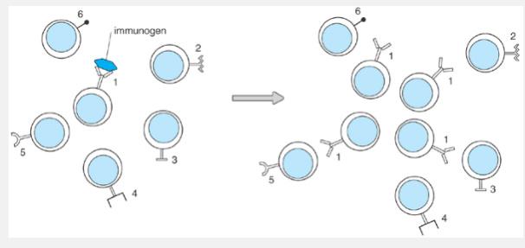

Fig1: Clonal selection of lymphocytes by a specific immunogen. Left: The unimmunized lymphocyte population is composed of cells from many different clones, each with its own antigen specificity, indicated here by the distinctive shapes of the surface antigen receptors. Right: Contact with an immunogen leads to selective proliferation (positive selection) of any clone or clones that can recognize that specific immunogen.
The antigen specificity of a given clone applies not only to its ability to recognize antigens but also to its effector functions. For example, cytotoxic effector T cells generally attack a target cell only if it bears the particular surface antigen recognized by their T-cell receptors; hence, the sequence of the T-cell receptor defines not only the antigen that can activate the T-cell clone but also the targets it will attack. Similarly, the antibodies secreted by a B-cell clone have exactly the same binding specificity as the surface immunoglobulins expressed on that clone. Clonal restriction thus ensures that the immune response
mounted by a lymphocyte clone is directed with a high degree of specificity against the antigen that induced its activation. The speed and intensity of response to a given antigen is determined largely by clonal selection: The larger the specific clone, the more lymphocytes are available that can recognize the antigen and can participate in the immune response.
The principles of clonal restriction and clonal selection were first postulated by Burnet, Jerne, Talmadge, and others in the 1950s and still rank among the most important conceptual insights in the history of immunology. Clonal restriction is the primary basis for the extreme specificity of immune responses: Each clone of lymphocytes can respond only to the limited set of antigens recognized by its unique immunoglobulin or T-cell receptor proteins and, when activated, carries out effector functions that are specifically directed against that same antigen. Clonal selection, on the other hand, is principally responsible for the phenomenon of immunologic memory: Exposure to an antigen sculpts and hones the lymphocyte population so that it can respond more quickly and more vigorously the next time the same antigen is encountered.

THE IMMUNE RESPONSE
Every immune response is a complex and intricately regulated sequence of events involving several cell types. It is triggered when an antigen enters the body and encounters a specialized class of cells called antigen-presenting cells (APCs). These APCs capture a minute amount of the antigen and display it in a form that can be recognized by antigen-specific helper T lymphocytes. The helper T cells become activated and, in turn, promote the activation of other classes of lymphocytes, such as B cells or cytotoxic T cells. The activated lymphocytes then proliferate and carry out their specific effector functions, which, in most cases, successfully inactivate or eliminate the antigen. At each stage in this process, the lymphocytes and APCs communicate with one another through direct contact or by secreting regulatory cytokines. They also may interact simultaneously with other cell types or with components of the complement, kinin, or fibrinolytic systems, resulting in phagocyte activation, blood clotting, or the initiation of wound healing. Immune responses may be either localized or systemic but are nearly always highly specific, focusing their full force against the antigen while causing little or no damage to normal host tissues. The responses are also precisely controlled and normally terminate soon after the inciting antigen is eliminated.
Figure 4-2 provides a schematic overview of the sequence of events that take place during a prototypical immune response. The following sections describe each step of this response in turn.

Immunogens & Antigens

Immunologists commonly use the term antigen when referring to the agent that triggers an immune response. Strictly speaking, however, this term actually refers to the ability of a molecule to be recognized by an immunoglobulin or T-cell receptor and hence to serve as the target of a response. For reasons that will be explained in, not all antigens are capable of inducing immune responses. Instead, a molecule or collection of molecules that can induce an immune response in a particular host is most properly referred to as an immunogen. Typical immunogens include pathogenic microorganisms (eg, viruses, bacteria, or parasites), foreign tissue grafts, or otherwise innocuous environmental substances, such as the proteins in pollen, grasses, or food.
Proteins are, in general, the most potent immunogens. Other classes of molecules, such as lipids, carbohydrates, or nucleic acids, most commonly become the targets of immune responses when they are linked to an immunogenic protein (as in lipoproteins, glycoproteins, or nucleoprotein complexes). Many of the immunogens encountered in nature are actually composites of several different immunogenic substances. A single bacterium, for example, is made up of a multitude of proteins and other molecules that may each elicit a specific immune response. In the prototypic immune response depicted in Figure 4-2, the immunogen is a virus that, like most viruses, contains several immunogenic proteins.

ANTIGEN PROCESSING & PRESENTATION
Responses to most proteinaceous immunogens can begin only after the immunogen has been captured, processed, and presented by an APC (see Figure 4-2). The reason for this is that T cells only recognize immunogens that are bound to major histocompatibility complex (MHC) proteins on the surfaces of other cells . There are two different classes of MHC proteins, each of which is recognized by one of the two major subsets of T lymphocytes. Class I MHC proteins are expressed by virtually all somatic cell types and are used to present substances to CD8 T cells, most of which are cytotoxic. Almost any cell can therefore present antigens to cytotoxic T cells and thus serve as the target of a cytotoxic response. Class II MHC proteins, on the other hand, are expressed only by macrophages and a few other cell types and are necessary for antigen presentation to CD4 T cells the subset that includes most helper cells. Since helper cell activation is necessary for virtually all immune responses, the class II-bearing APCs play a pivotal role in controlling such responses. In fact, unless otherwise stated, the term antigen-presenting cell usually refers only to these specialized cells that bear class II MHC proteins.
These cells, sometimes called professional APCs, include dendritic cells, macrophages, and B lymphocytes.
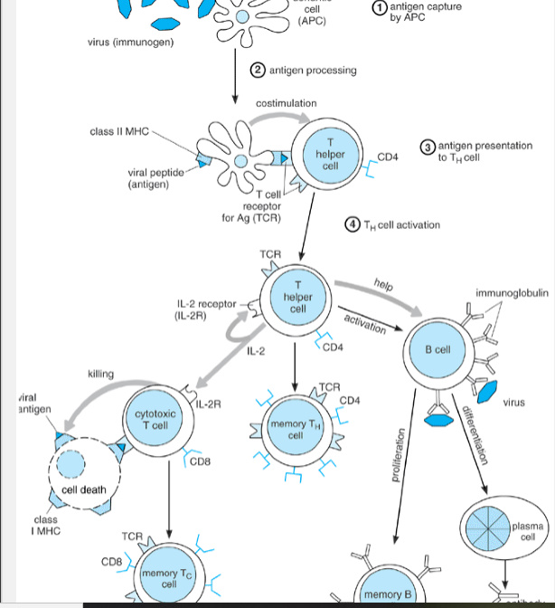
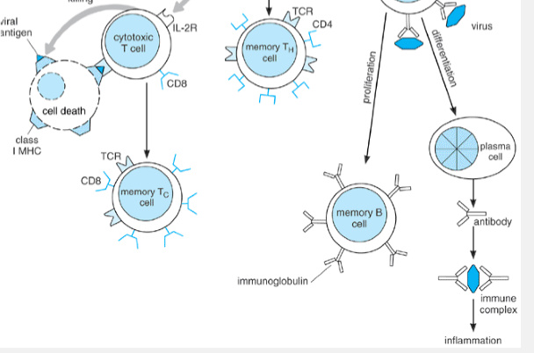
Fig2: Sequence of events in a prototypical immune response . Abbreviations: MHC = major histocompatibility class; APC = antigen-presenting cell; TCR = T-cell receptor.
The APC depicted in Figure 4-2 is a dendritic cell and so represents the class of APCs that initiates most immune responses (see Chapter 6). Dendritic cells are present in nearly all tissues, including surface epithelia and the T-cell-rich zones of lymphoid organs, which allows them to monitor the skin, gastrointestinal and respiratory tracts, blood, and lymph continually for foreign invaders. The cytoplasm of dendritic cells extends outward in sheet-like structures called veils, and in long, narrow tendrils called dendrites, which provides a large surface area for contacting immunogens. They also express numerous surface receptors â such as receptors for mannose or for bacterial lipopolysaccharide (LPS), similar to those found on macrophages that can recognize and bind pathogens. Dendritic cells readily capture particulate immunogens through phagocytosis and can also capture smaller immunogens through pinocytosis or receptor-mediated endocytosis . All three of these pathways are also used by macrophages. B lymphocytes are poor phagocytes, but can efficiently endocytose antigens that bind to their surface immunoglobulins or other receptors . As a group, the APCs are able to capture a very broad range of immunogens, which helps to ensure that potential immunogens will not escape detection.
Immunogens that are captured and engulfed by an APC become enclosed within membrane-lined vesicles in its cytoplasm and, within these vesicles, undergo a series of alterations called antigen processing (Figure 4-3). For proteinaceous immunogens, this involves denaturation (unfolding) and partial proteolytic digestion, so that the immunogen is cleaved into short peptides. A limited number of the resulting peptides then associate noncovalently with class II MHC proteins and are transported to the APC surface, where they can be detected by helper T cells. This process is called antigen presentation. A CD4 helper T lymphocyte that comes into direct contact with an APC may become activated, but only if it expresses a T-cell receptor that is able to recognize and bind the particular peptide-MHC complex presented by that APC.
Statistically, the odds that any given T cell will respond to a given antigen are very poor: Even for highly potent immunogens, fewer than one in 100,000 naive T cells have the necessary specificity. Moreover, T cells are normally quite scarce at most locations in the body. Fortunately, dendritic cells have the ability to transport antigens from the site where they were captured into lymph nodes or other lymphoid tissues, where T cells are abundant. Within minutes after an immunogen contacts the skin, for example, the resident dendritic cells (Langerhans' cells) migrate out of the epidermis and into the underlying lymphatic vessels, which carry them and their cargo of antigens into the regional lymph nodes in search of a responsive T cell. This ability to transport antigens rapidly to lymphoid tissues is one of the features responsible for the extreme efficiency of dendritic cells as APCs and for their central role in launching immune responses.

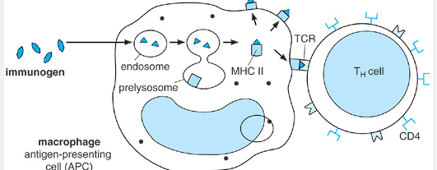
Fig3: Capture, processing, and presentation of antigen by an antigen-presenting cell (APC). The immunogen is captured by phagocytosis, receptor-mediated endocytosis, or pinocytosis and is broken down into fragments. Some fragments (antigens) become associated with major histocompatibility (MHC) class II proteins and are transported to the cell surface, where they can be recognized by CD4 T cells. Abbreviation: TCR = T-cell receptor.
Activation of Helper T Lymphocytes

Helper T (T_{H}) cells are the principal orchestrators of the immune response because they are needed for activation of the two other lymphoid effector cell types: cytotoxic T (T_{C}) cells and antibody-secreting plasma cells. T_{H} cell activation occurs early in an immune response (see Figure 4-2) and requires at least two signals. One signal is provided by binding of the T-cell antigen receptor to the antigenic peptide MHC

complex on the APC surface and is transmitted through the CD3 protein complex . The second, costimulatory signal also requires close contact between the APC and T_{H} cell surfaces and is usually delivered by the T_{H}-cell protein called CD28 when it binds to either one of a pair of B7 proteins on the APC surface (Figure 4-4).
Together, the two signals induce the helper T cell to begin secreting a cytokine known as interleukin-2 (IL-2) and also to begin expressing specific high-affinity IL-2 receptors on its surface (see Figure 4-4). IL-2 is a highly potent mitogenic factor for T lymphocytes and is essential for the proliferative response of activated T cells. The IL-2 protein has a very short half-life outside the cell and so acts only over extremely short distances. In fact, IL-2 is thought to exert its greatest effects on the cell from which it is secreted”a phenomenon known as an autocrine effect. Even if a T cell has received both activation signals from contact with an APC, it will not begin to proliferate in the absence of IL-2 activity or if its own surface IL-2 receptors are blocked. The IL-2 secreted by an activated T_{H} cell can also act on cells in the immediate vicinity, in a so-called paracrine effect; this is especially important for activating T_{C} cells, which generally do not produce enough IL-2 to stimulate their own proliferation (see later discussion). In addition to IL-2, activated T_{H} cells secrete other cytokines that promote the growth, differentiation, and functions of B cells, macrophages, and other cell types .
While the T_{H} cells are being activated as described earlier, some B cells may also have been engaging the immunogen through their antigen receptors, which are membrane-bound forms of the antibodies they will later secrete (. Unlike T cells, B cells recognize an immunogen in its free, unprocessed form (see Figure 4-2). Specific antigen binding provides one of the two signals needed for B-cell activation. The second is provided by activated T_{H} cells, which express proteins that help activate the B cell by binding to nonimmunoglobulin receptors on its surface. This second type of signal, called T-cell help, can act on any B cell regardless of its antigen specificity. The most effective form of help occurs when a protein called CD40 ligand (CD40L), which is expressed on T_{H} cells only after they become activated, binds to a protein called CD40 on B cells (Figure 4-5). In fact, direct contact with an activated T_{H} cell may be sufficient to activate a resting B cell even though its surface immunoglobulins have not engaged an antigen; this is known as bystander B-cell activation. The combination of antigen binding and helper factors, however, yields the strongest mitogenic signals, so that over time antigen-specific clones quickly outgrow any activated bystanders. Some cells in each activated clone differentiate into plasma cells that secrete antibodies specific for the immunogen.
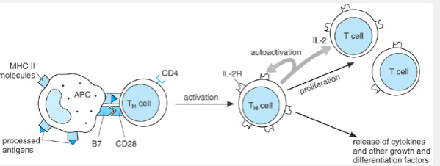
Fig4:T_{H}-cell activation. The antigen-presenting cell (APC) presents an antigenic peptide, bound to major histocompatibility class (MHC) II, to the T_{H} cell and also provides a costimulatory signal when a B7 protein on its surface binds CD28 on the T_{H} cell. The two signals lead to activation of the T_{H} cell. Activation leads to interleukin (IL)-2 receptor expression and IL-2 secretion by the T_{H} cell, resulting in autocrine growth stimulation.

T_{C} lymphocytes function to eradicate cells that express foreign antigens on their surfaces, such as virus-infected host cells (Figure 4-6). Most T_{C} cells express CD8 rather than CD4 and hence recognize antigens in association with class I rather than class II MHC proteins. When a somatic cell is infected by a virus, some immunogenic viral proteins may undergo processing within the cell, and the resulting peptides may then appear as surface complexes with class I MHC molecules. These peptide MHC complexes
may then be recognized by the T-cell receptor of an antigen-specific clone, providing one of two signals necessary for T_{C}-cell activation. This first signal alone induces high-affinity IL-2 receptors on the T_{C} cell. The second signal is furnished by IL-2 secreted from a nearby activated T_{H} lymphocyte. On receiving both signals, the activated T_{C} cell acquires cytotoxic activity, enabling it to kill the cell to which it is bound, as well as any other cells bearing the same peptide-MHC class I complexes. In some cases, killing occurs because the T_{C} releases cytolytic toxins onto the target cell; in others, the T_{C} induces the target cell to commit suicide by apoptosis). The activated T_{C} cell also proliferates, giving rise to additional T_{C} cells with the same antigen specificity.
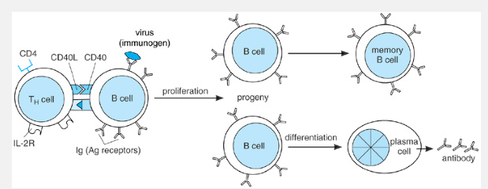
Fig5: B-cell activation. Antigen binding to the surface immunoglobulins, coupled with soluble or contact-mediated helper factors from an activated T_{H} cell, lead to proliferation and differentiation. Cytokines involved in T_{H}-cell help include interleukin (IL)-2, IL-4, and IL-6. Contact-mediated help generally involves binding of CD40 on the B-cell surface to CD40 ligand (CD40L) on the activated T_{H} cell.
Fig6f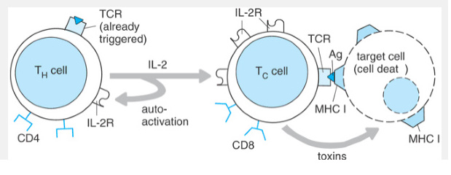
Fig 6: T_{C}-cell activation requires contact with a specific antigen complexed with a major histocompatibility class (MHC) I molecule on the surface of a target cell. It also requires interleukin(IL)-2 from a nearby activated T_{H} cell. The activated T_{C} cell kills the target cell either by secreting cytotoxins (as shown) or by inducing it to commit suicide. Abbreviation: TCR = T-cell receptor.
MECHANISMS OF ANTIGEN ELIMINATION

The ultimate function of the immune system is to seek out and destroy foreign substances in the body. Depending in part on the nature of the foreign substance, this can be accomplished in several ways. One, described in the preceding section, is the direct cytotoxic killing of antigen-bearing target cells by activated T_{C} cells (see Figure 4-6). Most other immunologic effector mechanisms require antibodies; the most important of these will now be described.
Toxin Neutralization

Antibodies specific for bacterial toxins or for the venom of insects or snakes bind these antigenic proteins and, in many cases, directly inactivate them by steric effects. In addition, formation of an antigen-antibody complex promotes the capture and phagocytosis of these toxins by macrophages and other phagocytes (see the section on opsonization). Because of their effectiveness, preformed antibodies against toxins or venom are often injected prophylactically or therapeutically as a means of protecting unimmunized individuals who have recently been, or are at risk of being, exposed to specific toxins.
Virus Neutralization

Antibodies specific for proteins on the surface of a virus may block the attachment of the virus to target cells, particularly if the antibodies bind at or close to the site of cell binding on the virus. This provides a means by which preexisting antibodies can protect against new viral infections. Once viral infection has become established, however, neutralization is often less important than the cytotoxic action of T_{C} cells for eradicating the infection.
Opsonization & Phagocyte Activation
Antibodies that coat bacteria or other particulate antigens can function as opsonins to promote phagocytosis. This occurs because macrophages and other phagocytes carry surface Fc receptors that facilitate engulfment of antibody-coated particles . Thus, just as macrophages control lymphocyte function through their role as APCs, B lymphocytes regulate macrophage function by directing these phagocytes to specific antigenic targets through the process of opsonization.
Immune responses also affect phagocyte functions in other ways. For example, some activated T_{H} cells release interferon gamma (IFNÎ³) and other cytokines that are potent macrophage activators. The resulting activation increases the phagocytic activity of the macrophage and may cause it to secrete numerous other cytokines and mediators . Activated lymphocytes also produce IL-2, IL-3, and IL-4, as well as colony-stimulating factors, which regulate macrophage growth and function.
Activation of Complement
Certain types of antibodies can activate the complement pathway when they are complexed with an antigen . If the antibody is bound to the surface of a cell, such as a bacterium, the cascade of complement enzyme reactions may lead to lysis of the cell, providing an important means of killing these pathogens. Some products of the complement cascade also act as opsonins when bound to an antigen “antibody complex, whereas others are chemoattractive for neutrophils. Still others cause the release of inflammatory mediators such as histamine from mast cells and basophils .
Antibody-Dependent Cell-Mediated Cytotoxicity
One major class of antibodies, called IgG, binds to Fc receptors on the surfaces of natural killer (NK) cells and certain other cell types and enables them to carry out a form of antigen-specific cell killing called antibody-dependent cell-mediated cytotoxicity (ADCC). The IgG antibodies bound on its surface enable the cell to bind specifically to antigen-bearing target cells, which might be bacteria or multicellular parasites, and to kill the target cells with cytotoxins. The antibodies are said to arm the cells to perform ADCC, and they are absolutely required for such killing; this fact distinguishes ADCC from T_{C}-mediated cytotoxicity, which occurs independently of antibodies.
INFLAMMATION
Although lymphocytes and APCs are the key cells in all immune responses, other types of cells may be recruited into the response. For example, cytokines, chemokines, or other products released by activated lymphocytes and macrophages may chemoattract neutrophils or eosinophils, stimulate proliferation of fibroblasts and endothelial cells, or cause mast cells and basophils to discharge other bioactive substances into the local tissues . These agents, as well as products of the complement cascade, may lead directly or indirectly to increased blood flow, increased vascular permeability, leakage of fluid into the extravascular space, and pain. Those four responses are, of course, the cardinal signs of acute inflammation, which often accompanies immune responses. In some instances, other enzymatic pathways such as the kinin, clotting, and fibrinolytic systems may also become activated . Different features of inflammation predominate in different settings, giving rise to several distinct categories of inflammatory reactions. LOCALIZATION OF IMMUNE RESPONSES
The initial response to an immunogen depends partially on its route of entry into the body. Most immunogens enter via one of three routes. Those that enter through the bloodstream are most likely to be detected by dendritic cells and macrophages in the spleen, which then becomes the principal site of the immune response. By contrast, immunogens that enter the skin and subcutaneous connective tissues are usually detected by resident APCs, such as epidermal Langerhans' cells or dermal macrophages, and, in addition, may be carried via the lymphatic circulation into regional lymph nodes; the immune response then
begins both at the site of contact and in the affected nodes. Alternatively, an immunogen may enter the body by traversing mucosal surfaces of the respiratory or gastrointestinal tract; in this case, it immediately encounters the submucosal lymphoid tissues, which launch a response that is directed both locally and into the adjacent lumen from which the immunogen came .
Regardless of the site at which a response begins, some trafficking of dendritic cells and lymphocytes to other sites via the blood and lymphatic vessels always takes place, so that the entire immune system can eventually be recruited into the response if the immunogen is especially abundant, widely disseminated, or resistant to immune elimination.
QUANTITATIVE & KINETIC ASPECTS OF IMMUNE RESPONSES
The quantitative aspects of immune function have been studied most extensively for B cells, since B-cell activity can easily be monitored by the concentrations of specific antibodies in the serum an area of investigation known as serology. The general conclusions of such studies, however, are thought to be applicable to T-cell responses as well.
At any given moment, active T- and B-effector cells account for roughly 1% of the total lymphoid population in a normal host. These belong to many different clones (the exact number is unknown and no doubt varies widely), most of which are probably involved in ongoing, low-level immune responses against the many antigens encountered in everyday life. As a result, the serum of a normal, healthy adult contains innumerable different types of antibody molecules. Each is present in only minute amounts, but altogether they account for roughly 20% of total serum protein. Each of these circulating antibodies provides a low level of protection against its specific antigen.
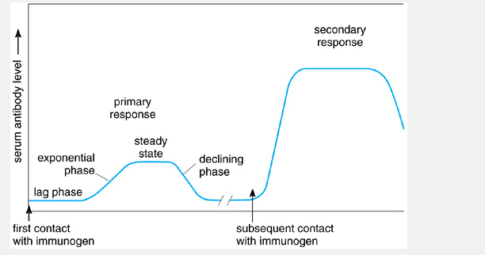
Fig7: Primary and secondary immune responses
When a person or animal is exposed to significant amounts of an antigen and mounts a B-cell response, the concentration of serum antibodies against that antigen generally rises. Serum from such an immunized individual is often called a specific antiserum. It is important to remember, however, that even in the serum of highly immunized individuals, antibodies against a given antigen make up only a small fraction of the total and antibodies with many other specificities are also present.
An individual's first encounter with a particular immunogen is called a priming event and leads to a relatively weak, short-lived response designated the primary immune response. This is divisible into several phases (Figure 4-7). The lag, or latent, phase is the time between the initial exposure to an immunogen and the detection of antibodies in the circulation, which averages about 1 week in humans. During this period, activation of T_{H} and B cells is taking place. The exponential phase is marked by a rapid increase in the quantity of circulating antibodies and reflects the increasing numbers of secretory plasma cells. After an interval during which the antibody level remains relatively constant because secretion and degradation are occurring at approximately equal rates (the steady-state, or plateau, phase), the antibody level gradually declines (declining phase) as synthesis of new antibody wanes. The decline indicates that new plasma cells are no longer being produced and that existing plasma cells are dying or
P.70
ceasing antibody production; this generally signifies that the immunogen has been eradicated. Thus, the duration of a humoral immune response is limited primarily by the duration of the antigenic stimulus and by the relatively short life spans of the plasma cells involved in the response.
Subsequent encounters with the same immunogen lead to responses that are qualitatively similar to the primary response but manifest marked quantitative differences (see Figure 4-7). In such a secondary, or anamnestic, immune response, the lag period is short and antibody levels rise more rapidly to a much higher steady-state level, thereafter remaining in the serum at detectable levels for much longer periods. The large numbers of antigen-specific memory T and B cells generated during the primary response are responsible for the rapid kinetics and the greater intensity and duration of secondary responses.
PROGRAMMED CELL DEATH IN THE IMMUNE SYSTEM
Antigen-dependent proliferation of a lymphocyte clone is an example of positive selection; that is, the antigen promotes growth of the cells on which it acts. Under some conditions, however, contact with antigens or other stimuli results in negative selection of a responsive clone, meaning that cells in the clone selectively die. Negative selection of lymphocytes is a common event and is essential to the ability of the immune system to discriminate self from nonself. In particular, most naive T or B cells whose antigen receptors recognize components found in normal host tissues are thought to be selectively killed before they leave the bone marrow or thymus, as a means of protecting the host against attack by these potentially autoreactive (ie, self-reactive) cells. This may account for the observation that at least 99% of developing thymocytes die within the thymus (see Chapter 3). Thus, the clonal composition of the immune system is shaped not only by positive clonal selection but also by the active elimination of potentially deleterious clones.
Lymphocytes frequently die after being instructed to commit suicide by signals in their environment. These signals often include events such as antigen binding to surface immunoglobulins or TCRs which, under other circumstances, would lead to clonal proliferation. When delivered in particular combinations or at certain vulnerable stages in a cell's life, however, these signals instead induce death by apoptosis (see Chapter 1). In particular, repeated or intense activation of a T or B cell commonly leads to apoptosis, a phenomenon termed activation-induced cell death (AICD). AICD triggered by contact with self-antigens is an important mechanism for eliminating autoreactive B- and T-lymphoid cells . and occurs commonly among normal thymocytes, bone marrow progenitors, and germinal center B cells.
Another signaling pathway that is especially important for killing of and by lymphocytes involves the surface transmembrane protein called Fas (also called APO-1 or CD95), which is expressed constitutively by many normal or neoplastic cell types as well as on activated B and T lymphocytes. The extracellular portion of Fas serves as a receptor for a different surface protein”a homotrimer of polypeptides called Fas ligand (FasL), found on many activated T cells and certain other cell types. When cells expressing these two proteins contact one another, binding of FasL causes Fas to trimerize and this, in turn, induces apoptosis in the Fas-bearing cell Cytotoxic T lymphocytes exploit this as one mechanism for killing: Activated T_{C} cells express FasL, which enables them to induce apoptosis in target cells that express Fas. But lymphocytes themselves can also be killed in this way. For example, after prolonged or repeated activation, helper T cells express both Fas and FasL and so may kill either themselves or one another; this is a major pathway of AICD and is thought to be one mechanism for limiting the intensity of an immune response. The same mechanism might also act to eradicate autoreactive T_{H} cells that encounter abundant self-antigens in peripheral tissue”and indeed, mutations in Fas are responsible for certain rare autoimmune diseases. Fas-mediated killing may also account in part for the phenomenon of immune privilege the observation that foreign tissues transplanted to certain sites in the body are much less prone to immunologic attack than they would be at other sites. Cells in two of the best studied privileged sites (the testes and anterior chamber of the eye) have been found to express FasL constitutively; this tends to induce apoptosis of any lymphocytes that become activated (and hence express Fas) within these tissues and so suppresses any local immune responses.
The importance of negative selection is also illustrated by follicular lymphoma, the most common form of B-cell cancer in humans). A major factor in the genesis of this disease is Bcl-2-”a normal cellular protein that acts to inhibit apoptosis in some lymphocytes and other cell types Follicular lymphoma arises when a clone of B cells expresses abnormally high levels of Bcl-2 protein and so becomes resistant to killing; as a result, these cells accumulate in abnormally large numbers and eventually evolve into a cancer. This implies that a high, controlled rate of programmed lymphocyte death normally benefits the host by restricting the growth of individual clones and of the lymphoid population as a whole, providing a counterforce against the stimuli that might otherwise drive excessive lymphocyte proliferation.

