Lec(5) Immunotechnology MSc/ Biotechnology
Prof .Dr .Ekhlass N. Ali
B-Cell Development & the Humoral Immune Response

The clonal selection theory, formulated by Burnet in the 1950s to explain the specificity of immune responses, postulates that each of the cells that make antibodies the B lymphocytes”makes only antibodies of a single specificity and, moreover, that each antigen selectively induces the expansion of those cells that can make antibody against it. This theory was soon expanded to account for the fact that the immune system normally makes antibodies to foreign entities but not to self-components. In subsequent years, a great deal has been learned about B lymphocytes and how they participate in immune responses. The tenets of the clonal selection theory have been upheld, and the molecular mechanisms by which it occurs are now largely understood. In this chapter, we consider the mechanisms by which B lymphocytes develop from precursors and how these mechanisms ensure that each B cell makes a unique antibody molecule. This, in turn, forms the basis for clonal selection. We then consider how antigen induces an immune response from the appropriate B cells and the role of helper T cells in this process, as well as the mechanisms by which B-cell responses are diversified to give different classes of immunoglobulin (IgM, IgG, etc) and to maximize the affinities of the antibodies produced. Finally, we review what is known about the mechanisms that act to prevent B-cell immune responses directed against self.

B-LYMPHOCYTE ONTOGENY
THE GENERATION OF B LYMPHOCYTES

Development of B cells from hematopoietic stem cells occurs in the bone marrow. In humans, approximately 10⁹ B cells are generated each day. Their development proceeds through a series of distinct stages that are accompanied, and in many cases defined, by the DNA rearrangements that assemble their immunoglobulin genes. These rearrangements occur in a strict developmental sequence (Figure 8-1). The first rearrangements take place in a population of mitotically active bone marrow cells, sometimes referred to as pro-B cells, which are the most primitive recognizable cells in the B lineage. These cells express the surface proteins CD10 and CD19, as well as the nuclear proteins terminal deoxynucleotidyl transferase (TdT) and recombination-activating gene products RAG-1 and RAG-2 (Figure 8-2). These latter proteins play important roles in V/D/J recombination The first rearrangement that occurs in a pro-B cell is the joining of D_{H} and J_{H} segments in the heavy-chain genes. This occurs on both copies of chromosome 14 in virtually all developing B cells. The cell then joins a V_{H} segment to the fused D_{H}/J_{H} segment on one of its two chromosomes. If this first attempt yields a functional gene in which the V and J regions are linked in such a way that they can be translated in the same reading frame of the genetic code and hence produce a functional protein, the cell (for reasons that will be discussed presently) carries out no further rearrangements of its other heavy-chain locus. If, on the other hand, the first rearrangement fails, a second attempt at V/D/J assembly is made using the other chromosome 14. Because of the error-prone nature of V/D/J joining, about 50% of pro-B cells fail at both tries to produce a functional heavy-chain gene; unable to proceed further through the maturation pathway, these cells simply die in the marrow.
Successful V/D/J rearrangement on either chromosome allows the cell immediately to begin synthesizing heavy-chain proteins. The heavy chains produced at this stage are all of the آµ isotype and have a short hydrophobic region at their carboxy termini that causes them to integrate into cellular membranes. This membrane-associated form of آµ protein is called آµ_{m}. Heavy chains ordinarily cannot be transported to the cell surface unless they are complexed with light chains. Pro-B cells express two proteins, known as surrogate light chains, that can bind to heavy chains, take the place of light chains, and be displayed transiently on the surface membranes of these

immature cells. The surrogate light chains are not true immunoglobulin proteins; they are expressed only in primitive B-cell precursors, are derived from genes that do not undergo somatic rearrangement, and have no role in immune responses per se. Nevertheless, they are essential for regulating early B-cell development. When the آµ_{m} and surrogate light-chain proteins reach the cell surface, they are believed to transmit a signal back into the cell, perhaps after contacting some unknown ligand. In effect, this signal notifies the cell that it has produced a functional heavy-chain protein. In response, the cell permanently halts any further rearrangements of its heavy-chain genes and stops expressing TdT. At about the same time, the cell gains the ability to rearrange its light-chain genes. This shift from heavy-chain to light-chain rearrangements does not appear to be due to changes in the recombinase machinery itself, but rather to changes in accessibility of the various immunoglobulin loci on the chromosomes, and is probably mediated by many of the same proteins that control transcription of these genes. Once the developing B cell expresses آµ_{m}, it also ceases to synthesize new surrogate light chains, so that the temporary signaling complex soon disappears from the cell surface. The آµ_{m} chain, now lacking a light-chain partner, is trapped in the endoplasmic reticulum at this stage. These events mark the transition into the next phase of ontogeny, known as the pre-B cell stage (see Figure 8-1).
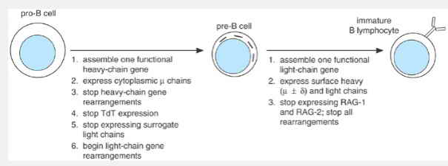 fig1: Major genetic events in early B-cell ontogeny. Listed are the sequences of events that occur in progressing from each stage of development to the next. Note that the ability to perform V/(D)/J rearrangements is lost by the time the cell becomes an immature B lymphocyte.
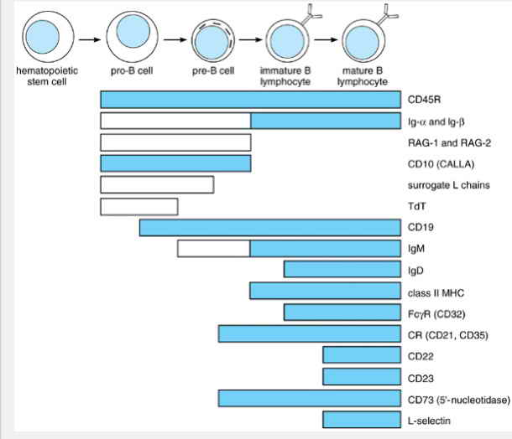Fig2: Expression of selected marker proteins at various stages of B-cell development. Open bars indicate that a protein is expressed only within the cytoplasm of a cell; filled bars indicate surface expression. Abbreviations: RAG = recombination-activating gene; CR = complement receptors; TdT = terminal deoxynucleotidyl transferase; MHC = major histocompatibility complex.
Pre-B cells are defined as cells that do not yet express immunoglobulin light chains but contain آµ_{m} heavy chains intracellularly (Figs 8-1 and 8-2). They are found almost exclusively in the bone marrow and represent a transient phase in B-cell development that lasts for about 2 days. Interestingly, generation of pre-B cells is deficient in a fairly common hereditary immunodeficiency disease known as X-linked agammaglobulinemia, or Bruton's agammaglobulinemia. The defect in this disorder is in the gene encoding an intracellular protein tyrosine kinase, called Btk. Although the exact role of Btk in B-cell development is not understood, its absence leads to decreased maturation of pro-B cells to pre-B cells and also to a reduction in subsequent steps in B-cell development. As a result, the affected patients have very few B cells, and they make little or no antibody.
On entering the pre-B-cell phase, the B-cell precursors divide several times in response to interleukin 7 (IL-7) produced locally by bone marrow stromal cells. Pre-B cells then cease dividing and do not resume mitosis until they have become fully mature B cells and encounter antigen in the periphery. The most important event taking place in pre-B cells is the rearrangement of light-chain genes, which begins only after heavy-chain rearrangements have ceased. Because TdT is no longer expressed, no N-region nucleotides are inserted as the light-chain genes rearrange. V/J joining is attempted on each chromosome 2 or 22 in succession, until a functional خ؛ or خ» gene is produced. As soon as either type of light-chain protein appears, it associates with the existing آµ_{m} heavy chains, and the resulting four-chain units are transported to the cell surface as membrane IgM. At that moment, the cell enters the B-lymphocyte stage of development and ordinarily loses the ability to perform additional V/J rearrangements because RAG-1 and RAG-2 expression ceases. It seems likely that the signal to shut off the recombinase is sent by the IgM molecules themselves when they first reach the cell surface.
The successful assembly of a single heavy- or light-chain gene prevents all other genes of that type from undergoing rearrangement in the same cell. Consequently, only one heavy-chain and one light-chain gene can give rise to protein in any individual B lymphocyteâ€”a phenomenon termed allelic and isotypic exclusion. If the lymphocyte subsequently divides in the periphery, chromosomes bearing the active rearranged genes are passed on to its progeny, and the daughter cells continue to express these genes without performing further V/J or V/D/J rearrangements. For this reason, all of the immunoglobulin molecules produced by a given B lymphocyte and its progeny have identical antigen specificity and light-chain type (خ؛ or خ»). This is the molecular basis of the phenomenon known as clonal restriction (Chapter 4). The diversity of antibody molecules produced by the immune system as a whole reflects the fact that innumerable B-cell precursors each rearrange their genes independently and in different combinations, resulting in a large assortment of clones that each possess a unique specificity for antigen.
MATURATION & RELEASE OF NAIVE B LYMPHOCYTES

The moment it begins to express surface IgM, a cell is considered to have become a B lymphocyte. Nevertheless, it is not yet ready to participate in immune responses. Instead, such immature B lymphocytes remain in the marrow for another 1â€“3 days before exiting to the periphery, where they continue their maturation. During this process, the cells acquire additional surface molecules that distinguish them as mature B lymphocytes (see Figure 8-2). One such marker is surface IgD, which, as noted in Chapter 7, is produced by alternative splicing of some of the RNA transcripts arising from the rearranged heavy-chain gene. The IgM and IgD on any individual lymphocyte both incorporate the same light chains and have identical antigen specificity. Other surface markers that appear on mature B lymphocytes include complement receptors (CR1 and CR2, the latter also known as CD21); a membrane-anchored enzyme called 5â€²-nucleotidase (CD73), whose function is unknown;
the lectin-like oligosaccharide-binding protein CD23; and the adhesion proteins leukocyte function-associated antigen-1 (LFA-1), intercellular adhesion molecule-1 (ICAM-1), and CD22. Individual cells also begin to express surface-homing receptors, such as L-selectin, which target them to lymph nodes or other peripheral sites. At about the same time, the cells acquire class II major histocompatibility complex (MHC) proteins, which enable them to present antigens to helper T cells, and they also begin surface expression of CD40â€”a protein involved in receiving T-cell help (see later discussion). With the acquisition of these various accessory molecules, the mature B lymphocytes become competent for immunologic function.
Mature B cells have a long life span, with a half-life of more than 3 weeks. Most immature B cells that exit the bone marrow, however, never mature fully and instead die with a half-life of less than 1 week. Maturation of these cells occurs only if they receive some low level of signaling through the B-cell antigen receptor (BCR), and even mature B cells rapidly die if they are deprived of such signals. (This phenomenon, called â€œdeath by neglectâ€‌, also applies to T-cell development, as will be described in Chapter 9). Thus, there is a darwinian competition among peripheral B cells to remain in the circulating pool. This is presumably advantageous to the host because signaling implies that a cell must have a functional BCR and may be more likely to respond to foreign antigens.
The developmental pathway outlined earlier is typical of the B-cell population as a whole but does not apply strictly to all of its cells. Individual B-lineage cells may differ significantly in the types and amounts of surface markers they express or the sequence in which these markers are acquired. This may reflect the existence of functionally distinct subsets of B cells. Indeed, there is considerable circumstantial evidence for the existence of distinct subsets. At present, however, only two types of B cells are clearly recognizable: the â€œconventionalâ€‌ B cells and a small, enigmatic subpopulation of B cells that express on their surface CD5â€”a protein of unknown function that is also expressed on most T lymphocytes. These CD5 B cells are long-lived cells that are found principally in the peritoneal cavity and that appear to be derived from precursor cells present in infant but not adult bone marrow. As these B cells arise soon after birth, they are the major source of antibody production in young individuals. The heavy-chain gene rearrangements of these B cells principally involve a few V_{H} genes near the D_{H} and J_{H} gene segments and often lack N regions. Thus, these cells have a less diverse antibody repertoire than do the B cells that dominate mature individuals. No unique immunologic function has yet been assigned to CD5 B cells, although they may be especially important for T-cell-independent antibody responses such as those directed at antigens of bacterial cell walls (see next section). Curiously, CD5 B cells are disproportionately more likely than other B cells to produce autoreactive immunoglobulins (ie, antibodies that recognize determinants in host tissues). Remarkably, the malignant cells in nearly all cases of human B-cell chronic lymphocytic leukemia carry the CD5 marker, suggesting that this malignancy arises from the CD5 B cell subpopulation.

THE HUMORAL IMMUNE RESPONSE

THE B-CELL ANTIGEN RECEPTOR

The production of large amounts of specific antibody in response to antigenic challenge depends on the ability of the immune system to activate only those rare B cells capable of producing antibody that can react with the antigen. These cells are induced to proliferate rapidly to expand their numbers. Subsequently, they either differentiate into antibody-secreting plasma cells or become memory B cells, which are long-lived cells that produce an antibody response later on reexposure to the antigen. This process is referred to as clonal selection, because a small number of B cells are selected, based on their antigen specificity, and then divide and give rise to a clone of progeny, all of which produce the same or nearly the same antibody as the founder cell.
Clonal selection requires each B cell to recognize the antigen that binds to the antibody secreted by that cell. This is accomplished by differential RNA splicing, yielding the expression of two forms of immunoglobulin heavy chainsâ€”a secreted form and a membrane form, the latter containing a hydrophobic transmembrane domain and a very short cytoplasmic tail. All heavy-chain isotypes can give rise to both secreted and membrane forms. The membrane form combines with immunoglobulin light chains to make membrane immunoglobulin. Interestingly, membrane immunoglobulin is retained in the endoplasmic reticulum unless it can associate with two additional proteins expressed exclusively in cells of the B-cell lineage. These proteins, called Ig-خ± and Ig-خ², associate with membrane immunoglobulin to form the B-cell antigen receptor (BCR), which can transit to the cell surface (Figure 8-3A). Ig-خ± and Ig-خ² are transmembrane glycoproteins, each of which has a moderately large cytoplasmic domain. These cytoplasmic domains each include a short region important for transmitting into the cell a signal indicating that antigen has bound. This region is called an immunoreceptor tyrosine-based activation motif (ITAM), and its key features are two precisely spaced tyrosine residues within a partially conserved surrounding sequence.
ITAM sequences are found not only in components of the BCR, but also in the T-cell antigen receptor complexes, in various Fc receptors, and in the activating receptors of natural killer cells. In each case, ITAM sequences are thought to induce transmembrane signaling in a fundamentally similar way. In B cells, cross-linking of two or more BCRs by a bivalent or multivalent antigen brings together several Ig-خ± and Ig-خ² cytoplasmic domains with their ITAMs. This clustering leads to phosphorylation of the ITAM tyrosines by protein tyrosine kinases belonging to the Src-family (see Chapter 1). The phosphorylated ITAM, in turn, becomes a binding site for a second type of tyrosine kinase, called Syk, which binds and becomes activated to phosphorylate other cytoplasmic proteins that activate various signaling pathways leading, for example to hydrolysis of phosphatidylinositol 4,5-bis-phosphate (PIP₂) and to activation of Ras (see Figure 8-3). The subsequent events are poorly understood at this time, although a number of transcription factors ultimately become activated, which leads to the expression of specific genes that contribute to cellular activation. In any case, it is the ability of bivalent or multivalent antigen to bring together multiple antigen receptors and their attached ITAMs that initiates the signaling events that inform a B cell it has encountered antigen.
T-CELL-INDEPENDENT ANTIGENS

The consequences of antigen contact with the BCR depend on the nature of the antigen and on other signals received by the B cell at that time. Generally, antigen contact alone is insufficient to activate B cells because most protein antigens require antigen-specific T-cell help to generate an antibody response. Some antigens do not require the presence of helper T cells, however, and are called T-independent antigens. These antigens typically fall into either of two categories, with different mechanistic properties (Figure 8-4). The first group, called TI-1 antigens, can, at high concentrations, induce activation of many B cells, both specific and nonspecific. Because many B cells are activated, these antigens are called polyclonal B-cell activators. Many polyclonal B-cell activators also potently stimulate macrophages to produce cytokines such as interleukin-1 (IL-1) and tumor necrosis factor alpha (TNFخ±), which augment immune responses. Typical TI-1 antigens are bacterial cell wall components, and their recognition by cells of the immune system appears to be an evolved feature of innate immunity. For example, the TI-1 antigen lipopolysaccharide (LPS), from gram-negative bacterial cell walls, can induce immunologic defense reactions in a number of invertebrate as well as vertebrate organisms. Mammalian cells recognize LPS with Toll-like receptor 4 (TLR4) and several other bacterial cell wall components with the closely related TLR2 (See Chapter 2). Interestingly, at low concentrations TI-1 antigens often do elicit an antigen-specific antibody response. It has been postulated that this occurs because BCRs that specifically recognize the TI-1 antigen can concentrate it onto the surfaces of specific B cells, where it can then stimulate Toll-like receptors more efficiently and trigger activation.
In contrast, TI-2 antigens do not have polyclonal B-cell activator properties, nor do they activate macrophages. These antigens are generally highly repetitive polymeric antigens such as polysaccharides from bacterial cell walls, or polymeric protein structures such as bacterial flagella. It has been postulated that their B-cell-activating properties derive from their ability to cross-link numerous BCR molecules and induce either intense, or especially prolonged, intracellular-signaling reactions (see Figure 8-4). Antibody responses to TI-2 antigens, although they do not require helper T cells, do appear to require low levels of cytokines, such as might be generated by a nearby immune response.

T-CELL HELP & ACCESSORY SIGNALS

Most protein antigens only induce antibody production in the presence of CD4 helper T cells. Typically, T-cell help can be provided in two forms: by soluble cytokines (especially IL-4 and IL-5) or by a cellâ€“cell contact-dependent signal (Figure 8-5). Contact-mediated help results from specific interactions between membrane proteins on the T_{H}- and B-cell surfaces. The most important interaction of this type occurs between the B-cell protein CD40 and a protein called CD40 ligand (or CD40L), which appears on T_{H} cells only after they become activated. In some circumstances, the CD40L signal in combination with the cytokines IL-4 and IL-5 can fully activate B cells even in the absence of antigen. In other circumstances, however, CD40L stimulation in the absence of antigen contact leads to death of the B cell via apoptosis. In general, however, the combination of antigen binding and CD40L acts synergistically to trigger B-cell activation. Binding of CD40 to CD40L is an extremely important mechanism of delivering T-cell help in vivo. An inherited defect in CD40L causes a form of congenital immunodeficiency known as hyper-IgM syndrome, in which humoral immunity is impaired due to a deficiency of T-cell help. In these patients, the antibody response to many antigens is markedly abnormal, and no IgG, IgA, or IgE is produced. IgM levels, on the other hand, are abnormally high, possibly as a secondary effect of recurrent infections. This IgM response may be due to T-independent antigen stimulation or possibly to residual T-cell-dependent antibody responses in the absence of CD40L.

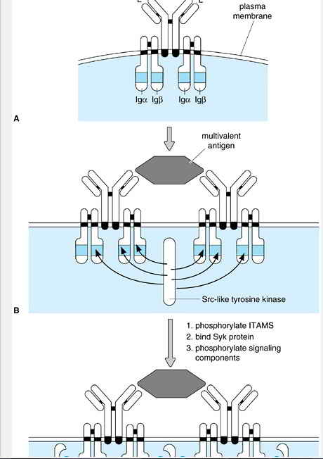
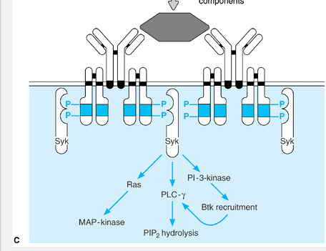
Fig3: Signaling through the B-cell antigen receptor (BCR). A: Antigen receptor transmembrane-signaling complex on mature B cells. Ig-خ± and Ig-خ² are disulfide-linked to each other but associate with membrane immunoglobulins noncovalently through their transmembrane and extracellular domains. The number of Ig-خ±/Ig-خ² heterodimers per membrane immunoglobulin unit is unknown but is believed to be two, as shown, for reasons of symmetry. Both Ig-خ± and Ig-خ² cytoplasmic domains contain copies of the immunoreceptor tyrosine-based activation motif (ITAM). The consensus sequence for the ITAM is YxxL/IxxxxxxxYxxL/I, where Y = tyrosine; L/I = leucine or isoleucine; and x = any amino acid. In the resting state, the ITAM tyrosines (Y) of Ig-خ± and Ig-خ² are largely unphosphorylated. B: On cross-linking with multivalent antigen, an Src-family tyrosine kinase phosphorylates ITAM tyrosines. C: Doubly phosphorylated ITAMS serve as binding sites for a second type of tyrosine kinase, called Syk. Once bound, Syk becomes phosphorylated on tyrosines and its activity is increased. Syk is thought to be largely responsible for phosphorylating downstream signaling targets, such as activators of Ras and phosphatidylinositol 3-kinase (PI 3-kinase). The latter enzyme synthesizes PIP₃ which, in turn, attracts to the membrane a third type of tyrosine kinase, called Btk, which then participates in BCR signaling. Btk and Syk are both needed to phosphorylate and activate phospholipase Cخ³ (PLC-خ³), which hydrolyzes inositol-containing phospholipids (eg, PIP₂), leading to elevation of intracellular free calcium and activation of protein kinase C.
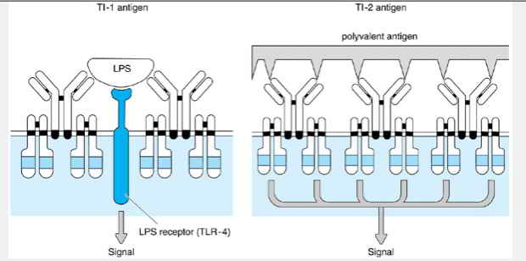

Fig4: B-cell activation by T-independent antigens. (Left) TI-1 antigens activate B cells by signaling primarily through nonimmunoglobulin receptors, most likely members of the Toll-like receptor (TLR) family, although specific surface antibodies can enhance signaling by concentrating the antigen on the cell surface. (Right) TI-2 antigens are highly repetitive structures and therefore can activate B cells by specifically binding and cross-linking numerous surface immunoglobulins
In B cells that coexpress surface IgM and IgD, both are capable of antigen binding and signal transduction, and they produce identical effects. Certain accessory molecules on the B cell (eg, CD22, complement receptors, and class II MHC proteins) can also send signals that augment activation when they bind their cognate ligands. Antigens that have complement fragments bound to them can simultaneously bind the BCR and CR2 complement receptor, bringing them together in the plasma membrane; this bridging greatly promotes B-cell activation (Figure 8-6B). In contrast, activation is suppressed by the binding of antigenâ€“antibody complexes (especially those containing IgG) to B-cell surface Fc receptorsâ€”this provides a negative feedback mechanism that may be important for terminating B-cell responses once saturating amounts of antibody have been produced. The mechanism of this suppression involves the clustering of the Fc receptors together with the engaged BCRs, leading to the engagement of molecules that inactivate Ras and counter PIP₂ signaling (see Figure 8-6C). Thus, the B cell can recognize complex antigenic ligands in which the antigen has either complement components or antibodies
bound to it, as distinct from simple antigens, and can modulate its response appropriately
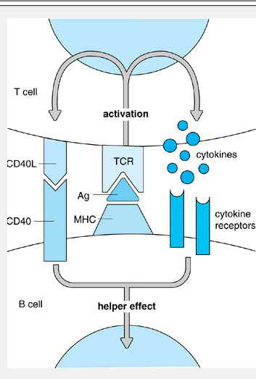
Fig5: B-cell activation by a helper T cell. Antigen-specific B cells are stimulated by antigen contact with the B-cell receptor (BCR). They also take up the antigen (Ag) for digestion into peptides that combine with class II major histocompatibility complex (MHC) molecules and then go to the cell surface to be presented to antigen-specific helper T cells. T-cell-receptor (TCR)-based recognition of the antigen leads to T-cell activation, which stabilizes the association between the T and B cells and induces T-cell synthesis of CD40L and cytokines, which provide coactivating signals for the B cell.
Another surface protein that may modulate lymphocyte activation is CD45, a membrane-spanning glycoprotein whose cytoplasmic domain has protein tyrosine phosphatase activity (ie, the ability to dephosphorylate phosphotyrosines of other proteins). CD45 is found on all hematopoietic cells, but its molecular mass varies considerably among cell types owing to differences in the size of the extracellular domain that result from alternative mRNA splicing. B lymphocytes express the largest (220 kd) isoform of CD45, designated CD45R. Although its precise role is unknown, CD45 paradoxically stimulates BCR or TCR signaling. It appears to do this by removing an inhibitory tyrosine phosphorylation of the Src-family tyrosine kinases, which initiate signal transduction by phosphorylating ITAMs in clustered antigen receptors.
B LYMPHOCYTES AS ANTIGEN-PRESENTING CELLS

The activation of B cells in response to T-cell-dependent antigens usually requires direct contact between the antigen-stimulated B cell and an antigen-activated T_{H} cell. T cells are constantly binding to other cells to determine whether they have ligands (specific antigenic peptide bound to an MHC molecule) for the TCR of that T cell. This interaction is short-lived if the T cell fails to detect the appropriate ligand. On the other hand, if a T cell encounters antigen presented by the bound cell, the interaction between the two cells is greatly strengthened. In the case of T_{H} cells, the resulting interaction can last for many hours and allow for efficient delivery of cytokines and contact-dependent signals involving CD40L. For efficient activation of B cells to occur, the B cell must present antigen to T_{H} cells to induce such a stable interaction. B cells are inefficient at taking up antigens by phagocytosis or pinocytosis but are extremely efficient at taking up antigen via the BCR. This is because the immunoglobulin acts as a high-affinity receptor, enabling the B cell to capture its cognate antigen at concentrations several orders of magnitude lower than those needed to engage the low-affinity, broad-specificity receptors on other types of antigen-presenting cells. The bound antigen is taken into the B cell by receptor-mediated (in this case, immunoglobulin-mediated) endocytosis. It is then processed by proteases in late endosomes or lysosomes. The resulting antigenic peptides can combine with newly synthesized class II MHC molecules, which are specially routed to endocytic compartments. Class II MHC molecules are constitutively synthesized by B cells, but their synthesis is upregulated by various activation stimuli, including specific antigen, IL-4, and polyclonal B-cell activators. The resulting class II MHCâ€“peptide complexes are then displayed on the B-cell surface, where they may be recognized by T cells that have the appropriate antigen- and MHC-specificities (Figure 8-7). Note that, if the antigen is a complex protein, the B cell may produce and display from it many different processed peptides that can serve as T-cell epitopes; these may or may not correspond to the B-cell epitope originally recognized by the immunoglobulin. If this sequence of events leads to helper T-cell activation, the presenting B cell is also likely to become activated because it not only receives signals from the bound antigen but is also already in direct contact with the helper cell (see Figure 8-6). Activated B cells express surface B7.1 and B7.2 proteins, which are T-cell costimulators that are important for activating naive T cells. In the absence of costimulation, B-cell
presentation of antigen to naive T cells leads to their inactivation. In contrast, a T_{H} cell that has recently been activated by antigen presented by other cells expressing B7.1 or B7.2 can provide help to a B cell even if it does not express the costimulatory molecules. Activated B cells may also secrete IL-6 and TNFخ±, which (like IL-1) increase the efficiency of T_{H}-cell activation.
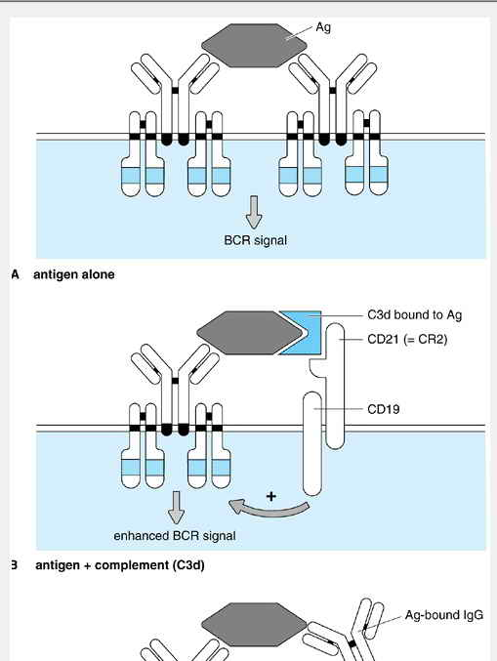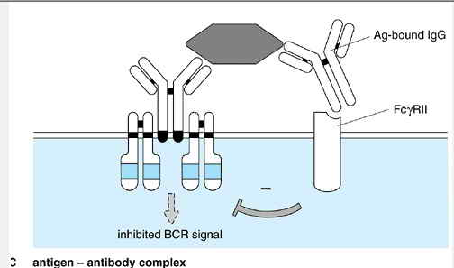
Fig6: Recognition of complex ligands by B cells. A: Immunoglobulin cross-linking by antigen can transmit a signal through the B-cell antigen receptor (BCR) alone. B: Signaling is enhanced when the antigen is complexed with other immunologically relevant ligands such as the C3d fragment of complement (see Chapter 12), which engages a separate receptor called complement receptor 2 (CR2) that synergizes with the BCR. C: Signaling may be inhibited if the antigen is complexed with an antibody (ie, the antigen exists as an antigenâ€“antibody complex) because the antibody engages a surface Fc receptor (in this case, Fcخ³RII), which antagonizes signaling by the BCR by recruiting signaling molecules that inactivate Ras and oppose PI 3-kinase.
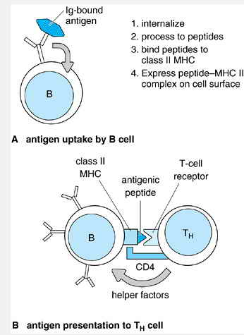
Fig7: Antigen presentation by a B lymphocyte to a CD4 T lymphocyte. A: The antigen-specific B cell can bind antigen via membrane immunoglobulin (Ig) and B: internalize the antigen and present it to helper T cells. Presentation does not require, but is likely to result in, activation of the B cell.

In addition to antigen uptake, the BCR stimulates the ability of a B cell to present antigen to T cells via its signaling function. BCR signaling induces increased expression of class II MHC molecules, induces expression of B7.1 and B7.2, and enhances cellâ€“cell adhesion by increasing the binding affinity of the adhesion molecule LFA-1. These features of BCR function serve to promote antigen-specific antibody responses by favoring interactions between antigen-specific T_{H} cells and antigen-stimulated B cells.
Although they offer unique advantages, B cells also have important limitations as antigen-presenting cells. They are not present in large numbers at most sites in the body, and, because they have little phagocytic capacity, they are unable to process many types of particulate antigens. Most importantly, in an unimmunized person, B cells specific for any given antigen are exceedingly rare. Consequently, other types of antigen-presenting cells, particularly dendritic cells, usually play the dominant role in initiating primary humoral responses. B cells then become increasingly important in this capacity at each subsequent encounter with antigen.

IMMUNOGLOBULIN SECRETION
When a B cell becomes activated and divides, its daughter cells do not regain the capacity for V/(D)/J rearrangement, but rather continue to express the rearranged genes they inherited from their clonal forebears. Some undergo further differentiation to become plasma cells, which secrete large amounts of immunoglobulin derived from the same genes (up to thousands of antibody molecules per second). Some of the cells that commit to becoming plasma cells migrate to the bone marrow in order to do so. Whereas plasma cells that remain in lymphoid tissue produce antibody for about a week and then die, plasma cells in the bone marrow have a much longer life span. As a result, the marrow contains the great majority of the body's plasma cells and is the main source of circulating antibodies.
The shift from producing membrane-bound to secreted immunoglobulin that occurs in plasma cells reflects a subtle change in the structure of the heavy-chain mRNA. The short hydrophobic tail that anchors a heavy-chain protein onto the cell membrane is encoded by the final two exons of every C_{H} region; when a B cell differentiates into a plasma cell, it produces an alternative form of heavy-chain mRNA that lacks these final exons and so encodes a heavy-chain protein that can be secreted from the cell (see Figure 3-4). In the case of آµ heavy chains, this slightly truncated mRNA is designated آµ_{s}. B cells that coexpress surface IgM and IgD almost always secrete only IgM (in pentameric form, complexed with J chains); IgD is rarely secreted.

MEMORY B LYMPHOCYTES
Most B cells within a proliferating clone that do not differentiate into plasma cells instead revert to the resting state to become memory B lymphocytes. Many of these memory cells ultimately take up residence within lymphoid follicles, where they survive for years; if subsequently activated, they undergo further cycles of replication to produce still more memory and plasma cells. In general, the progeny at each stage continue to express the same immunoglobulin genes as their parents. Two specialized types of genetic processes, however, occur at high frequency
whenever memory B cells proliferate in the periphery. These processesâ€”known as class switching and somatic hypermutationâ€”further diversify the immunoglobulin genes expressed by some of the replicating cells and can permanently alter the characteristics of the B-cell clone. In the following sections, we consider each of these phenomena in turn.

THE HEAVY-CHAIN CLASS SWITCH
As a B-cell clone proliferates, individual daughter cells often appear that express a heavy-chain class (such as خ³ or خ±) that differs from that of the founder (Figure 8-8A). This phenomenon is called class switching, or isotype switching. It results from a specialized type of DNA rearrangement in the expressed heavy-chain gene, whereby a new C_{H} region is moved to a position adjacent to the existing V/D/J exon by deleting all intervening C_{H} sequences on the chromosome (see Figure 8-8B). Although class switching bears some resemblance to V/(D)/J joining, the two processes are believed to occur through entirely different enzymatic pathways. In particular, switching occurs in mature B cells that no longer express RAG-1 and RAG-2 and hence cannot carry out V/(D)/J joining. In addition, switching takes place at distinct chromosomal sites (called switch regions)
that are located within the introns upstream of the first C_{H} exon of each heavy-chain gene. As switching occurs within introns, it does not change the structure of the V/D/J exon and therefore does not affect antigen specificity. Because class switching occurs by deleting one or more heavy-chain isotype genes, it is normally irreversible.
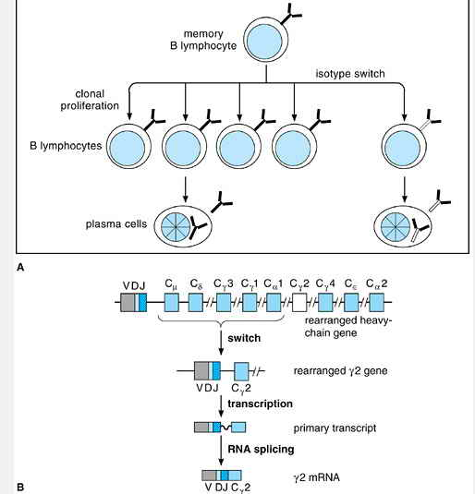

Fig8: Heavy-chain class switch. A: During clonal proliferation of an activated memory B cell, some daughter cells may arise that express a different heavy-chain isotype and pass this trait on to their progeny. B: Class switching takes place when a fully assembled heavy-chain locus undergoes an additional DNA rearrangement event that places a new C_{H} sequence adjacent to the V/D/J exon. This occurs by deletion of the intervening C_{H} exons and is carried out by an enzymatic pathway distinct from that of V/D/J rearrangement. In the example shown, the gene switches to the C_{خ³2} isotype.

Through the process of class switching, a preassembled V/D/J exon that was originally linked to C_{آµ} can become associated with any of the other heavy-chain constant-region sequences. By this means, the effector function of an antibody can be changed without altering its specificity for antigen. The choice of a new C_{H} isotype is strongly influenced by cytokines and other factors acting on the B cell. For example, the microenvironment found in Peyer's patches favors switching to C_{خ±1}, resulting in the production of IgA. This appears to be due to the action of a cytokine called transforming growth factor beta (TGFخ²). Similarly, exposure of the activated B cell to IL-4 promotes switching to C_{خµ}. In the mouse, IL-4, TGFخ², and interferon gamma (IFNخ³) each promote class switching to different IgG subtypes. In the human, less is known about the control of switching, although IFNخ³ and IL-4 are known to promote switching to IgG1 and IgG4, respectively. If a cell that has switched continues to divide, its progeny (both memory and plasma cells) also express the new heavy-chain isotype. As a rule, subclones expressing non-آµ isotypes become increasingly prevalent during a T-cell-dependent antibody response, and their isotype distribution increasingly reflects the peripheral tissue in which the proliferation has occurred: Memory cells in subepithelial regions most commonly express IgA, whereas IgM- and IgG- expressing memory cells are predominant elsewhere.

SOMATIC HYPERMUTATION

Fully assembled V/J and V/D/J exons in B cells undergo point mutation at an unusually high rate during the course of an immune response. The mechanism of this phenomenon, termed somatic hypermutation, is unknown but appears quite specific in that adjacent regions on the chromosome (including the C_{H} exon) are not affected. As the mutations are introduced into the variable region exon at random, they can have the effect of either increasing or decreasing affinity of the resulting immunoglobulin for its target antigen. Individual cells that express higher affinity mutants are selected from this pool of cells by virtue of their high affinity for antigen. This occurs by a complicated process in the germinal center, which is described later. This selection process is thought to account for a phenomenon known as affinity maturation: the observation that antibodies produced later in an immune response tend to have higher affinity for the target antigen than those produced earlier.

LYMPHOID FOLLICLES & GERMINAL CENTERS
The initial encounter between B cells and antigen most commonly occurs within a lymphoid organ, such as a lymph node or submucosal lymphoid tissue because that is where most B cells normally reside. An antigen may be transported into the lymphoid organ by a dendritic cell (see Chapter 6), which can then present it directly to cognate T_{H} cells. Alternatively, free antigen may enter by way of lymphatic channels to be captured and presented to the antigen-specific B cell by resident macrophages or may be captured directly by the specific B cell itself. In each case, antigen stimulates the B cell to alter its responsiveness to chemokines that direct traffic of lymphocytes within the lymph node. As a result, the antigen-activated B cell migrates toward the T-cell zone, where it may encounter antigen-specific helper T cells that have been activated by dendritic cells and that can recognize the complexes of antigen with class II MHC molecules on the B-cell surface. Recognition of this antigen by the activated T cell leads to a stable interaction between the two antigen-specific lymphocytes within the T-cell zone. This interaction promotes the proliferation of both cells. Some B cells soon terminally differentiate into plasma cells in the lymph node, whereas others migrate, along with some of the antigen-specific T_{H} cells, from the T-cell zone into a nearby lymphoid follicle, where they proliferate and differentiate (Figure 8-9A).
In the absence of an ongoing immune response, a lymphoid follicle consists mainly of a polyclonal collection of resting B lymphocytes, each enveloped within the spidery cytoplasmic processes of specialized supportive cells called follicular dendritic cells (FDCs). The FDCs, which are unrelated to other types of dendritic cells despite the unfortunate similarities in name and morphology, appear to be responsible for organizing the follicle and controlling many of its activities. Unlike dendritic cells, FDCs are not derived from a bone marrow precursor cell, and they do not ordinarily present antigens to T cells. FDCs express abundant surface Fc receptors, however, and are therefore very efficient at capturing antigenâ€“antibody complexes; in the presence of preformed antibodies, this enables FDCs to trap unprocessed antigens within follicles, where they may persist for weeks or even months on the FDC surface.
Activated B cells that enter the follicle then begin to proliferate very rapidly, with a generation time as short as 6 hours. The clonal progeny of the founder B cells become visible within 3 days to a week as a germinal centerâ€”a roughly spherical group of blast cells that tend to push aside the surrounding FDCs and resting lymphocytes of the original follicle (see Figure 8-9B). Each germinal center results from the
clonal expansion of only one or a few activated B-cell founders. Over time, the germinal center enlarges and becomes polarized into two morphologically distinct zones (see Figure 8-9C). The dark zone (which, in a lymph node, tends to be located near the efferent side of the follicle, ie, near the medulla) is composed of rapidly proliferating B cells called centroblasts. It is during the proliferation of centroblasts in the dark zone that hypermutation takes place within the V/D/J and V/J exons of the rearranged immunoglobulin genes.
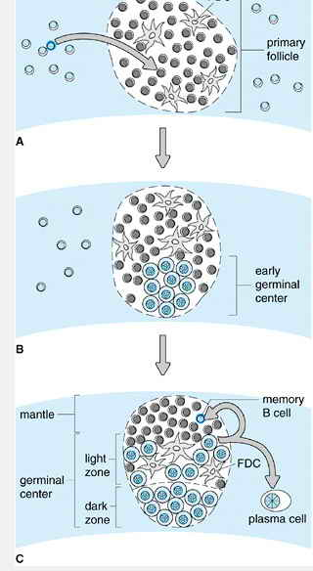
Fig9: Dynamics of a lymphoid follicle during a humoral response. A: An antigen-specific B cell (in dark blue) contacts antigen and receives help from an activated T_{H} cell in the T-cell-rich zone of a lymphoid organ (in this case, the paracortex of a lymph node). It migrates into an adjacent primary lymphoid follicle and undergoes blast transformation. Abbreviation: FDC = follicular dendritic cell. B: After 3â€“7 days, clonal progeny of the B cell (in dark blue) appear as an early germinal center, which displaces the FDCs and resting polyclonal B cells of the original follicle toward the afferent surface of the node. C: After 1â€“4 weeks, the germinal center has matured to form a dark zone, populated mainly by proliferating blasts, and an apical light zone, where nonproliferating progeny of these blasts contact FDCs. Cells that survive selection in the light zone emerge as memory cells or plasma cells. The newly formed memory B cells, as well as those from the original primary follicle, make up the follicular mantle overlying the germinal center. Photographs of germinal centers exhibiting these features can be seen in Figures 3-12 and 3-14.
As individual centroblasts cease dividing, they move into the adjacent light zone, where they acquire the name centrocytes and come into contact with FDCs that bear unprocessed antigens. The light zone is believed to be a region of intense selective pressure where numerous centrocytes compete to bind a limited amount of cognate antigen on the surface of the FDCs. Centrocytes whose BCR binds antigen survive, whereas those that fail to bind die by apoptosis. This is thought to be the basis for selecting cells that produce high-affinity immunoglobulins: In a competitive situation, surface immunoglobulins of higher affinity are thought to compete for antigen more effectively than those of lower affinity. Cells with higher affinity immunoglobulins not only are stimulated more strongly through their BCRs, but also compete more effectively in internalizing antigen and presenting it to local T_{H} cells, and hence receive more effective help, as described earlier. Together, these selective processes likely account for the antibody affinity maturation that occurs as a humoral response proceeds.
Centrocytes that survive the selection process emerge from the germinal center as either plasma cells or memory B cells. The plasma cells generally exit the follicle, either remaining in the lymphoid organ or migrating to the bone marrow. Memory cells often move into the follicular mantle, joining the original polyclonal population of memory B cells that remain in the follicle after the immune response subsides and the germinal center regresses. The T_{H}-cell surface molecule CD40L appears to play a role in inducing centrocytes to develop into memory cells rather than into plasma cells. Interestingly, patients with the X-linked hyper-IgM syndrome, in which CD40L is defective, fail to develop germinal centers at all.

PRIMARY & SECONDARY HUMORAL RESPONSES
Of necessity, the properties of a primary humoral immune response (ie, the antibody response that occurs the first time an individual encounters a given antigen) reflect the properties of naive lymphocytes. Because B cells with the appropriate specificity are rare in unimmunized hosts, most of the antigen must
be processed by dendritic cells and presented to antigen-specific helper T cells, which are also correspondingly rare. These antigen-activated T_{H} cells multiply and then must contact and promote the activation of antigen-specific B cells, which must in turn proliferate and differentiate into plasma cells in sufficient numbers to be effective. The initially low frequencies of antigen-specific T cells and B cells and the necessity of their expansion account for the lag time (typically 5â€“10 days) required to reach peak serum antibody concentrations in a primary response, and for the relatively low concentrations achieved (Table 8-1). The antibodies initially produced are predominantly IgMâ€”the type secreted by most direct progeny of naive B cellsâ€”and have, on average, low antigen affinities. The pentameric structure of IgM helps compensate for this low intrinsic affinity by providing multiple binding sites so that antigens with multiple copies of individual epitopes can be bound with a higher avidity.
Subsequent responses, by contrast, are increasingly dominated by antigen-specific memory cells, whose sheer numbers enhance both the speed and intensity of the response (see Table 8-1). In a highly immunized lymph node, as many as one in a few hundred B cells may be specific for the target antigen. Memory B cells may serve as the principal antigen-presenting cells in secondary responses, and so enable helper T cells to become activated at very low concentrations of antigen. In the process, the B cells themselves are ideally positioned for activation because they are stimulated strongly both by antigen induction of BCR signaling and by direct contact with the helper cells (see Figure 8-7). The responding B cells are more likely to express high-affinity antibodies, following selection in the germinal center during either the initial response or the secondary response. Although some plasma cells still produce IgM in a secondary response, a substantial number of plasma cells arise from class-switched B-cell subclones and instead secrete IgG, IgA, or IgE. These latter isotypes therefore tend to predominate in secondary responses, depending on the site at which the response occurs: Secondary responses in the peripheral lymph nodes are predominantly IgG, whereas those at mucosal surfaces are mainly IgA.

B-CELL TOLERANCE
The random assembly of V, D, and J segments during lymphopoiesis inevitably produces some B-cell clones whose immunoglobulins recognize self-determinants on normal host cells or tissues. Because such autoreactive immunoglobulins are potentially deleterious to the host, stringent measures are needed to ensure that they are not secreted. In most cases, these measures operate successfully; the immune system remains specifically tolerant toward the many self-determinants to which it is continually exposed. In contrast, in some people antibodies to certain self-components are made and lead to tissue or organ damage. These diseases are referred to as autoimmune diseases because the immune system has lost tolerance to certain self-components.
The B cells that make autoreactive immunoglobulins are normally silenced in two main ways. The first applies to the situation in which an immature B cell contacts antigen in the bone marrow shortly after it begins expressing surface immunoglobulins. This results in maturational arrest; the cell fails to mature further and does not exit the marrow. Instead, the cell reactivates expression of the RAG-1 and RAG-2 recombinase proteins, so that it is able to resume rearranging its light-chain genes. Like 60â€“70% of all human B lymphocytes, many autoreactive B cells initially express خ؛ light chains; in those cells, the reactivated recombinase is able to carry out a special type of DNA rearrangement in which a V_{خ؛} or J_{خ؛} segment in the active خ؛-gene locus becomes fused to a site downstream of the C_{خ؛} segment, which is called the خ؛-deleting element (Figure 8-10). As a result of this rearrangement, the C_{خ؛} segment and other important regions are deleted, the gene is permanently inactivated, and the cell can then attempt to assemble a new خ؛ or خ» gene on one of its other chromosomes. This process has been called receptor editing. If the
original خ؛ chain contributed to recognition of self-antigen, then replacing it with a new light chain may eliminate autoreactivity. In that case, the cell can resume maturation, shut off its recombinase activity, and be released from the marrow. If receptor editing fails, then the autoreactive B cell remains arrested in the undifferentiated state and eventually dies.
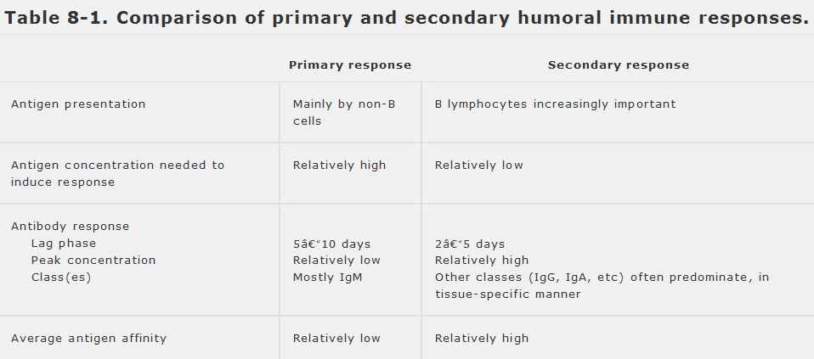
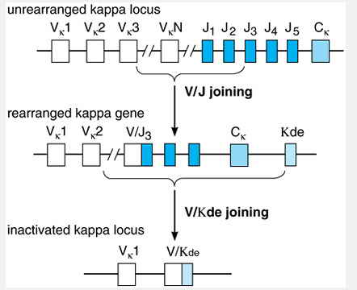
: Rearrangements that remove a functionally rearranged خ؛ fig 10: light-chain gene. In immature B cells that contact self-antigen, maturation is arrested and the recombination-activating genes RAG-1 and RAG-2 are reexpressed. Among the reactions that can be performed by the V/D/J recombinase is a rearrangement between either an unrearranged Vخ؛ gene (as shown) or a sequence in the intron between Jخ؛ and Cخ؛ with a sequence 24 kb downstream of the Cخ؛ gene called the خ؛-deleting element (Kde). This deletes the intervening DNA, including Cخ؛, and results in a nonfunctional gene. This reaction may occur as part of receptor editing, whereby a self-reactive immature B cell attempts to change light chain and thereby its antigen specificity.

The receptor-editing mechanism applies only to immature B cells, and so would be effective only for eliminating cells that recognize self-antigens found in the bone marrow, such as serum proteins and ubiquitous cell surface or extracellular matrix proteins. Many other self-antigens, however, are found only outside the marrow, and for these antigens a different mechanism is needed to ensure B-cell tolerance. This mechanism acts only on B cells in peripheral tissues and relies on the fact that B-cell activation by most protein antigens requires the participation of helper T cells. When a mature B cell contacts antigen in the absence of appropriate T-cell help, the B cell either dies or loses its ability to carry out an immune response. The fate of the B cell depends on the physical nature of the antigen involved. In the case of membrane-bound or particulate antigens, the self-reactive B cell generally diesâ”a phenomenon referred to as clonal deletion. Soluble protein antigens, which presumably generate weaker signals through the BCR of a self-reactive B cell, do not cause cell death but instead make the cell unresponsive to activating stimuliâa phenomenon called clonal anergy. Anergic B cells can become activated under some circumstances, so clonal anergy is thought to be a less absolute mechanism for enforcing tolerance to self. Anergic B cells, however, cannot compete effectively with nonanergic B cells for survival and proliferation in the body; as a result, the anergic cells probably die within a few days, so that clonal anergy and clonal deletion differ only in the short term. It remains to be determined precisely how clonal anergy and clonal deletion are circumvented in people who develop autoimmune disease.

