Lec7 Immunotechnology MSC/Biotechnology
Prof.Dr.Ekhlass N.Ali
Cytokines:
Many critical interactions among cells of the immune system are controlled by soluble mediators called cytokines. These cytokines are a diverse group of intercellular signaling peptides and glycoproteins with molecular weights (MW) between 6000 and 60,000, and most of them are genetically and structurally unrelated to one another. Several hundred have been identified to date. Each is secreted by particular cell types in response to a variety of stimuli and produces characteristic effects on the growth, mobility, differentiation, or function of target cells. Collectively, they regulate not only immune and inflammatory responses but also wound healing, hematopoiesis, angiogenesis, and many other biologic processes. They are extremely potent compounds that act at concentrations of 10⁻⁹-10⁻¹⁵ M by binding to specific surface receptors on target cells. Unlike endocrine hormones, they are not produced by specialized glands and secreted into the circulation, but rather are produced locally by a variety of tissues and cells. Only a few cytokines, such as transforming growth factor خ² (TGFخ²), erythropoietin (EPO), stem cell factor (SCF), and monocyte colony-stimulating factor (M-CSF), are normally present in detectable amounts in the blood and are able to influence distant target cells. Most other cytokines, unless produced in excess, act only locally over short distances, in either a paracrine manner (ie, on adjacent cells) or an autocrine manner (ie, on the producing cell itself).
Cytokine nomenclature has little to do with structural relationships among molecules; some of them have been termed interleukins (IL) and been assigned a number (Table 10-1), but many others retain their descriptive and frequently misleading historical names (Table 10-2). Some can be classified into families based on their use of receptors that share a common chain or exhibit other sequence homologies. Cytokines produced by lymphocytes are also called lymphokines, whereas those produced by monocytes or macrophages are called monokines. A given cytokine may be secreted individually or as part of a coordinated response along with other, unrelated cytokines. Many have activities that overlap extensively, and others may be antagonistic. Furthermore, one cytokine may induce expression of other cytokines or mediators, thus producing a cascade of biologic effects.
This chapter will focus primarily on the role of cytokines and their receptors in immune and inflammatory responses. We will consider the interleukins, TNFخ±, transforming growth factor خ² (TGFخ²), colony-stimulating factors (CSFs), and interferons (IFNs), emphasizing their effects on growth, differentiation, and function of leukocytes. Cytokines that act primarily on other tissue types will not be covered. Because it can be quite perilous to extrapolate from in vitro studies, much of what we know about cytokine functions in vivo has come from studying humans or animals with mutations that inactivate a particular cytokine or cytokine-receptor gene. Some of these mutations occur naturally, and others have been introduced deliberately into the chromosomes of laboratory mice to create so-called knockout mouse strains with defects in specific genes. In addition, the ability to produce cytokines in large quantities using recombinant DNA techniques has allowed them to be tested as potential therapeutic agents. We will briefly summarize the information available to date; readers may consult the accompanying references for additional details.
INTERLEUKIN-1 & TUMOR NECROSIS FACTOR

IL-1 and TNFα± are structurally unrelated and use different receptors, yet their spectra of biologic effects overlap considerably (Table 10-3). For example, each can directly promote growth and differentiation of B cells, activate neutrophils and macrophages, stimulate hematopoiesis, and produce a broad range of effects on nonhematopoietic cell types. They also induce expression of many other cytokines and mediators that promote inflammation and are therefore known as proinflammatory cytokines. Their main importance for immunity, however, lies in their ability to enhance the activation of T helper (T_{H}) lymphocytes by antigen-presenting cells (APCs). IL-1 and
TNFα± are each secreted by APCs on contact with a T_{H} cell that has the appropriate antigen and major histocompatibility complex (MHC) specificity. They then act in an autocrine manner to induce or increase expression of various adhesion molecules, IFNγ receptors, and class II MHC proteins on the APC surface and so increase the efficiency with which the APC can bind and activate T_{H} cells. They also act in a paracrine fashion on the T_{H} cell, augmenting secretion of IL-2, expression of surface receptors for IL-2 and IFNخ³, and other events leading to clonal T-cell proliferation. As a result, IL-1 and TNFα± help to initiate both humoral and cellular immune responses. Although each can function independently, they also synergize with one another, or with IL-6, to produce markedly augmented effects.
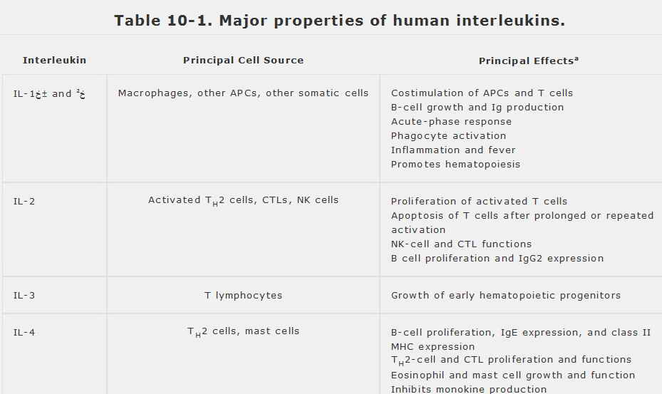

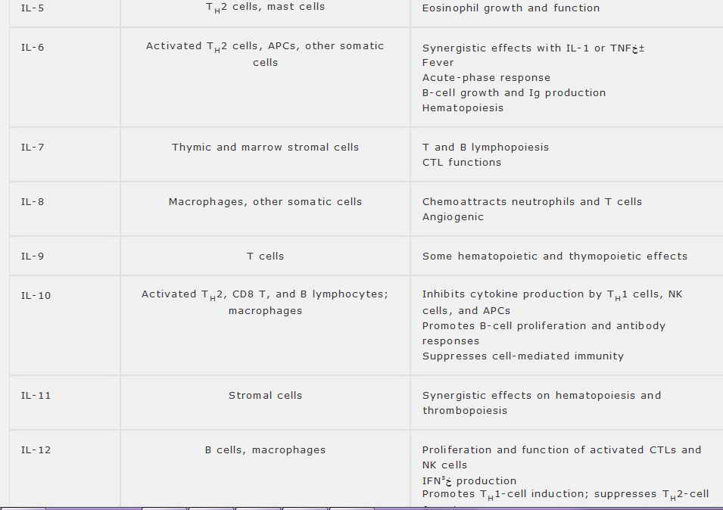
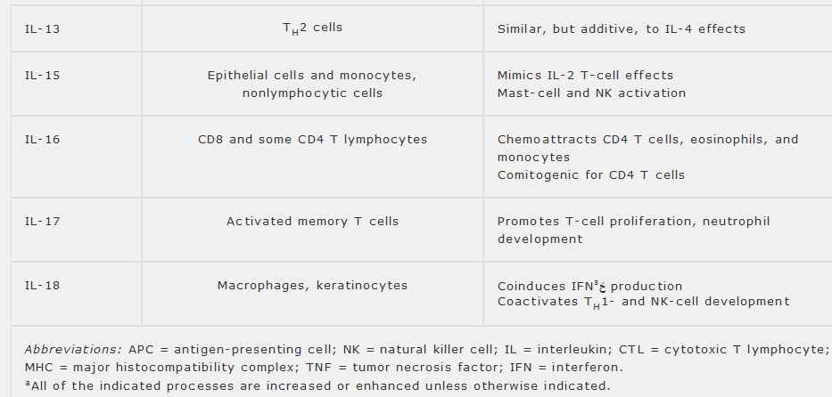
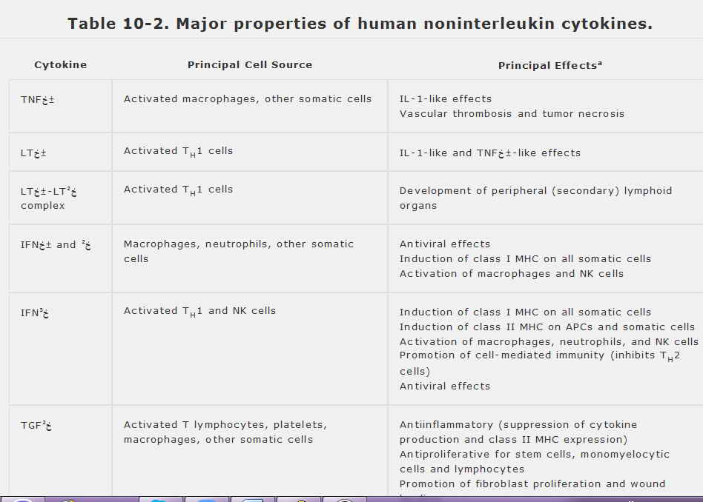
Abbreviations: TNF = tumor necrosis factor; LT = lymphotoxin; IFN = interferon; TGF = transforming growth factor; NK = natural killer; IL = interleukin; MHC = major histocompatibility complex.
ªAll of the listed processes are enhanced unless otherwise indicated.
IL-1 Proteins & Their Receptors
Like all species examined to date, humans express two distinct molecular forms of IL-1, called IL1α± and IL-1β². These are peptides, 159 and 153 amino acids long, respectively, that are encoded by separate genes and share only 26% amino acid sequence similarity, but have virtually identical potency and biologic activities and bind with about the same affinity to the same cell surface receptors. Virtually all nucleated cells can produce IL-1, and although many cell types express both forms, their relative levels of expression vary widely. For example, human monocytes produce predominantly IL-1βwhereas keratinocytes produce mainly IL-1α±. The biologic significance of this disparity is unknown. IL-γ± and IL-1β² are initially synthesized as propeptides, which are then processed enzymatically to mature form, either at or beyond the outer cell membrane. IL-1α² is processed by caspase-1 (also called IL-1β²-converting enzyme, or ICE) and is then released in soluble form. By contrast, IL-γ± most often remains on the cell surface and may thus participate in interactions that require cell-to-cell contact. A number of cell types can also express a third gene that codes for a protein called IL-1 receptor antagonist (IL-1RA), which has no intrinsic activity but competes for binding of IL-1 receptors and so is a competitive inhibitor of IL-γ± and IL-β.
A few tissues express IL-1, constitutively; for example, the skin, sweat, urine, and amniotic fluid contain significant amounts. In contrast, macrophages and most other cell types produce IL-1 only in response to external stimuli, such as bacterial lipopolysaccharide (LPS); urate or silicate particles; or adjuvants such as aluminum hydroxide (. It is thought that, during the process of antigen presentation, IL-1 production by the APC is initially triggered by contact with a specific T_{H} cell and may then increase further in response to TNFα± or IL-2 released from the T cell when it becomes activated. Prostaglandins, a class of lipid-derived inflammatory mediators, can also regulate IL-1 expression; for example, IL-1 production by macrophages is enhanced by leukotrienes, but is suppressed by products of the cyclooxygenase pathway, such as prostaglandin E₂ (see Chapter 13). Increased circulating levels of IL-1 are also observed during the luteal phase of the menstrual cycle and during strenuous exercise.
IL-1α± and IL-1β bind to high-affinity receptors (K_{d} = 10⁻¹⁰ M) present on most nucleated cell types. A fibroblast may carry several thousand IL-1 receptors; resting T cells express as few as 50, but this number increases after activation. Binding leads to endocytosis of IL-1 together with its receptor. Two distinct IL-1 receptors have been characterized, both of which are membrane glycoproteins that share only 28% sequence similarity but have comparable three-dimensional structures and bind IL-1α± and IL-1β² equally. The type-I receptor (IL-1RI) has a large cytoplasmic domain and transmits signals when it binds IL-1; the signaling pathway is not fully known, but shares some components with those used by the IL-18 and Toll-like receptor families. Binding to as few as five copies of IL-1RI on a cell can be sufficient to produce a response. The type-II receptor (IL-1RII), by contrast, has a small cytoplasmic domain and cannot transduce signals. The extracellular domain of IL-1RII is released in soluble form at sites of local inflammation and into the serum during times of systemic inflammation. This soluble IL-1RII is produced
in relatively large amounts, binds IL-1β much more strongly than it binds IL-1α± or IL-1RA, and functions as an endogenous inhibitor of IL-1β Both the soluble and cell-associated forms of IL-1RII have therefore been called IL-1 decoy receptors.
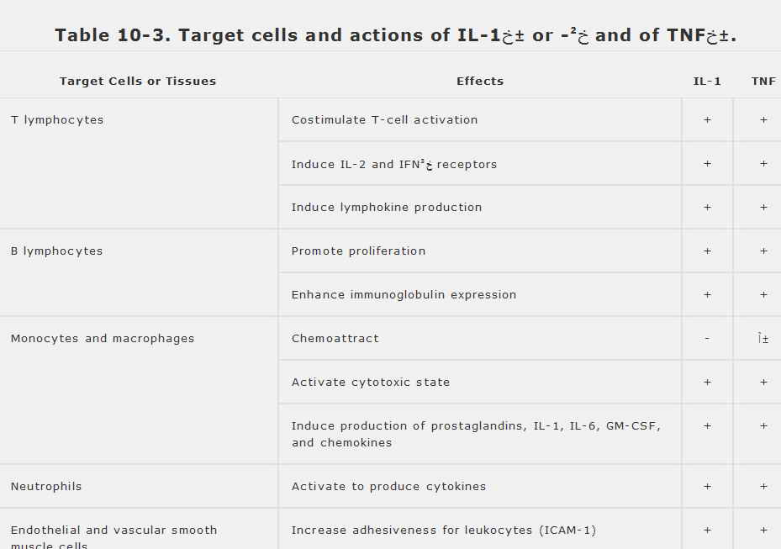

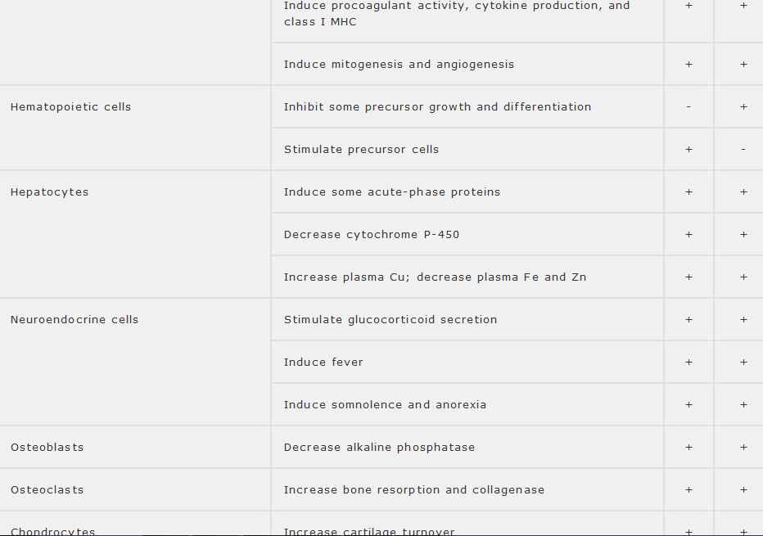
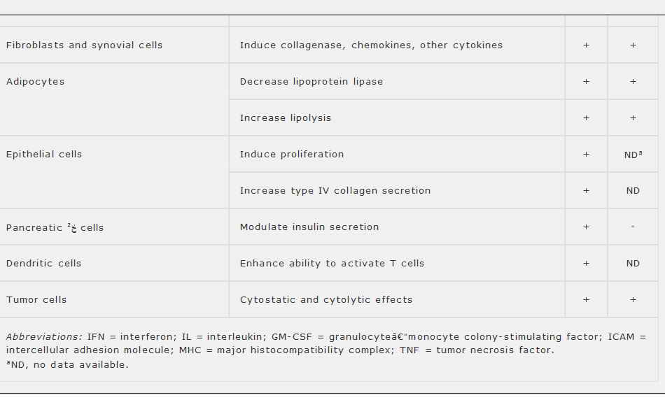
TNFα± & Its Receptors

TNFγ± was first described as an activity in the serum of LPS-treated animals that could induce hemorrhagic necrosis of certain tumors, and it was later discovered independently as cachectin, a circulating mediator of the wasting syndrome (cachexia) associated with certain chronic diseases. It is part of a large superfamily comprising at least 15 proteins that have diverse functions (Table 10-4) and that associate with at least 24 different receptors. Every member of the TNF superfamily has some effect on the immune system (see Table 10-4), and several (notably, FasL and CD40) have been highlighted in previous chapters. We will focus initially on TNFخ± itself, many of whose properties also apply to other members of the family.
TNFخ± is synthesized as a propeptide and then processed intracellularly by an enzyme called TNFخ±-converting enzyme (TACE) to its mature, secreted form, which is 157 amino acids long. An active membrane-bound form of TNFخ± has also been described. Like other members of its family, TNFخ± binds as a trimer to its receptor, with each trimer binding to two or three copies of the receptor simultaneously. This results in ligand-mediated cross-linking of the receptors, which then transmit signals into the cell.
Two different TNFخ± receptors have been identified. The type-II receptor (TNFRII) binds TNFخ± with about tenfold higher affinity (K_{d} = 5 أ— 10⁻¹¹ M)
than does the type-I receptor (TNFRI). Each has a large cytoplasmic domain and can transmit signals through the NFخ؛B pathway (see Chapter 1) that give rise to most of the immunologic effects of TNFخ±. In most respects, TNFRI is the principal mediator of TNFخ± activity, with TNFRII serving an auxiliary role. Moreover, unlike TNFRII, the cytoplasmic portion of TNFRI includes an 80-amino-acid sequence known as the death domain, which is also found in the Fas protein (the receptor for FasL). The death domains of TNFRI and Fas allow these proteins to trigger apoptosis when they bind their respective ligands; they do so by activating caspase-8, which in turn activates the downstream caspase cascade. Like the IL-1 receptors, TNFخ± receptors are internalized (endocytosed) after ligand binding. IL-2 increases expression of both types of TNFخ± receptors, whereas IFNخ³ selectively induces TNFRII. Activated cells shed their TNFخ± receptors, which can bind TNFخ± and may antagonize its activity during inflammatory responses. An inherited inability to shed TNFRI results in a syndrome of recurrent localized inflammatory episodes and fevers.
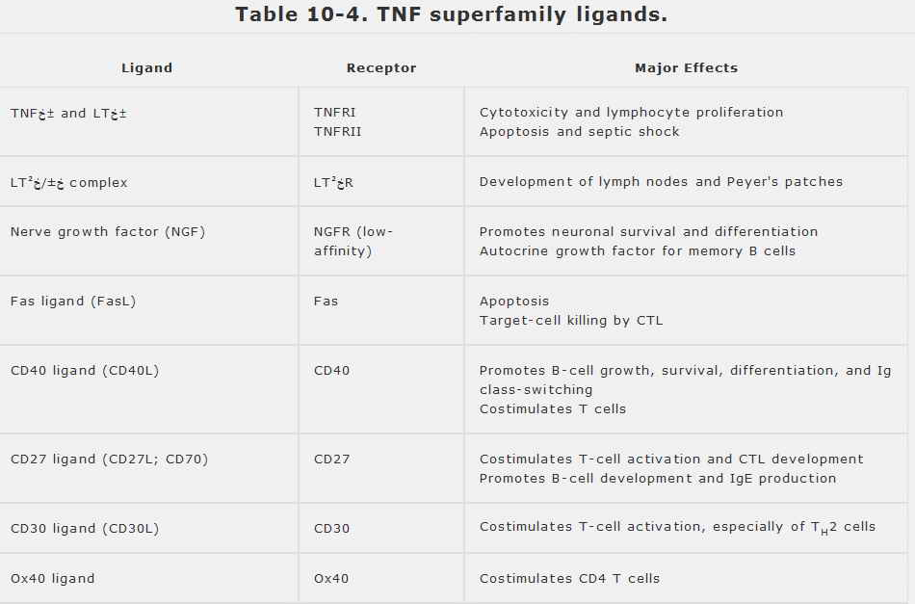

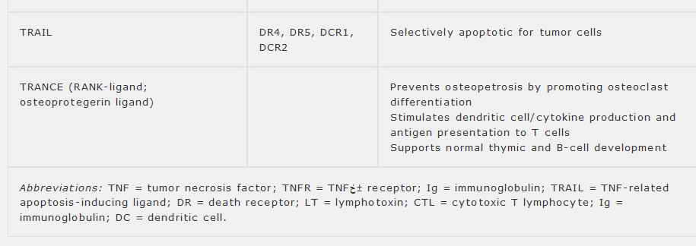
Nonimmunologic Inflammatory Effects of IL-1 & TNFα

TNFخ± is primarily responsible for a laboratory phenomenon known as the localized hemorrhagic Shwartzman reaction, in which repeated injection of LPS into a solid tissue leads to hemorrhagic infarction. This occurs because LPS-induced TNFخ± secretion by macrophages can stimulate endothelial cells to release prostaglandins, IL-6, and other mediators that cause coagulation, clotting, and obstruction of the local blood supply. A similar mechanism probably accounts for the ability of TNFخ± to cause infarcts and hemorrhagic necrosis of tumorsâ€”the property that led to its discovery. There is also a systemic form of the Shwartzman reaction in which intravenous LPS induces disseminated intravascular coagulation (DIC)â€”widespread thrombosis that blocks capillaries and may lead to hemorrhages, shock, and death. This systemic reaction resembles the effects of overwhelming bacterial sepsis and is mediated, at least in part, by TNFخ±. Repeated injections of IL-1 can also yield localized Shwartzman reactions, and low doses of IL-1 act synergistically with TNFخ± to mimic the fatal systemic effects of septic shock.
TNFخ± and IL-1 are important inducers of the acute-phase response, although they are exceeded in this regard by IL-6. Acting alone or synergistically, they can induce a number of effects that are mediated through the hypothalamus: they are endogenous pyrogens (ie, they induce fever) and stimulate the secretion of corticotropin-releasing factor, which stimulates the release of adrenocorticotropic hormone (ACTH) from the pituitary and in turn induces the production of glucocorticoids by the adrenals. Both IL-1 and TNFخ± have effects on bones and synovia and are present at increased concentration in inflammatory joint fluids, suggesting that they may contribute to the fibrosis and thickening of arthritic joints.

Other effects of IL-1 and TNFخ± are listed in Table 10-3. Overall, the functional overlap between these cytokines is probably beneficial because it provides parallel pathways for mobilizing host defenses. IL-1 and TNFخ± induce each other as well as IL-6, and their ability to synergize enables them to achieve maximal effects at suboptimal concentrations. Despite this redundancy, however, the disparate phenotypes of various IL-1 and TNFخ± ligand- and receptor-knockout mice indicate that each of these cytokines does have unique pathophysiologic roles (Table 10-5).

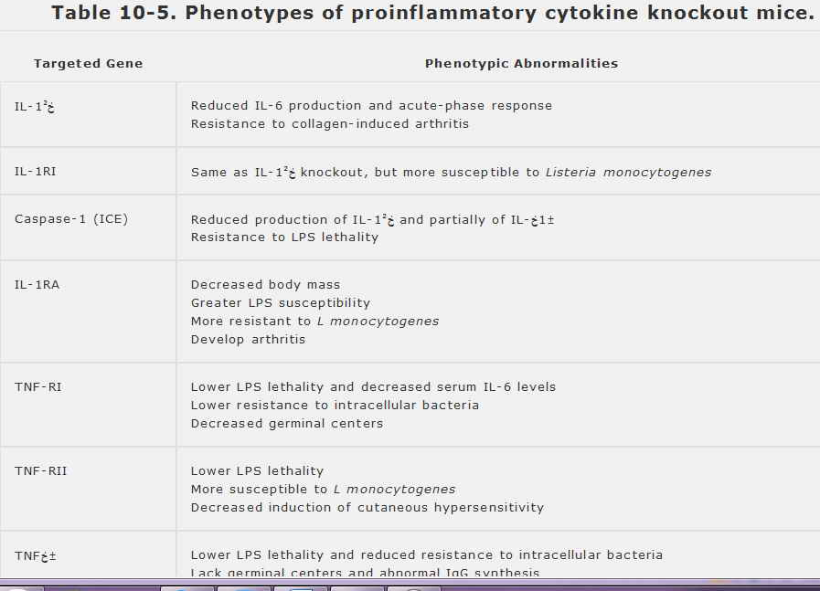
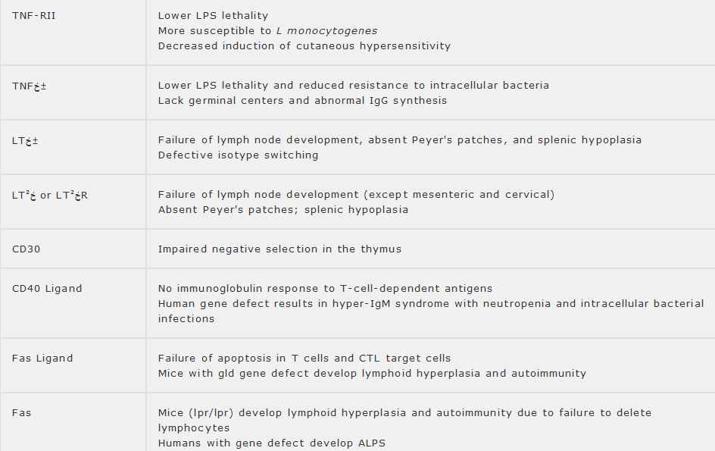
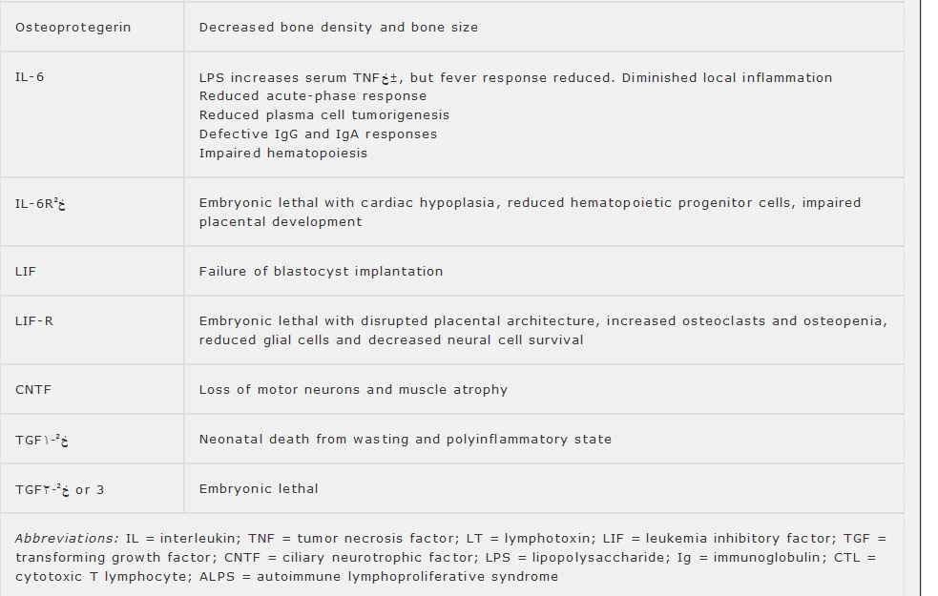
IL-1 & TNFخ± as Therapeutic Agents
Both IL-1 and TNF have been investigated as possible therapeutic agents, with emphasis on their immunostimulatory and antineoplastic activities, but neither has proven useful in practice, largely because of their numerous side effects. Antagonists of IL-1 and TNFخ±, on the other hand, are also of interest as a means of ameliorating chronic inflammatory diseases such as rheumatoid arthritis. Potent nonspecific antagonism to both these cytokines is exhibited by TGFخ² and by corticosteroids. In addition to reducing IL-1 production, TGFخ² inhibits IL-1RI expression and induces production of IL-1RAâ€”it is a â€œtriple threat!â€‌ Corticosteroids not only reduce the production of IL-1 and TNFخ±, but also increase expression of IL-1RII, which can further inhibit IL-1 effects. Inhibitors of the lipoxygenase pathway likewise reduce IL-1 secretion, whereas leukotrienes appear to increase it .
Other TNF & TNF-Receptor Superfamily Proteins

Proteins of the TNF receptor superfamily (see Table 10-4) differ from most other receptors in that they bind trimeric ligands and contain one or more copies of a cysteine-rich 40-amino-acid sequence in their extracellular domains. Nearly all members of this family characterized to date are involved in regulating immune functions, though they may do so through divergent signaling pathways. Indeed, the cytoplasmic signaling domains of these proteins resemble one another very little, except that a few of them (eg, TNFRI, Fas, and NGFR) contain death domains.
One prominent member is CD40, the principal receptor on B cells for contact-mediated help provided by T cells that express the CD40L protein (see Chapter 9). CD40 is also expressed on APCs and participates in T-cell costimulation. Another member is Fas, which, in conjunction with its ligand (FasL), transmits signals that trigger apoptosis in various settings, including target-cell killing by cytotoxic T lymphocytes (CTLs; see Chapters 4 and 9). Resting human B lymphocytes express the nerve growth factor (NGF) receptor and secrete NGF, which functions as an autocrine growth factor that is essential for survival of memory (ie, class-switched), but not naive, B cells. CD27 is expressed on activated T cells, B cells, and natural killer (NK) cells. The CD27 ligand (also known as CD70) is expressed on monocytes and some T and B cells and is thought to participate in IL-2-independent T-cell stimulation and CTL development. CD27â€“CD70 interactions augment IgE secretion by promoting B-cell maturation. CD30 is a T-cell costimulatory receptor that is reported to act preferentially on T_{H}2 cells and is also found on the Reedâ€“Sternberg cells of Hodgkin's disease. Interaction of Ox-40 with Ox-40L likewise provides costimulatory signals that sustain primary T_{H}-cell responses, and interference with these signals has been reported to suppress inflammatory bowel disease and autoimmune encephalomyelitis in animal models. TRAIL and its receptors are of interest because of their ability to induce apoptosis in cancer cells but, unlike TNFخ± or Fas, not in most normal cells. TRANCE is expressed on mature dendritic cells and serves both to induce cytokine production from these cells and to costimulate T_{H} cells that express its ligand.
Lymphotoxin خ± (LTخ±, also known as TNFخ²) is only 28% similar to TNFخ± but binds both TNFخ± receptors and has many of the same biologic effects. Unlike TNFخ±, however, LTخ± appears to be required for normal formation of lymph nodes and Peyer's patches during development, at least in mice. This reflects the fact that LTخ± also binds to a cell-surface protein known as LTخ², which is found on T and B lymphocytes and, to a limited degree, on myelomonocytic cells. The LTخ±/LTخ² complex binds and stimulates a receptor, called LTخ²R, which mediates the unique effects of LTخ±. The TNFخ±, LTخ±, and LTخ² genes lie adjacent to one another within the MHC gene cluster.

INTERLEUKIN-2

IL-2 is an autocrine and paracrine growth factor secreted by activated T lymphocytes and is essential for clonal T-cell proliferation. The discovery of IL-2 (then called T-cell growth factor) represented a major advance in immunology, because it made it possible to propagate and study individual clones of normal T cells that maintained their immunologic properties in cell culture. Its role in promoting T-cell proliferation, cytokine production, and the functional properties of B cells, macrophages, and NK cells, make IL-2 critical for activating all types of acquired immune responses. Paradoxically, however, this cytokine appears equally important in limiting such responses and eliminating autoreactive T cells: prolonged or repeated activation in the presence of IL-2 causes T-cell apoptosis, and mutations that inactivate IL-2 or its receptor lead to excessive T-cell proliferation and autoimmunity in both humans and animal models (Table 10-6). IL-2 is thus a two-edged sword that initiates immune responses but also limits their intensity and duration.
IL-2 is 133 amino acids long and is encoded by a single gene on human chromosome 4. Although it bears little obvious sequence similarity to other known cytokines, its three-dimensional structureâ€”consisting of two خ± helices forming planar faces around a very hydrophobic coreâ€”is similar to those of IL-4 and granulocyteâ€“monocyte CSF (GM-CSF). This configuration is maintained in part by the single intrachain disulfide bond, which is essential for biologic activity.
Resting T lymphocytes neither synthesize nor secrete
IL-2, but can be induced to do both by the appropriate combinations of antigen and costimulatory factors or by exposure to polyclonal mitogens (Chapters 4 and 9). Although CD4 T_{H} cells are the main source of IL-2, CD8 T cells and NK cells also can be induced to secrete it under certain conditions. Several signaling pathways, including the NFخ؛B pathway, regulate the IL-2 gene, and immunosuppressive drugs that interfere with NFخ؛B signaling (eg, cyclosporin A) produce their effects in part by inhibiting IL-2 production. When human lymphocytes are exposed to a T-cell mitogen, IL-2 mRNA expression becomes detectable after 4 hours, reaches peak concentration at 12 hours, and thereafter declines rapidly. The abrupt disappearance of IL-2 mRNA reflects not only cessation of IL-2 gene transcription but also the instability of IL-2 mRNA, which has a half-life of less than 30 minutes. Synthesis and release of IL-2 protein follow a similar time course, resulting in a transient burst of secretion that quickly subsides. Because IL-2 has very short half-life in the circulation, it primarily acts as an autocrine or paracrine mediator.
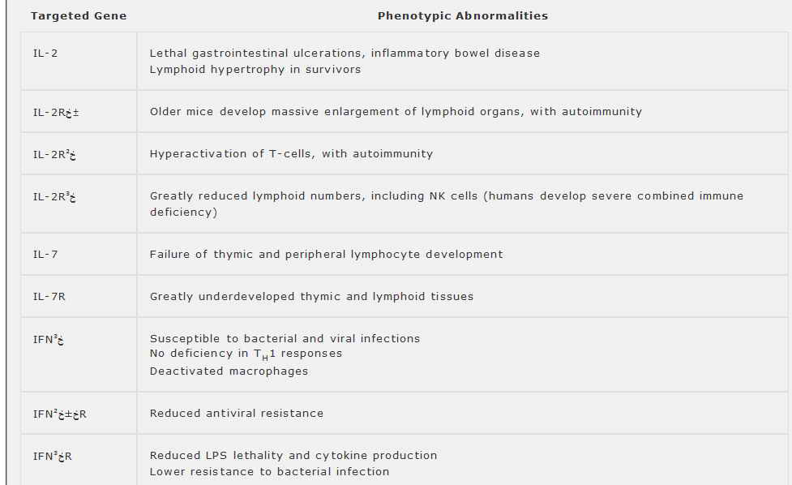

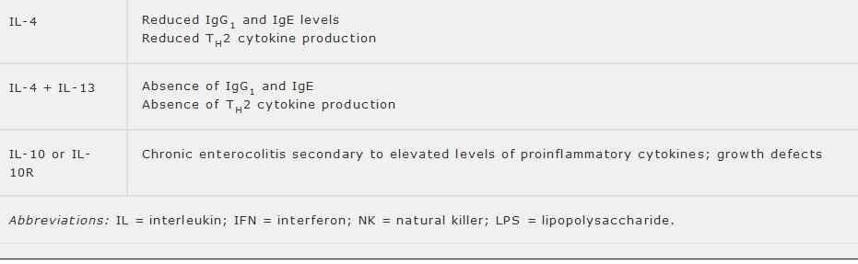
IL-2 Receptors & Signal Transduction
The high-affinity IL-2 receptor (IL-2R) is composed of three subunits, designated خ±, خ², and خ³, each of which is an integral membrane protein. This heterotrimer binds IL-2 with a K_{d} of 1.3 أ— 10⁻¹¹ M and a dissociation half-life of 50 minutes. The خ± chain alone (also called Tac or CD25) binds IL-2 with intermediate affinity (K_{d} 1.4 أ— 10⁻⁸ M), but cannot signal. The خ² and خ³ subunits alone can each transmit signals, but the خ² chain binds IL-2 with only low affinity (K_{d} 1.2 أ— 10⁻⁷ M), and the خ³ does not bind it detectably. Receptors composed of خ±/خ³ or خ²/خ³ heterodimers bind with K_{d} of about 10⁻⁹ M and, like the heterotrimer, can mediate IL-2 signaling. The IL-2R خ³ chain is also a functional component of the IL-4, IL-7, IL-9 and IL-15 receptor complexes (Figure 10-1), enabling all of these cytokines to act as T-cell growth factors.
Several distinct cytoplasmic regions of the IL-2R خ² chain contribute to signaling: A serine-rich region is required for induction of c-Myc protein; an acidic region mediates interaction with Lck and other Src-like protein tyrosine kinases and activation of the Ras pathway; and phosphorylation of this chain activates phosphatidylinositol 3-kinase (see Chapters 1 and 9). In addition, both the خ² and خ³ chains can interact with components of the Jak/Stat pathway (Chapter 1), and mutations either in the خ³ chain or in Jak-3-kinase can lead to severe immune deficiency in humans.
Resting T cells express the خ²/خ³ receptor dimer, but not the خ± subunit. Activation of T-cells by antigens or polyclonal mitogens leads to خ±-chain expression and assembly of high-affinity receptor trimers, which reach maximal levels within 2â€“3 days, coinciding with the peak of the T-cell proliferative response. Interference with either IL-2 or its receptor (eg, by treatment with specific antibodies) blocks proliferation. Unless the cell is repeatedly stimulated, receptor expression then declines to undetectable levels by 6â€“10 days after activation. This decline occurs regardless

of whether IL-2 is present and ensures that, within a few days after activation, T cells become refractory to IL-2 and clonal proliferation ceases. The transient nature of IL-2R expression helps to maintain the cyclical, self-limiting pattern of normal T-cell growth in vivo. CD8 T cells are generally unable to produce adequate amounts of IL-2 and so require exogenous IL-2 from T_{H} cells in order to proliferate. In contrast, T cells that have been transformed by human T-cell lymphotropic virus type I (HTLV-I), the etiologic agent of adult T-cell leukemia, constitutively express the IL-2R خ± chain, giving these cells a growth advantage. Some HTLV-1-infected cells also constitutively produce IL-15, suggesting that autocrine growth stimulation can play a role in T-cell transformation.
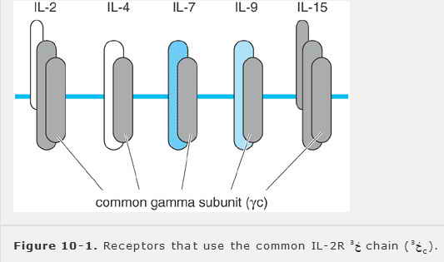
IL-2 Effects on Non-T Cells

NK cells constitutively express IL-2R خ²/خ³ dimers and thus are IL-2-responsive even in a resting state, although they respond only to relatively high IL-2 concentrations. Once stimulated by IL-2, however, NK cells begin to express the IL-1-2R خ± chain and assemble high-affinity receptors. IL-2-stimulated NK cells have enhanced cytolytic activity and secrete numerous chemokines and cytokines, including several (IFNخ³, GM-CSF, and TNFخ±) that potently activate macrophages. IL-2 also induces lymphokine-activated killer (LAK) activity, which is predominantly due to NK cells (see Chapter 9).
Activated or transformed B lymphocytes express high-affinity IL-2R at approximately 30% the density found on activated T cells. IL-2 enhances proliferation and antibody secretion by normal B cells, although at concentrations two- to threefold higher than are required to obtain T-cell responses. Human monocytes and macrophages constitutively express low levels of IL-2R خ² chain, but inducibly express high-affinity receptors containing all three chains on exposure to IL-2, IFNخ³, or other activating agents. Continued exposure of an activated macrophage to higher concentrations of IL-2 enhances its microbicidal and cytotoxic activities and promotes secretion of hydrogen peroxide, TNFخ±, and IL-6. High concentrations of IL-2 can activate neutrophils as well.
IL-2 as a Therapeutic Agent
Administration of IL-2 to normal or immunodeficient mice has been shown to enhance immune responses, particularly those mediated by CTLs or NK cells. Its potential use in humans, unfortunately, is limited by the severe toxic side effects of pharmacologic IL-2 dosages. One of the most important of these is the â€œvascular leak syndrome,â€‌ characterized by the accumulation of edema fluid in the pleural cavities, peritoneum, and other extravascular spaces; this may result from the ability of IL-2 to induce other cytokines that activate endothelial cells and increase vascular permeability. IL-2 treatment can also increase serum cortisol levels, with consequent immunosuppressive effects. High-dose IL-2 has been tested as an immunostimulatory agent in the treatment of various cancers and has produced partial remissions in some cases, most notably in some renal cell cancers. IL-2 has been tested at low doses as a treatment for the T-cell anergy that occurs in patients with lepromatous leprosy; although some clinical benefit was observed, the anergy persisted, and the beneficial effects have been attributable to activation of macrophages and NK cells. Low doses of IL-2 have also been shown to improve T-cell production and function in patients with the acquired immune deficiency syndrome (AIDS) or with idiopathic CD4 T-cell deficiency.
INTERLEUKIN-4 & INTERLEUKIN-13

IL-4 is a glycoprotein cytokine secreted by activated T_{H} cells, mast cells, and a subset of NK cells. IL-4 is now best known for the role it plays in allergic diseases by promoting IgE production, expression of low-affinity Fcخµ receptors, and the growth and function of mast cells and eosinophils. Secretion
of IL-4 is a hallmark, as well as an inducer, of T_{H}2 differentiation in T cells.
IL-4 and the closely related cytokine IL-13 are produced in the same cell types and are regulated in similar ways. They also produce many of the same biologic effects, in part because their receptors share at least one common chain called IL-4Rخ±. Two IL-4 receptors have been described: One is a heterodimer of IL-4R خ± and IL-2R خ³ chains; the second consists of IL-4Rخ± and IL-13Rخ±1 and can transduce both IL-4 and IL-13 signals. Specific IL-13 receptors are either IL-4Rخ±/IL-13Rخ±2 heterodimers or are homodimers of IL-13Rخ± chains. All of these receptors appear to use similar signaling pathways.
Both IL-4 and IL-13 favor T_{H}2-cell development while suppressing development and function of T_{H}1 cells. They promote CTL activity, growth of mast cells and other hematopoietic cells, and expression of vascular cell adhesion molecule 1 (VCAM)-1 on endothelial cells. They also have multiple effects on macrophages, activating cytocidal functions and increasing expression of class II MHC proteins, but suppressing the synthesis of proinflammatory cytokines, such as IL-1, IL-6, IL-8, and TNFخ±. Studies in knockout mice indicate that, despite their overlapping functions, IL-4 and IL-13 have additive effects in T_{H}2-mediated immune responses: Pulmonary granuloma formation, eosinophil infiltration, and levels of serum IgE and IL-5 were all reduced in schistosome-infected mice that lacked either one of these cytokines, but were completely eliminated in mice that lacked both (see Table 10-6).
INTERLEUKIN-5
IL-5 is a disulfide-linked homodimeric glycoprotein that was originally described as a B-cell growth factor in mice, but functions mainly as an eosinophil growth and differentiation factor in humans. T_{H}2 cells are the major source of IL-5. The human IL-5 receptor shares a common خ² chain with the IL-3 and GM-CSF receptors, and an خ± chain expressed only in eosinophils and basophils. IL-5 may have an important role in the pathogenesis of certain allergic diseases and asthma, as well as in helminth infections. Human IL-5 also enhances the activities of basophils by priming them to release mediators such as histamine and leukotrienes in response to other signals .
INTERLEUKIN-6 & RELATED CYTOKINES

Major activities of IL-6 include synergizing with IL-1 and TNFخ± to promote T-cell activation by APCs; inducing the acute-phase response (Chapter 2); enhancing B-cell replication, differentiation and immunoglobulin production; and promoting hematopoiesis and thrombopoiesis (Table 10-7). It does not induce production of any other cytokines and has relatively little direct effect on immune cells at physiologic concentrations, suggesting that its main immunologic function is to potentiate the effects of other cytokines. IL-6 is a single polypeptide, but can be glycosylated and phosphorylated to various degrees. It is produced by many cell types, including activated B and T cells, monocytes, and endothelial cells. Stimuli that induce its expression include TNFخ±, IL-1, and agents that activate lymphocytes or macrophages. The malignant plasma cells of multiple myeloma both secrete and respond to IL-6, suggesting it may be an autocrine growth factor for these cells.
IL-6-responsive cells typically express 10²-10⁴ high-affinity IL-6 receptors with an apparent K_{d} of 10⁻¹⁰-10⁻¹² M. The receptor consists of two glycoprotein chains. IL-6 first binds with low affinity to the IL-6R خ± chain, which has a short cytoplasmic domain and does not signal; the resulting complex then associates with the IL-6R خ² chain, which increases the affinity of IL-6 binding and transmits a signal into the cell.
The IL-6R خ² chain also forms part of the receptors for five other cytokines that are structurally unrelated to IL-6 (see Table 10-7). Each has it own specific receptor made up of one or more unique ligand-binding chains together with the IL-6R خ² chain, which functions as a common signal-transducing subunit. As a result, these cytokines have both unique and overlapping activities, as summarized in Table 10-7. Three members of the family (IL-6, IL-11, and leukemia inhibitory factor [LIF]) promote multilineage hemato-poiesis.
INTERLEUKIN-7

IL-7 is a glycoprotein secreted by thymus, spleen, and bone marrow stromal cells. It provides critical signals for the development of both T- and B-cell precursors. The receptor for IL-7, composed of a ligand-binding IL-7R خ± chain and the common IL-2R خ³ signal transducer, is expressed on lymphoid progenitors, mature T cell, monocytes, and macrophages. IL-7 provides an essential survival signal to thymocytes and pre-B cells; when IL-7 is withdrawn, these cells rapidly die through apoptosis. IL-7 is also thought to provide a signal that initiates T-cell receptor gene rearrangement during thymocyte development, and it enhances خ² integrin-mediated adhesion of thymocytes onto extracellular matrix proteins.
Mature human peripheral blood T cells do not respond significantly to IL-7 unless activated, but after activation this cytokine enhances cytotoxic activity and other effector functions of mature cells. It can also induce lymphokine-activated killer (LAK) activity,
although much less potently than IL-2. At higher dosages, IL-7 increases macrophage cytotoxic activity and induces cytokine secretion by monocytes. Pharmacologic doses of IL-7 produce marked leukocytosis in normal mice and hasten recovery of bone marrow leukocytopoiesis in mice exposed to sublethal irradiation or cytotoxic agents. At these dosages, it produces greater effects on B-lineage than T-lineage cells.
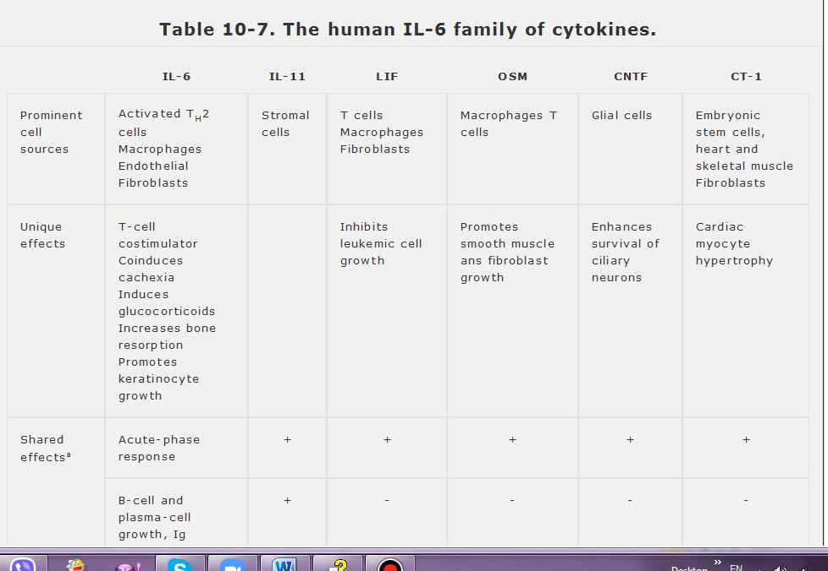
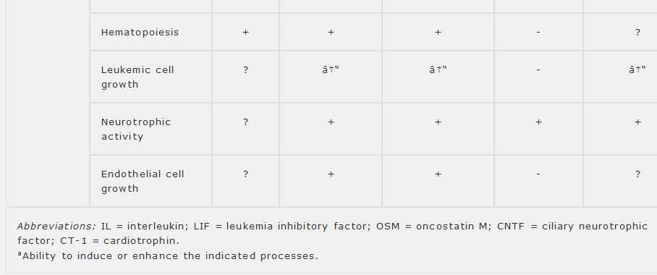
INTERLEUKIN-9
IL-9 is a heavily glycosylated polypeptide lymphokine secreted by activated T cells and has growth-promoting effects on T cells and mast cells. The IL-9 receptor is a heterodimer composed of IL-9R خ± and IL2R خ³ chains. Mice that express high levels of IL-9 systemically develop mucosal mastocytosis and allergic eosinophilia in the lungs, as well as enhanced T-cell transformation. IL-9 can synergize with IL-2 or IL-4 in T-cell costimulation and may also stimulate hematopoietic progenitors. Its physiologic role has not been firmly established.
INTERLEUKIN-10

IL-10 is a potent inhibitor of inflammatory and immune responses, in part because it inhibits APC function by suppressing class II MHC expression on dendritic cells and macrophages. It is a product of activated T_{H}2 and CD8 T cells, B cells, monocytes, and keratinocytes and was originally identified because of its ability to inhibit cytokine production by activated T cells, often acting synergistically with TGFخ². For example, IL-10 inhibits the production of IL-2 and IFNخ³ by T_{H}1 cells, thereby favoring T_{H}2- dependent responses. It inhibits production of cytokines by NK cells, and of cytokines, reactive oxygen species, nitric oxide, and adhesion proteins by macrophages. It is also thought to promote immune tolerance to ingested antigens in the gut (Chapter 14) and may have a more general role in anergy. Mice lacking IL-10R develop severe gastrointestinal inflammatory disease due to overexpression of proinflammatory cytokines. High-level endogenous expression of IL-10 correlates with graft survival in skin, cardiac, and islet-cell transplantation. On the other hand, IL-10 is not entirely immunosuppressive
because it has direct comitogenic effects on T cells, B cells, and mast cells and promotes B-cell antibody production.
INTERLEUKIN-12

IL-12 is a critical regulator of both innate and acquired immunity. By selectively promoting differentiation of T_{H}1 lymphocytes, it potentiates cell-mediated immunity while suppressing T_{H}2- dependent functions such as the production of IL-4, IL-10, and IgE antibodies. It enhances proliferation of activated T and NK cells, enhances lytic activity of NK and LAK cells, and is the most potent inducer of IFNخ³ production by resting or activated T and NK cells. In addition, IL-12 induces the production of GM-CSF, TNFخ±, IL-6, and, to a small extent, IL-2, and it synergizes with IL-2 in promoting CTL and NK-cell responses. It is being explored for potential clinical usefulness as an immunomodulator.
IL-12 is produced by â€œprofessionalâ€‌ APCs (macrophages, dendritic cells, and activated B cells) and also by astrocytes. It is a heterodimer composed of a smaller protein subunit expressed by many cell types that is disulfide-linked to a larger subunit expressed preferentially by APCs. The IL-12 receptor is composed of two chains, called خ²1 and خ²2. IL-12 synthesis is controlled in part through a feedback mechanism: the T_{H}2-cell products IL-4 and IL-10 suppress it, whereas IFNخ³ (a T_{H}1 cytokine) is required for sustained IL-12 production.
INTERLEUKIN-15

IL-15 shares many of the biologic properties of IL-2 in that it enhances proliferation of activated T cells, generation of CTLs, and activation of LAK cells. It is also essential for NK-cell survival, development, and activation. Unlike IL-2, IL-15 is expressed most abundantly by epithelial cells and monocytes, as well as by numerous other cell types, including placenta, skeletal muscle, kidney, lung, liver, heart and bone marrow stroma, but not by T lymphocytes. It is thought to provide a means by which diverse nonlymphoid cells can potentiate T-cell-mediated immune responses. It has been reported to promote T_{H}1 responses preferentially. IL-15 generally binds to a receptor composed of the IL-2R خ² and خ³ chains and a unique IL-15R خ± chain, but on mast cell it uses a distinct receptor that does not incorporate any IL-2R subunits.
INTERLEUKIN-16
IL-16 is a product of CD8 T cells and acts as a chemoattractant for CD4 T cells through direct interaction with CD4 molecules on their surfaces. Binding of IL-16 inhibits IL-2 production by CD4 T cells and inhibits mixed lymphocyte reactions, suggesting a possible role in T-cell anergy. IL-16 binds to the region in CD4 that mediates CD4 dimerization. Although it does not interfere with CD4 binding or cell entry by the human immunodeficiency virus (HIV), IL-16 does inhibit HIV replication, reportedly by blocking viral mRNA expression.
INTERLEUKIN-17
IL-17 is a homodimeric cytokine that is produced by activated memory T cells and binds to receptors on a wide variety of cells, particularly resting T lymphocytes and cells of the spleen and kidney. It was first identified as the cellular homologue of a protein encoded by the T-cell-tropic virus Herpesvirus saimiri. Il-17 induces target cells to express IL-6, IL-8, G-CSF, and the chemokine MCP-1. It stimulates T-cell proliferation and the growth and differentiation of neutrophil precursors and may have a role in organ transplant rejection.
INTERLEUKIN-18
IL-18 was originally discovered by its ability to induce release of IFNخ³ and other proinflammatory mediators from macrophages and has since been shown to influence expression of other cytokines as well. In synergy with IL-12, for example, it potentiates IFNخ³ and GM-CSF production by T, B, and NK cells, and promotes T_{H}1 differentiation. It also synergizes with IL-2 to induce IL-13 production by T and NK cells. IL-18 is constitutively produced by keratinocytes and macrophages. It is structurally related to IL-1 and, like IL-1, is synthesized as a precursor that is then processed by caspase-1 to yield the mature cytokine. The IL-18 receptor is likewise remarkably similar to IL-1R and signals through the same pathways. IL-12 can induce IL-18R expression on T and NK cells. An IL-18 decoy receptor also exists.
INTERFERONS
In 1957, it was discovered that cells exposed to inactivated viruses produce at least one soluble factor that can â€œinterfereâ€‌ with viral replication when applied to newly infected cells. The factor was named interferon (IFN). It has since been shown that the interferons consist of a large family of secretory proteins that not only share antiviral activity, but also have the ability to inhibit proliferation of vertebrate cells and to modulate immune responses. Interferons do not exert their antiviral effects by acting on viral particles, but rather by inducing an antiviral state
within the host cell that makes it inhospitable to viral replication. This, as well as the antiproliferative and immunomodulatory effects of interferons, reflects their ability to regulate specific gene expression and metabolic activity in their target cells. Several types of proteins can induce an antiviral state in vertebrate cells and therefore are, by definition, interferons. The molecular and immunoregulatory properties of IFNخ³ are so different from those of the other interferons, however, that it must be considered separately.
The Antiviral IFNs
IFNs with relatively high antiviral potency are called antiviral, or type I, IFNs. They are not normally found in tissues or serum, but can be synthesized and released rapidly by most cell types in response to infection by viruses, bacteria, or protozoa, or on exposure to certain cytokines (Figure 10-2). These IFNs can also be induced artificially by treating cells with double-stranded RNA molecules, which presumably mimic the genomes of certain RNA viruses. One commonly used inducer of type I IFN is poly(I:C)â€”a heteroduplex of polyinosine and polycytidine RNA chains.
There are three major forms of type I IFN: IFNخ±, IFNخ², and IFNد‰. IFNخ± is the primary IFN produced by leukocytes and consists of at least 14 glycoproteins encoded by a closely related family of genes. The amino acid sequences of these various IFNخ± proteins are approximately 73% identical to one another. Fibroblasts and most other nonleukocytes primarily express IFNخ², a protein that is only about 30% identical to IFNخ±. Small amounts of IFNخ² are also expressed by leukocytes. IFNد‰ has only a single functional gene, which resembles the IFNخ³ gene and is primarily expressed by leukocytes.
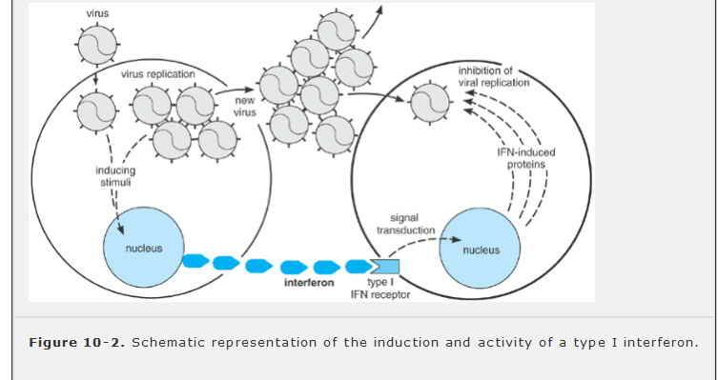
All type I IFNs bind to a single multichain receptor, which is expressed on nearly all cell types and is structurally related to the IL-10 receptor. Binding of type I IFN to this receptor leads to increased expression of at least 30 different proteins in the target cell. Among these are the class I MHC proteins, which enable an infected cell to present viral antigens and so to be killed by CTLs. The type I IFNs also stimulate IL-12-independent production of IFNخ³, which promotes T-cell and macrophage function. Other IFN-inducible proteins include an RNA-dependent protein kinase (PKR) and 2â€²-5â€² oligoadenylate (2-5A) synthetase, each of which requires the presence of double-stranded RNA for activity. When activated, PKR phosphorylates a component of the cellular translational machinery (called eukaryotic initiation factor 2, or eIF2), thereby inhibiting protein synthesis. The 2-5A synthetase produces short chains of adenylate residues joined by 2â€²-5â€² phosphodiester bonds; these bind and activate a cellular endoribonuclease that specifically degrades single-stranded RNA. These enzymes, together with other IFN-inducible proteins, combine to confer a relatively nonspecific but potent intracellular defense against viruses.
In addition to inhibiting viral replication, type I IFNs can modulate specific cellular functions. They
arrest the growth of (but generally do not kill) many types of cells in culture, including transformed cell lines. They also may either inhibit or promote cellular differentiation, depending on the cell type, timing, and dosage of treatment.
Clinically, type I interferons have proven most useful in treating hematologic disorders. Recombinant IFNخ±, either alone or in combination with chemotherapy, is used to treat hairy cell leukemia, chronic lymphocytic leukemia (CLL), cutaneous T cell lymphoma, and certain other non-Hodgkin's lymphomas. Both IFNخ± and IFNخ² have been effective in subsets of patients with acute and chronic hepatitis B and C infections, and in patients with relapsing remitting multiple sclerosis.
Immune IFN
IFNخ³ (also called type II IFN or immune IFN) arises from a single gene and differs in virtually all respects from the type I IFNs. There is only a single active form of IFNخ³ proteinâ€”a homodimer of polypeptides that can be glycosylated to various degrees. The receptor to which it binds is likewise unrelated to the receptor for type I IFN. Although IFNخ³ has some antiviral activity (which led to its discovery and is the source of its name), it is much less active in this regard than the type I IFNs. Moreover, IFNخ³ expression is not directly inducible by infection or by double-stranded RNA. It is involved in the regulation of nearly all phases of the immune and inflammatory responses, including the activation and differentiation of T cells, B cells, NK cells, macrophages, and others. It is therefore best regarded as a distinct immunoregulatory cytokine and has found clinical application as an immunostimulator in chronic granulomatous disease and other disorders.
IFNخ³ secretion is a hallmark of T_{H}1 lymphocytes. It is also secreted by nearly all CD8 T cells, by some T_{H}0 cells, and by NK cells. Each of these cell types secretes IFNخ³ only when activated, usually as part of an immune response and especially in response to IL-2 and IL-12. IFNخ³ production is inhibited by IL-4, IL-10, TGFخ², glucocorticoids, cyclosporin A and FK506. Nearly all cell types express the heterodimeric receptor for IFNخ³ and respond to this cytokine by increasing the surface expression of class I MHC proteins. As a result, virtually any cell in the vicinity of an IFNخ³-secreting cell becomes more efficient at presenting endogenous antigens and hence a better target for cytotoxic killing if it harbors an intracellular pathogen. Unlike the type I IFNs, IFNخ³ also increases the expression of class II MHC proteins on professional APCs, and so promotes antigen presentation to helper T cells as well. It also induces de novo expression of class II MHC proteins on venular endothelial cells and on some other epithelial and connective tissue cells that do not otherwise express them, thus enabling these cell types to function as temporary APCs at sites of intense immune reactions.
IFNخ³ is also a potent activator of macrophages. Exposure to IFNخ³ greatly enhances the microbicidal (and, to a lesser degree, cytotoxic) activity of macrophages and induces them to secrete nitric oxide and monokines such as IL-1, IL-6, IL-8, and TNFخ±. It also activates neutrophils, NK cells, and vascular endothelial cells. IFNخ³ synergistically enhances the cytotoxic effects of TNFخ±. Although IFNخ³ tends to promote the differentiation of B cells and CD8 T cells into immunologically active effectors, it does not promote lymphocyte proliferation. It enhances the activity of T_{H}1 cells, but inhibits the production of T_{H}2 cells. IFNخ³ not only decreases the production of IL-4 by T_{H}2 cells but also potently blocks the effects of IL-4 on B cells, promoting IgG1 production at the expense of IgE production.

TRANSFORMING GROWTH FACTORβ

TGFخ² was initially discovered as a growth factor for fibroblasts that promoted wound healing. It also has considerable antiproliferative activity, however, and acts as a negative regulator of immunity and hematopoiesis. TGFخ² is produced by many cell types, including activated macrophages and T lymphocytes. Humans express at least three forms of TGFخ²: TGFخ²-1, -2, and -3. These are the products of separate genes, but they all bind to five types of high-affinity cell surface receptors. Type I and II receptors transduce signals, whereas the function of type III, IV, and V receptors is not yet clear. TGFخ² receptors are expressed in widely different numbers by many cell types. Studies in mice suggest that TGFخ²-1 is the most important immunoregulator in this group; mice that lack it die of fulminant inflammatory and autoimmune disease.
TGFخ² has antiproliferative effects on a wide variety of cell types, including macrophages, endothelial cells, and T and B lymphocytes (Figure 10-3). It also suppresses the production of most lymphokines and monokines and reduces the cellular expression of class II MHC proteins and of IL-1 receptors. At 10⁻¹⁰-10⁻¹² M, it blocks the proliferative effects of IL-2 on T and B cells, as well as of IL-1 on thymocytes. In addition, TGFخ² inhibits T-cell-dependent antibody production by B cells, mixed-leukocyte reactions, and the generation of CTLs. It also inhibits induction of NK-cell activities and of LAK cells by IL-2. Thus, TGFخ² is unique in that it can act as a negative-feedback regulator that dampens immunologically mediated reactions. Recently, a new subset of helper T cells (dubbed T_{H}3 cells) has been identified that mainly produces TGFخ²; these cells appear important in maintaining tolerance to orally administered antigens in the gut (see Chapter 14), further demonstrating the role of TGFخ² as a major immunosuppressive cytokine.
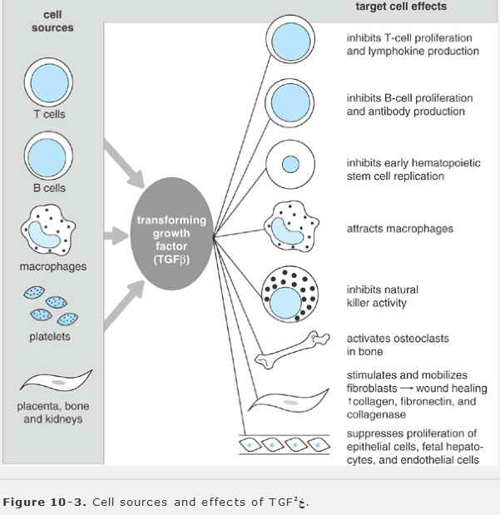

TGFخ² also has some proinflammatory activities. It is a chemoattractant for neutrophils and monocytes, and it increases expression of adhesion proteins on monocytes. These effects may account for the observation that injecting TGFخ² directly into inflamed joints exacerbates the inflammation. On the other hand, systemic administration of TGFخ²-1 has antiinflammatory effects.
HEMATOPOIETIC COLONY-STIMULATING FACTORS

CSFs are cytokines that support the production of particular mature blood cell types from pluripotent stem cells or committed progenitors in the bone marrow. Examples include G-CSF, GM-CSF, EPO, thrombopoietin (TPO), SCF, and IL-3 (also known as multi-CSF because it promotes formation of all hematopoietic cell types). The biologic properties of the CSFs and their receptors have been summarized in Chapter 1; only a few points will be highlighted here.
The various CSFs are unrelated to one another structurally and bind to distinct receptors. Nevertheless, many have overlapping functions and induce quite similar biologic effects. This is particularly true of CSFs that influence granulocyte and macrophage production. The biologic significance of this redundancy is unclear. Some CSFs have unique functions that become apparent in knockout mice that lack them (Table 10-8), although these are not always relevant to hematopoiesis. Certain cytokines (eg, IL-1, IL-6, and IL-11) that have little or no independent effect on hematopoiesis act synergistically with CSFs. SCF is the most potent synergistic CSF; it interacts with many other cytokines to promote growth of myeloerythroid and lymphoid stem cells, and hence increases the production of all blood cells. Nevertheless, hematopoietic stem cells will not proliferate in
response to any single cytokine; instead, their growth is promoted by combinations of cytokines that include one from each of the following three groups: (1) SCF or Flt-3 ligand; (2) IL-1, IL-6, IL-11, IL-12, TPO, or G-CSF; and (3) IL-3, IL-4, or GM-CSF. These synergistic effects are direct and can be observed in single-cell assays.
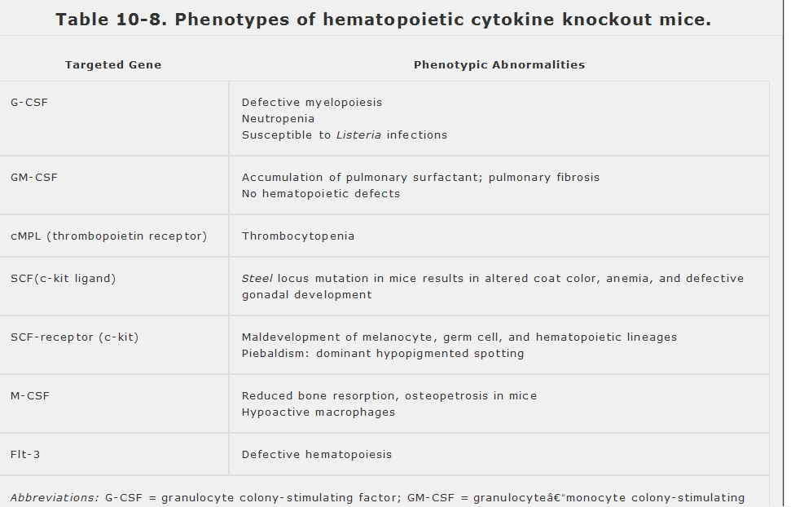
The production of some CSFs is selectively increased during immune or inflammatory responses. For example, activated T cells can secrete IL-3, IL-5, and GM-CSF, and activated macrophages produce a host of CSFs and other cytokines. Similarly, fibroblasts and endothelial cells secrete G-CSF and GM-CSF only when stimulated by IL-1, TNFخ±, or other products of activated macrophages.
Several of the CSFs profoundly affect immune and inflammatory cells. Those that act on granulocytes, for example, help prolong the survival and function of neutrophils and eosinophils at an infected site by suppressing apoptosis. Macrophages produced in the presence of GM-CSF alone have more potent APC function and, when activated, have greater cytotoxic activity than those produced with M-CSF, in part because M-CSF reduces MHC protein expression and stimulates production of IL-1RA. GM-CSF also is essential for the generation of dendritic cells from their marrow-derived precursor cells, and the local release of this cytokine by activated macrophages, T cells, and keratinocytes in the course of an immune response is thought to trigger dendritic cell maturation into functional APCs.
Many CSFs are currently being tested for possible clinical use. GM-CSF and G-CSF may prove to be of value in preventing the therapy-induced granulocytopenia that is the major cause of death among cancer patients undergoing chemotherapy or radiation therapy. Both of these cytokines may also help protect against bacterial septicemia. In contrast to many of the other cytokines, G-CSF, EPO, and TPO, which act on more limited cell populations, produce relatively few toxic side effects and are in clinical use to increase the production of neutrophils, red cells, and platelets, respectively. In addition, G-CSF is the agent of choice for mobilizing hematopoietic stem cells into the peripheral blood for harvest and use in autologous bone marrow transplantation.

CYTOKINE RECEPTOR FAMILIES

The characterization of many cytokine receptors and their corresponding genes has revealed that most belong to larger multigene families (Table 10-9). The members of each family share distinctive structural features and are thought to be evolutionarily related. The divisions among families are not mutually exclusive, however, and some receptors (eg, IL-6R) can be assigned to multiple families. The receptors for IL-1, IL-6, M-CSF, G-CSF, and SCF each contain an immunoglobulin-like domain in their extracellular regions and thus belong to the immunoglobulin gene superfamily (see Chapter 7). Many of the remaining cytokines belong to the hematopoietin receptor family, whose members can be recognized by a distinctive set of four spaced cysteines in their extracellular domains as well as by a conserved sequence motif (Trp-Ser-X-Trp-Ser, where X is any amino acid) located near the external membrane surface. It has been proposed that receptor dimerization is required for signal transduction by hematopoietin receptors; the dimers can be either homodimers, as in IL-4R, or more complex heterodimers, as in IL-6R and some others.
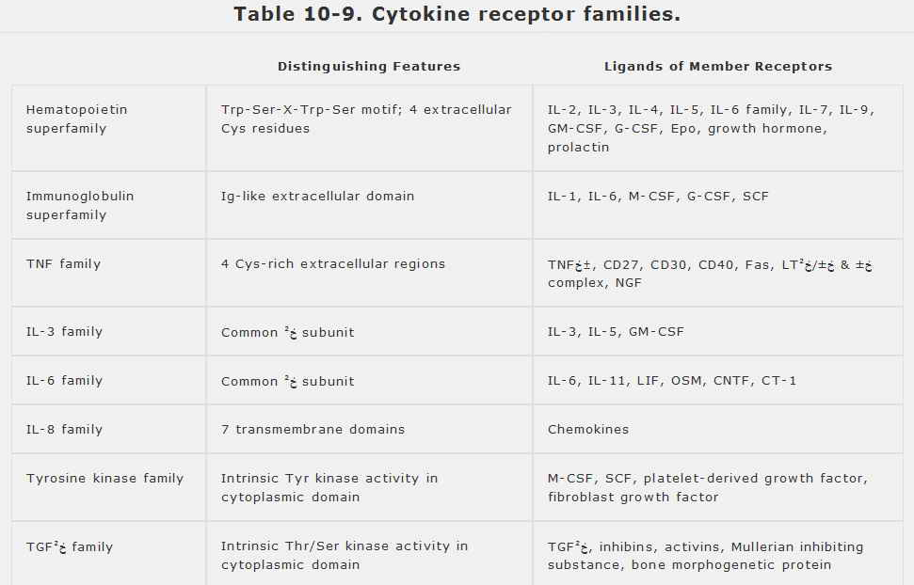

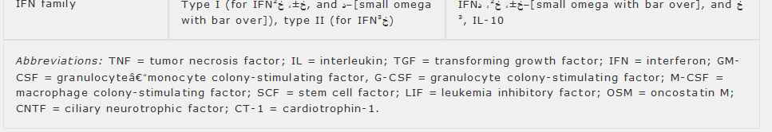
VIROKINES & VIRORECEPTORS

Many viruses encode proteins that resemble specific cytokines or cytokine receptors. These probably play an important role in the viral life cycles, particularly in immune evasion. It has been proposed that these so-called virokines or viroreceptors are descended from cellular proteins whose genes were usurped by the viruses. For example, Epsteinâ€“Barr virus, which infects and immortalizes B lymphoid cells, encodes an IL-10-like protein which, like IL-10 itself, stimulates B-cell proliferation and differentiation (and so enhances viral replication) while suppressing cellular immune responses. Similarly, the T-cell-tropic virus Herpes saimiri encodes a protein resembling IL-17, which promotes T-cell proliferation. Other viruses, such as the poxviruses, encode proteins that resemble cellular receptors (eg, those for IL-1, TNFخ±, IFNخ³, or certain chemokines) and that appear to suppress immune reactions by binding and inhibiting these cytokines in vivo. Interestingly, the cowpox virus also encodes an intracellular inhibitor of caspase-1; this inhibitor not only blocks processing and secretion of IL-1خ², but also helps suppress apoptosis of the infected cell.

