Food microbiology: is the study of the spoilage & pathogenic microorganisms that inhabit in food, mainly Accompanied by changes in the food.

TYPES OF FOOD SAMPLES

Liquid samples semisolid samples solid samples
Ex: milk, juice , et cetera ex: chesses, ice-cream.. etc. fruits, grains,..

-In liquid sample shake before sampling for homogenization.
- In solid sample the sampling done by using sterile knife or cork borer.
- Some samples done by taking thin layers from the surface.

Dealing procedures with the sample in lab

Sampling :
It is about 10 gm or ml is collected from food.
The pestle
A usually club-shaped for grinding substances in a mortar.
or
Mash or crush the solid foods and turn them into emulsion.
The mortar or container
Sterile, wide-mouth, glass, ceramic, hard stone or plastic are used.

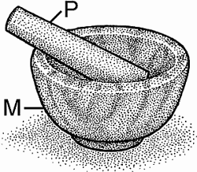
Other tools :
- Use a sterile utensil to aseptically transfer the samples like
probe to take the sample or spoon & knife to cutting & transport sample.
- Pipette , tubes , graduated cylinder, plates and rack ….. etc.
Instruments
Incubator , sensitive balance , water bath, autoclave and colony counter…etc.
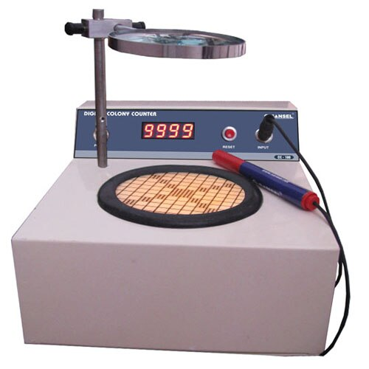

Sampling report
1- Date of sampling.
2-Nature of food.
3-Suggested tests.
4- Any useful information.

Labeling :
All plates or tubes should be marked or labeled before testing or pouring; the label includes: the name of the culture media, the dilution number, the name of the food sample, the name of the test, and other information.
Preparation & dilution of food homogenate:
- Aseptically, 10 gm or 10 ml are transferred into a sterile container, 90 ml diluted and shaken or mashed several times in the mortar by pestle to obtain a 10 ^{– 1} the mixture is left for 3-5 min just before making dilution.
- serial ten –fold dilutions are made.

- Tubes containing 9ml volume of diluents are prepared in a raw.
These are numbered in order with the ten-fold dilutions (10⁻²,10⁻³,10⁻⁴,ect).
1ml of the 10 ⁻¹ dilution is transferred into the first of the 9 ml tubes. each 1 ml transferring from the previous tube into next.
0.1 % peptone water protein samples.
Diluent solutions
Phosphate buffer water & dairy products.
Culturing method
Pour plate technique:
1 ml of any ten-fold dilution is put in Petri dishes about 15-20 ml of the molten agar (44-46Cº) is added to each of the duplicate plates within 15 minutes the agar will be solidified
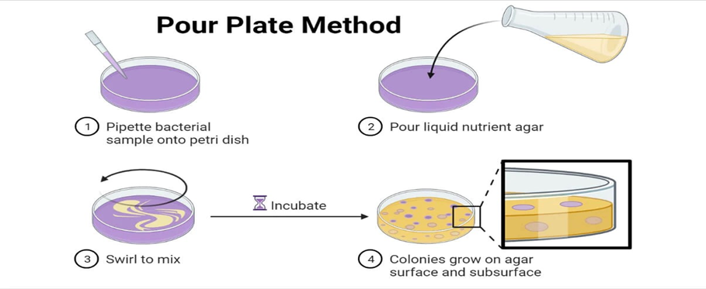

Incubation
The Bacterial plates are incubated in an inverted position for 24-48 hours at 37Cº.

Determination of M.Os Numbers

Standard plate count
(Viable Count)
Direct microscopic count (Total Count)

Breeds method Petrohof Husser method

- TOTAL COUNT : (Live and dead cells)
Breed method:
This method is used for counting microorganisms in milk is characterized as easy and the rapid.
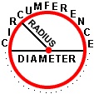
Area for Circular microscopic field = = 3.14.
Diameter microscopic field= 160 >>>> So Radius of a circle is 80 80*80*3.14=20096
To prepare area of the bacterial film, draw a square 1 cm on slide.
Transfer 0.01 ml or drop by loop to slide and spread, wait to dry.
By Methylene blue dye for then washed and examines
Calculate the number of microbes cells then take the rate of 10 fields.

1cm² =100 000000 Micron
Area of the drawn square
Number of microscopic fields in 1cm² =
One Area of the microscopic field

100000000
= ــــــــــــــــــــــــــــــــ = 4976 ~ 5000 = Microscopic coefficient
20096

Loopfull= 0.01 or 1/100
Number of microbial cells in 1 ml = (coefficient microscopic * average number of cells * dilution factor *drop volume ) cell / ml

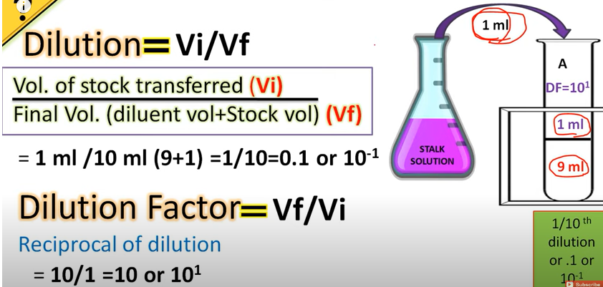

Q/Calculate the number of microbial cells in half a liter of milk if you know that the loopfull from second dilution and the average number of cells 25 cells?

- Viable count or Standard plate count or Aerobic plate count
Standard plate count is designed to determine viable bacterial density in the samples.
Standard plate count is based on mixing decimal dilutions of food sample , after incubation of plates at 37C^{O} for 24-48 hrs , the NO. of bacteria per ml is calculated from the NO. of colonies obtained in selected petri dishes at levels of dilutions giving significant results.

Counting & calculation of colony – forming units (CFU):
Only the plates containing 30-300 CFUs are counted.
When the counting the NO. of bacteria per gm or ml , the total count is calculated as follows:
Colony forming unit (CFU) = Dilution factor * No. of colonies
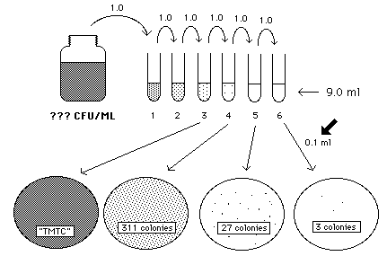

TMTC= too many to count >>> more than 300 colonies
TFTC= too few to count >>> less than 30 colonies
LAB. Procedures
Food samples (10g or 10 ml) + 90 ml 1st. Dilution

Highly contamination sample low contam. Sample
(serial dilutions … 10 ^{–x}) (1st – 2 ^{nd} dilution)
Pour plate method

(put inoculum 1ml on sterile petri dish under sterile conditions)

The medium (general or selective)

Incubation at 37C for 24 hrs
Microbial count
(Direct plate count or standard plate count )
Identification

Large Large Colonies
(Rhizoid, Filamentous,
Irregular, raised.)

Small Colonies (circular, punctiforms ,flat, convex, entire,)
Large colonies, regular, colored or not.

Yeast
Molds Bacteria simple stain
mold Slide Gram stain

