Practical Pathogenic Bacteria
Lab 1
Methods of Bacterial Identification (Gram Positive Bacteria)
1- Microscopic examination.
2-Cultural appearance.
3-Biochemical reactions.
4-Serological identification.
5-Molecular methods.
Microbial Causes of Infection could be Bacteria, viruses, fungi, and parasites.
Specimen Selection, Collection, and Processing:
- The quantity of specimens must be adequate, and selected on the basis of symptoms, should be representative of the disease process.
- Contamination of the specimen must be avoided by using a sterile equipment and aseptic precautions.
- The specimen must be taken to the laboratory and examined promptly. Special transport media may be helpful. Reliable specimens must be secured for diagnosis of the bacterial infection before antimicrobial drugs are administered.

- Microscopic Examination:
- Gram staining is a differential staining technique into gram- positive (purple) bacteria from gram-negative (red) bacteria depending on their ability to retain color.It is based on the composition of the bacterial cell wall of both Gram- negative and Gram-positive bacteria. Microbial morphology and arrangement can be observed. For example, Staphylococci are Gram-positive cocci which are arranged in clusters (grapes)
- Gram-positive bacteria: Staphylococcus and Streptococcus.
- Gram-negative bacteria: E. coli and Klebsiella.
- Microbiological Culture Examination (Media Selection):
- It is based on the specimen source (urine, blood, etc.).The appropriate bacteriological media are selected to grow the organism for further work-up , in addition to selection of the appropriate temperature and incubation conditions (aerobic versus anaerobic) allow the optimal bacterial growth.
-Colony morphological characteristics on growth media. For example, size, color, odor and the ability to lyse (break apart) .
- Nonselective media permit the growth of many microorganisms, while Selective media contain inhibitory substances that permit the isolation of specific types of microorganisms.
- Biochemical Identification:
- The ability of a bacterial species to use a sugar, an amino acid or an enzymatic substrate is very useful for bacterial identification.
- These tests can be used individually (coagulase for Staphylococcus aureus) to identify an organism, or in a set of tests to identify Gram- negative bacilli by Many commercially prepared kits .
- Serologic Methods:
- These methods typically involve testing an unknown antibody against a known antigen bound to a latex particle or similar structure.
- After mixing the antigen and antibody together and rotating, a visible agglutination (clumping) will appear if positive for the organism tested.
- Molecular Methods
- These methods are the latest and most specific methods available in the laboratory.
- These tests are based on the ability to detect, identify and characterize microorganisms based on their DNA or RNA.
- Polymerase chain reaction (PCR) is a common molecular method used to identify bacteria.
- Antimicrobial Susceptibility Examination:

- Microorganisms, particularly bacteria, are tested in vitro to determine whether they are susceptible to antimicrobial agents.
Biochemical tests for the identification of Gram-positive bacterial species
- Catalase test
- Oxidative/Fermentative
- Bacitracin susceptibility test
- Bile Esculin test
- Hippocrates hydrolysis test
- Coagulase test
- Catalase Test
- It determines the ability of bacteria to produce the catalase enzyme which forms gas bubbles when reacting with 3% H₂O₂.Catalase mediates the breakdown of hydrogen peroxide (H₂O₂) into oxygen and water.
Principle:
2H₂O₂ → 2H₂O+ O₂ (gas bubbles)
- A small inoculum of a bacterial isolate is mixed into hydrogen peroxide solution (3%). It is observed for the rapid elaboration of oxygen bubbles. The lack of catalase is evident by a lack of or weak bubble production.
- Catalase producing Gram-positive bacteria include strict aerobes as well as facultative anaerobes e.g. Staphylococcus spp, Streptococcus spp and Micrococcus spp .Catalase-negative bacteria may be anaerobes or facultative anaerobes (i.e. Streptococci).
Procedure for Slide Test

- Transfer a small amount of bacterial colony to a surface of a clean, dry glass slide using a loop or sterile wooden stick .
- Place a drop of 3% H₂O₂ onto the slide and mix.
- A positive result is the rapid evolution of oxygen (within 5-10 seconds), as evidenced by bubbling. While, A negative result is no bubbles or only a few scattered bubbles.

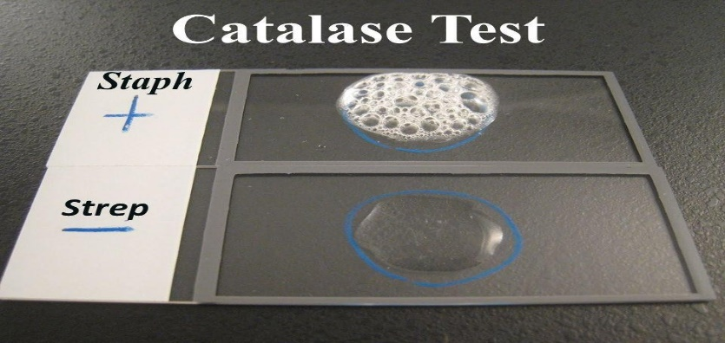
-Procedure for Tube Test
- Add 4 to 5 drops of 3% H₂O₂ to a test tube
- Using a wooden applicator stick, collect a small amount of organism from a well-isolated 18 to 24-hour colony and place it into the test tube (Note: Be careful not to pick up any agar (especially if using Blood Agar).
- Place the tube against a dark background and observe for immediate bubble formation (O₂ + water = bubbles) at the end of the wooden applicator stick.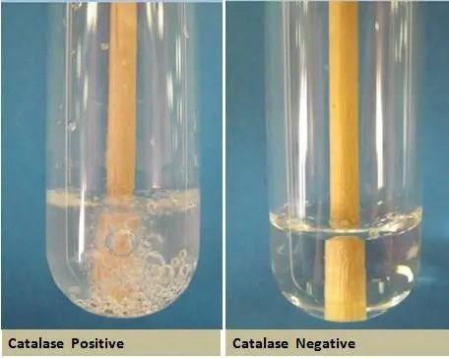
- Oxidative/Fermentative Test
- During the metabolism process, bacteria either break down complex organic molecules aerobically or anaerobically.
- The aerobic metabolism process is referred to as the oxidation process whereas the anaerobic metabolism process is referred to as a fermentative process.
- Two tubes with Hugh and Leif son’s medium are used where one tube is sealed with paraffin oil to create an anaerobic condition.
- Oxidative Gram-positive organism: Micrococcus spp and Pseudomonas spp
- Fermentative Gram-positive organism: Staphylococcus aureus

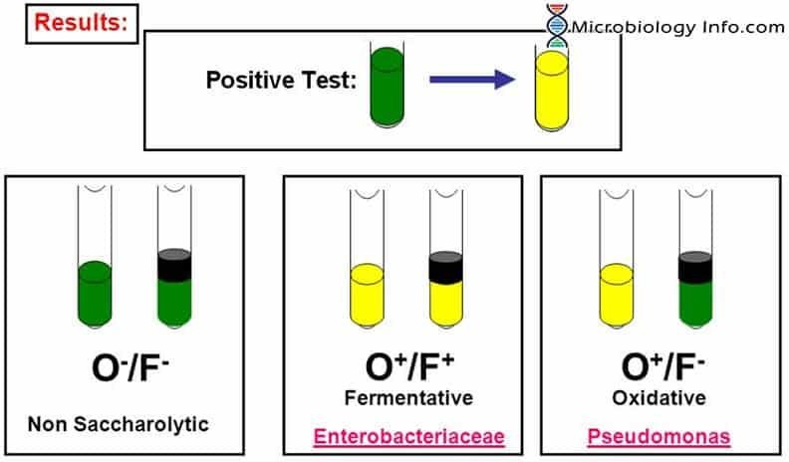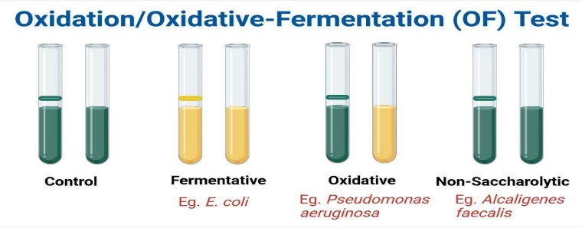

- Oxidase Test
-This test principle is performed to determine or identify the presence of an enzyme cytochrome oxidase (of the electron transport chain) in bacterial cells. This enzyme sometimes called indophenol oxidase.
-The reagent used is tetramethyl-p-phenylene diamine dihydrochloride, which is oxidized to a purple-colored end product called indophenol by the enzyme oxidase.
- The development of a dark purple color is a positive test that indicates the presence of oxidase, whereas if the enzyme is not present, the reagent remains reduced and is colorless.
Procedure:
- Take a filter paper and moisturize it with the substrate i.e. 1% tetramethyl-p-phenylene diamine dihydrochloride or select a commercially available paper disk that has been saturated with the same substrate.
- Remove a small portion of a bacterial colony (preferably not more than 24 hours old) from the agar surface with a sterile platinum wire or wooden stick.
- Rub the sample on the filter paper or commercial disks.
- Observe the inoculated area of the paper of disks for the color change to deep blue or purple within 10 seconds because timing is very critical.
*Positive result: Development of a dark purple color within 10 seconds of inoculation. Neisseria gonorrhoeae, Vibrio cholera, Pseudomonas are oxidase positive.
*Negative result: No change in color (no blue color seen). Members of family Enterobacteriaceae like E. coli are oxidase negative.
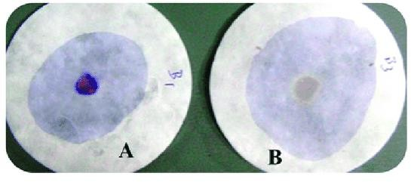
- Coagulase Test
- The coagulase test is one way to differentiate the highly pathogenic S. aureus (coagulase-positive) from the other less pathogenic staphylococcal species on the human body (coagulase-negative Staphylococcus (CONS)).
- S. aureus produces a bound and free form of coagulase that converts soluble fibrinogen into insoluble fibrin.Coagulase test is done either in a slide or in a tube which is determined by the form of coagulase produced.
- Cell bound coagulase is detected by the slide coagulase test which forms agglutination in case of positive results.
- Free coagulase is detected in a tube which forms a clot if the organism is tested positive.Coagulase producing Gram-positive organism : Staphylococcus aureus

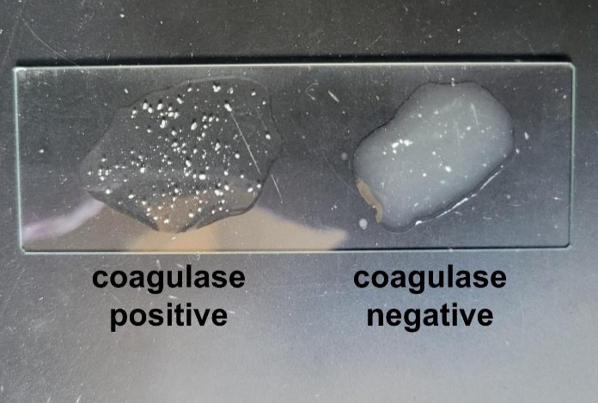
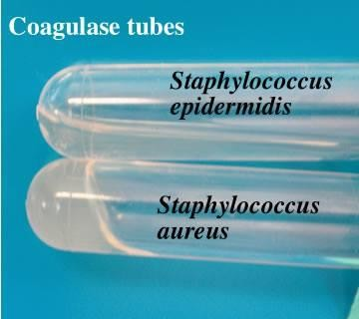

- Bile Esculin Test:
- The bile-esculin test is widely used to differentiate enterococci and group D streptococci (which are bile tolerant and can hydrolyze esculin to esculetin) from non-group D viridans group streptococci (which grow poorly on bile).
- Bile esculin agar medium is both selective differential medium , its selective ingredient is bile that inhibits the growth of other Gram-positive bacteria except enterococci and some streptococci species.Esculin is the differential ingredient that differentiates Enterococcus from Streptococcus.
- The bile esculin test determines the ability of bacteria to hydrolyze esculin when in the presence of bile salt, esculin is formed.Ferric citrate is present in the medium and when it reacts with esculin, it turns the entire medium dark brown to black due to the formation of the phenolic iron complex. Bile esculin Gram-positive organism: Enterococcus faecalis
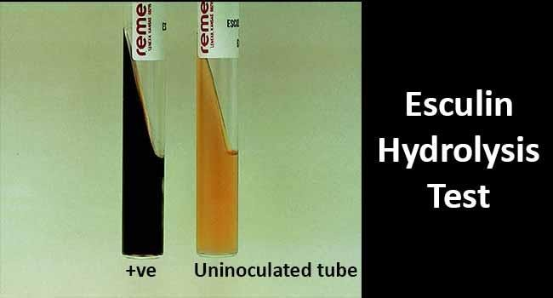

- Hippurate hydrolysis test
Hippurate hydrolysis relies on the ability of the enzyme called hippurate hydrolase produced by microorganisms to hydrolyze sodium Hippurate to benzoic acid and glycine. Glycine is detected by using the Ninhydrin reagent which forms a deep purple or violet color. This test differentiates β-hemolytic Streptococcus agalactiae from other β-hemolytic streptococci.
*Hippurate gram-positive organism: Streptococcus agalactiae
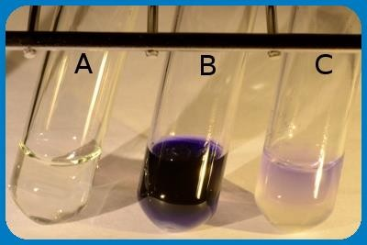

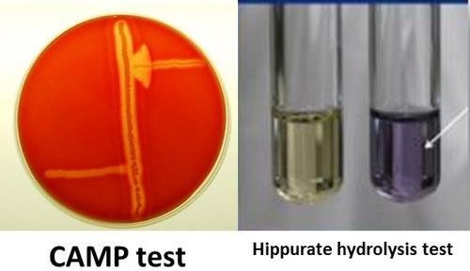
- Bacitracin Susceptibility Test
- The Bacitracin test is used to distinguish β-hemolytic streptococci. It can distinguish between Streptococcus pyogenes, which forms a zone of inhibition around the bacitracin disc (Positive result), and Streptococcus agalactiae, which grows up to the disc (negative result).Bacitracin is antibiotic produced by group of Bacillus subtilis
- Bacitracin susceptibility test is a presumptive test for the differentiation between beta-hemolytic Group A streptococci and beta-hemolytic non-Group A streptococci.
- This test is performed on the blood agar with a streaked culture of streptococci where the bacitracin disk is impregnated with sterile forceps before incubation.
- A zone of inhibition will be observed if the isolated organism is beta- hemolytic Group A streptococci whereas beta-hemolytic non-Group A streptococci will be resistant towards bacitracin showing no zone of hydrolysis and will grow all over the disk.
- Example of Bacitracin sensitive is Group A streptococci e.g. Streptococcus pyogenes ,while Bacitracin resistant non-Group A streptococci: Streptococcus agalactiae and other Beta hemolytic Streptococci, Streptococcus pneumoniae and viridans group.

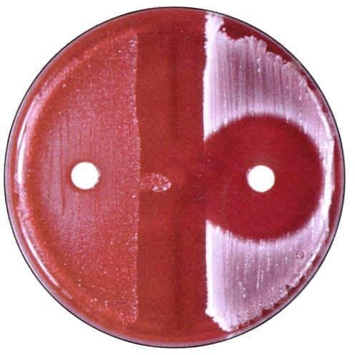

- Optochin Susceptibility Test:
- It is a useful test for the identification and Differentiation of Streptococcus pneumoniae from other viridans streptococci depends on demonstrating optochin susceptibility, bile solubility, or detection of species-specific capsular polysaccharides.
- Alpha-hemolytic Streptococcus is the most commonly susceptible bacteria for this test. Other alpha-hemolytic streptococcal species are optochin-resistant and do not display this clear zone of inhibition in the presence of optochin.
- 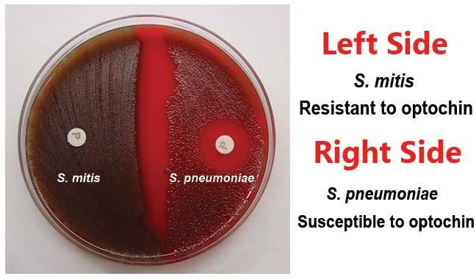The optochin test is widely used in the form of filter paper discs, saturated with ethylhydrocupreine hydrochloride, which are applied directly to inoculated plates before incubation. A positive presumptive identification of S. pneumoniae is made when a well-defined zone of inhibition results around the saturated disk.

Procedure:
- Using an inoculating loop, select three to four well-isolated colonies aged (18-24) hr of the alpha-hemolytic organism to be tested.
- Streak the isolate onto one-half of a TSA-5% sheep blood agar plate so as to obtain confluent growth. Note: Use of media other than TSA-5% sheep blood agar is not recommended, as false identification may result.
- Using sterile forceps, place an optochin disk onto the inoculated surface of the agar.Press disk gently with the sterile forceps or loop so that the disk adheres firmly to the agar surface.
- Incubate the plate at 35 C for 18-24 hours in 5-10% CO₂ enriched environment.
- If zone of inhibition is present, measure the diameter with a millimeter ruler .Positive result: Zone of inhibition is 14 mm or greater in diameter with 6 mm disk.
Negative result: No zone of inhibition or a zone of inhibition of <14mm diameter.

- Motility Test
- Touch a straight needle to a colony of a recent culture (18- to 24 hr) growing on agar medium (Semi solid medium 0.7-0.8% agar is used ).
- Stab once to a depth of only 1/3 to 1/2 inch in the middle of the tube.
- Incubate at 35°-37°C and examine daily for up to 7 days.
- Observe for a diffuse zone of growth spreading out from the line of inoculation.
- Motile Bacteria: Escherichia coli, Helicobacter pylori, Pseudomonas aeruginosa.
- 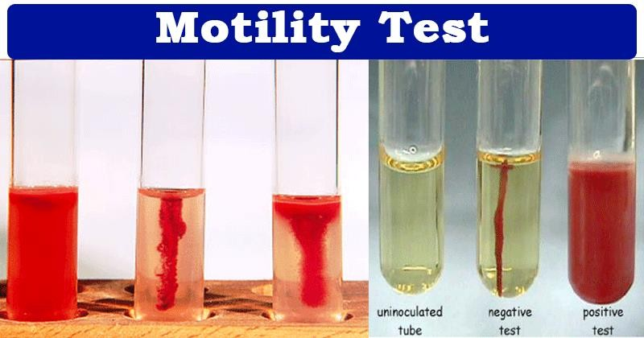None Motile Bacteria: Klebsiella, Shigella, Staphylococcus

10- Bile Salt Solubility Test
- It is the test which differentiates Streptococcus pneumoniae (positive-bile soluble) from alpha-hemolytic streptococci (negative- bile insoluble).
- Principle:
S. pneumoniae has an autolytic enzyme which can be demonstrated by allowing a broth culture to age in the incubator; at 24 hours the broth is turbid; after a few days the medium will become clear.
Bile or a solution of a bile salt (e.g., sodium desoxycholate) rapidly lyses pneumococcal colonies. Lysis depends on the presence of an intracellular autolytic enzyme, amidase. Bile salts lower the surface tension between the bacterial cell membrane and the medium, thus accelerating the organism’s natural autolytic process. Bile salts activate the autolytic enzyme which induces clearing of the culture.
Procedure:
Tube Method
1- Prepare a heavy suspension of a pure culture in 2 ml of 0.85% saline. Adjust the turbidity to that of 0.5-1 McFarland standard
2- Divide the organism suspension into two tubes. To one tube (test tube), add 2 drops of 2% sodium deoxycholate and mix. To the other tube (control tube), add 2 drops of sterile water distilled water and mix.
3-Leave both tubes for 10-15 minutes at 35-37°C.Then Observe for a clearing of turbidity in the tube containing 2% sodium deoxycholate. If negative, continue to incubate up to 3 hours. Observe again for clearing.
Plate Method
- Incubate the sample on 5% sheep blood agar for 12 to 24 hours.
- Place one to two drops of 10% sodium deoxycholate to the side of a freshly isolated colony (18 -24 hours) on 5% sheep blood agar.
- Gently wash the solution over the colony with dislodging the colony from the medium.
- Incubate the culture plate at 35-37°C for 30 minutes.
- Examine for lysis of colony (Disappearance of the colony).
- Positive result: Suspension clears in tube labelled test and remains turbid in control tube.
- Negative result: Suspension remains turbid.
Note: Partial clearing (partial solubility) is not considered positive for S. pneumoniae identification.
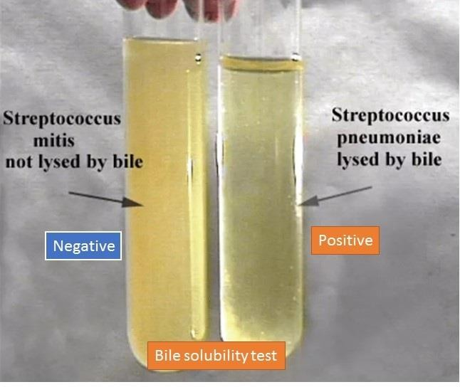

Laboratory Speciemens
1- Blood : Septicemia
- Urine: Urinary tract infections
- Stool: Gastrointestinal infections.
4- Sputum: Respiratory infection
- Vaginal swabs: Vaginal infections .
- Nose & ear swabs : Nose & ear infections
- Cerebral spinal fluid :CNS infections
- Food & vomit : Food poisoning
- Pus : Acne , burns , wounds.
10-Seminal fluid :Urethral discharge

