Practical Pathogenic bacteria
Lab 2

Genus: Staphylococcus
Staphylococcus includes at least 43 species. Of these, nine have two subspecies, one has three subspecies, and one has four subspecies.
Many species cannot cause disease and reside normally on the skin and mucous membranes of humans and other animals. Staphylococcus species have been found to be nectar-inhabiting microbes. They are also a small component of the soil microbiome.
Staph. aureus : their habitat on nasal passages , skin, oral cavity and gastrointestinal tract.
Staph. epidermidis : their habitat on skin
Staph. saprophyticus : rarely found in healthy humans

Specimens come to laboratory
Urine, Blood, Stool, swabs from ear, nose , eye, acne, burns and wounds, seminal fluid.

Laboratory Diagnostics
- Gram stain: purple grape like clusters
- Catalase test
- Oxidase test
- Coagulase test
- Motility test
- DNase test
- Grow on milk agar for pigments
- Grow on blood agar for blood hemolysis
- Grow on Mannitol salt agar for mannitol fermenting

Gram stain
It’s named by Danish bacteriologist Hans Christian Gram, who first introduced it in 1882, mainly to identify organisms causing pneumonia.
A Gram stain is a laboratory test that checks for bacteria at the site of a suspected infection or in certain bodily fluids, gives relatively quick results, so healthcare providers can know if bacteria are present. But , it is not final diagnosis .
Under a Gram stain, bacteria change one of two sets of colors (pink to red or purple to blue) under a special series of stains and are categorized as “gram- negative” or “gram-positive,” accordingly depending on the chemical and physical properties of their cell walls.
However, not all forms of bacteria can be tested using the Gram stain method.

Gram staining procedure
At the lab, a medical laboratory scientist smears or spreads the sample on glass microscope slides. These slides are known as smears. They then apply a series of stains to the smear to perform a Gram stain.
The Gram staining process includes four basic steps, including:
  - Applying a primary stain (crystal violet).1min
  - Adding a mordant (Gram’s iodine).1min
  - Rapid decolorization with ethanol, acetone or a mixture of both.20 sec
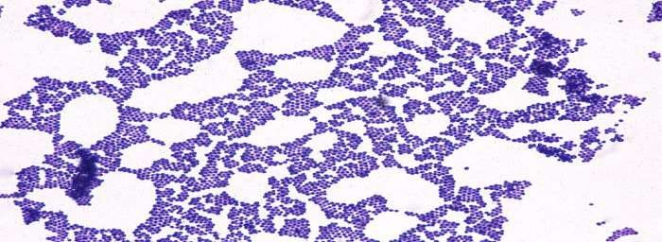
  - Counterstaining with Safranin.0.5 min
Staphylococcus spp = Cocci , Grape like clusters and Purple

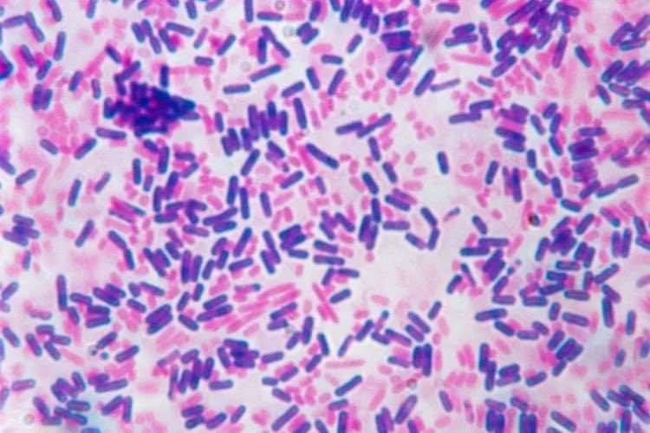
Gram negative bacteria (red), while Gram positive bacteria (purple)

Mannitol salt agar
Chapman Agar or Mannitol Salt Agar is a selective differential medium used for the isolation, enumeration and differentiation of Staphylococcus from clinical, food, antiseptic and cosmetic samples.

◈ The selectivity of this medium is based on the presence of sodium chloride (7.5%) which inhibits most Gram negative and Gram positive bacteria. So, it will select organisms that can live in areas with a high concentration of salt
◈ The differentiation is based on the ability or not to ferment the mannitol (the only sugar in the medium). If there is fermentation, this induces acidification which leads, at pH levels below 6.9, to a yellow coloration of the medium in the presence of phenol red (pH indicator).

Note :
- In clinical samples, mannitol positive isolates are suggestive of Staphylococcus aureus and should be further tested.
- A non-fermenting bacteria that resists the high salt concentration results in a red to pink area due to the degradation of the peptone.
-Staphylococci aureus form lush, pigmented colonies surrounded by a yellow halo due to the fermentation of mannitol. Several species of Staphylococcus other than S. aureus are positive for mannitol and produce yellow colonies surrounded by yellow areas (eg S. capitis, S. xylosus, S. cohnii, S. sciuri, S. simulans). Therefore, further biochemical testing is needed to identify S. aureus or other species.
- Non-pathogenic staphylococci usually form small red colonies which do not change the color of the medium.
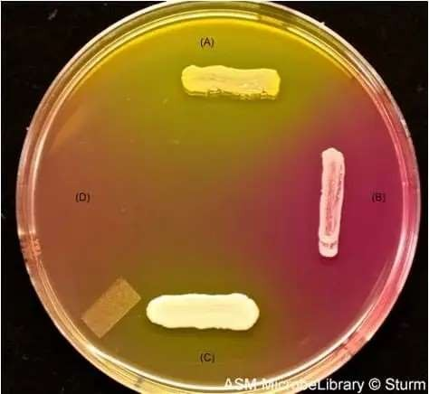
(A).Staphylococcus aureus: large yellow halo around growth indicates fermentation of mannitol.
(B). Staphylococcus epidermidis: Growth but not color change to the media indicating no fermentation of mannitol.
(C). Staphylococcus saprophyticus: small yellow halo around growth indicates fermentation of mannitol. (10% of S. saprophyticus ferment mannitol)
(D). E. coli: no growth. Inhibited by the 7.5% NaCl

Blood agar
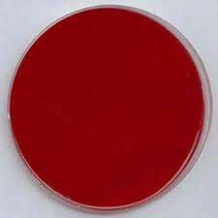
Blood agar is a general purpose, enriched medium often used to grow fastidious organisms and to differentiate bacteria based on their hemolytic properties Beta, Alpha and Gamma hemolysis. In the U.S., blood agar is usually prepared from tryptic soy agar or Columbia agar base with 5% sheep blood.

Blood agar : Selective differential medium

DNase Test
This test is presumptively used to differentiate Staphylococcus aureus which produces the enzyme deoxyribonuclease (DNase) (a heat-stable enzyme, a thermonuclease) from other Staphylococci which do not produce it.
To detect this enzyme, first the organisms are destroyed by heat and then the free DNase reacts with the medium. This test is also given positive by Vibrio, Helicobacter, Moraxella, Serratia, and Aeromonas.

Principle
DNase are extracellular endonucleases that cleave DNA and release free nucleotides and phosphate. To detect these enzymes, DNase agar using no indicators or various indicators (toluidine blue or methyl green) are used to detect the hydrolysis of DNA.

In DNase agar without indicator, the hydrolysis of DNA is observed by a clearing of the agar after addition of HCL (oligonucleotides dissolves in acid but DNA salts are insoluble). The acid precipitates unhydrolyzed DNA making the medium opaque. Therefore, DNase producing colonies hydrolyze DNA and produce a clear zone around the growth.

In case of DNase agar with methyl green, DNA combines with methyl green (act as cation) to produce mint green color. When the DNA is hydrolyzed, the complex is released and the free methyl green is colorless at pH 7.5. So the clear halo is appeared around the areas where DNase producing organism grow.
When toluidine blue O (TBO) is added to the DNase agar, a complex is formed with the DNA, which changes structure when DNA is hydrolyzed, resulting in a bright pink color.

Uses
- Used to determine the ability of an organism to hydrolyze deoxyribonucleic acid.
- Used to differentiate Staphylococcus aureus which produces the enzyme deoxyribonuclease from other Staphylococci which do not produce DNase.
- Particularly useful if plasma is not available to perform coagulase test or when the result of coagulase tests are difficult to interpret.

Procedure for DNase test method
- Using a sterile loop, several colonies from an 18-24 hours culture is picked.
- Inoculate the test and control organism in each test area.
- Incubate the plate at 35-37°C for 24 hours.
- After incubation observe the color change in DNase with methyl green.
- In DNase agar without indicators:
- Flood the surface of agar with 1N HCL solution. Tip off the excess acid.
- Allow the reagent to absorb into the plate.
- Observe for clear zone around the colonies within 5 minutes.

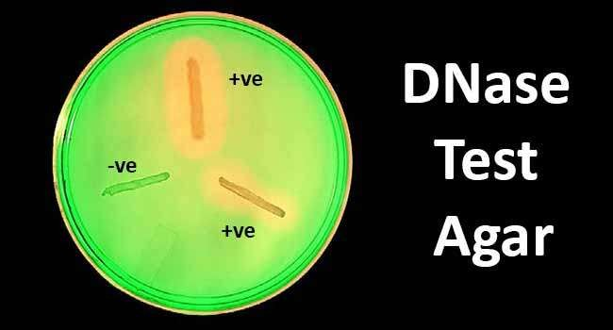

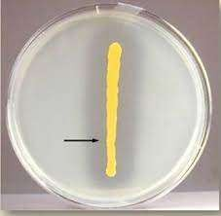

DNase test for Staphylococcus aureus : positive result
DNase test for Staphylococcus epidermidis : Negative result

Differentiation between Staphylococcus species
Tests | S.aureus | S.epidermidis |  | S.saprophyticus
Gram stain | Gram+ve  cocci |  | Gram+ve  cocci | Gram+ve  cocci
Catalase | Positive |  | Positive | Positive
Oxidase | Negative |  | Negative | Negative
Blood agar | Beta |  | Gamma | Gamma
Coagulase | Positive |  | Negative | Negative
DNase | Positive |  | Negative | Negative
Mannitol  fermentation | Ferment  mannitol |  | Dose not  ferment | Dose not  ferment
Novobiocin  sensitivity | S |  | S | R
Colony | Golden |  | White | Light yellow

