**C II. INTERFERENCE BY DVSION OF AMPLITUDE**

1-MICHELSONt INTERFEROMETER

The main optical parts consist of two highly polished plane mirrors *M1* and *M2*and two plane-parallel plates of glass Gland *G2•* Sometimes the rear side of the plate  
G1 is lightly silvered (shown by the heavy line'in the figure) so that the light coming  
from the source S is divided into (1) a reflected and (2) a transmitted beam of equal  
intensity. The light reflected normally from mirror *M1* passes through G1 a third  
time and reaches the eye as shown. The light reflected from the mirror *M* 2 passes  
back through G2 for the second time, is reflected from the surface of G1 and into the

Even when the above adjustments have been made, fringes will not be seen  
unless two important requirements are fulfilled. First, the light must originate from  
an *extended* source. A point source or a slit source, as used in the methods previously  
described, will not produce the desired system of fringes in this case. The reason  
for this will appear when we consider the origin of the fringes. Second, the light must  
in general be *monochromatic,* or nearly so. Especially is this true if the distances of  
*M1* and *M2* from G1 are appreciably different

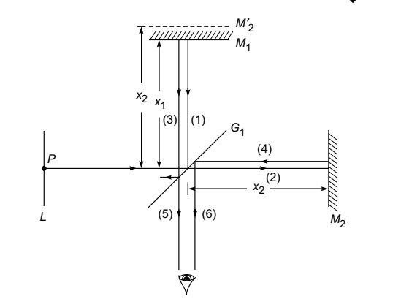 Schematic of the Michelson interferometer.

**Circular fringes**

Circular fringes are produced with monochromatic light when the mirrors M1 and M2 are exactly perpendicular to each other.

**Visibility of the Fringes**

In case of Michelson interferometer, the intensity is given by:



Here The intensity distribution across the rings follows Eq. (13b), in which the phase difference  
is given by:

The intensity distribution across the rings follows Eq. (13b), in which the phase difference  
is given by

Michelson tested the lines from various sources and concluded that a certain red line in the spectrum of  
cadmium was the most satisfactory. He measured the *visibility,* defined as

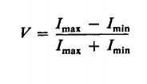

where *Imax* and Imin are the intensities at the maxima and minima of the fringe pattern. The more slowly *V* decreases with increasing path difference, the sharper the line.

**Uses of Michelson's Interferometer**

**1.determnation of wavelength of monochromatic light**

$∆x=x_{2- }x_{1}=N.\frac{λ}{2}$

$$λ=\frac{2\left(x_{2}-x_{1}\right)}{N}=\frac{2x}{N}$$

**X2-x1:** no. of fringes counting the center of the field of view.

(Conversely, if *x* is increased, the fringe pattern will expand.)

*N: no. of* fringes

**2- determination of different in wavelength between two neighbor lines or two waves**

Let the source of light emit close wavelength $λ_{1}$ and $λ_{2}$,condition λ1>λ2 . the apparatus is adjusted to form circular rings. the arrangement of the position of mirror M1 is moved and reached when a bright fringes of one set falls on the bright fringe of the other an fringes are again distinct. So the small difference $∆$ λ is given by:

$$∆λ=\frac{λ^{2}}{2x}$$

**3-thickness of a thin transparent sheet**

**4-determination of the refractive index of gases**

the path difference introduce between the two interfering beam is 2(n-1)L

where n:Refractive index of gas

L: length of the tube. If m fringes cross the center of the field of view thus:

2(n-1)L=mλ

$$n=\frac{mλ}{2L}+1$$

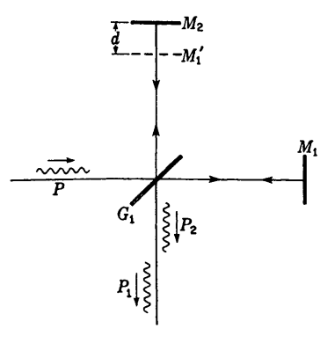

Limiting path difference as determined by the length of wave packets.

**Interferometry**

Instrument used by the principle of interference of light is called **interferometer** this instrument designed by Jamis and Rayleigh are used to determine the refractive index of gases and are known as **refract meter**

**INTERFEROMETRIC MEASUREMENTS OF LENGTH**The principal advantage of Michelson's form of interferometer over the earlier  
methods of producing interference lies in the fact that the two beams are here widely  
separated and the path difference can be varied at will by moving the mirror or by  
introducing a refracting material in one of the beam

**TWYMAN AND GREEN INTERFEROMETER**If a Michelson interferometer is illuminated with strictly parallel monochromatic  
light, produced by a point source at the principal focus of a well-corrected lens, it  
becomes a very powerful instrument for testing the perfection of optical parts such  
as prisms and lenses. The piece to be tested is placed in one of the light beams, and  
the mirror behind it is so chosen that the reflected waves, after traversing the test  
piece a second time, again become plane. These waves are then brought to interference  
with the plane waves from the other arm of the interferometer by another lens, at the  
focus of which the eye is placed. If the prism or lens is optically perfect, so that the

returning waves are strictly plane, the field will appear uniformly illuminated. Any  
local variation of the optical path will, however, produce fringes in the corresponding  
part of the field, which are essentially the contour lines of the distorted wave front.  
Even though the surfaces of the test piece may be accurately made, the glass may  
contain regions that are slightly more or less dense. With the Twyman and Green  
interferometer these can be detected and corrected for by local polishing of the surface.

INDEX OF REFRACTION BY INTERFERENCE  
METHODS



In principle a measurement of *lim, t,* and), thus gives a determination of *n*

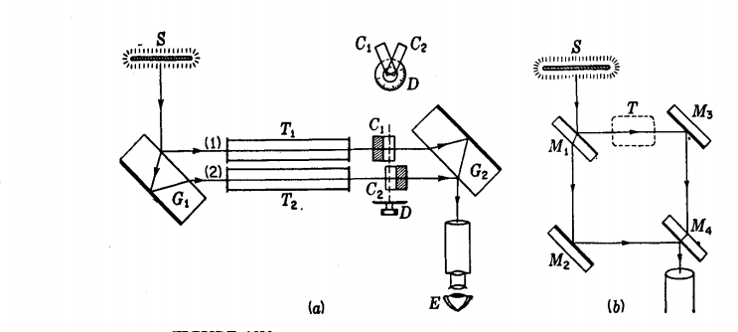figure ( 9 ) *(a)* The Jamin and *(b)* the Mach-Zehnder interferometer.

**Coherence source**

Light which is capable of interference is called ‘coherent,’ and it is evident that in order to  
yield many interference fringes, it must be very monochromatic. Coherence is conveniently  
measured by the path difference between two rays of the same source, by which they can  
differ while still giving observable interference contrast. This is called the coherence length. . Rayleigh and Albert Michelson were the first to understand that it is a reciprocal measure of  
the spectroscopic line width.

The coherence time t  
*c* represents the average duration of the  
wave trains; i.e., the electric field remains sinusoidal for times  
of the order of t *c*.

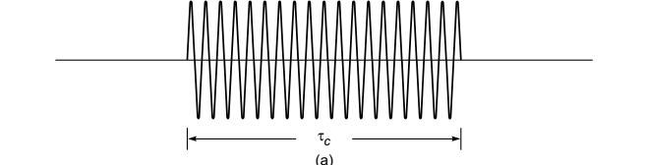  
The length of the wave train, given by  
*Lc* = *c*t*c*(where *c* is the speed of the light in free space) is referred to  
as the coherence length.

Producing Coherent Sources

Light from a monochromatic source is used to illuminate a barrier.

The barrier contains two small openings.

* + The openings are usually in the shape of slits.

The light emerging from the two slits is coherent since a single source produces the original light beam.

This is a commonly used method.

**INTERFERENCE IN THIN FILMS**

Interference effects are commonly observed in thin films, such as thin layers of oil on water or the thin surface of a soap bubble. The varied colors observed when white light is incident on such films result from the interference of waves reflected from the two surfaces of the film.  
Consider a film of uniform thickness *t* and index of refraction *n*, as shown in Figure 10. Let us assume that the light rays traveling in air are nearly normal to the two surfaces of the film. To determine whether the reflected rays interfere constructively or destructively, we first note the following facts:  
• A wave traveling from a medium of index of refraction *n* 1 toward a medium of index of refraction *n* 2 undergoes a 180° phase change upon reflection when and undergoes no phase change if  
• The wavelength of light *n* in a medium whose refraction index is *n*   
*n* film *n* air.  
  
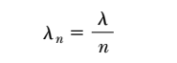

However, we must also consider that ray 2 travels an extra distance 2*t* before the waves recombine in the air above surface *A*. If then rays 1 and 2 recombine in phase, and the result is constructive interference. In general, the condition for constructive interference in such situations is



This condition takes into account two factors: (1) the difference in path length for the two rays (the term *mn*) and (2) the 180° phase change upon reflection



If the extra distance 2*t* traveled by ray 2 corresponds to a multiple of *n*, then the two waves combine out of phase, and the result is destructive interference. The general equation for destructive interference

INDEX OF REFRACTION BY INTERFERENCE METHODS

If a thickness *t* of a substance having an index of refraction *n* is introduced into the path of one of the interfering beams in the interferometer, the optical path in this beam is increased because of the fact that light travels more slowly in the substance and consequently has a shorter wavelength. The optical path [Eq. (It)] is now *nt* through the medium, whereas it was practically *t* through the corresponding thickness of air *(n* = 1). Thus the increase in optical path due to insertion of the substance is

*(n - l)t.t* This will introduce *(n - l)tl).* extra waves in the path of one beam; so if we call *lim* the number of fringes by which the fringe system is displaced when the substance is placed in the beam, we have:



In principle a measurement of *lim, t,* and), thus gives a determination of *n.*

In practice, the insertion of a plate of glass in one of the beams produces a is continuous shift of the fringes so that the number lim cannot be counted. With monochromatic fringes it is impossible to tell which fringe in the displaced set corresponds to one in the original set. With white light, the displacement in the fringes of different colors is very different because of the variation of *n* with wavelength, and the fringes disappear entirely. This illustrates the necessity of the compensating plate

G2 in Michelson's interferometer if white-light fringes are to be observed. If the plate of glass is very thin, these fringes may still be visible, and this affords a method of measuring *n* for very thin films. For thicker pieces, a practicable method is to use two plates of identical thickness, one in each beam, and to turn one gradually about a vertical axis, counting the number of monochromatic fringes for a given angle of rotation. This angle then corresponds to a certain known increase in effective thickness.

For the measurement of the index of refraction of gases, which can be introduced gradually into the light path by allowing the gas to flow into an evacuated tube, the interference method is the most practicable one. Several forms of refractometers have been devised especially for this purpose, of which we shall describe three, the Jamin, the Mach-Zehnder, and the Rayleigh refractometers.

Jamin's refractometer is shown schematically in Fig. 13V(a). Monochromatic



light from a broad source S is broken into two parallel beams 1 and 2 by reflection at the two parallel faces of a thick plate of glass Gl' These two rays pass through to another identical plate of glass *Gz* to recombine after reflection, forming interference fringes known as Brewster's fringes (see Sec. 14.11). If now the plates are parallel, the light paths will be identical. Suppose as an experiment we wish to measure the index of refraction of a certain gas at different temperatures and pressures. Two similar evacuated tubes *T1* and *Tz* of equal length are placed in the two parallel beams.

Gas is slowly admitted to tube *Tz.* If the number of fringes *Am* crossing the field is counted while the gas reaches the desired pressure and temperature, the value of *n* can be found by applying Eq. (13k). It is found experimentally that at a given temperature the value *n -* 1 is directly proportional to the pressure. This is a special case of the *Lorenz-Lorentz* law,* according to which:



Here *p* is the density of the gas. When *n* is very nearly unity, the factor *(n* + *I)j(nz* + 2) is nearly constant, as required by the above experimental observation.

The interferometer devised by Mach and Zehnder, and shown in Fig. *13V(b),* has a similar arrangement of light paths, but they may be much farther apart. Therole of the two glass blocks in the Jamin instrument is here taken by two pairs ofmirrors, the pair *M1* and *Mz* functioning like *G1,* and the pair *M3* and *M4* like *Gz•*

The first surface of *M1* and the second surface of *M4* are half-silvered. Although it is



more difficult to adjust, the Mach-Zehnder interferometer is suitable only for studying slight changes of refractive index over a considerable area and is used, for example, in measuring the flow patterns in wind tunnels (see also Sec. 28.14). Contrary to the situation in the Michelson interferometer, the light traverses a region such as *T* in the figure in only one direction, a fact which simplifies the study of local changes of optical path in that region.

The purpose of the compensating plates Ct and *Cz* in Figs. 13V(a) and 13W is to speed up the measurement of refractive index. As the two plates, of equal thickness, are rotated together by the single knob attached to the dial *D,* one light path is shortened and the other lengthened. The device can therefore compensate for the path difference in the two tubes. The dial, if previously calibrated by counting fringes, can be made to read the index of refraction directly. The sensitivity of this device can be varied at will, a high sensitivity being obtained when the angle between the two plates is small and a low sensitivity when the angle is large.

In Rayleigh's* refractometer (Fig. 13W) monochromatic light from a linear source S is made parallel by a lens *Lt* and split into two beams by a fairly wide double slit. After passing through two exactly similar tubes and the compensating plates, these are brought to interfere by the lens *Lz.* This form of refractometer is often used to measure slight differences in refractive index of liquids and solutions.

REFLECTION FROM A PLANE-PARALLEL FILM

Let a ray of light from a source S be incident on the surface of such a film at *A* (Fig. 14B). Part of this will be reflected as ray 1 and part refracted in the direction *AF.*

Upon arrival at *F,* part of the latter will be reflected to *B* and part refracted toward *H.* At *B* the ray *FB* will be again divided. A continuation of this process yields two sets of parallel rays, one on each side of the film. In each of these sets, of course, the intensity decreases rapidly from one ray to the next. If the set of parallel reflected rays is now collected by a lens and focused at the point *P,* each ray will have traveled

a different distance, and the phase relations may be such as to produce destructive or constructive interference at that point. It is such interference that produces the



colors of thin films when they are viewed by the naked eye. In such a case *L* is the lens of the eye, and *P* lies on the retina.

In order to find the phase difference between these rays, we must first evaluate the difference in the optical path traversed by a pair of successive rays, such as rays 1 and 2.

If this path difference is a whole number of wavelengths, we might expect rays 1 and 2 to arrive at the focus of the lens in phase with each other and produce a maximum of intensity. However, we must take account of the fact that ray 1 undergoes a phase change of 1t at reflection, while ray 2 does not, since it is internally reflected. The condition



then becomes a condition for *destructive* interference as far as rays 1 and 2 are concerned.

As before, *m* = 0, 1, 2, ... is the order of interference.



Next we examine the phases of the remaining rays, 3, 4, 5,.. .. Since the geometry is the same, the path difference between rays 3 and 2 will also be given by Eq. (l4e), but here there are only internal reflections involved, so that if Eq. (14f) is fulfilled, ray 3 will be in the same phase as ray 2. The same holds for all succeeding pairs, and so we conclude that under these conditions rays 1 and 2 will be out of phase, but rays 2, 3,4, ... , will be in phase with each other. On the other hand, if conditions are such that



ray 2 will be in phase with 1, but 3, 5, 7, . .. will be out of phase with 2, 4, 6, ....

we have taken the fraction reflected internally and externally to be the same.

Adding the amplitudes of all the reflected rays but the first on the upper side of the film, we obtain the resultant amplitude,



Since *r* is necessarily less than 1, the geometrical series in parentheses has a finite sum equal to 1/(1 - *r2),* giving





But from Stokes' treatment, Eq. (14c), *tt'* = 1 - *r2 ;* so we obtain finally

*A* = *ar*  (14h)

This is just equal to the amplitude of the first reflected ray, so we conclude that under the conditions of Eq. (14f) there will be complete destructive interference.

FRINGES OF EQUAL INCLINATION

If the image of an *extended* source reflected in a thin plane-parallel film is examined, it will be found to be crossed by a system of distinct interference fringes, provided the source emits monochromatic light and provided the film is sufficiently thin.

Each bright fringe corresponds to a particular path difference giving an integral value of min Eq. (l4g). For any fringe, the value of *φ* is fixed; so the fringe will have the form of the arc of a circle whose center is at the foot of the perpendicular drawn from the eye to the plane of the film. Evidently we are here concerned with fringes of equal inclination, and the equation for the path difference has the same form as for the circular fringes in the Michelson interferometer .

Note that if *m* is the order of interference for light incident on the film at *φ* = 0°, Eq. (l4f) gives



which would be a dark fringe. Since the path difference for the first, second, and third, etc., bright fringes will be at progressively larger angles of *φ* and *φ'* [Eq. (14g)], the successive path differences, *2nd* cos *',* will be successively shorter and bright-light fringes will be at angles where *2nd* cos *φ'* is equal *(m – 1/2)λ., (m - /2)λ., (m –*/2)λ., etc.

The necessity of using an extended source will become clear upon consideration of Fig. 14B. If a very distant point source S is used, the parallel rays will necessarily reach the eye at only one angle (that required by the law of reflection) and will be focused to a point *P.* Thus only one point will be seen, either bright or dark, according to the phase difference at this particular angle. It is true that if the source is not very far away, its image on the retina will be slightly blurred, because the eye must be focused for parallel rays to observe the interference. The area illuminated is small, however, and in order to see an extended system of fringes, we must obviously have many points S, spread out in a broad source so that the light reaches the eye from various directions.

These fringes are seen by the eye only if the film is very thin, unless the light is reflected practically normal to the film. At other angles, since the pupil of the eye has a small aperture, increasing the thickness of the film will cause the reflected rays to get so far apart that only one enters the eye at a time. Obviously no interference can occur under these conditions. Using a telescope of large aperture, the lens may include enough rays for the fringes to be visible with thick plates, but unless viewed nearly normal to the plate, they will be so finely spaced as to be invisible. The fringes seen 

**Newton’s Rings**

Another method for observing interference in light waves is to place a plano convex lens on top of a flat glass surface, as shown in Figure With this arrangement, the air film between the glass surfaces varies in thickness from zero at the point of contact to some value *t* at point *P*. If the radius of curvature *R* of the lens is much greater than the distance *r*, and if the system is viewed from above using light of a single wavelength , a pattern of light and dark rings is observed, as shown in Figure b. These circular fringes, discovered by Newton, are called **Newton’s rings.**The interference effect is due to the combination of ray 1, reflected from the flat plate, with ray 2, reflected from the curved surface of the lens. Ray 1 undergoes a phase change of 180° upon reflection (because it is reflected from a medium of higher refractive index),

discovered by Newton, are called **Newton’s rings.**

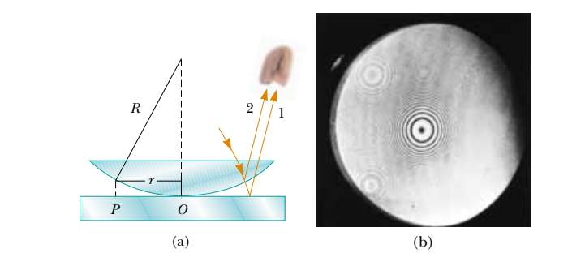

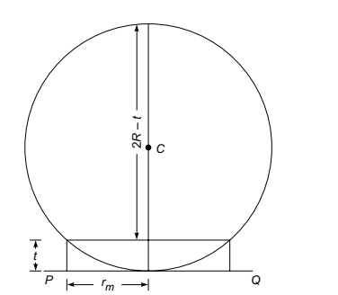

rm represents the radius of the mth dark ring;the thickness of the air film (where the mth dark ring is formed) is t.the optical path difference between the two waves is very nearly equal to 2*nt*, where *n* is the refractive index of the film and *t* is the thickness of the film. Thus, whenever the thickness of the air film  
satisfies the condition

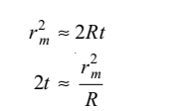

If a liquid of refractive index *n* is introduced between the  
lens and the glass plate, the radii of the dark rings are given by

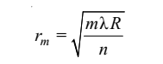 (because it is reflected from a medium of lower refractive index). Hence,

the optical path difference between the two waves is very nearly  
equal to 2nt, where n is the refractive index of the film and t is the  
thickness of the film. Thus, whenever the thickness of the air film  
satisfies the condition  
R2= rm2+(R –t) 2

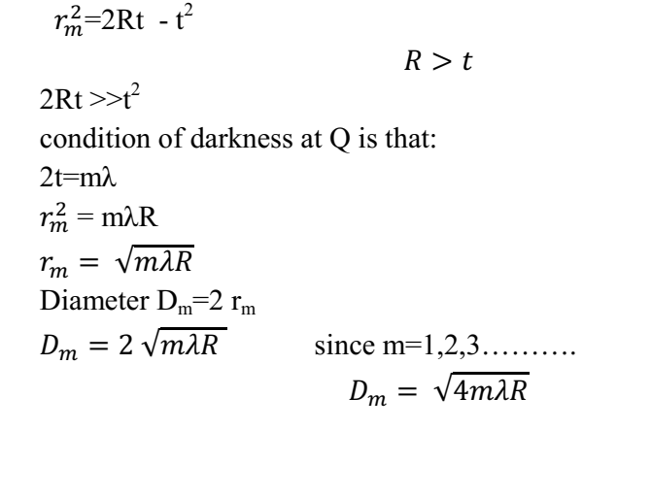

**The Fabry-Perot interferometer**This instrument uses multiple beam interference by division of amplitude. Figure 8.1 shows a beam from a point on an extended source incident on two reflecting surfaces separated by a distance *d*. Note that this distance is the optical distance i.e. the product of refractive index *n* and physical length. For convenience we will omit *n* from the equations that follow but it needs to be included when the space between the reflectors is not a vacuum. An instrument with a fixed *d* is called an *etalon*. Multiple beams are generated by partial reflection at each surface resulting in a set of parallel beams having a relative phase shift δ introduced by the extra path 2*d*cosθ between  
successive reflections which depends on the angle θ of the beams relative to the axis. Interference therefore occurs at infinity - the fringes are of equal inclination and  
localized at infinity. In practice a lens is used and the fringes observed in the focal plane where they appear as a pattern of concentric circular rings

**The Fabry-Perot interference pattern**This is done in all the text books (consult for details). The basic idea is as follows:

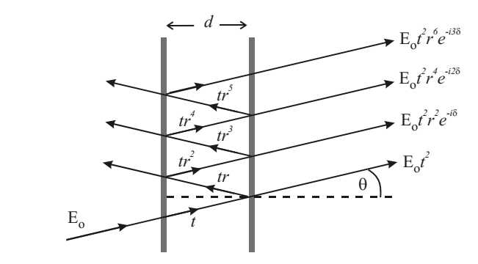 ***Figure 8. Multiple beam interference of beams reflected and transmitted by parallel surfaces with amplitude reflection and transmission coefficients ri, ti respectively.***Amplitude reflection and transmission coefficients for the surfaces are *r*1, *t*1 and *r*2, *t*2,  
respectively.  
The phase difference between successive beams is: 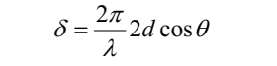

An incident wave *E*oe-*i*ωt is transmitted as a sum of waves with amplitude and phase given by:

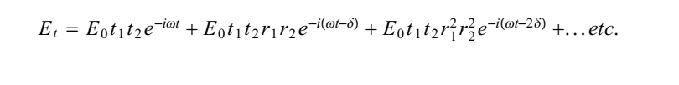 Taking the sum of this Geometric Progression in *r*1*r2ei*δ

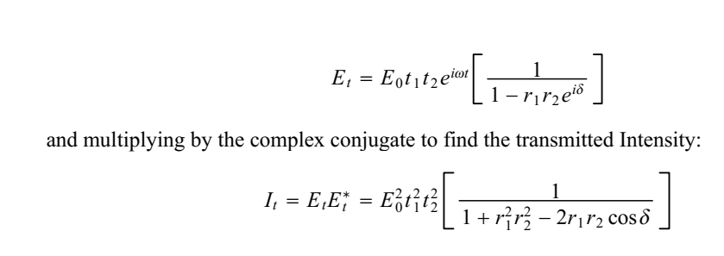 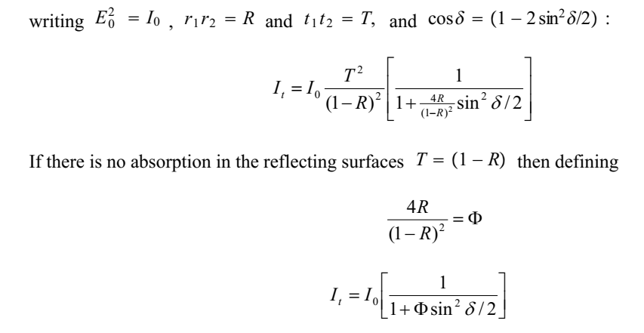 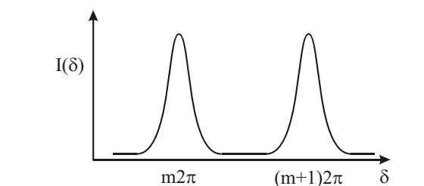 **fig .9 Observing Fabry-Perot fringes**The Airy function describes the shape of the interference fringes. Figure 9 shows the intensity as a function of phase shift δ. The fringes occur each time δ is a multiple of

2π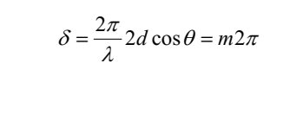

*m* is an integer, the order of the fringe. The fringes of the Airy pattern may be observed by a system to vary *d,* λ, or θ. A system for viewing many whole fringes is shown in figure 9. An extended source of monochromatic light is used with a lens to form the fringes on a screen. Light from any point on the source passes through the F.P. at a range of angles illuminating a number of fringes. The fringe pattern is formed in the focal plane of the lens.  
Extended

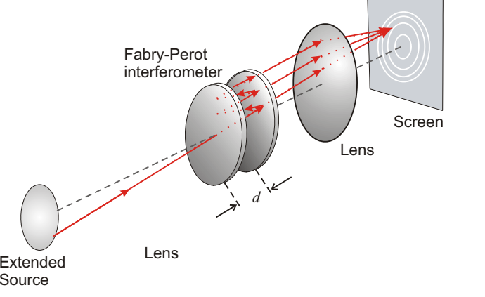 ***Figure 9 Schematic diagram of arrangement to view Fabry-Perot fringes. Parallel light from the Fabry-Perot is focussed on the screen.***