CHROMATIC RESOLVING POWER OF A PRISM
the use of this criterion for the resolving power of a rectangular
aperture is found in the prism spectroscope, if we assume that the face of the prism
limits the refracted beam to a rectangular section
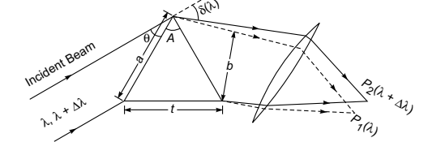
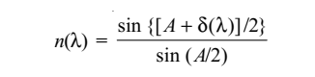
where A represents the angle of the prism and Dmin or δ the angle of
dpoints P1 and P2 represent the
images corresponding to λ and λ + dλ, respectively. We are assuming that dλ is small so that the same position of the prism. where t is the length of the base of the prism. 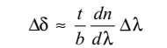
the resolving power
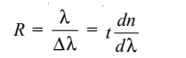
CIRCULAR APERTURES
The ability of optical systems to distinguish between closely spaced objects is limited because of the wave nature of light. To understand this difficulty, let us consider Figure (6), which shows two light sources far from a narrow slit of width a.
The sources can be considered as two noncoherent point sources S1 and S2—for example, they could be two distant stars. If no diffraction occurred, two distinct bright spots (or images) would be observed on the viewing screen.
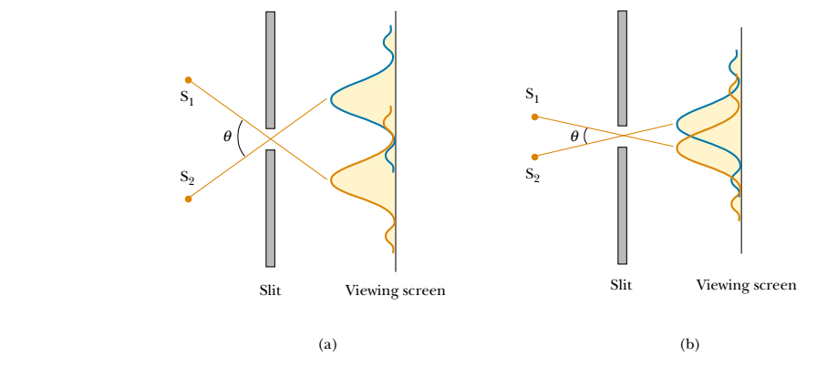
Fig .(6) : Two point sources far from a narrow slit each produce a diffraction pattern. (a) The angle subtended by the sources at the slit is large enough for the diffraction patterns to be distinguishable. (b) The angle subtended by the sources is so small that their diffraction patterns overlap, and the images are not well resolved. (Note that the angles are greatly exaggerated. The drawing is not to scale.)
RESOLVING POWER OF A TELESCOPE
Rayleigh's criterion for the resolution of diffraction patterns to the circular aperture we say that two patterns are resolved when the central maximum of one falls on the first dark ring of the other. The resultant pattern in). The minimum angle of resolution for a telescope is therefore,
consists of a central circular bright disk surrounded by progressively fainter bright and dark rings. Analysis shows that the limiting angle of resolution of the circular aperture is
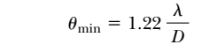 where D is the diameter of the aperture
Resolving power of a Microscope
consider the resolving power of a microscope objective of diameter D as shown in Fig
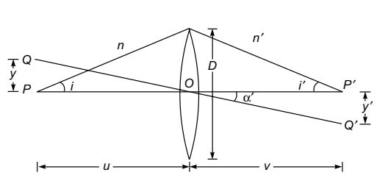 Let P and Q
represent two closely spaced self-luminous point objects which are to be viewed through the microscope. Assuming the absence of any geometrical aberrations, rays emanating from points P and Q will produce spherical wave fronts (after refraction through the lens) which will form Airy patterns around their paraxial image points P' and Q' For points Pand Q to be just resolved, point Q' should lie on the first dark
ring surrounding point P', and therefore we must have
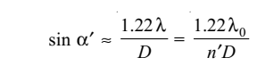
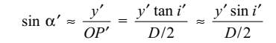
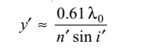
limited of resolution d=$\frac{1.22 λ}{2\sin{α}}$
$$R.P=\frac{1}{d}= \frac{2\sin{α}}{1.22 λ}$$

