Lecture 2

Dr. Mariam M. Abud

**Chapter 2: *Geometrical optics***

|  |
| --- |
| **Chapter Two ( Reflection and Refraction)**  Reflection and refraction at plane surface, The laws of reflection and refraction. |
| Ray treatment of reflection and refraction, the principle of Reversibility, Fermat’s principle, problems. |

**Huygens’ proof of law of reflection**



*L*



**Huygens’ proof of law of refraction**



*vt t*

*vi t*

*i*

*L*

*t*

***vi = c*/*ni***

***vt = c/nt***

**Chapter 2 : Reflection and Refraction**

* + 1. **Optical path :** In a medium of constant refractive index, *n*, the OPL for a path of physical length *d* is just

O P L = n d . {\displaystyle \mathrm {OPL} =nd.\,}

If the refractive index varies along the path, the OPL is given by

OpL= n1d1+n2d2………..

where *n*(*s*) is the local refractive index as a function of distance, *s*, along the path *C*.

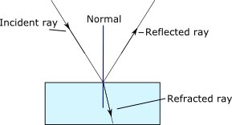

**Law of Reflection**

[Fermat's principle](https://en.wikipedia.org/wiki/Fermat%27s_principle) states that the path light takes between two points is the path that has the minimum optical path length

|  |  |
| --- | --- |
| http://hyperphysics.phy-astr.gsu.edu/hbase/phyopt/imgpho/reflaw.gif | http://hyperphysics.phy-astr.gsu.edu/hbase/phyopt/imgpho/reflaw2.gif |

**Def. Normal.** A line drawn perpendicular to a plane.

**Def. Angle of incidence.** The angle between the incident ray and the normal drawn to the point of incidence. See. Fig. 1.

**Def. Angle of reflection.** The angle between the reflected ray and the normal drawn to the point of incidence. See Fig. 1.

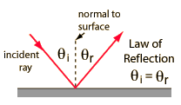

. The law of [reflection](http://hyperphysics.phy-astr.gsu.edu/hbase/phyopt/Fermat.html#c1) can be derived from this principle as follows:

|  |  |
| --- | --- |
| http://hyperphysics.phy-astr.gsu.edu/hbase/phyopt/imgpho/fer1.gif | The pathlength from A to B is  http://hyperphysics.phy-astr.gsu.edu/hbase/phyopt/imgpho/fer2.gif  Since the speed is constant, the minimum time path is simply the minimum distance path. This may be found by setting the [derivative](http://hyperphysics.phy-astr.gsu.edu/hbase/math/maxmin.html#c1) of L with respect to x equal to zero.  http://hyperphysics.phy-astr.gsu.edu/hbase/phyopt/imgpho/fer3.gif |

|  |  |  |  |
| --- | --- | --- | --- |
| This reduces to | http://hyperphysics.phy-astr.gsu.edu/hbase/phyopt/imgpho/fer4a.gif | which is | http://hyperphysics.phy-astr.gsu.edu/hbase/phyopt/imgpho/fer4b.gif |

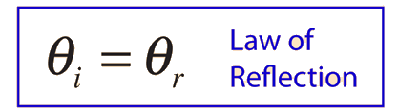

**Fermat's Principle and Refraction**

Fermat's Principle: Light follows the path of least time. [Snell's Law](http://hyperphysics.phy-astr.gsu.edu/hbase/geoopt/refr.html#c3) can be derived from this by setting the [derivative](http://hyperphysics.phy-astr.gsu.edu/hbase/math/maxmin.html#c1) of the time =0. We make use of the [index of refraction](http://hyperphysics.phy-astr.gsu.edu/hbase/geoopt/refr.html#c2), defined as n=c/v.

|  |  |
| --- | --- |
|  |  |

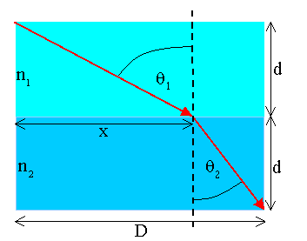

|  |  |
| --- | --- |
| Now assume we want light to propagate from point A to point B across the boundary between medium 1 and medium 2.  For the path shown in the figure on the right the time required is  http://electron9.phys.utk.edu/optics421/modules/m1/images/Image1306.gif.  Setting dt/dx = 0 we obtain  http://electron9.phys.utk.edu/optics421/modules/m1/images/Image1307.gif,  or  n1sinθ1 = n2sinθ2.  **Principle of reversibility**   * Rays in optics take the same path backward or forwards   Fermat's principle yields Snell's law |  |

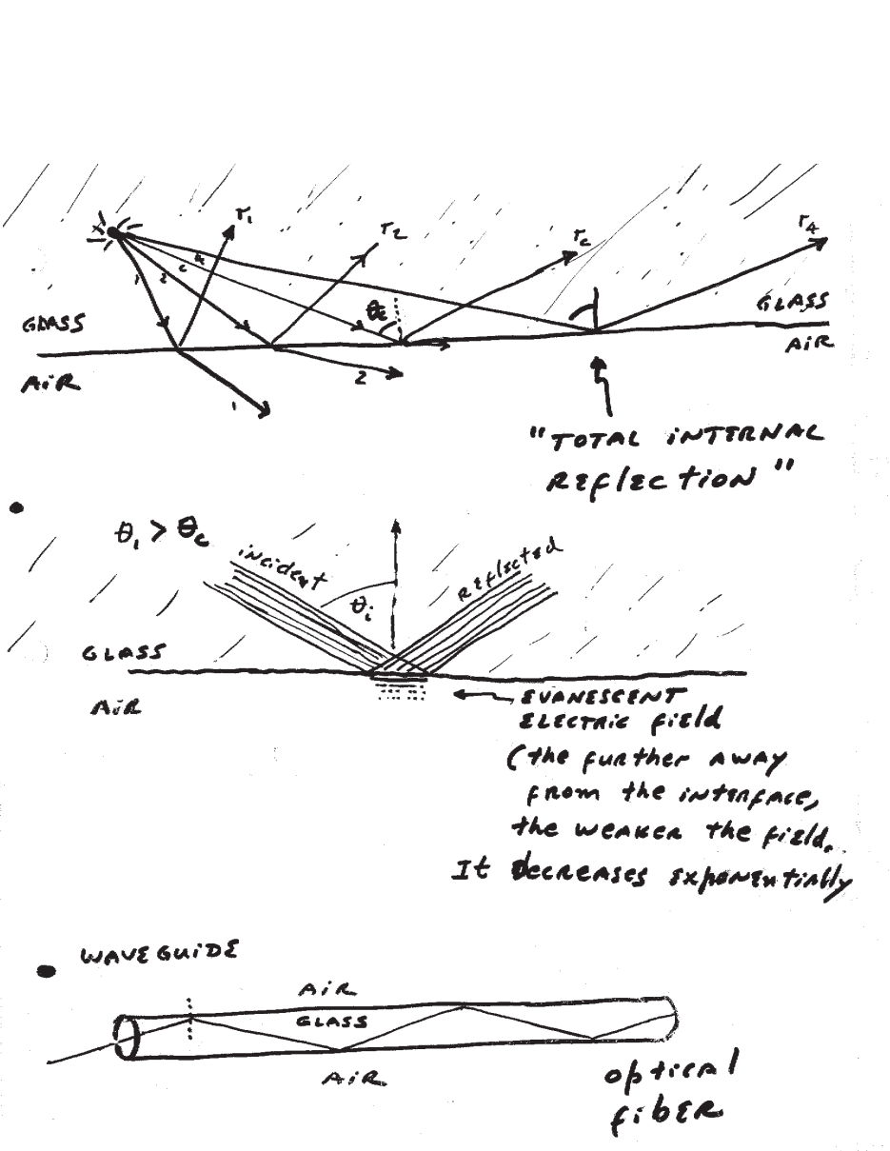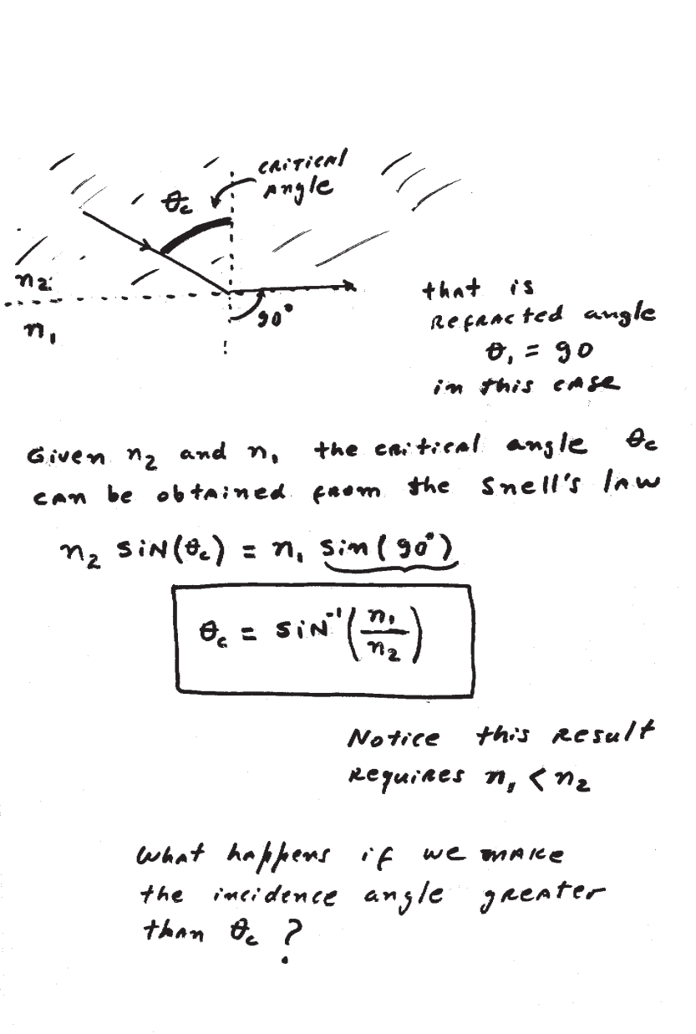**Example 1**

A beam of light enters the flat surface of a diamond at an angle of 30º from the normal. The angle of refraction in the diamond is measured to be 12º from the normal. Determine the speed of light in the diamond.

**Solution**

The angle of incidence *θ1* = 30º and the angle of refraction *θ2* = 12º. The index of refraction can be found by Snell’s law:



The speed of light in diamond can be found by



**Example 2**

The speed of light in a particular piece of glass is 2.0 x 108 m/s, and the speed of light in water is 2.3 x 108 m/s.

(a) Find the index of refraction for

i. the glass

ii. water

(b) A sheet of this glass is placed over a tank full of water. Laser light is incident on the glass from the air above the glass at an angle of 40º. Determine whether or not the light passes into the water, and, if it does, find the angle of refraction of the light in the water.

**Solution**

(a) i. 

ii. 

(b) First, let’s find the critical angle for the light traveling from the glass to the water.



If the light passes from the glass toward the water at an angle greater than 60º, it will totally internally reflect inside the glass. The angle of refraction inside the glass can be found by



Since the angle of the light in the glass less than 60º, the light will refract in the water. The angle of refraction in the water can be found by



D-x

40º

glass

air

water

θg