Part ( 1)
Classification of computer architecture

Von Neumann Machines:
• The "von Neumann" in von Neumann architecture refers to Hungarian-American mathematician John von Neumann, Von Neumann became a consultant to the E NIAC ( E ctronic Numerical Integrator and Computer) project, which upon its completion in 1945 became the world's first general purpose electronic computer.

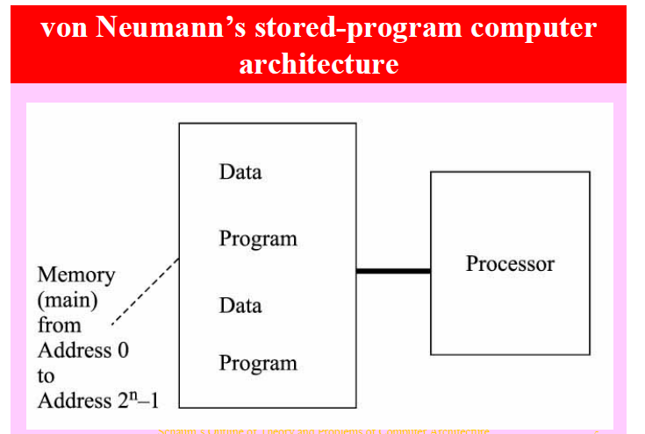

* The principal feature of a von Neumann computer is that the program and any data are both stored together,
A von Neumann computer has five parts:
* arithmetic-logic unit
* control unit
* memory
* some form of input/output
* A bus that provides a data path between these parts.
Such a computer operates by performing the following sequence of steps:
1. Fetch the next instruction from memory at the address in the program counter.
2. Add the length of the instruction to the program counter.
3. Decode the instruction using the control unit. The instruction may change the address in the program counter, permitting repetitive operations. The instruction may also change the program counter only if some arithmetic condition is true.
4. Go back to step 1.

Von Neumann computers have some drawbacks:
* They carry out instructions one after another, in a single linear sequence
* They spend a lot of time moving data to and from the memory.
This slows the computer leading to a problem called the von Neumann bottleneck. One way to solve the von Neumann bottleneck is:
* to build the computer so it performs operations in parallel (so-called parallel processing).
* Another common trick is to separate the bus into two or more busses, one for instructions, another for data.

The Non Von Neumann Architecture
*One example is the MIMD architecture which is : Multiple instruction/Multiple data
*Other examples are Analog Computers, Optical Computers, Quantum Computers, Cell Processors, DNA, Neural Nets (in Silicon).
*Most Non Von Neumann models distributes the computation amongst processing units - for example FPGA or neural networks.
*They can be thought of as a class of computer programs ideally suited for parallel computation.

