Four class Computer security exam 2

Q1) Encrypt the following message “secrete disclosed” with the key “hello” by using
- Playfair Cipher.
- Columnar transposition cipher.

Sol:-
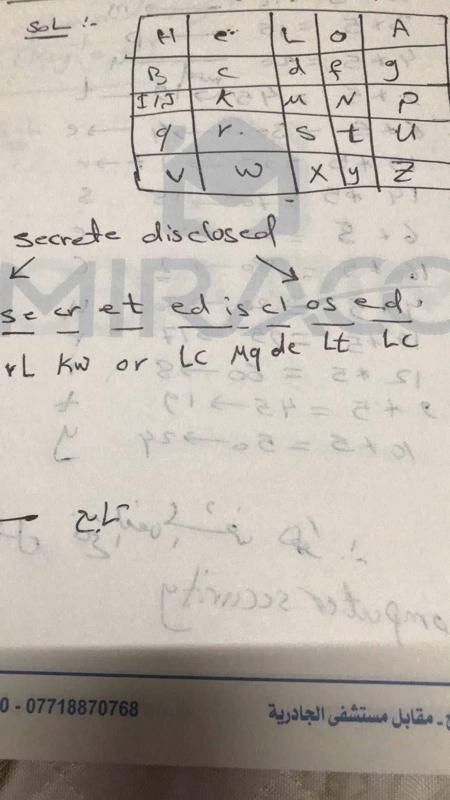
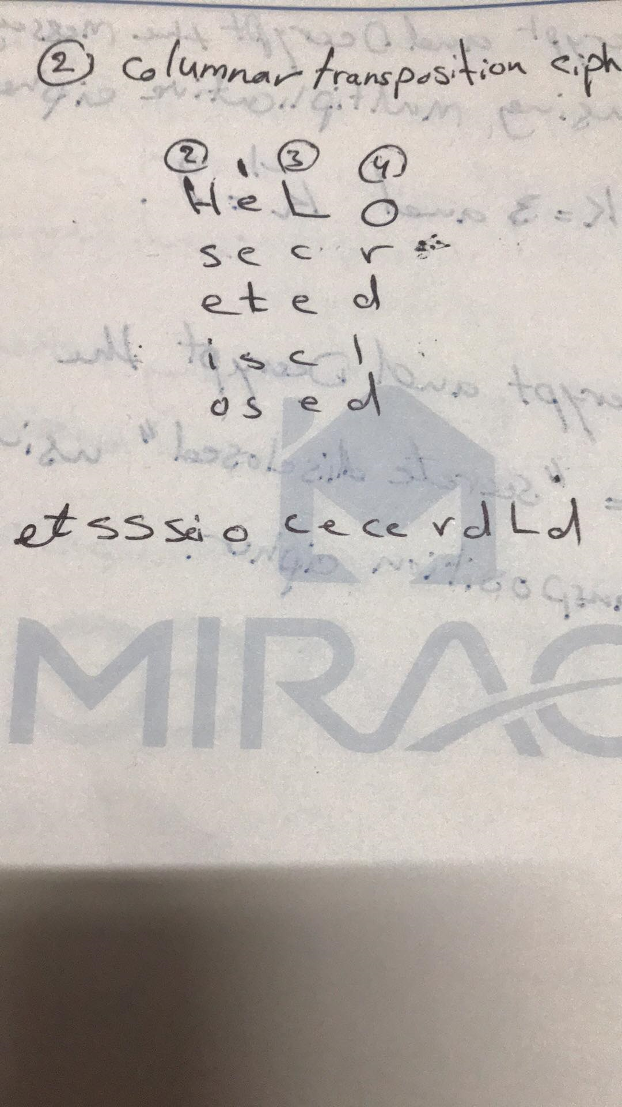

Q2) Decrypt the following message “QISDEJGTOGQETMJK” where it encrypts using multiplication cipher and using the encryption key 21(key ⁻¹ =5).

Sol:- C=p*k
P=c*k⁻¹

