Four class Computer security exam 2

Q1) Encrypt message =" enemy attack tonight", using combined keyless(rail fence) and columnar transposition cipher ( key= german)
-----------------------------------------------------------------------------
Sol:-

Q2) Decrypt the following message “FAXAEYMQLWXO” where it encrypts using multiplication cipher and using the encryption key 19 (key⁻¹=11)

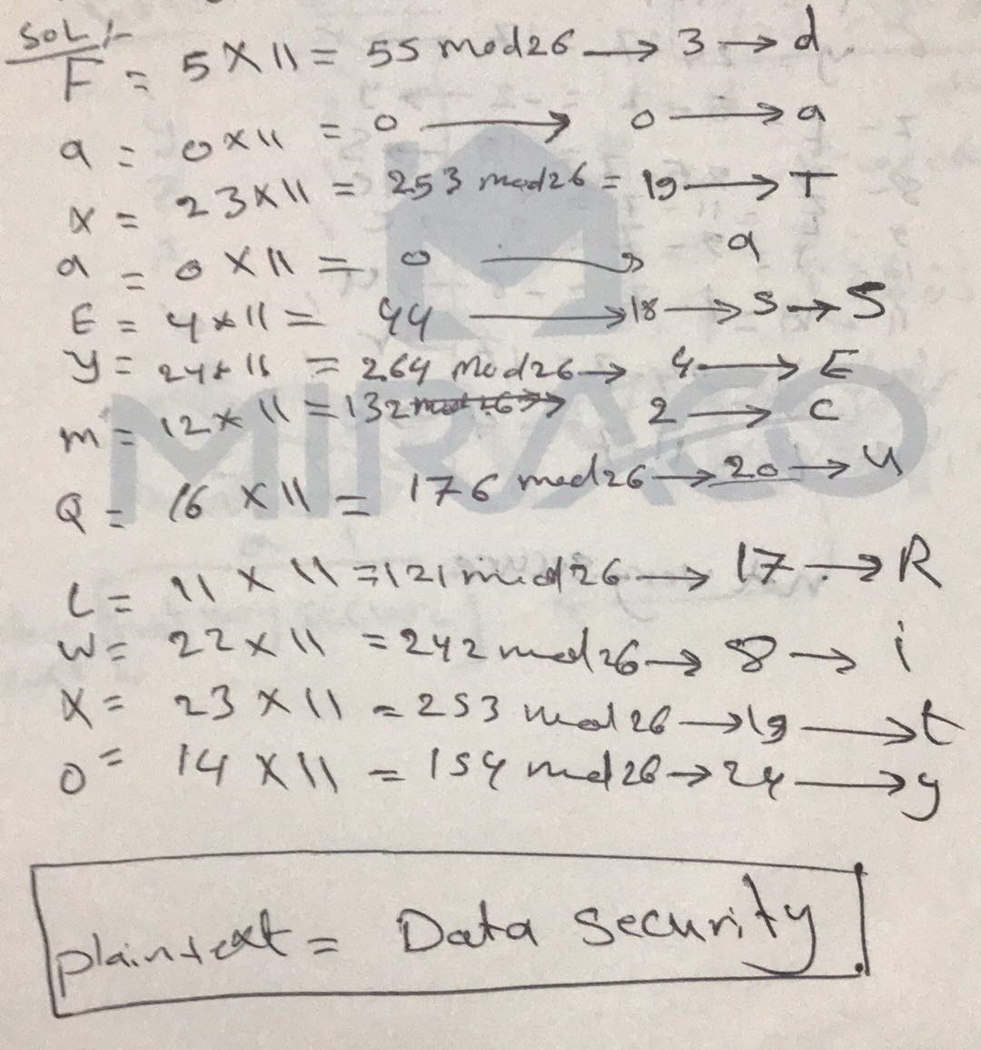

Q3/ Decrypt the following message “UVACLYFZLJBYL”,
By using statistical attack ?
--------------------------------------------------------------------

Sol:-

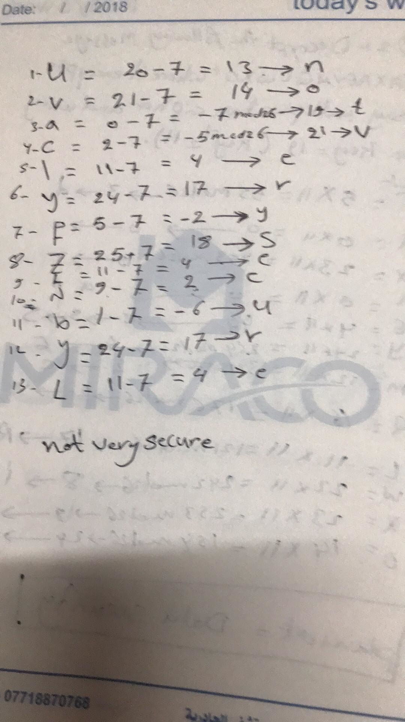

Q4/ The following was encrypted with a Playfair Cipher with keyword =Galois. Decrypt the message.
AQOUNGCIEYEOKVNG, BIMEHOTUEUNBCLOKIH
Sol:-

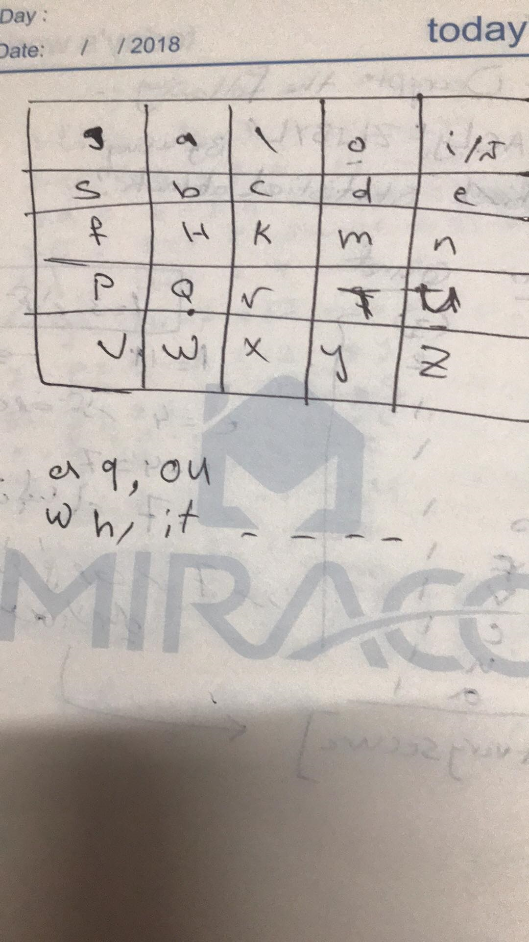
انتباه:::لفتح الشفره الخطوات تكون عكس خطوات التشفير

