

***University of mustansiriyah /College of Education***

***Computer Science Department***

***Software Engineering 3rd Class***

**Chapter 4**

**Formal Requirements**

**منهج المتطلبات**

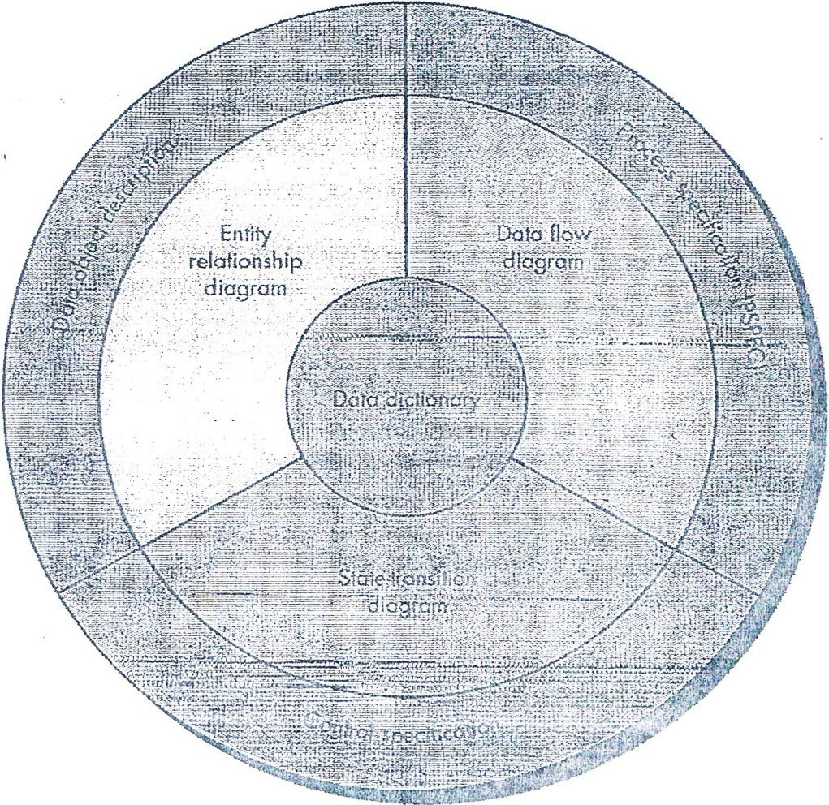

## Figure 4.1:The structure of the analysis model

**ElementsofAnalysis Model(Componentsforstructureoftheanalysismodel)**

### 1-Datadictionary

2-Entityrelationdiagram(ERD)

3-Dataflowdiagram(DFD)

4-Statetransitiondiagram(STD)

Atthecoreofthemodelliesthe*datadictionary:*isanorganizedlistingofalldataelements that''arepertinenttothesystem,withprecise,rigorousdefinitionssothatbothuserandsystemanalystwillhaveacommonunderstandingofinputs,outputs,componentsofstoresand[even]intermediatecalculations.

Or*datadictionary*arepositorythatcontainsdescriptionsofalldataobjectsconsumedorproducedbythesoftware

Three different diagrams surround the core:.

1-The*entityrelationship diagram*(ERD)depictsrelationshipsbetweendata objects.TheERDisthenotationthatisused toconductthedatamodelingactivity.The attributesofeachdataobjectnotedintheERDcanbedescribedusingadataobjectdescription.

2- The*dataflowdiagram*(DFD):isagraphicalrepresentationthatdepictsinformationflowandthetransformsthatareappliedasdatamovefrominputto output.Thebasicformofadataflowdiagram,alsoknownasadataflowgraphorabubble chart.,

**Servestwopurposes:**

(1)toprovideanindicationofhowdataaretransformedastheymovethroughthesystemand(2)todepictthefunctions(andsubfunctions)thattransformthedataflow.TheDFDprovidesadditionalinformationthatisusedduringtheanalysisoftheinformationdomainandservesasabasisforthe*modelingoffunction.*A descriptionof eachfunction presented in the DFD is contained in a *processspecification*(PSPEC).

DFDareusedtorepresentdataandtheprocessesthatmanipulateit.

1. *State transitiondiagram (STD ):* BystudyingtheSTD,asoftwareengineer candeterminethebehaviorofthesystemand,moreimportant,canascertainwhether thereare"holes"inthespecifiedbehavior.STDisabehavioralmodel

TheSTDindicateshowthesystembehavesasaconsequenceofexternalevents.Toaccomplishthis,theSTDrepresentsthevariousmodes ofbehavior(called *states)*ofthesystemandthemannerinwhichtransitionsaremadefromstatetostate.The STDservesasthebasisforbehavioralmodeling.Additionalinformationaboutthecontrolaspectsofthe softwareiscontainedinthe*controlspecification*(CSPEC).

Data objectDescription:TheattributesofeachdataobjectnotedintheERDcan bedescribedusingadataobjectdescription.

Inotherword:incorporatesthedataobjectandallofitsattributes.

ProcessSpecification(PSPEC):isusedtodescribeallflowmodelprocessesthat appearatthefinallevelofrefinement.Thecontentoftheprocessspecificationcanincludenarrativetext,a*programdesignlanguage*(PDL)description.oftheprocessalgorithm,mathematicalequations,tables,diagrams,orcharts.

The controlspecification (CSPEC):representsthebehaviorofthesystemintwodifferentways.TheCSPECcontainsastatetransitiondiagramthatisasequentialspecificationofbehavior.Itcanalsocontainaprogramactivationtable-acombinatorialspecificationofbehavior.

CSPECisusedtoindicate(1)how thesoftwarebehaveswhenaneventorcontrolsignalissensedand(2)whichprocessesareinvokedasaconsequenceoftheoccurrenceoftheevent.



ElementsofAnalysisModel(Componentsforstructureoftheanalysismodel)

#### Datadictionary

* 1. Entityrelationdiagram(ERD)
  2. 3-Dataflowdiagram(DFD)

4-Statetransition diagram(STD)

Control FlowDiagram (CFD):containsthesameprocesses astheDFD,but showscontrolflow,ratherthandataflow.CFDshowhoweventsflowamong processesandillustratethoseexternaleventsthatcausevariousprocessestobeactivated.

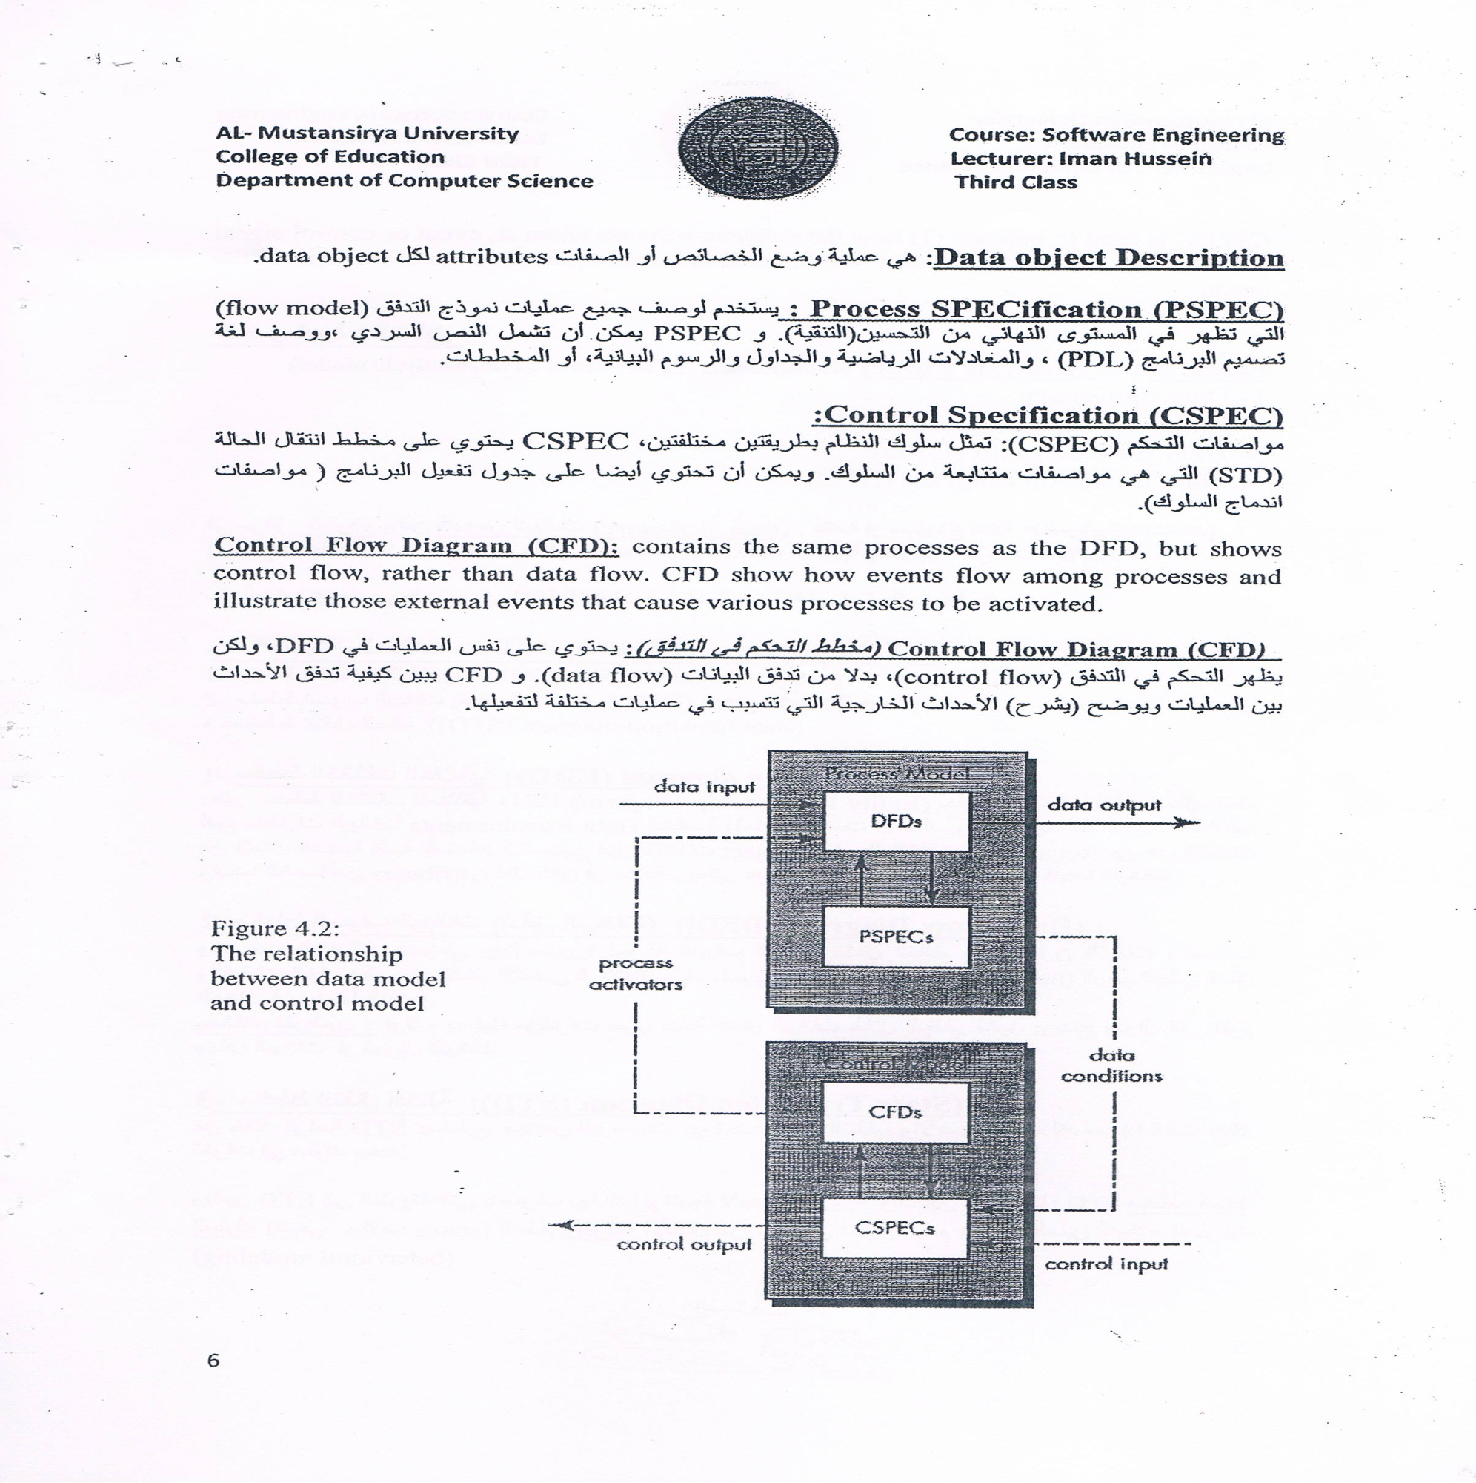

**Figure4.2:Therelationshipbetweendatamodelandcontrolmodel**

* 1. **4.3 DataModel**:

Thedatamodelconsistsofthree interrelatedpiecesofinformation:

1-Dataobject(inpu.tandoutput fromasystem)

2-Attributesthatdescribe thedataobject

3-Relationshipsthatconnectdataobjectstooneanother.

1-Dataobject:A dataobjectisarepresentationofalmostanycompositeinformationthatmust beunderstoodbysoftware.Bycomposite information,wemeansomethingthathasanumberofdifferentpropertiesorattributes.Adataobjectcanbeanexternalentity(e.g.,anythingthatproduces orconsumesinformation),athing(e.g.,areport ora

display),anoccurrence(e.g.,atelephonecall)orevent(e.g.,analarm),arole(e.g.,salesperson), an organizational unit (e.g., accounting department), a place (e.g.,awarehouse),orastructure(e.g.,afile).Adataobjectencapsulatesdataonly-thereisnoreference withinadataobjecttooperationsthatactonthedata.

1. Attributes:Attributesdefinethepropertiesofadataobjectandtake onone ofthreedifferentcharacteristic$.Theycanbeusedto(I)nameaninstanceofthedataobject,(2)describetheinstance,or(3)makereferencetoanotherinstanceinanothertable.

-Inaddition,oneor moreoftheattributesmustbedefinedasanidentifier-thatis,theidentifierattributebecomesa"key"whenwewanttofindaninstanceofthedataobject.Insomecases,valuesfortheidentifier(s)areunique,althoughthisisnotarequirement.

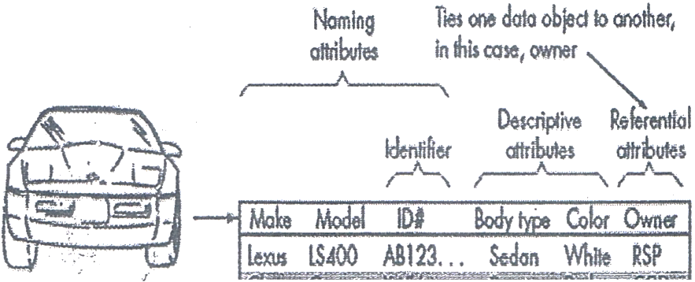

,,.,

--;=--•--'

BiWN750il *W65...*CoupeWhileIJL

Ford Taurus Q12A45...SedonBlue » BLFBlf

1. Relationships:

Dataobjectsareconnectedtooneanotherindifferentways.Relationships define asetofobject/relationship pairs thatdefinethe relevantrelationships.Itisimportanttonotethatobject/relationshippairsarebidirectional.Thatis,they canbereadineitherdirection.Abookstoreordersbooksorbooksareorderedbyabookstore.

TherearetwobasicpointsintheRelationshipsbeawareof:

**1- Cardinality 2-Modality**

-

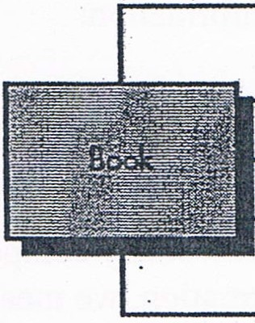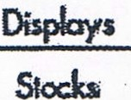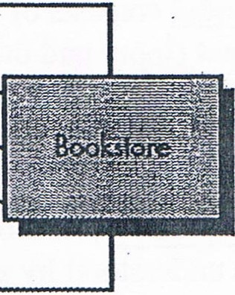

Sells

Returns

1-Cardinality:thespecificationofthenumberofoccurrencesofone[object]thatcanberelatedtothenumberofoccurrencesofanother[object].Cardinalityisusuallyexpressedassimply'one'or'many.'

Takingintoconsiderationallcombinationsof'one'and'many'two[objects]canberelatedas:

* + One-to-one(1:1)Anoccurrenceof[object]'A'canrelate:tooneandonlyoneoccurrenceof[object]'D,'andanoccurrenceof'D'canrelatetoonlyoneoccurrenceof'A.'
  + One-to-many(l:N)-Oneoccurrenceof[object]'A'canrelatetooneormanyoccurrencesof[object]'B,'butanoccurrenceof'B'canrelatetoonlyoneoccurrenceof 'A.'Forexample,amothercanhavemanychildren,butachildcanhaveonlyonemother.
  + Many-to-many(M:N)--Anoccurrenceof[object]'A'canrelatetooneormoreoccurrencesof'B,'whileanoccurrenceof'B'canrelatetooneormoreoccurrencesof'A.'Forexample,anunclecanhavemanynephews,whileanephewcanhavemanyuncles.

2-Modality:Themodalityofarelationshipis0ifthereisnoexplicitneedfortherelationshiptooccurortherelationshipisoptional.Themodalityis1 ifanoccurrenceoftherelationshipismandatory. ·

* 1. Creating anEntity/Relationship Diagram

The entity/relationshipdiagramenablesasoftwareengineertofullyspecifythedataobjectsthatareinputandoutputfromasystem,theattributesthatdefinethepropertiesoftheseobjects,andtheirrelationships.Likemostelements ofthe.Analysismodel, theERBisconstructed inaniterativemanner.Thefollowingapproachistaken:

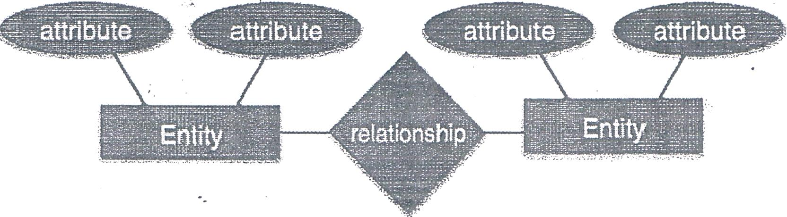

Key:مفتاح

Attributeالخاصية :

**امثلة على المخطط الكائنات العلائقية (ERD**

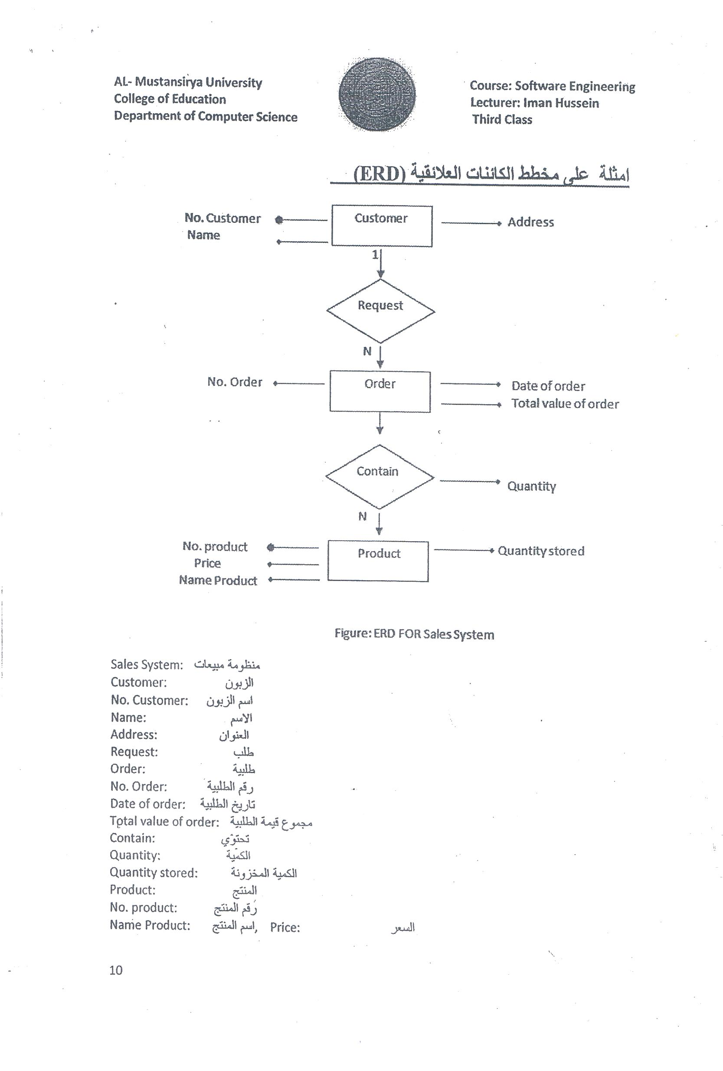

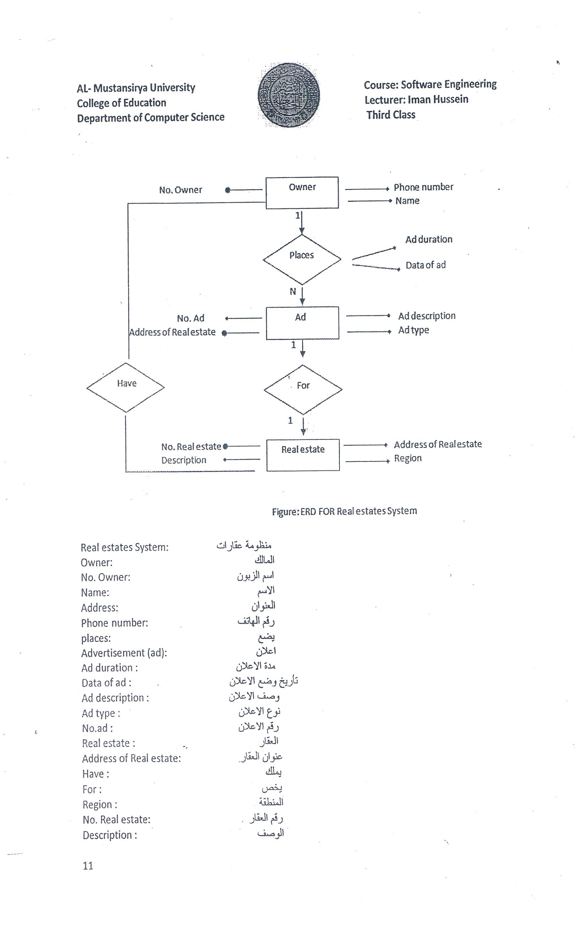

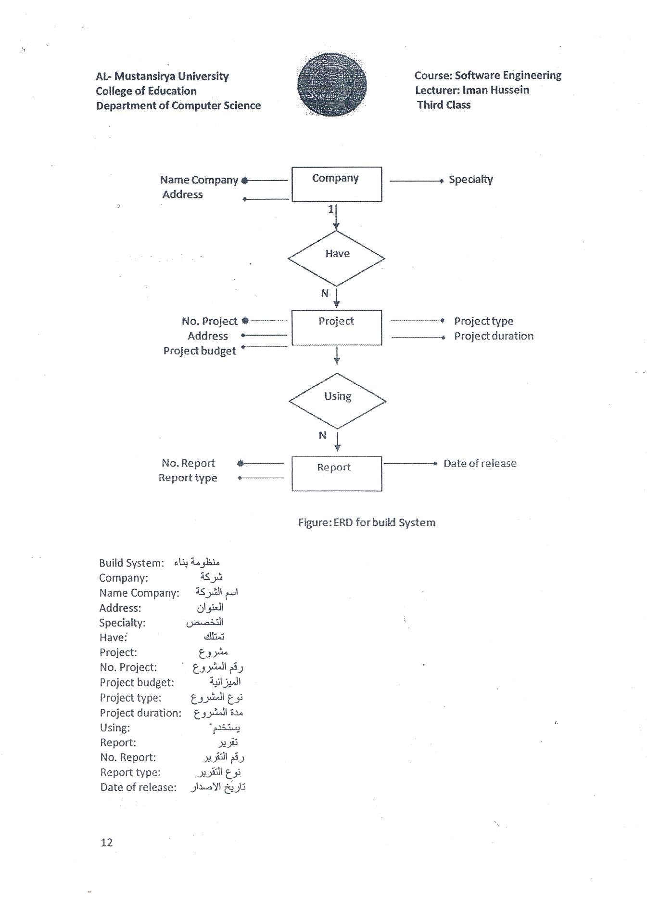

**4.5CreatingaDataFlowModel**

Afewsimpleguidelinescanaidimmeasurablyduringderivationofadata flowdiagram:

1. thelevel0dataflowdiagramshoulddepictthesoftware/systemasasinglebubble;
2. primaryinputandoutputshouldbecarefullynoted;
3. Refinementshouldbeginbyisolatingcandidateprocesses,dataobjects,andstorestoberepresented atthenextlevel;
4. Allarrowsandbubblesshouldbelabeledwithmeaningfulnames;
5. Informationflowcontinuitymustbemaintainedfromleveltolevel,and
6. Onebubbleatatimeshouldberefined.Thereisanaturaltendencytoovercomplicatethedataflowdiagram.

**DFDComponents**

DFDcanrepresentSource,destination, storageandflow ofdatausingthefollowingsetofcomponents-

**Data Flow**

Entity

**Data Store**

* **Entities**-Entitiesaresourceanddestinationofinformationdata.

Entitiesarerepresentedbyrectangleswiththeirrespectivenames.

* **Process**-ActivitiesandactiontakenonthedataarerepresentedbyCircleorRound-edgedrectangles.
* **Storage** - There are two variants of data storage - it can either be represented as a rectangle with absence of both smaller sides or as an open-sided rectangle with only one side missing.
  + **DataFlow**-Movementofdataisshownbypointedarrows.Datamovementisshownfromthebaseofarrowasitssourcetowardsheadof



LevelsofDFD

(On lineshoppingsystem) نظام التسوق عبر الانترنيت

* Level0-HighestabstractionlevelDFDisknownasLevel0DFD,whichdepictstheentireinformationsystemasonediagramconcealingalltheunderlyingdetails.Level0DFDsarealsoknownascontextlevelDFDs.

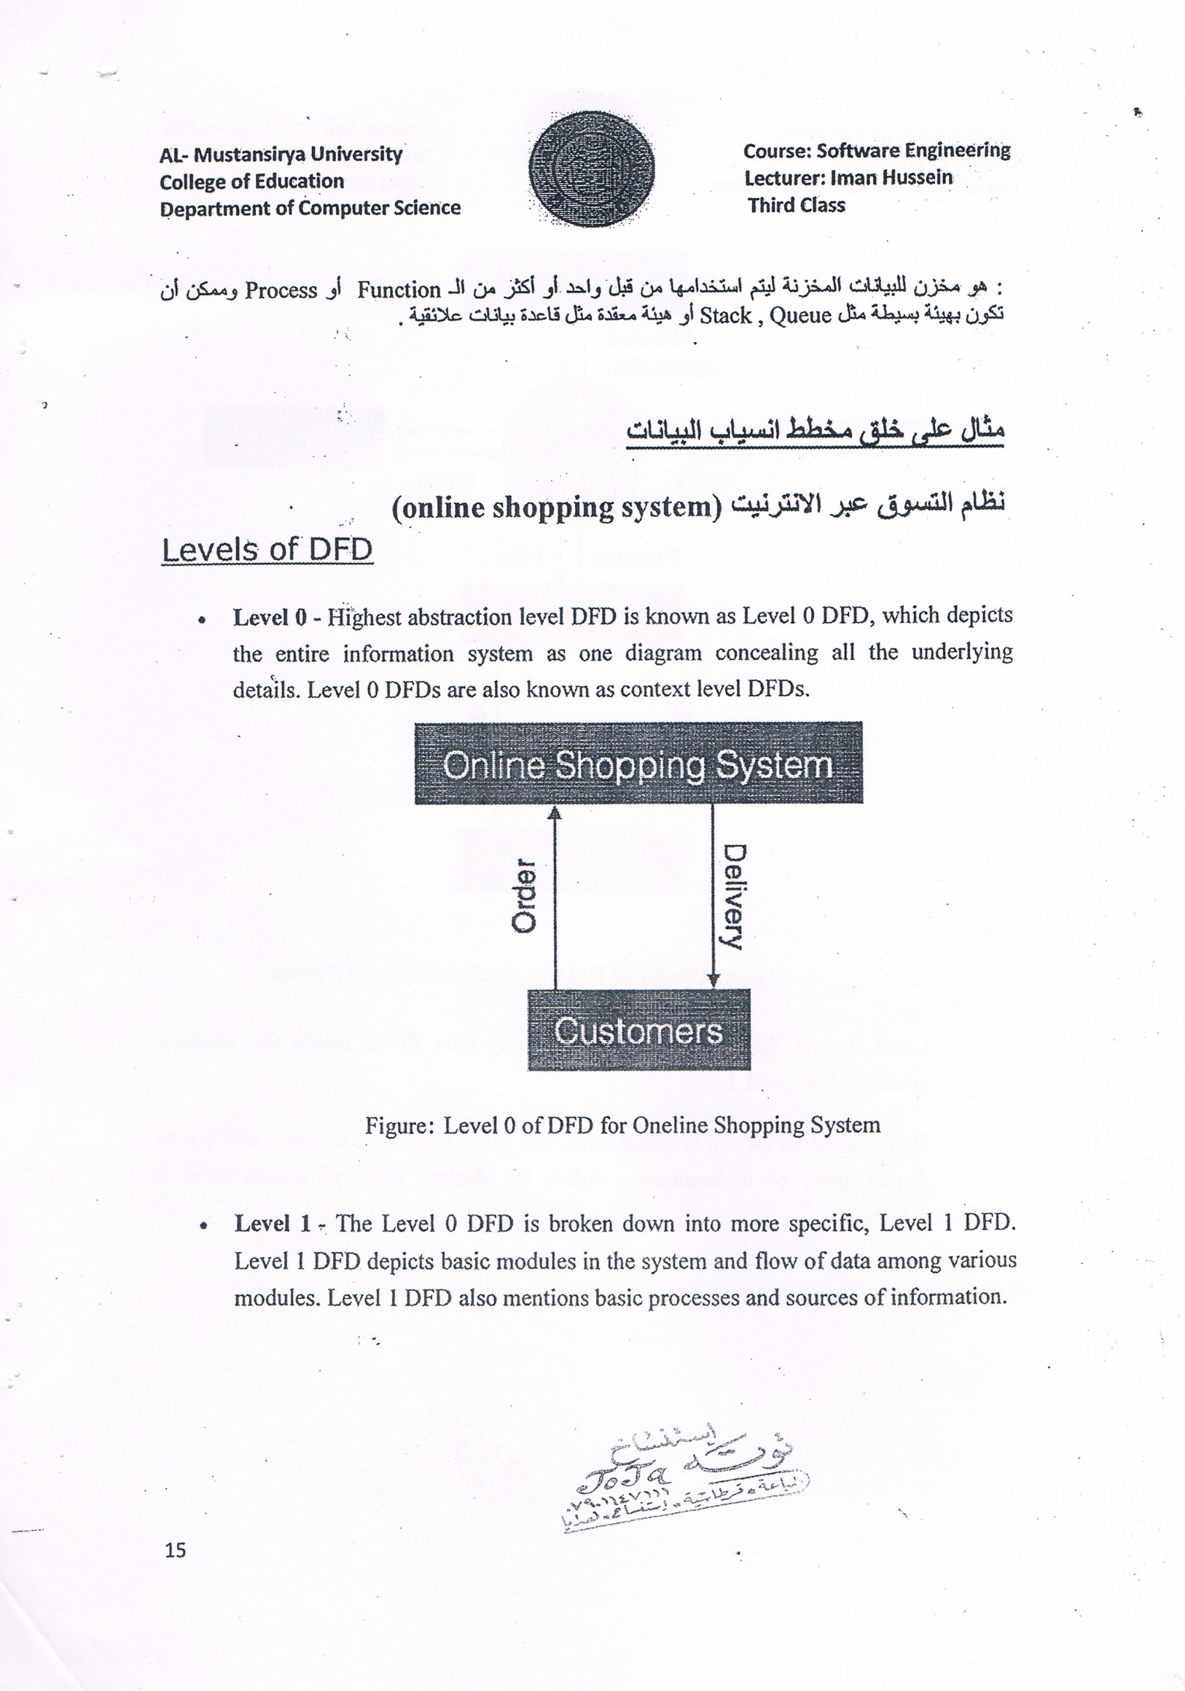

Figure:Level0ofDFDforOne lineShoppingSystem

* Level1- TheLevel0DFDisbrokendownintomorespecific,Level1DFD.

Level 1 DFDdepictsbasicmodulesinthesystemandflowofdataamongvariousmodules.LevelIDFDalsomentionsbasicprocessesandsourcesofinformation.

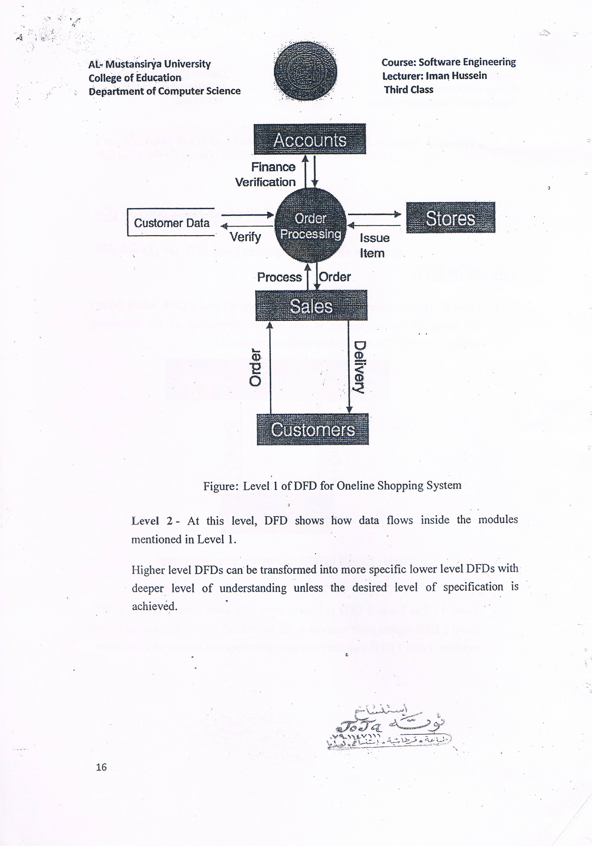

Figure:Level1ofDFDforOne lineShoppingSystem

Level 2- At this level, DFD shows how data flows inside the modulesmentionedinLevelI.

HigherlevelDFDscanbetransformedintomorespecificlowerlevelDFDswithdeeper level of understanding unless the desired level of specification isachieved.







