**EXAMPLE 11** Write an equation for line passes through (4, 10) and perpendicular to the line .

Sol

 

 

 (normal ) (perpendicular)



 and (4 , 10)









**Home work (H.W) (واجب بيتي)**

**12)** Find the equation of line that make angle 30⁰ with y-axis and passes through (1, 2)

**13)** Find an equation of line for

1) Line through P (2, 1) and parallel to  

2) Find an equation for the line through

point P and perpendicular to 

**14)** Find the slope of the line  and what are the line x-and y-intercept?

**15)** Find the equation of line that passes through P (2, -1) and parallel to the line .

**16)** Find the equation of line that passes through P (1,4) and perpendicular on the ?

**1.5 Distance between two points**

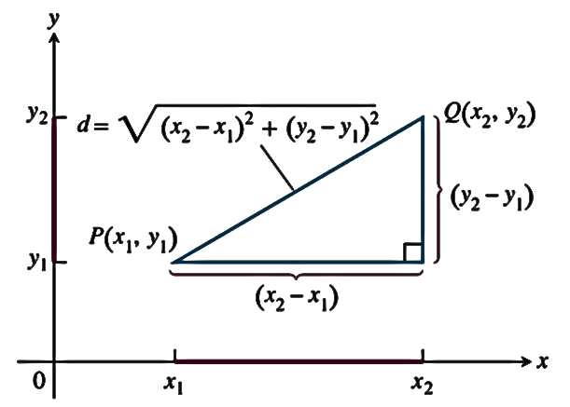The distance between points in the plane is calculated with a formula that comes from relation.



**EXAMPLE 1:** Find distance between the point (1, -3) and (4, 2)

Sol









**EXAMPLE 2**: Find distance between the point P (2, 1) and the line L ?

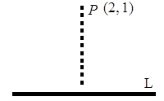Sol



We have  (1)

 



 perpendicular 



Equation of normal







 (2)



 

 

Q (1/2, 5/2) , P (2, 1)



**H.W 3**: Find distance between the point P (4, 6) and the line L: ?

**Function and graphs**

The values of one variable quantity which we might call y, depend on the values of another variable quantity which we might call x

If the value of y is completely determined by the value of x, so y is function of x i.e.





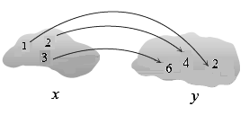







 



**Note** The variable x called independent variable, the variable y called dependent variable on value of x

**Function:** A function from a set D to a set  is a rule that assigns a unique (single) element  to each element.

1. The set  of all possible input values is call “Domain”
2. The set of all values of as x varies throughout  is called Range of the function.
3. 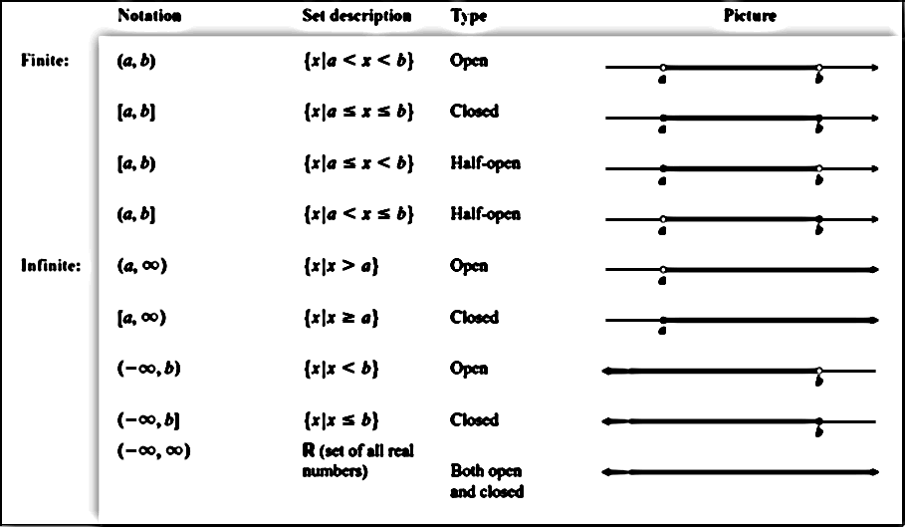The domains and range of many functions in mathematics are interval of real number are shown in figure.

**Root function**

General form 

 

 we have two cases

1. If the value of  unbounded



Find domain  and range of

**EXAMPLE 1:** 

Sol







**EXAMPLE 2:** 

Sol













***H.W***

**Ex 3**: 

**Ex 4**: 

**Ex 5**: 

**EXAMPLE 6:** 

Sol









 or 





***H.W*** **Ex 7**: 

2. If the value of  bounded 



**EXAMPLE 8:** 

Sol











 just positive

***H.W* EX 9**: 

**EXAMPLE 10:** 

Sol













**EXAMPLE 11:** 

Sol

1. 



1. 











***H.W* Ex 12**: 

**Ex 13**: 

**Ex 14**: 