**Relative function**

General form 



To find  rewrite function 

Find domain  and range 

**EXAMPLE 1:** 



 





**EXAMPLE 2:** 

Sol









To find 











***H.W* Ex 3**: 

**Ex 4**: 

**Ex 5**: 

**EXAMPLE 6:** 

Sol











**EXAMPLE 7:** 

Sol





1. 







1. 





***H.W* Ex 8**: 

**Ex 9**: 

**Ex 10**: 

**Graphs of functions**

Another way to visualize a function is its graph. If ƒ is a function with domain D, its graph consists of the points in the Cartesian plane whose coordinates are the input-output pairs for ƒ.

**EXAMPLE 1:**Graph the function over the interval 

1. 

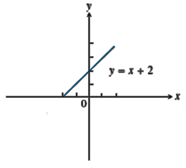

|  |  |
| --- | --- |
| x | y |
| 2 | 4 |
| 1 | 3 |
| 0 | 2 |
| -1 | 1 |
| -2 | 0 |

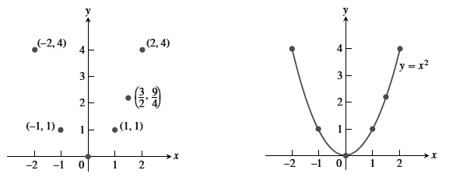

1. 

***H.W* Ex 2**:Graph the function over the interval 

1. 

2. 

3. 

4. 

**Graphing piecewise –Defined function**

Sometimes a function is described by using different formulas on different part of its domain:

**EXAMPLE 1:** Graph the absolute value function

Sol

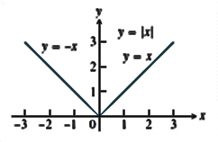 

**EXAMPLE 2:** Graph the function 

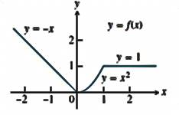

***H.W*** Graph the functions 

**10: Limits and continuity**

Let  be defined on an open interval about , except possibly at  itself. The limit of  as approaches  is the number L .

The limit of a function as  never depend on what happen when 

Right hand limit 

Left hand limit 

A functionhas a limit at point  if and only if the right and left hand limit at exit and equal



**10.1 The Limit Laws:**

If L, M, C and K are real number and  , 

1. Sum rule 
2. Deference 
3. Product 
4. Constant multiple 
5. Quotient rule 
6. power rule 