Memory system

The memory hierarchy system consists of all storage devices employed in a computer system from slow but high capacity auxiliary memory to a relatively faster cache memory accessible to high speed processing logic. The figure below illustrates memory hierarchy.

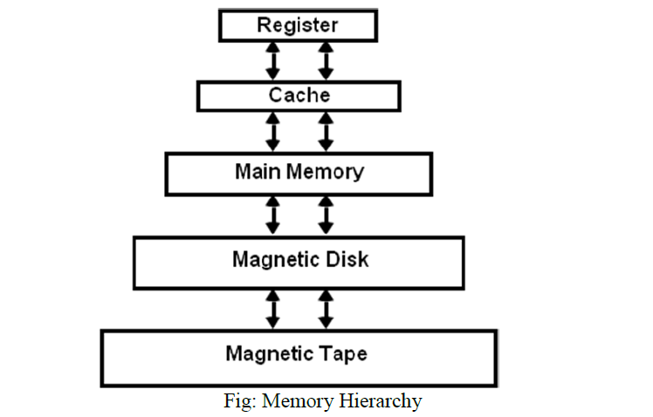

Note that the registers in the processing unit are temporary storage
devices. They are the fastest components of the computer system memory.

As we go down in the hierarchy
• Cost per bit decreases
• Capacity of memory increases
• Access time increases
• Frequency of access of memory by processor also decreases.

Thus, in a general purpose computer system, the highest speed memory is closest to the processing unit and is most expensive. The least expensive and slowest memory devices are farthest from the processing unit.

MEMORY SYSTEM characteristics:

The most important characteristics of any memory system are its capacity,
data access time, the data transfer rate, the cycle time, and cost.

The capacity of the storage system: Is the maximum number of units
(bits, bytes, or words) of data it can store:
RAM capacity= no. of words X word size

The access time: Is the time taken by the memory module to access the
data after an address is provided to the module. The data appear in the
MDR at the end of this time in a RAM.

The data transfer rate: Is the number of bits per second at which the
data can be read out of the memory. This rate is the product of the reciprocal of access time and the number of bits in the unit of data (data word) being read( Transfer rate=(1/ t).B )

The cycle time :Is a measure of how often the memory can be
accessed.

The cost: Is the product of capacity and the price of memory device per
bit. RAMs are usually more costly than other memory devices.

